Mentally Ill Homeless Veterans
[Name of the Writer]
[Name of the Institution]

Mentally Ill Homeless Veterans Group Guidelines
I would like to welcome everyone to our “Mentally Ill Veterans Group”. It is significant to note that the ratio of mentally ill homeless people is increasing with the passage of time. A major school of thought has also lamented that there are two paradigms associated with this fact, one of the phenomena highlights that mentally ill people are homeless veterans because it is the stance of deprivation that makes them physically ill, while other aspect highlights that people who are mentally ill are not addressed by rehabilitation center and their families push them out of their houses. (West, et, al. 2019). Sometimes it is the state of mind that made them leave their houses and live in freedom. The purpose of this group is to clarify certain characteristics with this dilemma highlighting the nature of a homeless and ill veteran. We also aim to explain the personality of a homeless veteran who is mentally ill. Please ensure the safety and discipline of the group by abiding by a few rules
- Examples are highly confidential
- Don’t try to humiliate other
- Stay punctual
- Avoid aggression and abusive language
- Try to mitigate disruptions by adhering to set time pattern

Outline 1
Group one: Homeless and Home drifted
Introduction 10 min
Homelessness refers to the one who has no place to live in or called a place as its home. It is asserted that there are a number of homeless people taking into account that there is a great diversity in age, race and other social paradigms. However a greater ratio of homeless people belongs to old age. Now, there are several factors behind homelessness, sometimes is the conflict of social lives such as economic scenario and sometimes it is the “adulthood” that does not match with the living standards of the family members leading to home drifting.
Purpose: The purpose of this session to help people dig out the underlying stance behind the analysis of being “homeless and home drifted”. What kind of stance is actually associated with such people, with an aim to define relationship with mental illness?
Setting tone 5 min
(A group leader will read out the handouts for the audience)
Dyads 20 Min
I will arrange people in a group of two and each of the group will be asked to write about "how many homeless people they have seen around them”, were they all mentally ill and what is the ratio of age of such people. After that each of the group will share if they have ever got a chance to speak to any of the homeless or home drifted people, what they think, was that entity homeless or home drifted?
Reading Answers
After that answers would be read to all the people around. It will take about 15 minutes.

Group Discussion 20
After sharing all the responses, an open-ended discussion would be made for about 20 minutes taking into account the homeless and home drifted people. It will last for about 20 minutes.
Conclusion 5
In the last 5 minutes, the class will be rated on a scale from 1-10; each individual will pass a single sentence comment.
Hand out
An insight into homeless people
Today, our streets and roads are full of people who have no place to live and no shelter to take; such people are called homeless people. A number of homeless people are home drifted taking into account that homeless people are actually too rare or they have a shelter at least. It is significant to note that the context of mentally ill veterans is highly applicable on the people who are home drifted. It would not be wrong to say that people who rush out of their homes are obviously motivated or enforced to do so. There are about 0.17% of people who are home drifted and this stance was also treated as a national issue in the year 1870. It is interesting to note that each of the justification regarding homeless people is equally valid, taking into account that there are different paradigms that pave the way for homelessness, and then mental illness. Another aspect highlights mental illness leading to homelessness. (Forsyth, et, al. 2018).

Outline II
Group ii: Identities and mental illness
Purpose: The purpose of this session is to identify the relationship between mental illness and human identities. Either are identities that cause mental illness or mental illness is a driver to mistaken identities
Introduction 5 min
Usually, a very conflicting stance is associates with mentally ill individuals, people think that many people lost their identities and in many of the cases it is the obsession of identities that can threaten an inner self to lose its identity. It would not be wrong to say that both the ideas are equally persistent and equally acceptable. The resources that would be used in the curriculum planning are handouts, paper, and pen
Setting tone 10 min
(Handouts would be read aloud for group)
Dyads 10 Min
Each of the individuals will be asked to "write about their ideology" in terms of mental illness and then justify their points. It is significant to note that each individual has to write about a single position.
Reading answers 15 min
All individuals would be asked to read out what they have written; taking into account that it would be compact, concise and with short paragraphs.

Group Discussion 15 min
An open-ended discussion will be made in which each of the participants will be allowed to incorporate a specific idea; this idea can be an answer towards the point of view of other individual. However all the group’s rules should be fulfilled
Conclusion 5 min
In the end, all of the people will write about one of the resolutions that they are going to consider in terms of homeless people.
Home drifting and mental illness
For instance, if it is believed that these are the mentally ill people who are homeless. A major section of the people will refer to the fact that either it would be a natural ailment or there must be a complete background. If it is asserted that mentally ill people themselves leave their home, then it is significant to note that there are many factors that must have made them to do so. It could be the lack of attention of the family members or it can also be the availability of the resources that could have enforced an individual to leave home. If such an individual is lost, the family must have opted for finding them, taking into account that one way or other the overall framework leads back to the enforcement of social roles. Mental illness causes an individual to lose identity and become a part of road traffic. On the other hand, if it said that it is the stance of home drifting that made an individual to become mentally ill, it will also be justified because the conflict of societal roles and the restrictions of “set pattern” that consider oldies as by-product may lead an individual to be alienated. This aspect is void of age realms because it addresses all the homeless people who are mentally ill. (West, et, al. 2019).

Outline 3
Group III: Imposition or illness
Purpose: The purpose of this discussion is to assert or extract any of the position in terms of mentally ill homeless veterans, taking into account that what is the catch line of such people either an imposition or an illness
Setting tone 10 min
A documentary will be shown that would be a video narrating research result regarding illness and major drivers of illness
Introduction 5 min
“Catharsis” is one of the catch lines of a happy and balanced life. It is important to note that sometimes it is the imposition or over imposition that disturbs the actual pattern or sometimes it is the natural instinct that paves the way for illness. This setting refers to the identification of cognition of mentally ill homeless veterans. The resources that could be used are documentary, questionnaires, paper, and pen
Dyads 20 Min
Questionnaires would be distributed that is based on the daily life setting and the major happenings of each of the family. There are four options to be chosen, “good, bad, worst, no idea". Anyone of the four reactions or emotional stance is to choose regarding each of the stances.
Following are the questions to be addressed
- What do you feel when you face an increased interruption
- How do you feel when elders impose something in front of others
- How do you perceive oldies extra interruptions
- How do you think when you have a continuous exposure of such circumstances
After that each of the individual will raise hands in terms of their answer to every question and each of the reaction will be counted, it will allow having a rough estimate of the assumption regarding each stance. It will allow us to adhere to the validity and existence of each of the fact.
Open discussion 15 min
Now, each of the individuals will be allowed to express her opinion. It is us who force old people to get drifted from their normal mindset or it is the passage of time. It will also include a comprehensive detail of human efforts to address the stance of mental illness and then homelessness.
Conclusion 10 min
In the end, each of the participants will jot down the causing agents of mental illness on a sheet by considering a figure or someone who have met in their lives. In case, an individual has never been exposed to a mentally ill old entity he/she has to express the idea of assumption. In a nutshell, the aim of this platform is to impart a verbal collection of logics and facts.
Analysis of daily life to extract conclusion
In accordance with the research depicted in documentary, it has been analyzed that there are a number of perspective about people who are homeless in our society as well as in our homes. Usually we think that old people are more towards stereotypes, they are more irritating because they cannot bear thing more. It is critical to think that sometimes it is the excessive light or our existence that distract or disrupts them. In accordance with the research, all these sections are proved with qualitative research, stressing that all attributes are age related. Now it is the time for self-reflection, for minutes think about any of the aged identity in your home and in your surroundings, how have you felt what they are around or they criticize and how do they react when you correct them. It is asserting that the main crux of this analysis is to incorporate an assessment of the facts and figure that contribute towards imbalance in the relationship. (Forsyth, et, al. 2018).

Outline 4
Group IV: Societal Conflict and mental illness
Purpose: The purpose of this discussion to get an idea or to impart the idea that it is the confused social conflicts that pave the way for mental illness that ultimately leads to homelessness
Introduction 5 min
On this forum, we are going to discuss an aspect of mentally ill homeless veterans that are related to societal conflicts. Sociological research has highlighted that “societal roles” are ranked third position in terms of the causative agents, it is asserted that societal conflict leads to mental illness and it is the cause of homelessness both drifted and self-directed. Resources that are used in this discussion is a real life example found by an interview
Setting tone 15 min
The handout will be read to the group
Dyads 15 Min
All the participants will be made to sit in groups and critically analyze the societal conflicts that are acting as a major driver of the conflict between the old people and their families. Each of the group will comprise of 3 participants taking into account that they have to justify their points and it would be appreciated if they could quote any real life example.
Reading answers 15 min
All the groups will share their critique and story taking into account that none of the race, family or belonging will be targeted. Abusive language should be avoided and no one has the right to criticize because there are different age groups within single setting, each of the groups will listen to their other group mates with equal patience and sympathy.
Conclusion 10 min
In the last 10 minutes, each of the members will pass a compliment in terms of their belief regarding social role conflict and the impact of time on misperception towards worlds and its duties.
Man and Manhood
It is a common observation that pity is confined to something very tragic that has the potential to empower disaster. However, another form of destruction is the treatment given to mentally ill people taking into account that documentary of the man will be shown who was knocked down by his family. It is asserted that the man who once belonged to a high-status family, as soon as he reached the 60s became a road side being. He associated all his wealth with his sons. He felt himself deprived from his family, at times his family members threatened him to stay out the family matters. With the passage of time, he was doomed to stay in his room only. After a few weeks dementia and depression was diagnosed. One day, all the family members were planning to go out for skating in snow he was continuously denying and opposing taking into account extreme weather condition. His elder son being much aggressive forced him out of the home. According to the old man, he wandered and shuddered in snow but no one opened the door, he kept knocking. After that he made his way to the countryside, he said he kept on walking and falling regretting for sharing his will but now everything was gone. All these are the chunks he remembers, he said he slept under shops and shelter, he ate from dustbins, no one bothered and he is waiting for his death now. (Evans, et, al. 2019).

Outline 5
Group 5: Relationship dynamics
Purpose: The purpose of this discussion to undergo an exegetical analysis of the facts and figures that can allow each of the individual to comment about his role in terms of homeless people they have seen or any other practical stance that is observed in the surrounding.
Introduction 5 min
It is said that the entire human beings on this Earth are bound together in terms of relationship of brotherhood, love, and hope. This is an abstraction that is actually named when different people came to interact with each other in terms of society and societal rules, chained in blood relationship. The question to address is the relationship dynamics with the mentally ill homeless veterans. The resources would be paper and pen.
Setting tone 10 min Handout will be read aloud
Dyads 15 Min
Each of the individuals will write certain points in terms of self-reflection, how many times an individual has tried to approach an individual who is homeless and mentally ill. For how many times, an attempt is made to do something for such needy people. One of the major questions to address is, for how many time one has sacrificed his personal needs for the other entity that’s in need.
Reading answers 20 min
After an analysis of what everyone has written, all the answers will be shuffled taking into account that there is no identification of one’s answers. Each one of the participants will read out the paper he/she has got. It will be a true reflection that will not only express the notion of dynamics of human relationship but it will elaborate the stage today's generation has achieved being overwhelmed by self-centeredness.
Group Discussion 5
After this narration, groups’ leader will share a generalized view regarding relationship dynamics taking into account that research has highlighted a major deviation in the relationship dynamics adhering to the framework of man in today’s society. It is asserted that several survey responses have also highlighted that direct and blood relationships are also compromised in a certain life setting. It is dejecting to affirm that many people see their relatives homeless but they hardly bother about it thinking that he is well deserved.
Conclusion 5 minutes
Each of the participants will be given a note pad on which they will write all their regrets taking into account that it will allow them to reflect themselves leading to catharsis where each of the individuals will write something they are going to do after stepping out of this setting.
Humans and Humanity
Today, we are all in a global village where all things are in a direct approach. It is not the stance where man has to chase its aims and ambitions. It is significant to note that this impact of globalization has reduced the material distance but increased the spiritual distances. Everyone is seen busy with oneself and this influence has neglected what is expected of us being a human. It is significant to note that we don’t feel the same about others as we are more concerned with self-interest. All that matters for us is ME. A common example is, whenever there is an emergency we rush to look for our shelter rather than supporting others who are unable to defend themselves. (West, et, al. 2019).

Outline 6
Group 6 : Government Policy and mentally ill homeless veterans
Introduction 5 min
Mentally ill homeless veteran are treated as the most pity full section of society, taking into account that there are several organizations that are trying to help them out. In accordance with the stance of “public interference”, it is to acknowledge that there are different policies that have been induced to address the issue. It aims at the acknowledgment of policies. The resources that will be used are paper, and pens.
Purpose:
The purpose of this group dynamics is to analyze what government policies are intrigued to address a large number of mentally ill homeless veterans, side by side, an exegetical analysis will reveal how much practical implication of the idea is seen in a social setting. Side by side, human actions will also be highlighted taking into account that there is a dire need to address the relevant facts and figures in terms of social conduct.
Setting tone 5 min
Handout will be given regarding policies that have been brought into practice and are announced.
Dyads 30Min
After a clear elaboration, all the participants are asked to write about the policy. How much implication of such policy can be seen in their surroundings? Each of the members will write an account of the adequacy and practicality of policy.
Group Discussion 15 min
Each of the participants will share a catch lime of what they have written taking into account that there would be no biases in the political account.
Conclusion 5 min
In the last five minutes, there would be a regulation stance; taking into account that each of the participants will show what they think they should try to do for such people. Each of the participants will make a particular resolution till next year until this day.
Relevant Policy
MISSION-VET-HUD-VASH is a policy that has been introduced by the government in order to address the ratio of mentally ill homeless veterans. It is important to note that about 80% of the homeless people suffering from mental illness. The policy aims at the rehabilitation of such people taking into account that they are granted adequate treatment as well as place to live. It also acts as a home to people who suffer from substance abuse and has become a victim to mental illness. Both the categories of people are addressed under legal implementations stressing safety of life and rights. There are different organization and public offices that are working in this office with an aim to facilitate such people. (Forsyth, et, al. 2018).

Outline 7
Group 7: We and homeless mentally ill veterans
Purpose:
The purpose of this sitting is to comment and critically analyze the perception that we hold against mentally ill homeless people, taking into account that these people are also part of our society.
Introduction 5 min
The aim of this setting is to create a beam balance in which one side is occupied by the normal people and the other with people who belong to the mentally ill homeless veteran. Our aim is to analyze where we stand in terms of catering to the needs of such people. What is the perception that we behold? The resources would be flash cards, projector, and paper-pen.
Setting tone 5 min (Flashcards would be distributed to the people each with a picture of homeless veterans doing something)
Dyads 10 Min
All the participants of the group would be allowed to sit in two groups. Each of the group will be given one flash card with picture. They would be asked to evaluate the apparent reality of the picture, what they can see in the picture.
Reading answers 15 min
After Dyad, each of the group will narrate what they think they perceive taking into account that the picture will be portrayed on the projector in front of the board.
Group Discussion 20 min
A group discussion will be conducted in which each of the participants will express their view if contradictory to the one that is elaborated by the actual group to whom the picture was assigned. It will allow all the members to get an insight into the actual stance of the perception, how much distance we have
Conclusion 5 min
In the end, all the members of the group will demonstrate social spectrum that is associated with people who are mentally ill homeless veterans. It is a common observation that all such people are usually termed as robbers, rapist, and criminals. The stance of assuming a book from its cover is so common that we always believe in over-generalized thinking.
Handouts
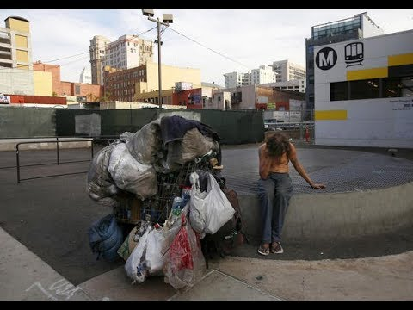

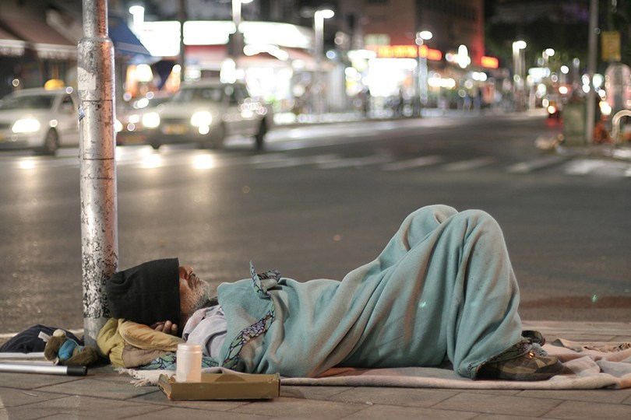

References
Evans, M. B., Graupensperger, S., Benson, A. J., Eys, M., Hastings, B., & Gottschall, J. S. (2019). Group structure and entitativity in group fitness: considering groupness at within-and between-group levels. Psychology & health, 1-18.
Forsyth, D. R. (2018). Group dynamics. Cengage Learning.
West, V. J. (2019). Links between group dynamics and responses to environmental challenges in the jackdaw, Corvus monedula (Doctoral dissertation, University of Newcastle upon Tyne).

