Joyci Man
Professor
Course
10 April 2019

Title: Car Research Project
A number of dynamic forces act on the vehicle when it is driven. When the speed or direction of the vehicle is changed, force is first exerted on the car’s tires from where lateral, motive and braking forces are further transmitted to the vehicle’s system, determining the overall dynamic forces acting upon it. The paper will discuss and analyze the maximum torque that a 1997 Automatic transmission Toyota Corolla could exert on standard size tires, along with the forces acting on the road, and the acceleration and RPM of the car.
Maximum Torque
In a car that is running at its peak horsepower RPM, its potential to accelerate would be highest, however, the potential to accelerate is even higher in the first gear. Thus, the maximum torque that a car can produce on its wheel would be a function of its gear ratio and differential ratio which determine the extent to which the engine’s torque gets transferred to the tires. Assuming the car runs under ideal conditions would rule out the possibility of drag, friction, or slips in the clutch or torque converter systems, and thus it is assumed that the differential and the gearbox receive all of the engine's torque without loss. In a 1997 corolla which uses an automatic transmission, a clutch-closed, lock-up torque converter is used. The torque exerted on the gearbox T_{g} is, therefore, a product of the engine torque T_{e} and the gear ratio at the time i_{x}.
The torque at the gearbox T_{g} applies to the differential as it is transmitted to the axle by the propeller shaft. The differential Torque T_{d} would be a product of the final drive ration i₀ and the gearbox Torque T_{g.} Furthermore, the differential Torque T_{d} splits between the two front tires, assuming equal RMP under ideal conditions and that the car is not turning. The torque at any wheel, left or right, would thus be half of T_{d,} thus T_{w} = T_{d}/2. As the various functions defined above are combined, we can get the final form of T_{w,} which is the maximum torque exerted by the car on the tires or simply wheel torque, as:
T_{w} = (T_{E} x I_{x} x I_{o})/2
The formula requires determining the final drive ratios and gear ratios to obtain the torque on each tire. The given torque T_{e} at 110 ft-lb is likely to be the maximum torque that the engine can generate at peak horsepower RPM. The 7A-FE Engine comes in the automatic variant of the 1997 model, and ideally, the peak engine torque is obtained from a torque-RPM curve where the gradient becomes stable for varying RPM values. Here, T_{e} is taken to be 110 ft-lb or 138 N.m
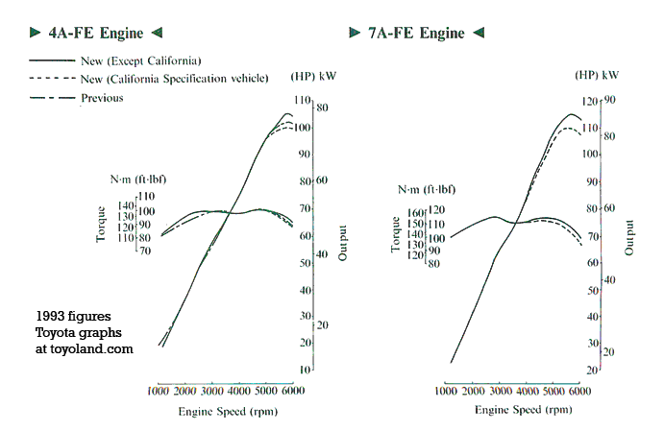
Figure 1 - Torque vs RPM Graph of Toyota's 7A-FE Engine used in 1997 Corolla (toyoland)

In the first gear, the car is able to exert maximum torque on its wheels potentially compared to other shifts. Therefore, it is assumed that the car is moving under ideal conditions at 100% engine efficiency, without slippage, and in its first gear. The gear ratio of the 1997 automatic corolla in its first gear can be obtained from the manufacturer’s specifications. According to Corolland, the gear ratio in the 1st shift is i₁ = 3.643:1 while the i₀ = 2.821:1 for the final drive ratio (Corolland). Therefore,
T_{w} = (T_{E} x I₁ x I_{o})/2
T_{w} = (138 x 3.643 x 2.821)/2
= 709.10 Nm
Maximum Force exerted on the road by the wheels
To calculate the force exerted by tires on the road requires the maximum torque on the wheels T_{w} along with the radius of the tire r. Torque is the product of the force applied on a lever arm, and in this case, T_{w,} the wheel torque, is assumed to apply on the exact geometric center of the wheel hub. The lever arm can thus be obtained from the radius of the wheel r_{w} upon which the force is being applied as a result of the Torque. This assumption is based on the fact that under ideal conditions, there is no change in the dimensions of the tires as the car is moving and that the radius of both tires is exactly equal. Moreover, since both tires will experience the same Torque, therefore the resulting force F_{w} will be applied on both wheels equally, as a function of the tire's radius r_{w} and the wheel torque on any given wheel, T_{w.}
Therefore T_{w} = F_{w} x r_{w}
Or F_{w} = T_{w}/ r_{w}

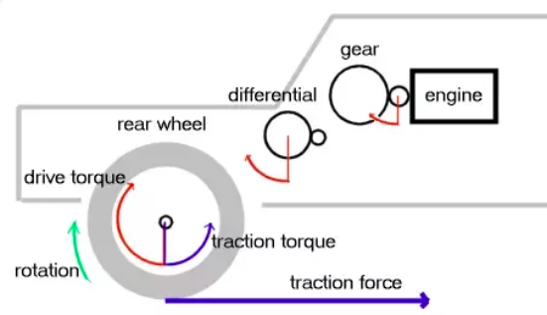
Figure 2 - Torque acting on the wheel, gearbox and differential

Since T_{w} was dependent on the final drive and gear ratios, the maximum force exerted by the tires too is a function of these values. According to Toyota’s specifications, the 1997 corolla with a standard tire size uses 175/65R14 81S tire size, which can be used to calculate the radius R_{w} (Wheel Size). The radius is thus taken to be 0.291m

F_{w} = T_{w}/ R_{w}
= 709.10 x 0.291
= 206 N

Maximum acceleration
Using the value of the maximum force that was being exerted on the road by the tires, f_{w}, the acceleration of the car, a_{w}, can also be determined as the car moves along a straight line in the first gear. Under ideal conditions, it is assumed that other dynamic forces and resistances being exerted on the vehicle such as the friction force, slippage, slope of the road, or the aerodynamic drag, can be ignored. For any given car, the acceleration of the vehicle depends on the total number of resistance forces acting on it that are subtracted by the maximum force it is able to exert F_{w.} As force is the product of mass and acceleration
∑F_{w} - ∑F_{R} = m.a
Assuming ideal conditions, we can safely ignore the ∑F_{R}
F_{w} = m x a_{w}
The mass of the vehicle is again obtained from Toyota's specifications of their model. In this case, the curb weight of the 97 corolla would be used as it represents the weight of the average number of passengers that are usually seated in the vehicle along with the weight of the actual car. The curb weight, m, for the model is 1045 kg (Auto 123).
Therefore,
a_{w} = F_{w}/m
= 206/1045 = 0.197 m/s²

RPM in 3rd gear, with vehicle speed 70mph
The given values of the vehicle along with the aforementioned manufacturer’s specifications and calculated values are:
ω= 9.5 v/r
v= 70mph = 312.29 m/s
r = 0.291m (Wheel Size)
At 3rd gear at i₃ = 1.296 (Corolland)
And I_{o} = 2.821 (Corolland)
To calculate the RPM values from the velocity of the car, it is to be known that the gearbox’s primary function is to use its transmission ratios to modify the engine’s rpm. The power from the engine is transmitted via the output shaft to the drive train, where the final rpms are modified as a result of the final differential ratios i₀ following the gear ratios i_{x}. Moreover, every revolution of the tire of the car will move the car to a certain distance as a function of the circumference of the wheel. The final drive ratio i0. The total rpm produced by the engine is ω_{e} will be reduced according to i_{x} and i_{o} giving the final rpm at the tire ω_{t}
ω_{t} = ω_{e} / (i_{x}.i_{o}).
Since the distance travelled by car for each revolution is determined by the wheel's circumference, therefore the radius of the tire obtained from the manufacturer's specifications can be used to calculate its circumference.
The distance would thus be 2πr_{w} x ω_{t}
Combining between the above functions, the final formula will be:
0.00595 x (ω * r) / (i₃ * i₀) = v (mph)
where 0.000595 serves as the multiplication factor derived for miles per hour)
at v = 70 mph or 31.29 m/s, the third gear i₃ is engaged
I₃ ₌ 1.296:1
i_{o} = 2.821:1
r = 0.291
0.00595 x (ω * 0.291) / 3.656 = 31.29
0.297ω = 70*3.656
ω = 385 rpm

Works Cited
Auto 123. Technical Specifications 1997 Toyota Corolla SD. 2018. 12 March 2019. <https://www.auto123.com/en/new-cars/technical-specs/toyota/corolla/1997/base/sd/>.
Corolland. 1993-1997 Toyota Corolla (US-Spec): transmissions, driveshafts, and axles. 2000. 12 March 2019. <https://www.corolland.com/corolla/1993-1997/transmissions.html>.
toyoland. Toyota 4A-F and 7A-FE engines: details and photos. 2000. 13 March 2019. <https://www.toyoland.com/engines/4A-F.html>.
Wheel Size. Toyota Corolla 1997 Alloy wheel fitment guide US domestic market. 2019. 12 March 2019. <https://www.wheel-size.com/size/toyota/corolla/1997/>.

