**Motivation at a Glance**

Your Name

School Name or Class

**Motivation and Its Components**

Motivation can be defined as the reasons which are implicitly or explicitly reflect on behaviors (Guay et al., 2010). Moreover, motivation also widely asserted as an attribute that compels people to do or not do some specific tasks or actions. Motivation is the underlying driving force in almost all métier of life, including workplace and education, even domestic management necessitates a particular sort of motivational factor. According to Harlen and Crick (2002), motivation is comprised of several components, among which endeavor, objective orientation, locus of control, self-actualization, learning inclinations, self-esteem, interest, and self-regulation are prevalent.

**Motives and Their Types**

Motives are objectives or goals that require fulfillment; the emergence of any biological, psychological, physical, behavioral, or social desire or need can be defined as motives. Motives are limited in nature because, unlike external stimuli, they arise from within. Motives can be divided into three major types, which are as follow.

* **Biological Motives:** Such motives are widely addressed as primary motives and elucidate all innate requirements including hunger, need to breath, thirst, temperature, unique physical necessities, evading the peril of pain, maternal emotions, and excretion etcetera.
* **Social Motives:** Such motives are also defined as secondary motives and highlight the significance of social stimuli such as an urge for winning, aggressive, or influential causes as well as socialization, curiosity and attainment, and possessive motives.
* **Personal Motives:** Such motives prominently elucidate the significance of habits, the objective of life, and aspirations, etcetera.

**Biological Theories of Motivation**

The field of psychology elaborates on different biological approaches that are intertwined with the notion of motivation and are described below.

* **The Intuition Theory:** According to this approach, neural patterns of recognition incidences shape different levels of motivation. In this context, people strive to attain some targets to gratify their subconscious thrives and exert extraordinary efforts on humanity.
* **The Instinct Theory:** The approach affirms the exceptional interconnectivity between biological impulse and motivated demeanors.
* **The Drive Reduction Theory:** According to the underlying proposition of drive reduction theory, some behaviors are motivated to eradicate or lessen the stress triggered by multiple factors such as temptation, pain, or starvation.
* **The Arousal Theory:** The arousal approach suggests that triggered behaviors are the outcomes of experience that involves the highest level of arousal.
* **The Psychoanalytic Theory:** According to the approach, motivated behaviors are caused by a primary urge to survive and to evade the probability of demise.
* **The Humanistic Theory:** The humanistic approach of motivation features a broader horizon and also embraces the eminent proposition devised by Abraham Maslow, known as the Hierarchy of Needs. According to the theory, people exert their potencies to gain maximum outcomes.

**Behavioral and Social-Cognitive Theories of Motivation**

**Cognitive Theories**

* **The Expectancy Theory:** The approach states that motivation is a by-product of an individual’s want, generally, in the form of some extrinsic rewards. The desire to achieve the incentive hurls the individual to pursue the required behaviors. In this context, the motivated person believes and expects to attain the desired reward through performance.
* **Equity Theory:** The approach signifies the notion of fairness that motivates an individual to take certain actions in the attainment of a predetermined standard, equivalent to others.
* **Goal Setting Theory:** The theory states that a clear direction and guideline of objective or goal keep individuals motivated to move forward, toward the target.
* **Social-Cognitive Theory:** The approach encapsulates the idea of psychological functioning that underlines the learning from observing, the social surrounds, and the environment.

**Behavioral Theory**

* **Behavioral Modification Approach:** The mentioned theory, in fact, is a therapeutic design that molds out individuals’ behaviors through the implementation of a system of positive or negative outcomes.

**Maslow's Hierarchy of Needs**

In 1943, the psychological theory, “Hierarchy of Needs”, was presented by Abraham Maslow. Throughout his proposition, Maslow emphasizes a pyramid of essentials that motivate an individual to pursue a specific set of actions or performances. In due course, Maslow formulated a hierarchy and arranged the fundamental needs and drives of an individual in descending order. The pyramid holds the most basic psychological necessities on the base of the archetype; the psychological needs include the urge to survive that, in turn, elevates the significance of sleep, food, shelter, and water etcetera. On the upper section, Maslow placed a sense of protection, security, and safety. According to the theory, without ensuring safety and security, no human can manage anything effectively. On the third tier, Maslow infuses the need of belonging and affection that could be received from family, spouse, and partners, collogues, mates, and etcetera. On the fourth layer, Maslow addresses the efficacy of self-esteem because people need a sense of respect and recognition in order to surpassing the premium performance. Moreover, the last but not the least, level of hierarchy pivots the façade of self-actualization that enwraps all the relative notions of spontaneity, morality, and problem-solving, acceptance of facts, and lack of prejudices, as well as creativity (Abulof, 2017).

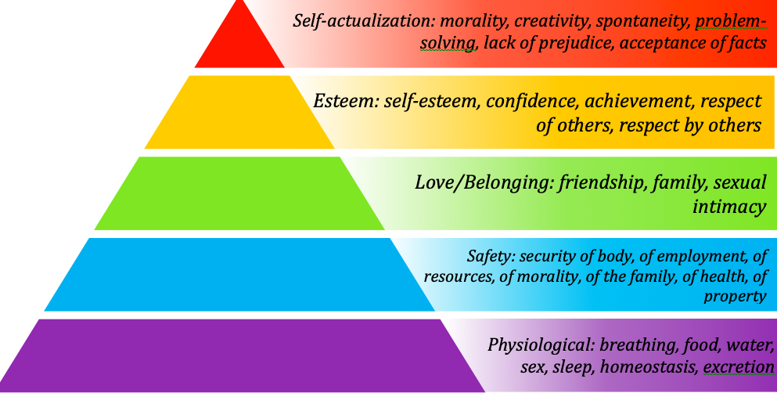

**Which Level Of Maslow's Hierarchy Provides The Strongest Motivation For Behavior In General?**

Though all the levels of Maslow’s hierarchy reflect on the most indispensable motivational drives, but in general, the tiers of self-esteem and self-actualization provide me the strongest motivation for behavior. I am a person who gets motivated by constructive feedback and self-esteem. On the other hand, I believe that self-actualization is a vital concept to live a vigorous, purposeful, and meaningful life. And these two levels are universal and applicable to almost every situation and circumstances at hand.

**Reference**

Abulof, U. (2017). Introduction: Why We Need Maslow in the Twenty-First   
 Century. *Society*, *54*(6), 508-509. doi: 10.1007/s12115-017-0198-6

Guay, F., Chanal, J., Ratelle, C., Marsh, H., Larose, S., & Boivin, M. (2010). Intrinsic,   
 identified, and controlled types of motivation for school subjects in young elementary   
 school children. *British Journal Of Educational Psychology*, *80*(4), 711-735. doi:   
 10.1348/000709910x499084

Harlen, Wynne & Crick, Ruth. (2002). A systematic review of the impact of summative   
 assessment and tests on students' motivation for learning. http://lst-iiep.iiep-  
 unesco.org/cgi-bin/wwwi32.exe/[in=epidoc1.in]/?t2000=021193/(100).