Name
Instructor Name
Course Number
Date
AMAZON (a Monopolistic firm)
Market structure of Amazon.
Amazon is a major online retailer of home goods and cleaning supplies. Amazon’s organizational structure makes it grip over the e commerce operations strongly. It has adopted strategies to operate its activities in various part of the globe. As a leading online retailing business Amazon has diversified its business areas and it has withstand the capabilities of competitors, like Walmart and Google (Amazon.Com). It has an organizational design that make sure to strengthen the relation among members and to compete as the best online retail business
It compete the famous stores like Walmart, Bed, Target and Bath. It also competes with DSW, Gap and foot locker as a shoe and clothing retailers. Recently it has purchased the biggest online shoe and diaper store. It is working very successfully in delivering all of its product and it has the most traffic on its website. Last year its sales were six time more than Walmart, Best BAY, Home deposit and Costco. It generated 30 percent of U.S online as well as off line sales growth. IT has diversified products and it also publishes books and design hardware. The most important characteristic of Amazon is that it operates web services of a $12-billion dollar that rents services along with computing powers to firms (Carnevale). Amazon has made the market harder for its competitors and now it’s competing against everyone. Thus its market structure is monopolistic.
Characteristic of the market structure of Amazon:
Amazon has launched Diapers.com in 2010 and it is the most tarnished example among its products. Thus it dropped diapers price 30 percent and small retail business are being targeted. It has enough money to compete any form and it has a very strong focus on consumer behaviors by lowering prices and making its self the leading online retail store. It has fixed its targets of calling together of policy making mind in order to shoot out companies that can easily distort market structure (Dirksen et al.)
Amazon’s profit maximizing behaviors.
Since its market characters is monopolistic and it has lowered prices for it products, then its demand curve will shift to the left. It also makes the demand more elastic.
Suppose the price and quantity are below.
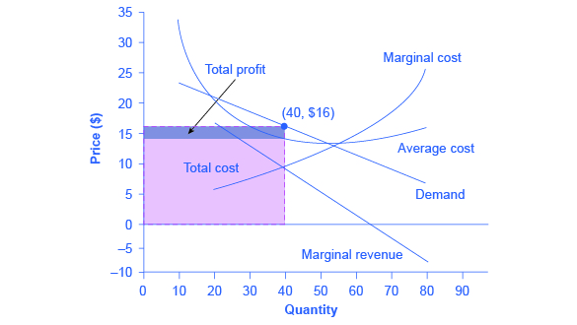
The pro9fit maximizing quantity is 40 with a price of $16. The firms MR=MC. The difference between AR AND Ac will give the total profit that is the space above total cost. ³

Work Cited
Amazon.Com: Online Shopping for Electronics, Apparel, Computers, Books, DVDs & More. https://www.amazon.com/. Accessed 2 Apr. 2019.
Carnevale, Eric. “Questions of Copyright in Google’s Image Search: Development in Perfect 10, Inc. v. Amazon. Com, Inc.” BUJ Sci. & Tech. L., vol. 14, 2008, p. 132.
Dirksen, Stephen, et al. “Who’s Afraid of Amazon. Com v. Barnesandnoble. Com?” Duke Law & Technology Review, vol. 1, no. 1, 2001, p. 3.

