Kill and Kill Again and Bamboo Gods and Iron Men
[Name of the Writer]
[Name of the Institution]

Kill and Kill Again and Bamboo Gods and Iron Men

Introduction
Art has been an essential form of human expressions, thoughts, and moods. Since the very beginning of time, humans have taken the help of art to express themselves. Art was there even before the evolution of language. Even before human had learned to speak and developed languages, they used to express their thoughts and ideas through various forms of drawings. Such evidence of art has been found extensively all over the world wherever the evidence of ancient human life was found (Edwards, 2014). Anthropologists and experts have found fossil fuels and scripts written on stones and leaves. One of the most transparent forms of evidence that have supported the use of art and drawings in the past is the discovery of pictures on the walls of caves where the earliest humans used to live.
Then came the era of Post Modernism. Postmodernism refers to a broader category of developments and growth in various sectors of human life, especially that involved creativity and thinking. Post Modernism comprises of a whole era, a huge range of period of time in which the societies moved from modernism to postmodernism. The wave of postmodernism started from the mid-twentieth century and lasted until the late same century. The era of post-modernism encompasses the subjects of philosophy, critical thinking, art, architecture, and criticism.
Although the wave of post-modernism affected all the dimensions of creative sciences, the most affected fields were architecture and art. Post-modernism affected each and every aspect of these disciplines and brought a great revolution in them bringing many changes. Most of them were positive, whereas some of them carried drawbacks with them as well.

Discussion
One of the significant and prominent forms of arts is visual arts. Motion art also forms a part of visual arts. Motion arts constitute of movies, dramas, stage plays and multiple types of series, whether it is a tele-series or web series. One of the prominent fields of art that was affected due to the wave of post-modernism was the area of movies.
Before the postmodern era, movies made were not that much flashy and used less representation of arts. There were only limited numbers of genres that were focused by the producers and directors and almost all the movies revolved around the same styles. The story lines were the same, and the audience was bored of watching the same thing again and again. The creators of the movies did not dare to think out of the box and bring something new to the stories. If any movie maker dared to go out of the box. The movie was badly rejected by the audience, and he had to face a loss.
During the era of Post-modernism, where many things changed, the area of movies also went through multiple changes. The most significant difference was the inclusion of many new genres to the movies. In addition to romance, the subjects of action were also produced now to entertain the audience, and the audience also accepted them as a category of the storylines. This change came because of the modification in the thinking patterns of the society (Boyne, R., & Rattansi, (Eds.), 2017). People had become more flexible and started to accept new things in their lifestyles like clothing, footwear, etc. The same thing happened in the case of entertainment, in which people began to accept new things to watch and welcomed any new development in the plots of the movies.
Multiple examples are present that represent the modifications going through the society and the in the arenas of motion pictures. Many movies represent and glorify the significance of that area. Two of such notable movies produced through that time period are “Kill and Kill Again” and “Bamboo Gods and Iron Men." Both the movies were prominent works of art that depict the changing environments of the film, during the post-modern era. The following details discuss each movie in particular, encompassing what the plots and themes of these movies were and how they succeeded in grabbing audiences attention in the changing times.

Kill and Kill Again (1981)
Introduction
“Kill and Kill Again” is an action movie that was released in 1981. The film was directed by Ivan Hall and Starred James Ryan, Anneline Kriel and Michael Mayer in the lead roles. The supporting cast included Ken Gampu, Norman Robinson, Stan Schmidt, and Bill Flynn.
Plot
James Ryan outshines in the role of Steve Chase, who has been assigned a mission to save famous scientist Horatio Kane. Kane has been kidnapped by his rival and evil counterpart, Marduk. Marduk is also a scientist and wants to take over the whole world, for his evil purposes. For this purpose, he is planning to collect a whole army of karate slaves, whose mind he controls by a weird invention. The invention was a potato-based serum that is used to control the minds of people. Chase succeeds in gathering a group of mercenaries who set out to find Dr. Kane (Hall, 1981). Chase leads the team to the stronghold of Marduk, who was living in his high-walled fort which also accommodated his large laboratory, that he used for his evil purposes. Steve is assisted by his team that consists of characters with multiple gifted abilities; Gorilla, the strongman, has been shown as a character with immense power, The Fly, a mystic character, The Gypsy Billy, who is shown to be "the former champion of the world" and the Hotdog, who is a funny character and an expert in understanding and operating any kind of weapon. Steve’s team also contains Kandy Kane, who claims to be the daughter of Dr. Kane.
Characters
The characters of Steve Chase has been played by James Ryan, whereas the other characters like Gorilla is played by Ken Gampu, Gypsy Billy by Norman Robinson, The Fly by Stan Schmidt, Hotdog by Bill Flynn and Kandy Kane by Anneline Kriel.
Production
The movie is a sequel to “Kill or be Killed” that was released in 1977. The making of the film “Kill and kill Again began in June 1980. The locations used for the shootings was Europe and the United States of America, whereas most of the cast was from South Africa.
Release
The film was released in New York on May 8, 1981. There was another picture planned in the pipeline to be released shortly after the release of this movie, as per the announcement made by Hollywood Reporter, but it never came.
Reception
Just after its release, the picture got mixed reviews. One group of viewers was of the view that the film is an excellent representation of the action sequences and adventure. The general audience loved the combination of comedy, action, drama, and thrill, whereas another group regarded it as a total waste of time and effort. According to the reviews in the Variety, the action was not thrilling and very non-existing. It also found the choreography session very dull and flat. Another film critic Vincent Canby wrote in the New York Times that the picture had a “Horrible Plot” and “contains a lot of action, but most of the violence is in the grunting and groaning that accompanies the various karate chops."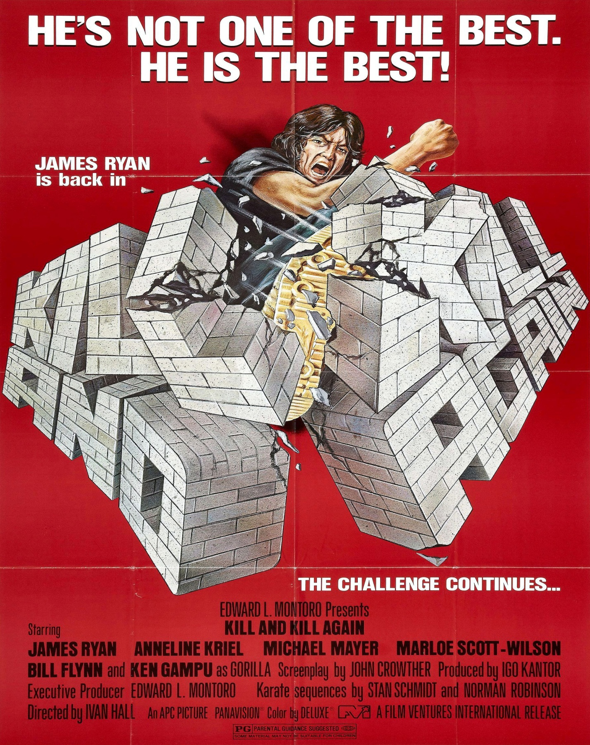
The official poster of the movies Kill and Kill Again (1981)
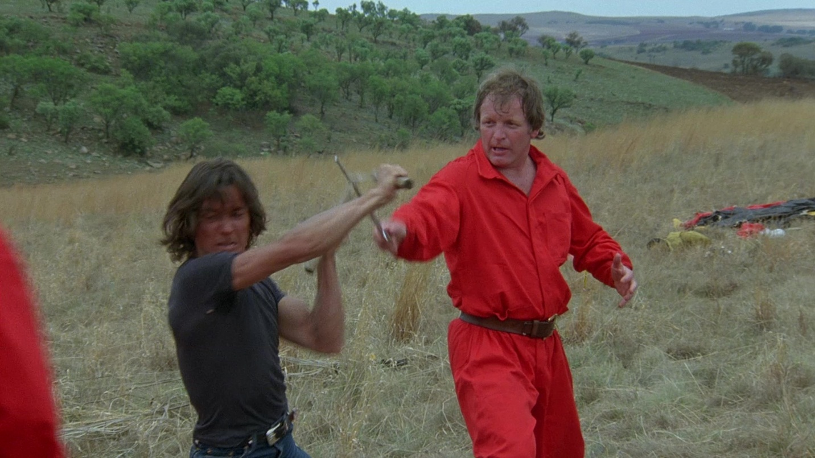
Chase finds himself fighting with Marduk in a fight sequence.

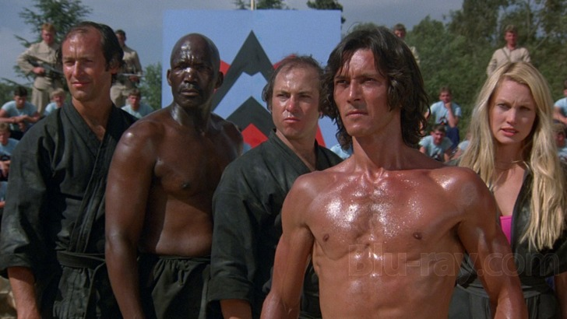
Steve Chase with his team of Mercenaries
Bamboo Gods and Iron Men
Introduction
Bamboo Gods and Iron Men is a Philipinese movie that is based on the physical art of martial arts. The movie also includes the elements of comedy and touch both the genres of action and humor. The film was released under the banner of American International Picture on January 1974.
Plot
The movie starts with the famous fighter Cal Jefferson on his honeymoon vacation in Hong Kong. Cal finds a Chines man drowning in the sea, whom he jumps to save immediately. The newly saved man seems to be very thankful and happy after getting a new life saved by the fighter. But the man appears to be mute as he does not speak (Gallardo, 1974). The couple finds it extremely difficult to get rid of this newly-saved stranger as he accompanies them everywhere they.
Trouble arises for the couple when they become highlighted in the eyes of a criminal gang. Cal buys a rare gift for his wife that they had noticed in an antique shop while window shopping the other day. The gang, led by Kenneth Metcalfe, is not ready to leave the couple and is ready to go to any lengths to retrieve the gift. The couple moves to Manila, and then finally Philipines, where they find themselves chased by the gang and the same mute Chinese man attacks them.
Characters
The characters of Cal Jefferson and Mrs. Jefferson (Arlene Jefferson) have been played by James Iglehart and Shirley Washington respectively. The other characters have been played as Chiquito by Charley, Eddie Garcia by Ambrose, Kenneth Metcalfe by Leonardo King and Marissa Delgado as Pandora.
Reception
The movie received a very warm welcome by the audience, and they thoroughly enjoyed the genre of martial arts. Although martial arts was not a common affair in those days, the audience demanded more of such movies in the future.
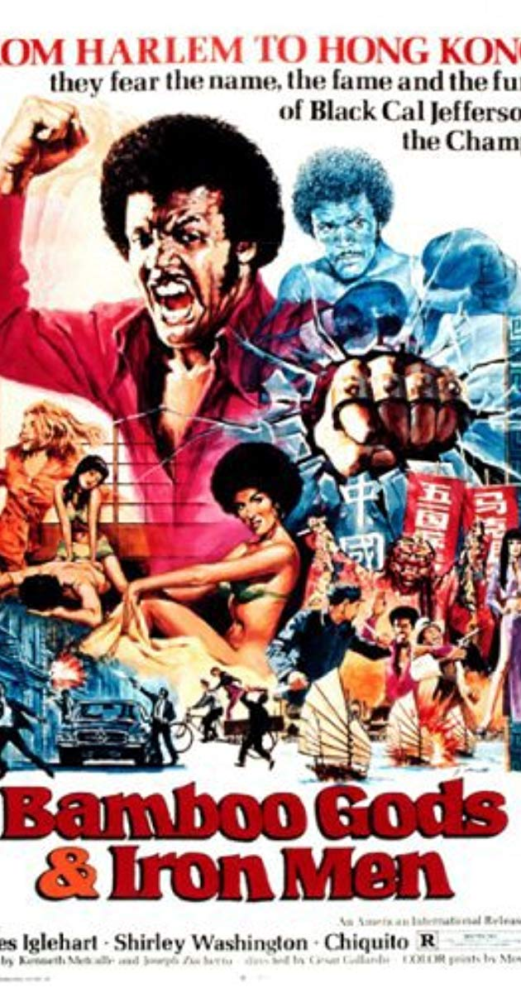
The official poster of “Bamboo Gods and Iron Men” (1974)
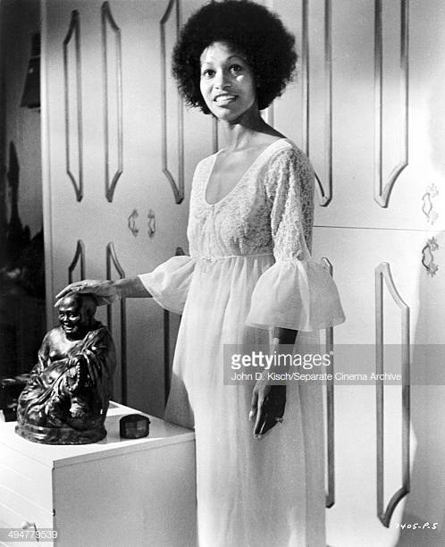
Mrs. Jafferson (Shirley Washington) with the controversial Buddha Statue in the movie

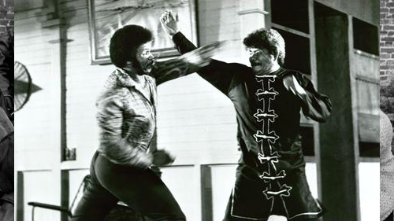
Cal Jefferson (James Iglehart) fights with the gang leader (Kenneth Metcalfe) in a fight scene
Conclusions
In Short, it is evident that art has been considered a very effective and useful way of communicating thoughts and ideas in every era, be it past or present, Art has never lost its significance and had been present among humans in various forms. In fact, it has evolved and grown with the passage of time, and many types of art have been introduced in this aspect. Art, just like any other field had gone through many had gone through many ups and downs in its journey to the modern or contemporary art that we see today. One of such changes was the post-modern era.
During postmodern days, almost everything changed included various forms of art. Motion arts also transformed to a great extent. Movies were now made in a distinctly new form, and the audience witnessed a number of films being made in unique genres.
Both of the movies discussed above are proof of the effects of post-modernism. Both movies ‘Kill and Kill Again" and “Bamboo Gods and Iron” depict the entry of new genre in the halls of movies of Hollywood. Although action and martial arts was not a common practice at that time, still, the audience gave a very warm and overwhelming response to both the movies and loved the concepts, actions, and the plots.

References
Boyne, R., & Rattansi, A. (Eds.). (2017). Postmodernism and society. Macmillan International Higher Education.
Edwards, D. (2014). Art therapy. Sage.
Gallardo, C. (Director). (1974). Bamboo Gods and Iron Men [Motion Picture].
Hall, I. (Director). (1981). Kill and Kill Again [Motion Picture].

