HEAD: SENSITIVITY OF COMPACTION PROPERTIES

Sensitivity of Compaction Properties of Low to High Plastic Clays to Biopolymers
[Name]
[Institution]

Contents
Introduction and Background 2
Why Compaction is necessary 4
Benefits of compaction 5
Objectives 5
Description 5
Scope of the Project 8
Required Resources 10
Equipment and Procedure 10
10
Assembly of the apparatus 11
Preparation of the sample 11
Calculations 12
Stakeholders 12
Physical Constraints 13
Bibliography 15

Sensitivity of Compaction Properties of Low to High Plastic Clays to Biopolymers

Introduction and Background
Formation of bentonite squares and pellets is intended to be done near the source for spent fuel. The material, which is a bentonite might be put away in the dock zone prior to pulverizing and parching. In the wake of pulverizing and parching bentonite clay will be conveyed to the manufacturing block where the material will be blended with adequate amount of water and compressed to squares Amid the years a lot of production techniques have been implied to bentonite clay for its conversion into pellets. Amid these experiments a few of the issues concerning the material being converted into pellets have been found and not been completely comprehended. Such issues can be evaded from or decreased by adjusting the procedural constraints, for example, adequate amount of water and compaction stress. However, the real causes of the issues aforementioned have not been comprehended wholly (Guo, 2014). Along these lines various compaction tests have been performed following the variation in constraints and the impact on compaction properties and square quality have been calculated.
The primary focal point of this thesis is to comprehend the outcome from different examinations and assess information that has been comprehended in the older works. The resolution is to attempt and determine the constraints that could impact the very nature of bentonite squares. This work can be utilized to come out with enhanced specifications regarding bentonite that would render square compaction progressively steady and unswerving (Guo, 2014).
A lot of production experiments have been carried out on inlay squares and cushion squares. Nonetheless, there have been a few inquiries concerning how the clay acts amid the production procedure (Eriksson, 2017). The inquiries are connected both to how the procedure is structured and to issues that has emerged amid the production experiments.
Some of the inquiries identified with the procedure configuration are as follows:
- Can clay be reused, or will the square quality crumble following re-crushing and re-compacting?
- Does the time delay between blending and compaction affect the procedure of clay compaction? An impact of this time delay could be witnessed if the water quantity does not get sufficient time/energy to homogenize adequately prior to clay pallet compaction.
- Does lubrication require to the buffer mould? As of now an oil is utilized to lessen abrasion between the buffer mould and the clay. Nevertheless, compaction with no grease would be an advantage, on the grounds that the material subjected to machining from the square can be reprocessed.
The problems which can be experiences during the compaction of clay are as follows:
- Breakable pellets
- Variance in the properties of compaction
- Stripping of pellets

Why Compaction is necessary
The compaction of clay has a profound effect on the grain size of the clay. Tests have been carried out before so as to discover how the size of the granule and its dissemination influences the compaction properties of the clay and the quality of the square. The experiments demonstrated that there were a few contrasts in the compaction properties when the granule dissemination was differed. Nevertheless, a few factors were altered between the diverse compaction experiments and along these lines it is hard to tell which factors are the most significant. While trying to lessen the quantity of factors another test arrangement was performed (Delage, 2009). These new tests were intended to discover the impact of granule measure on the compaction properties of the bentonite clay. Accordingly, the clay was filtered to acquire distinctive granule portions. Following that the quality and thickness could be resolved after subjecting granules to compaction. It has also been demonstrated that the rougher granules in the Asha 2010 clay yielded more swelling properties then the fine granules. So as to see whether this distinction in properties renders any impact on the compaction properties the coarsest portion was processed and filtered once more. The nature of the compacted squares were assessed by estimating the tensile strength.

Benefits of compaction
- Compaction builds the shear quality of the clay.
- Compaction diminishes the voids proportion making it increasingly hard for water to pass through clay/soil. This is significant if the clay is being utilized to hold water. For example, earth dam.
- Compaction can forestall the development of greater water stresses that renders the soil to condense amid seismic activity.

Objectives
Objectives of this works are delineated as follow:
- The key purpose behind compacting clay is to diminish resulting settlement under loads.
- To study properties of low to high plastic clays following their compaction when balanced out with biopolymers.
- Develop a prescient framework to demonstrate the association between the greatest dry unit weight and ideal dampness content by utilizing the database acquired yielded by compaction.
- Generating a database acquired from experiments for compaction.

Description
Of late, there are various soil advancements on account of contractors through experience and development; meanwhile, designing specialists have examined these innovations' basic improvements to check their appropriateness and execution. Clay improvement forms are commonly ordered as utilizing either mechanical or substance techniques; in a few cases, a combination of methodologies is utilized. Normally acknowledged mechanical procedures incorporate earth fortification. Chemical soil stabilizers are commonly arranged as being either customary or nontraditional added substances (Day, 1992).Conventional added substances incorporate concrete, lime, bituminous materials, and industrial by-products, for example, fly powder, calcium carbide buildup, and granulated impact heater slag .The utilization of bond and lime for soil improvement applications is expensive, especially in less created nations, in which a portion of these fasteners may not be created locally and must be imported. The utilization of concrete and lime are commonly viewed as costly. Mechanical by-products, which are innately increasingly practical, on the grounds that they speak to a "useful reuse" application that is an option in contrast to landfilling or other comparative by-product disposal. Customary added substance adjustment generally builds the dirt pH after treatment due to the high CaOH₂, which may effectively impact the earth, for example, undermining the nature of the groundwater or restricting vegetation. Generally treated soils likewise show too much fragile execution that can influence the presentation and steadiness of structures (Lees, 2019). The generation of conventional added substances, especially Portland bond and lime, likewise expends a lot of assets and vitality, bringing about the arrival of carbon dioxide. Carbon dioxide outflows because of the assembling of Portland concrete are the second biggest supporter of mankind's generation of this ozone depleting substance around the world, second just to non-renewable energy source ignition .The generation of one metric ton of Portland bond discharges around one metric ton of carbon dioxide and the creation of one metric ton of lime discharges roughly 0.86 metric ton of carbon dioxide. Particulate air discharges in the type of concrete residue are another natural issue that can occur when customary stabilizers are utilized in the field.
Nontraditional added substances comprise of different synthetic substances in fluid or powder structure, for example, catalysts, polymers, saps, acids, silicates, ions, and lignin subordinates; a considerable lot of these materials will in general be normally happening, or they can be delivered through a characteristic procedure (Nima Latifi, 2016). Modernly created water-insoluble gel-shaping biopolymers of microbial birthplace for example, xanthan, chitosan, polyglutamic corrosive, sodium alginate, and polyhydroxy butyrate can be utilized as added substances for soil improvement, for encasing a bioremediation zone, or for relieving soil liquefaction. Despite the critical potential points of interest of these nontraditional added substances, a significant number of which are exclusive in nature, most engineers are hesitant to apply them by and by. This absence of across the board acknowledgment is by and large credited to a blend of variables, including an absence of freely distributed research to check the presentation enhancements that are guaranteed by an added substance's producer, an absence of standard lab testing methodologies and philosophies for the assessment of field execution, and deficient data given by makers as for an added substance's mystery dynamic constituents, which can at times raise ecological concerns (Guo, 2014).
Fine-grained clays having high compressibility and low shear strength are universal in numerous areas of the world, especially in tropical locales, for example, Malaysia, Thailand. The nearness of these clays’ underneath establishments is regularly connected with bearing limit issues, differential settlement issues, and unsuitable horizontal developments on stacking; consequently, soil improvement methods are usually prescribed for these. Concoction adjustment methods have been consistently utilized for shaky fine-grained soils amid the development of thruways, rail tracks, and airplane terminal runways to upgrade bearing limit, lessen settlements and permeability, and control contracting/swelling. The related concoction responses and components of adjustment for conventional added substance treated soils have been explored broadly the outcomes from these investigations demonstrate that the designing properties of treated soils are reliant on both the kind of added substance that is utilized and the hidden properties and attributes of the soil that is balanced out.

Scope of the Project
This is to gauge, recognize and investigate the compaction properties of low plastic clays to high plastic clays by utilizing miniature Harvard compaction test with expansion of two biopolymers. Compaction experiment executed on clays of various extents to distinguish the quality and settlement of the clays. We will gauge and recognize the properties of clays owing to the addition of biopolymers and will come up with the possible and plausible outcomes (Guo, 2014). These outcomes are then contrasted to devise the association between the ideal dampness substance and parched element load. By performing experiments on the clays at various extents, a sufficient database will be concluded. This outcomes additionally demonstrates the distinctions between ideal dampness substance and parched element load. By utilizing this database, we can plot the diagrams which aid to ponder the disparities of soil nature under compaction.

The study will appraise the impacts of biopolymer and monomer adjustment on the shear quality and stress-strain conduct of clay (Lytton, 2002). The study will also reflect on the shear quality of biopolymer-altered sand was essentially expanded by expansion of the polymer. The study will also reflect on the Polymer adjustment expanded the shear quality of the sand. The biopolymer utilized in this examination along these lines may give a progressively manageable option in contrast to customary adjustment techniques while offering ecological and monetary advantages (Guo, 2014).
The assessment of the biopolymer adjustment for shear quality of clay was directed utilizing compaction. The gainful impacts of polymer maturing ought to be considered further by playing out an increasingly exhaustive arrangement of tests at relieving times of 28 days what's more, past. Rheological tests on the polymer itself ought to likewise be performed to describe its thickness and shear quality as an element of the distinctive polymer mixes and polymer age (Smart, 1998). Measurable demonstrating utilizing conditions or diagrams ought to be created to foresee the impacts of different fixations and sorts of polymer on soil quality. Moreover, computational multi-material science demonstrating ought to be performed utilizing a limited component investigation of the coupled mechanical and compound wonders, to create prescient models for a more extensive scope of soil types and proposed biopolymer types (Guo, 2014).
The response of soil and polymer can be seen through infinitesimal approaches to decide potential components of holding for any polymer under examination and the subsequent quality of corrected soil. The waterproofing capacities of different polymers ought to likewise be analyzed by testing the static quality of dry and immersed polymer-corrected examples. At that point, cyclic triaxial or cyclic basic shear tests with pore weight estimation ought to be performed to assess the capability of the bio-polymers for improving liquefaction obstruction of sands and sediments. Extra applications and soil types could be analyzed, for example, solidify/defrost conduct, or on the other hand adjustment of clays concerning shear quality, decrease of combination settlements, and improvement in therapist/swell conduct.

Required Resources
This work would require us to use two types of clays i.e. Kaolinite and Bentonite, and the available biopolymers in the laboratory in the university. Compaction tests will be carried out using Miniature Harvard compaction test apparatus. The section below will discuss the equipment which will be used to carry out the compaction test and the procedures od the test.

Equipment and Procedure
Miniature Harvard compaction test apparatus will be used to carry out the compaction test.

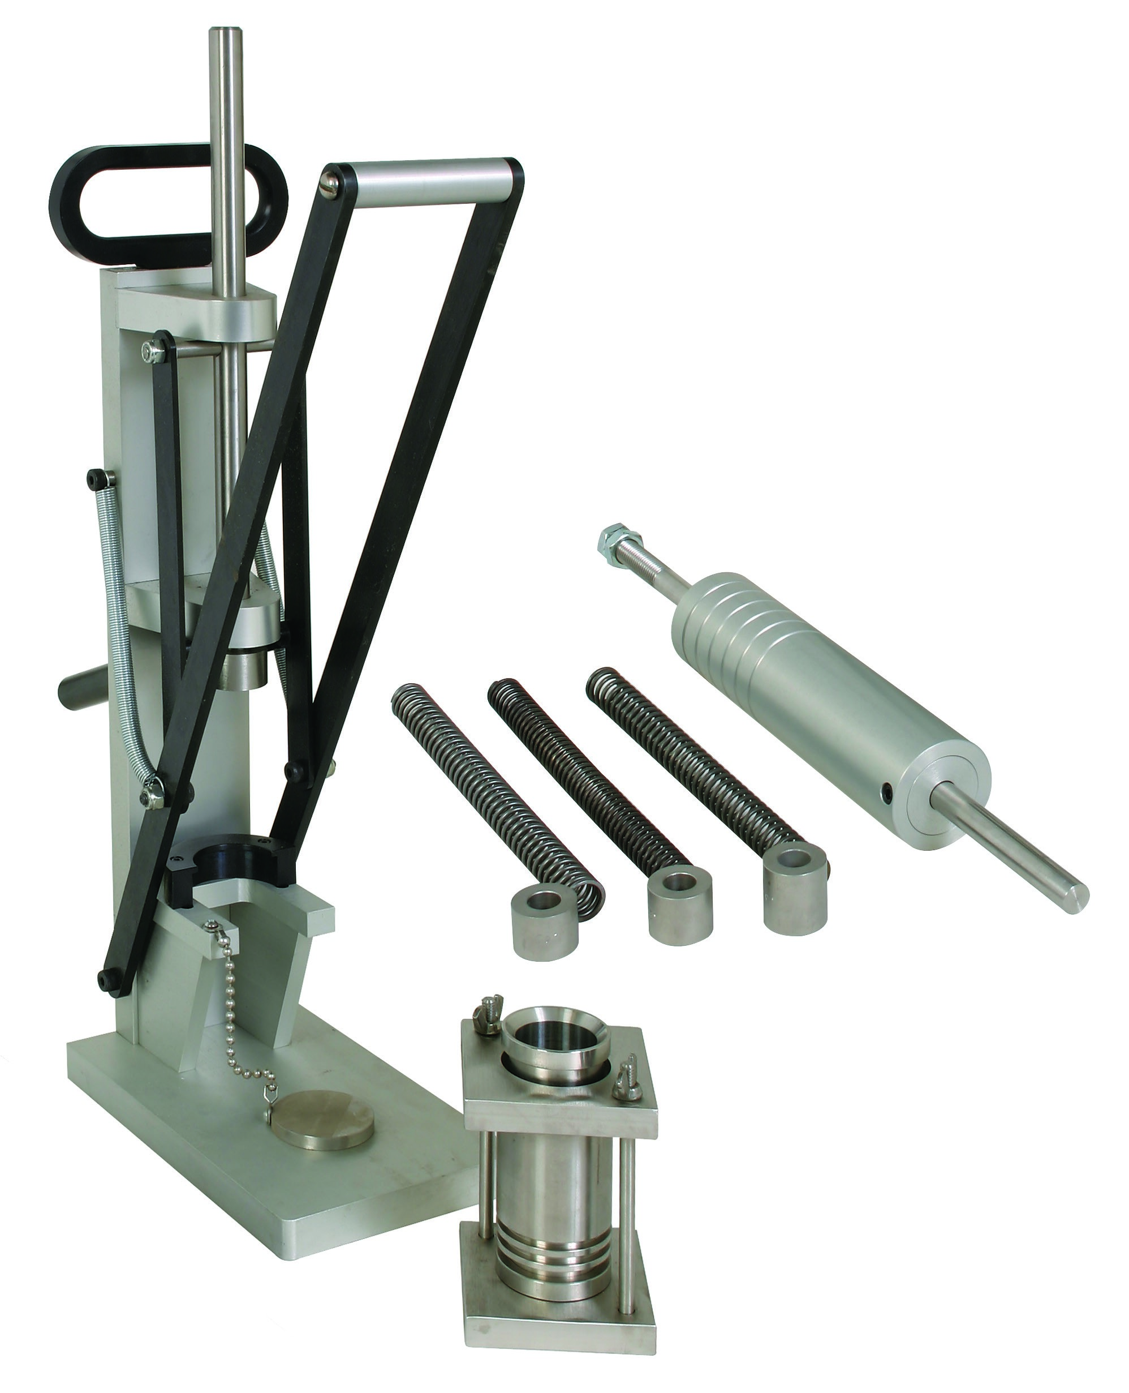

This compaction test decides the connection between the dampness of soils and densities (stove dry weight/ft³) when the clay is compacted in the research facility with this mechanical assembly. Choice of the most suitable number of layers, various packs per layer and damping power relies upon the sort of material and the proposed use to which the compacted material will be put. When all is said in done, minimum five layers and ten packs for every layer are required to create homogeneous test samples (Arnold, 1993).

Assembly of the apparatus
Assembly requirement is very little since the neckline remover and sample ejector is sent totally collected. To gather the form, collar will be placed on the mold. Set in the focal point of the base plate with top of shape neckline fitted into the break in the top plate. Fix knurled nuts. The tamper is provided with 20-pound compaction spring set up. To change springs, evacuate the two lock nuts and expel embed in the lower end by extricating the two set screws.

Preparation of the sample
Air-dry to a slight to marginally sodden condition a 2 to 3 lb. test of clay taken from a segment of the material passing the No. 4 (4760-micron) strainer. Blend completely to separate the irregularities and confirm a homogeneous blend. Following this, split into six to eight segments, that each segment contains somewhat all that could possibly be needed material for one test (Arnold, 1993). To each bit include around the required measure of water to get the ideal scope of dampness substance. After exhaustive blending, place each part in a little glass container with tight-fitting spread and store medium-term or until prepared for testing. For soils that blend promptly with water and have low dry qualities, it is tasteful to include water and blend the example quickly preceding testing. It is significant that a compacted example not be remixed and utilized over once more.

Calculations
The calculation of moisture quantity and weight of the dry clay will be carried out using the formula
w = ___A – B___ X 100
B – C

And
W = ___W1___ __ X 100
W + 100

The plots can then be drawn using the excel software or matlab or any other software suitable to obtain moisture unit-weight curves. The curves will be evaluating dry unit weight against the number of lifts.

Stakeholders
Compaction impacts various natural parameters even at extensive separation from the first area at which the compaction happened. Compaction may change the transitions of ozone depleting substances from the clay to the environment through instruments related with consequences for soil penetrability, air circulation, and yield improvement. Compaction builds CO2 outflows since development of compacted soils requires apparently more vitality than development of uncompacted soils. Around 90% of the worldwide N2O discharges to the air originates from soils. Compacted soils will in general be wetter than noncompacted soils and denitrification is upgraded. The motion of N2O increments quickly as air-filled porosity decreases. Compaction from vehicle traffic before the foundation of grain harvests can cause stamped increments in the N2O transition amid the early development time frame in spring.
Aforementioned discussion delineates that State government and Local community groups are the key stakeholders. It offers industrial benefits as well.
All the construction projects require the stable soil so infrastructure industry is very dependent upon the soil compaction. While carrying out mega project like Dam construction, soil compaction plays a very critical role in such mega projects. Because clay compaction will make sure that water don not seep the Dam walls and make it vulnerable to seismic activity. It will help the authorities to carry out foundation investigations of the structures Further soil compaction would evaluate that to what extent the soil is vulnerable to seismic activity. So, it would benefit the meteorological departments as well to carry out research and will also help disaster management authorities to adopt suitable measures while dealing with any natural hazard.

Physical Constraints
In the compaction procedure, soil particles are pressed together in a closer condition of contact shown by an adjustment in mass thickness, porosity and so forth. Under a dynamic loading necessary to build the thickness of soil, the accompanying changes may occur:
- Liquid and gas compression
- Clay solids compression
- Amount of liquid and gas may change in the pore space
- Clay solids get re-arranged.
In addition, soil crushing and soil cracking are also two major constraints in compaction test. soil crushing is related with weakening of soil structure, where the regular clay entireties break and scatter. In the event that the scattering is trailed by quick drying the dirt clay gets modified (Revil, 2002). Soil cracking is associated with the shrinkage which emerges because of extension and compression of soil mass. It has been discovered that as shrinkage process advances, the lines of cleavage are developed where there is less resistance, typically relating to the plane of most astounding water content.
The work is doable and the constraints can be addressed by replacing poor quality of clay with better quality. Furthermore, use of rendering material can also address the constraints. Biopolymers, which are being used in our work, is only because biopolymers can enhance the clay stability. Reinforcing clay can also help in this regard.

Bibliography
Arnold, P., 1993. Manual of soil laboratory testing. Vol. 1. Soil classification and compaction tests. Geoderma, 58(1-2), pp. 125-126.
Day, R. W., 1992. Effective Cohesion for Compacted Clay. Journal of Geotechnical Engineering, 118(4), pp. 611-619.
Delage, P., 2009. DISCUSSION: Compaction behaviour of clay. Géotechnique, 59(1), pp. 75-77.
Eriksson, P., 2017. Compaction properties of bentonite clay, Solna: SVENSK KÄRNBRÄNSLEHANTERING .
Guo, L., 2014. Investigation of soil stabilization using biopolymers. Iowa State University Capstones, Theses and, p. 97.
Lees, A. S., 2019. The bearing capacity of a granular layer on clay. Proceedings of the Institution of Civil Engineers - Geotechnical Engineering, pp. 1-24.
Lytton, C. A. a. R., 2002. PROPERTIES OF HIGH-PLASTICITY CLAYS, texas: Texas Department of Transportation.
Nima Latifi, S. H. M. M. T., 2016. Improvement of Problematic Soils with Biopolymer—An. Journal of Materials in Civil Engineering.
Revil, A., 2002. Mechanical compaction of sand/clay mixtures. Journal of Geophysical Research: Solid Earth, 107(B-11), pp. ECV 11-1-ECV 11-15.
Smart, P., 1998. Deep soil compaction. Soil Use and Management, 14(2), pp. 69-69.

