HLTENN012

Assessment 1: Written assignment
Student Name | Rachel Maree Taylor
Training Package  National Code | HLT54115 | Qualification Name | Diploma in Nursing
Unit Code | HLTENN012 | Unit Name | Implement and monitor care for a person with chronic health problems

ASSESSMENT INSTRUCTIONS
Type of Assessment | Students are required to answer the following questions.
Instructions for Written Assessment Task | Students are to complete all questions  ALWAYS keep a copy of your assessment  Use the Harvard System for referencing  Word limit 1500
What do I need to do to achieve a satisfactory result? | All questions must be answered correctly to be deemed satisfactory in this assessment task.
Due date/time allowed | As per Assessment Timetable
Declaration | I declare this assessment to be solely my own work or, I have acknowledged within my assessment if this work was completed with a peer

SUMMARY OF ASSESSMENT TASKS
Summary of Assessment Tasks | Task | Satisfactory |  | Unsatisfactory
 | Written Assessment | ☐ |  | ☐
Assessor Feedback | Assessors Feedback
 | Assessor’s Comments:
 | Print Name:  Signature: |  | Date:
Student acknowledgement of assessment outcome | Student Feedback  Please sign and date to acknowledge that you have received results and feedback on your assessment. You have the opportunity to provide feedback to your Assessor in the space below.
 | Student’s Comments: Would you like to make any comments about this assessment?
 | Signed: |  | Date:

Please note that TAFE NSW is required to retain copies of all completed assessments, where practical, for a period of 3 years (or in accordance with regulatory/licencing requirements) after the completion of a student’s studies.

ASSESSMENT 1
Part A – Individual Patient Case study

You are required to select one personwith a chronic health issue. The personwill be based on a patient you select from your Clinical Placement.Remember to maintain patient confidentiality.
Examples of health issues could include but are not limited to:
- Chronic Obstructive Pulmonary Disorder (COPD)
Using a problem solving (Specific, Measurable, Achievable, Realistic, Time Specific) SMART approach, achievable goals and evidence based practice, cover the following:
- Provide a holistic history of the patient.
The patient was a chain smoker along with minimum physical activity. He was also involved in eating oily food.
- Summarise the person’s understanding of their condition.
The person does not understand the condition according to him he has asthma which will be fine once he will use inhalers ¹
- Identify the clinical manifestations of the chronic health problem and possible impact on their body systems.
There are various symptoms of COPD and some of the most prominent symptoms of COPD include shortness of breath which occurs very frequently during any physical activity, wheezing, and tightness in the chest along with chronic cough that which is further accompanied by white or greenish mucus. The impact of COPD on the body of the individual is quite severe. It affects various structural and functional domains of the lungs. Other less known but important effect of COPD on the body includes cardiovascular diseases, various skeletal and neurological defects. Along with that weight loss and nutritional abnormalities are quite common in case of the COPD patients ²
- Describe the pathophysiological processes associated with the person’s chronic illness. Support your written response with diagrams.
COPD is basically a chronic lungs disease which makes it quite difficult dor the lungs to breathe it is a progressive condition which only get worse over time. In people with COPD the airways and also the air sacs lose their stretchiness, the walls of these air sacs are damaged completely and in most of the case they become thickened and also inflamed. Mucus is produced in the air sacs which make them to clot. As a result of this tightness the individual finds it difficult to breathe properly ^{3.}
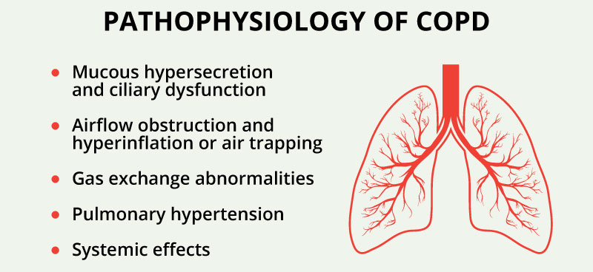
- Discuss the potential and/or actual social, emotional and psychological symptoms that impact on the person’s ability to achieve maximum performance in ADLs. You may also need to consider the impact on the person / family / significant others.
The symptoms of COPD are quite serious which makes it impossible for the person to live a normal life. As a result of the breathlessness which is one of the most common symptoms of COPD the patient become dependent on the surrounding people for simple stuffs. The family of the person becomes bound to the patient in order to do the daily chores of the individual which makes the situation worse. Due to the emotional frustration and also social isolation it becomes hard for the patient to focus on the treatment plan and it may be possible that the treatment turns out to be ineffective for the patient.
- Write a Nursing Care Plan for the person using the nursing process. A Nursing Care Plan template has been provided. This Care Plan should include nursing diagnosis of identified problems, and evaluation of the relevant nursing interventions for the person in consultation with the person and interdisciplinary team. Take into consideration the person’s self-management, rehabilitation, restorative and palliative care needs.
The role of nurses in case of the COPD patient is quite important. Most of the nurse’s role is mainly focused on helping the patients to adjust their overall health condition and also their self management skills. One of the most significant of the nurses in case of teaching the patient about the use of the inhaler. It is the responsibility of the nurse to check the inhaler technique in both primary and secondary care before their discharge which is very important for the COPD patients. The role of the nurse is also very important in encouraging the patients about the hazards of smoking and also to take care of diet because nutrition is very important for these patients ^{3.}

- Conduct an academic search of literature and identify current best practice associated with one nursing intervention for the person’s chronic health problem.
Currently one of the best practices that is associated with nursing intervention is the involvement of exercise in the routine of the patient, due to COPD most of the patients are scared to do simple activity due to breathlessness so encouraging patients to do exercise is the best practice that is done by nurses ³
- Describe three strategies that actively involve the person to self-manage their chronic disease.
There are various activities that help the patient to involve in self-management and some of them are giving counselling sessions to the patient, encouraging the patient to do daily routines and also telling the patient about the importance of nutrition in the overall management of COPD ^{2.}
- Identify three (3) supporting agencies / health professionals that may contribute to the care of this individual and their family / carers.
In case of the COPD the three healthcare professionals who will be helpful are nutritionist, physiotherapists and also

Part B – Rehabilitation (general application)
Describe the purpose and expected outcomes for each of the following rehabilitation strategies.
Chronic Rehabilitation Strategies for Chronic Health Disorders
Strategy | Purpose / Expected Outcome
Physiotherapy | This approach includes exercise which helps in controlling breathing problem of the patient.
Occupational Therapy | This leads towards better mastery and being active in life
Hydrotherapy | The breathing problem along with the fatigue problem will be resolved
Pilates | It helps the body to become flexible and helps to be active
Massage | Massage will help in the overall flexibility of them body, pain will be relieved
Art and Music Therapy | This will help the patient to stay calm and relax.
Wheel chairs, Scooters, Walking Aids | These aids are important because COPD patients experience weakness and breathlessness
Application of Prosthesis | Prosthesis will help the patient in the self management of COPD

Unit No: | Surname: | Ward / Doctor:
 | Other Names: | Pension No:
 | D.O.B. / Sex: | Medicare No:
Nursing Care Plan
Date | Actual Observation  (What do you see?)  (What could happen?)  (Potential observation) | Goals  (What do you want to achieve for the person?) | Interventions  (What needs to happen to achieve the goal?) | Rationale  (Why are you doing the nursing interventions?) | Evaluation (time frame)  (When will you assess to see if the interventions are working?)
 | The patient have frequent coughs with greenish mucous along with weakness and breathlessness | I want the patient to do his daily activities by himself without any external family help and also I want the patient to be socially active by controlling the breathing problem effectively | The patient should be encouraged to abandon smoking and also to follow the nutritional plan that is provided by the dietician. | Because the treatment plan is incomplete without proper guidance and encouragement therefore I am helping out the patient | After duration of 2 weeks i will see if any improvements happen in the patient.

Date | Actual Observation  (What do you see?)  (What could happen?)  (Potential observation) | Goals  (What do you want to achieve for the person?) | Interventions  (What needs to happen to achieve the goal?) | Rationale  (Why are you doing the nursing interventions?) | Evaluation (time frame)  (When will you assess to see if the interventions are working?)
 | The patient is socially isolated sue to the symptoms of the disease | I want the patient to be active and also be normal as much as possible | The patient should be convinced that he can be social along with the symptoms | COPD patients are normally scared to go out and interact due to their disease so unless a they are not encouraged they stay indoors and confine themselves | After 10 days.

References
1. Agustí, Alvar. "Systemic Inflammation After Inspiratory Loading In Chronic Obstructive Pulmonary Disease". International Journal Of Chronic Obstructive Pulmonary Disease, Volume 3, 2008, pp. 149-153. Dove Medical Press Ltd., doi:10.2147/copd.s2108.
2. Macnee W. Pathology, pathogenesis, and pathophysiology. Bmj. 2006;332(7551):1202-1204. doi:10.1136/bmj.332.7551.1202.
3. 10 September 2002. COPD - nursing care and implications for nursing. Nursing Times. https://www.nursingtimes.net/clinical-archive/copd/copd-nursing-care-and-implications-for-nursing/205879.article. Accessed April 23, 2019

