Title: Report
Your Name (First and Last Name)
School or Institution Name (University at Place or Town, State)

Report
Introduction
In today’s competitive and fast paced world, individuals and people have to change and adapt with the times to stay relevant. If they slack off and are not concentrated towards a certain goal they will always be left behind. So, to grow and prosper change is necessary. This change can be in a person's characteristics, his manners, business ethics or anything else. Even a minute change in the smallest parts of a person can give them the boost or an added push to achieve their goals. Same can be said for companies as well as change change is really important for the company’s longevity and profitability (Hekkert et al, 2007). If they ever want to stay relevant and keep their market share and customer base strong they would have to bring change and innovation into their operational and strategic structure. These changes can be of a minute nature such as allowing more flexibility in employee work hours to a high amount such as totally changing the managing structure to improve efficiency and increase profitability. Every little percent of change can have a huge impact on the company's future, which can be either positive or negative. This depends on whether change has been brought to the place where it was needed the most or at the part of the company or a person that the company’s management had a bias against.
So change and innovation brought at the right place is more beneficial than to change something that already is working perfectly. In a case where changing the structure of a part of the company that is already working smoothly and effectively would bring harmful effects on the company and it would have been better to not bring any change at all. In this report, an analysis is being done of a company (XYZ) that is trying to match the competitiveness of its market by bringing change into its production machinery. It has three options to choose from use an old machinery (Old Press), buy a sophisticated new machinery (Press A) or buy a less sophisticated new machinery (Press B). This report will analyse the financial effects of these decisions by doing an NPV, IRR and a Sensitivity Analysis. Then it will give a recommendation on whether to choose either one of the new machinery or the old one.

Methods Used
To analyze the financial viability of this report several methods have been taken into consideration. These methods include NPV, IRR, and Sensitivity Analysis (DeFusco, 2015). Other methods such as the Depreciated value of the machinery after their lifetimes, Payback Period would also be used to determine if its feasible to either take up the new machinery or to stick with the old one.

NPV
Press A
Total investment: 830,000 + 40,000 + 12,000 = $882,000
Working Capital = (Cash + Acc receivable + Inventories) – Acc Payable
= (25000 + 120000 + 20000) – 35000
= $ 130000

Years | 0 | 1 | 2 | 3 | 4 | 5
Operating Cash flow |  | 250000 | 270000 | 300000 | 330000 | 370000
Cost | (882000)
Scrap |  |  |  |  |  | 400000
Working Capital | (130000) |  |  |  |  | 130000
 | (101200) | 250000 | 270000 | 300000 | 330000 | 900000

Years | Cash Flows ($)
0 | (101200)
1 | 250000
2 | 270000
3 | 300000
4 | 330000
5 | 900000
NPV = | 1134996.29

Working
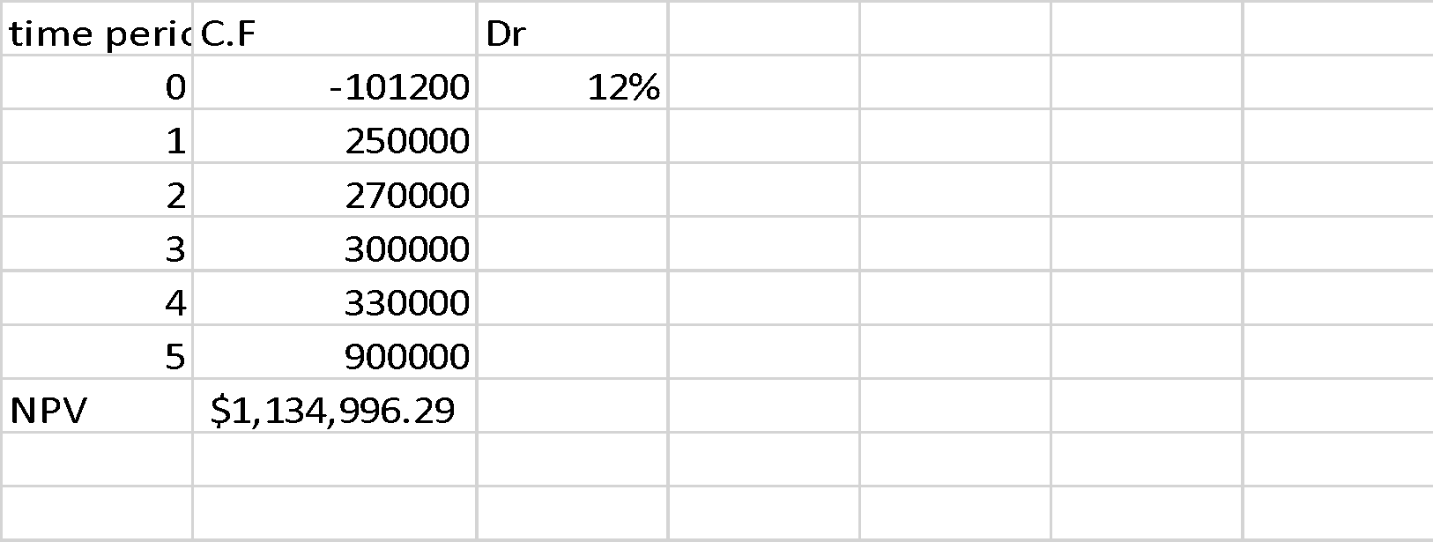

Press B
Total Investment = 640,000 + 20,000 + 12,000 = 672,000
Years | Cash Flows
0 | (672000)
1 | 210000
2 | 210000
3 | 210000
4 | 210000
5 | 210000
NPV= | 75895.54

Working
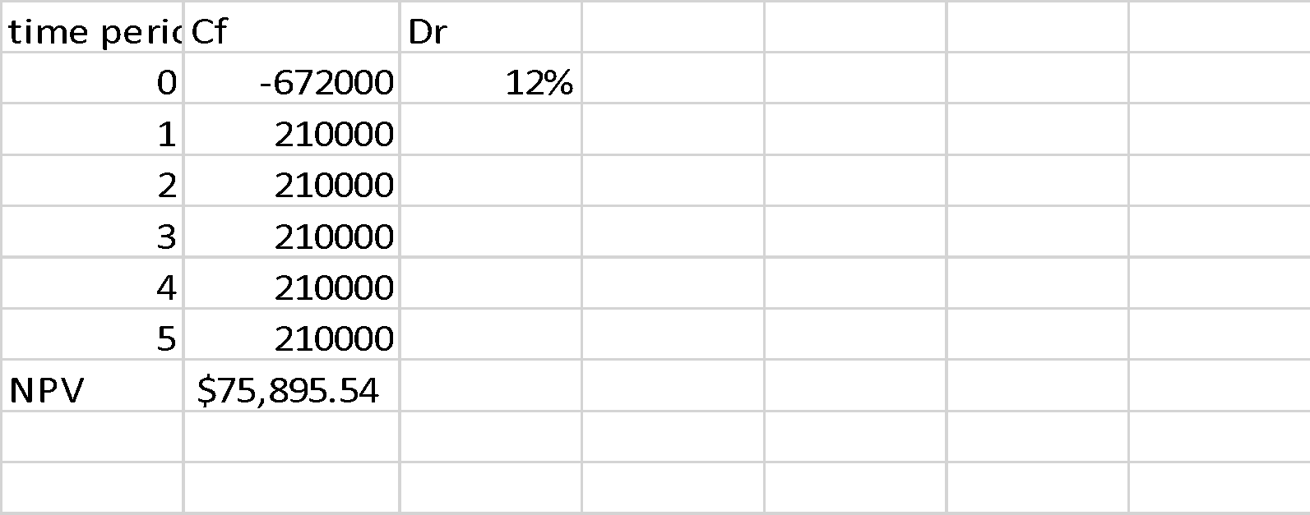

Old Press
Depreciation expense for 3 years at 20% using reducing balance method = 38400
= 300000*20%= 60000
1st year=300000-60000= 240000
=240,000*20%=48000
2nd year=240000-48000=192000
=192000*20%=38400
3rd year= 192000-38400=153600
Depreciation expense =$\left(\frac{cost-salvage calue}{useful life}\right)$
Cost $=(Depreciation Expense*useful life)+salvage value$=$(38400*5)+300000$ $=492000$
Total investment = 492,000 + 400,000 + 12,000 = 904,000
Years | Cash Flows
0 | (904000)
1 | 120000
2 | 120000
3 | 120000
4 | 120000
5 | 120000
NPV = | (420916.84)

Working
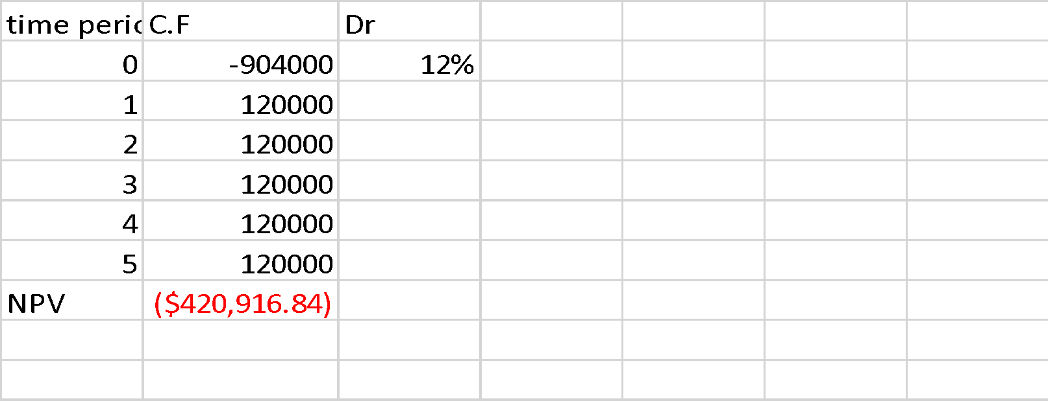

IRR
For the case of Company XYZ, its NPV for all three of its presses is as follows:
For Old Press:
Years | Cash Flows
0 | (904000)
1 | 120000
2 | 120000
3 | 120000
4 | 120000
5 | 120000
IRR= | -12%
Working

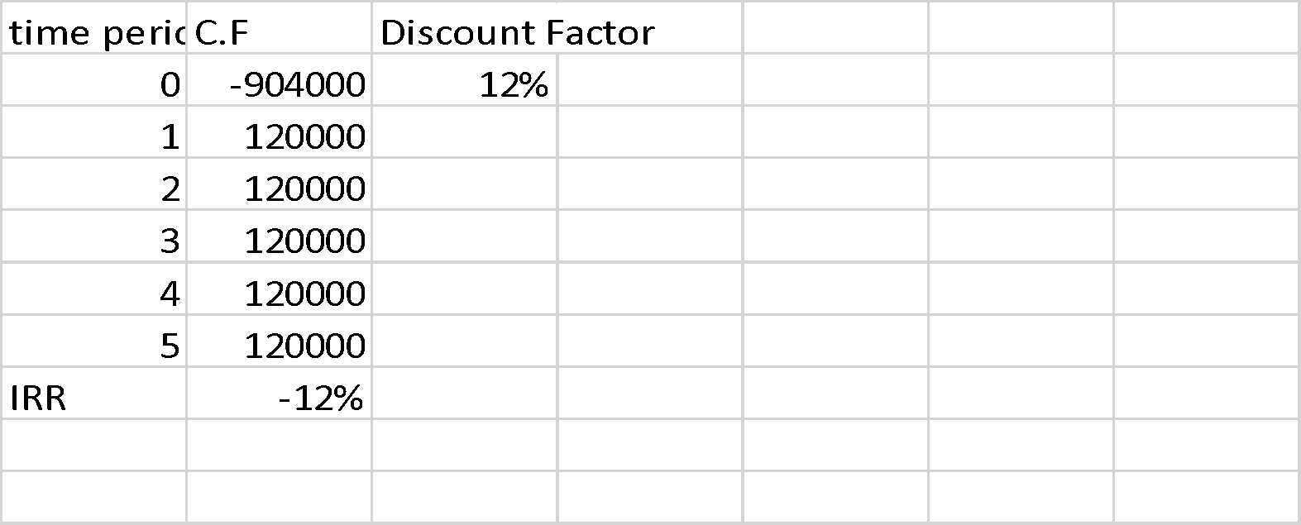
For Press A

Years | Cash Flows ($)
0 | (101200)
1 | 250000
2 | 270000
3 | 300000
4 | 330000
5 | 900000
IRR= | 28%

Working

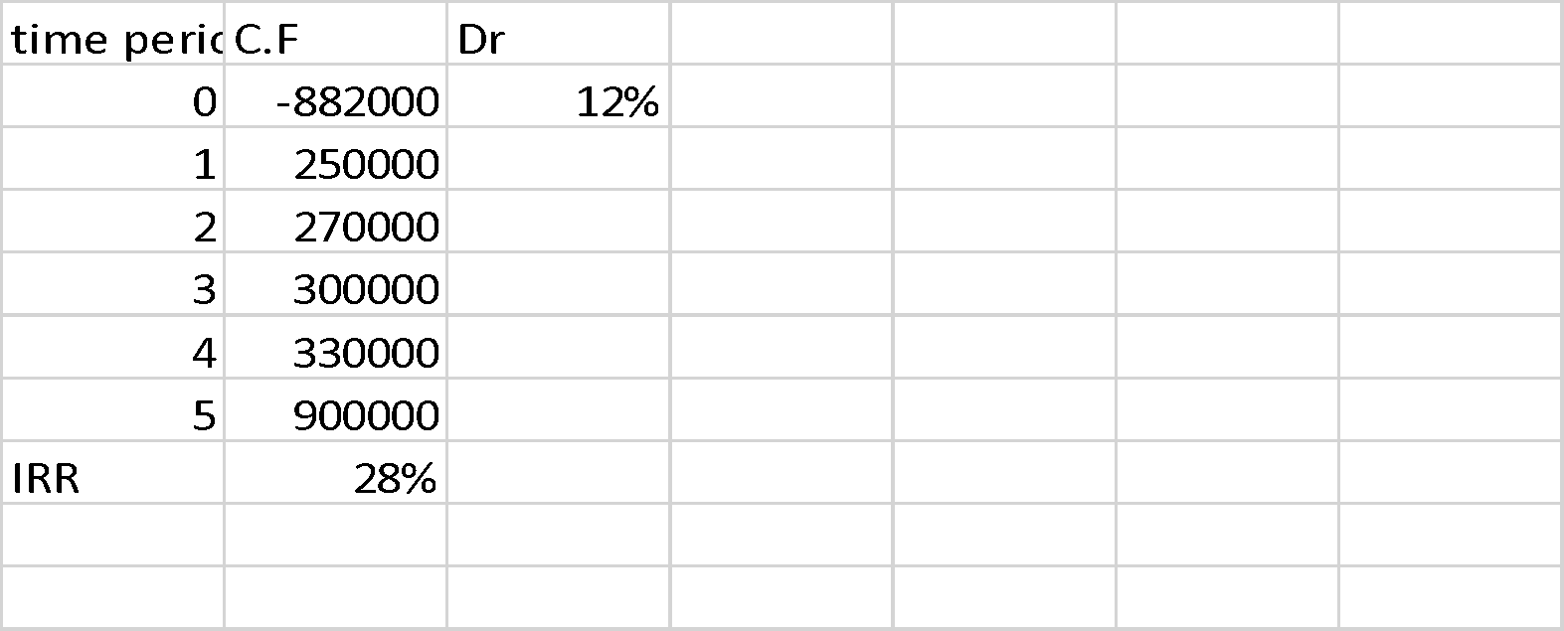

For Press B

Years | Cash Flows
0 | (672000)
1 | 210000
2 | 210000
3 | 210000
4 | 210000
5 | 210000
IRR = | 17%
Working

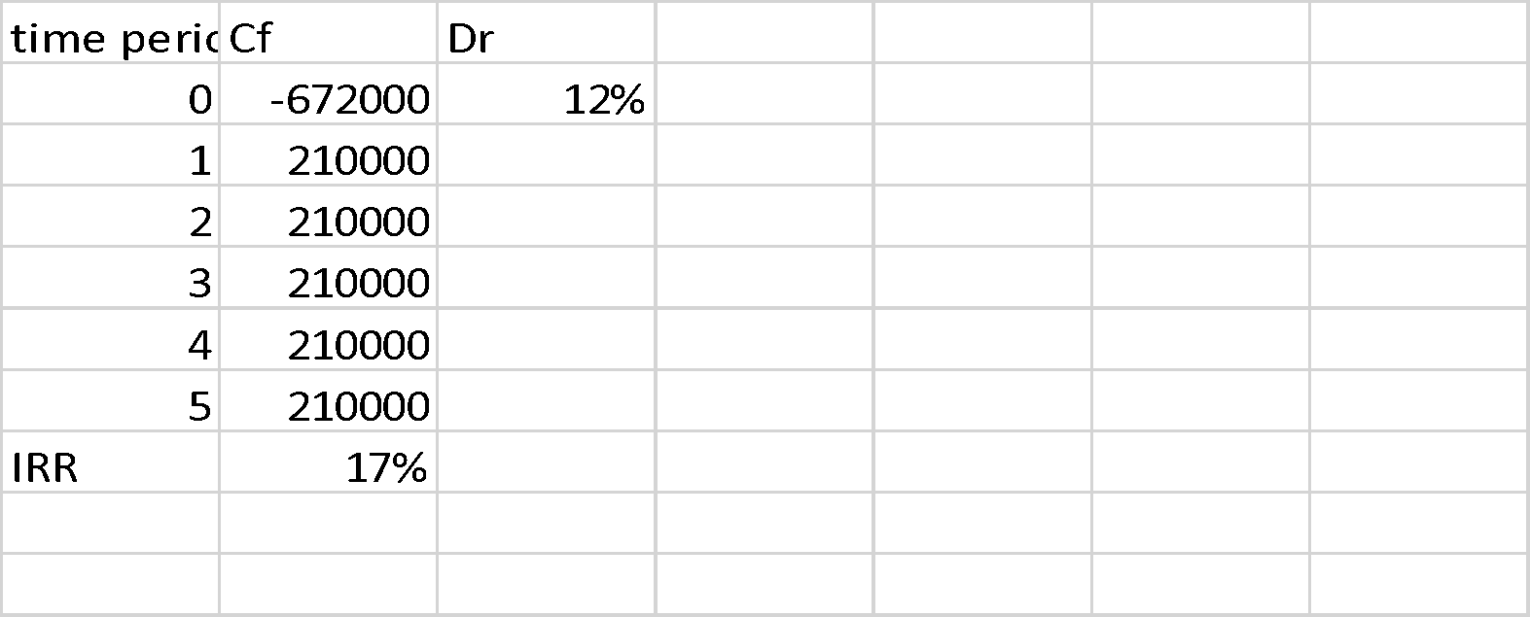

(A) Press A versus Old Press:
In comparison between the choice of investment between old press and press A. The recommended choice would be Press A. This choice has been taken by taking into consideration both NPV and IRR. In the view of NPV, any investment having NPV more than zero is a better option than any investment that has less than zero or negative NPV (De Reyck et al, 2008). The NPV for old press is negative which means that cash flows generated would result in a net loss compared to Press A which has a positive NPV and has likely a higher chance to generate profit for the company. By taking IRR into the mix the decision to take up Press A as an investment is even more strengthened. This is because Press A has an IRR more than the cost of capital of the investment meaning it will gain profit higher than the capital infused in it. This scenario is reversed in considering Old Press as it has a negative IRR and will result in a loss.
(B) Press B versus Old Press:
In comparison between the choice of investment between old press and press A. The recommended choice would be Press B. This choice has been taken by taking into consideration both NPV and IRR. In the view of NPV, as already stated in the above part negative NPV and a negative IRR is bad for the company and vice versa. Old Press has again a negative NPV and a negative IRR. Having both of these calculations in the negative is evident of the fact that using and investing in Old Press would be a financial nightmare for XYZ Company, as it will definitely result in a loss. Whereas, in Press B’s case both NPV and IRR are positive and the IRR is even higher than the than the cost of capital. This represents that the future return on investment would be positive and that the profit gained would definitely cover the cost of capital (Hartman & Schafrick, 2004). These are good indicators for the company and should boost their confidence in Press B as an investment.

Qualitative factors:
Environmental Concern
Putting in the new machinery such as Press A would result in the release of harmful gases. These harmful gases would pollute the working environment and the external environment. They could become a cause for spread of diseases such a breathing diseases in adults and children of varying ages. If the emission of toxic or harmful gases is not controlled and is left to go on unchecked, it might cause deaths and can become a financial and legal liability for XYZ Company.

Training of Employees
Also Press A is a more sophisticated machine than any of the other two presses. This means that it will require special experts or specialists to operate the mission at its full production without any fault. It is assumed that the labour already present in the XYZ Company has been there for quite some time. So they would be quite set in their ways of doing things and would have a hard time using new and sophisticated machinery. So XYZ Company would have to invest more money and time in re-training their employees. This will incur more costs for the company and will adversely affect the profits generated from the new machines.
Output versus Input
By investing in latest technology XYZ Company can decrease the cost of input and increase its output. As technology used gets more sophisticated and automatic it will also require less input in terms of product and labour. This will increase efficiency in the production cycle as the machine will efficiently use the resources available. With higher efficiency in the production cycle will result in a high quality of product and also it will be less costly to produce. As cost of production will decrease so will the price of the product and the company will reap the benefits of this by having an increase in profits.
Sensitivity Analysis

On NPV of Press A
Due to change in discount factor (+/- 15%)

Discount Factor | -3% | 12% | 27%
NPV | 819609.2 | 169338.94 | -65847.9

Working:

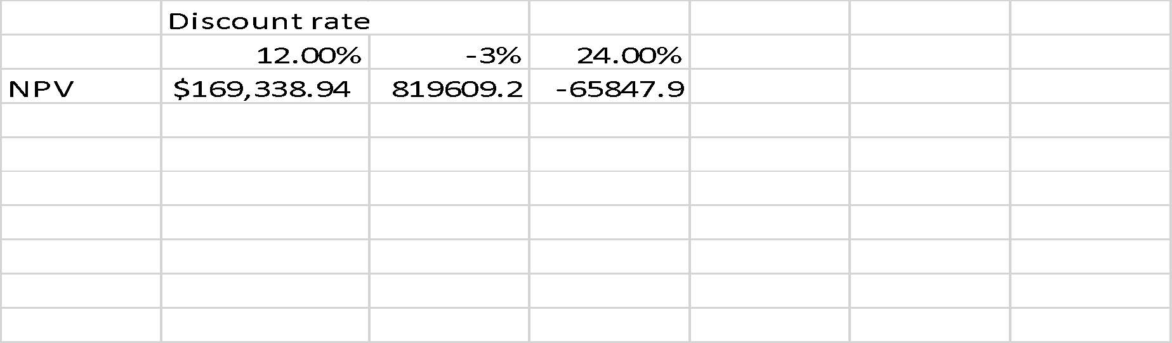

Earnings of Press A

Years | Cash Flows ($) (12%)  original | Cash Flows (12%)  Subtracted 15% | Cash Flows (12%)  Added 15%
0 | (101200) | (101200) | (101200)
1 | 250000 | 21250000 | 28750000
2 | 270000 | 22950000 | 31050000
3 | 300000 | 25500000 | 34500000
4 | 330000 | 28050000 | 37950000
5 | 900000 | 76500000 | 103500000
NPV = | 1134996.29 | 951,193.27 | 1,318,799.30
Working

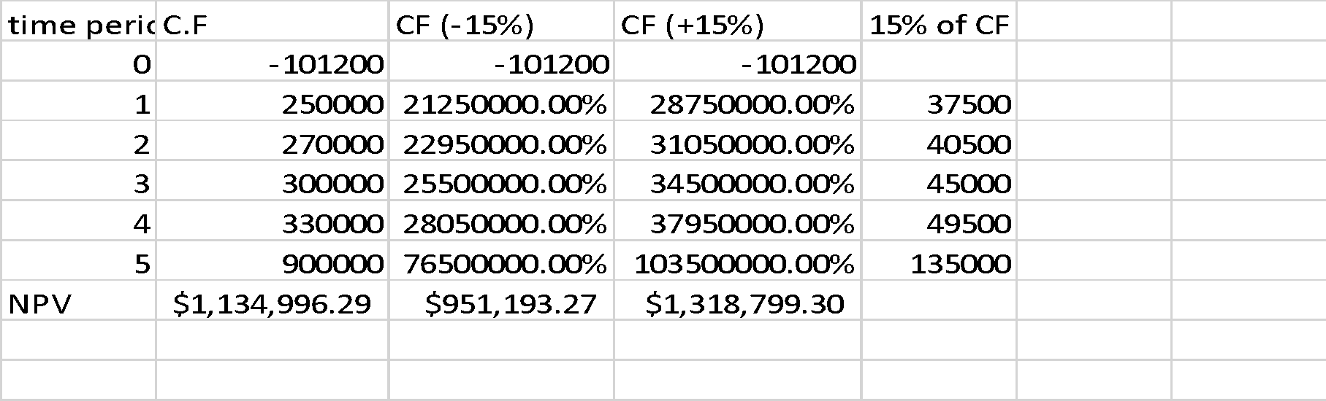
On NPV due to change in Press B
Change in Discount factor of Press B

Discount Factor | -3% | 12% | 27%
NPV | 494365.4 | 75895.54 | -76991.3
Working

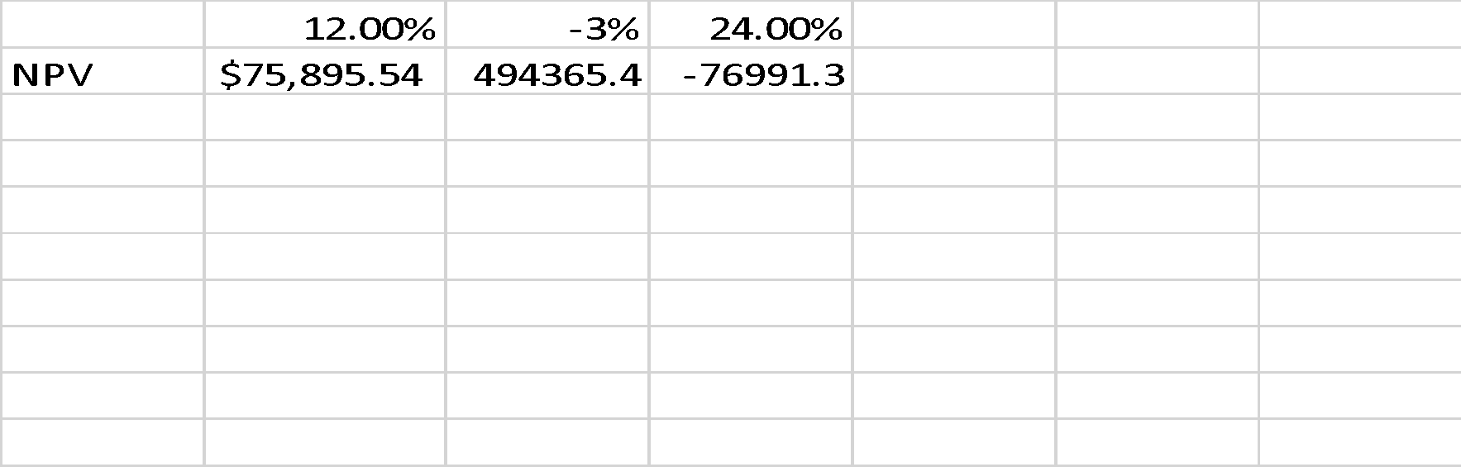

Earnings of Press B

Years | Cash Flows ($) (12%)  original | Cash Flows (12%)  Subtracted 15% | Cash Flows (12%)  Added 15%
0 | (672000) | (672000) | (672000)
1 | 210000 | 178500 | 241500
2 | 210000 | 178500 | 241500
3 | 210000 | 178500 | 241500
4 | 210000 | 178500 | 241500
5 | 210000 | 178500 | 241500
NPV = | 75895.54 | (25,488.79) | 177,279.87

Working
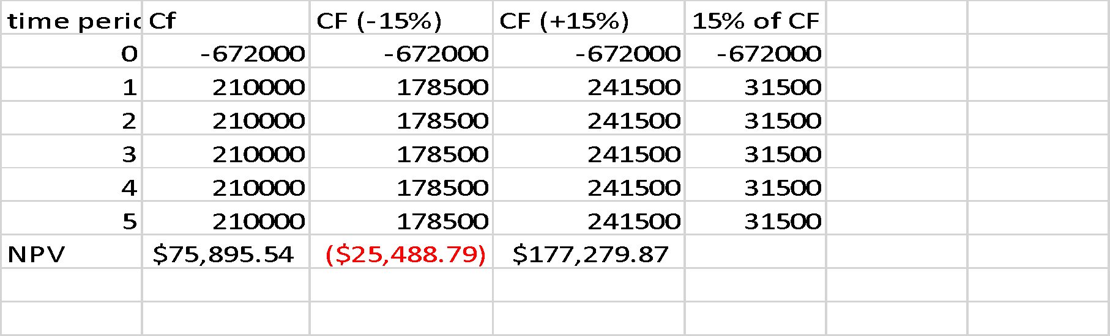
Effect on NPV Due to Change in Accounts Receivable

Working Capital = (Cash + Acc receivable + Inventories) – Acc Payable
= (25000 + 120000 + 20000) – 35000
= $ 130000
Cost = 830000 + 40000 + 12000 = 882000
Less 15% of Working Capital = 110500
Years | 0 | 1 | 2 | 3 | 4 | 5
Operating Cash flow |  | 250000 | 270000 | 300000 | 330000 | 370000
Cost | (882000)
Scrap |  |  |  |  |  | 400000
Working Capital | (110500) |  |  |  |  | 110500
 | (992500) | 250000 | 270000 | 300000 | 330000 | 880500

Year | CF (12%)
0 | 992500
1 | 250000
2 | 270000
3 | 300000
4 | 330000
5 | 880500
NPV= | 33919.72

Working

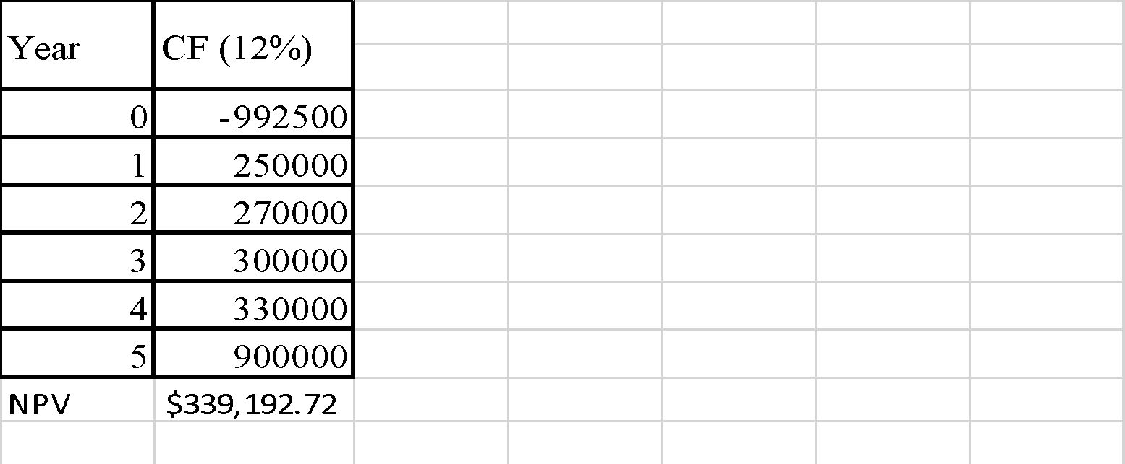
Add 15% on Working Capital = 149500
Years | 0 | 1 | 2 | 3 | 4 | 5
Operating Cash flow |  | 250000 | 270000 | 300000 | 330000 | 370000
Cost | (882000)
Scrap |  |  |  |  |  | 400000
Working Capital | (149500) |  |  |  |  | 149500
 | (1031500) | 250000 | 270000 | 300000 | 330000 | 919500

Year | CF (12%)
0 | (1031500)
1 | 250000
2 | 270000
3 | 300000
4 | 330000
5 | 919500
NPV= | 314250.60

Working

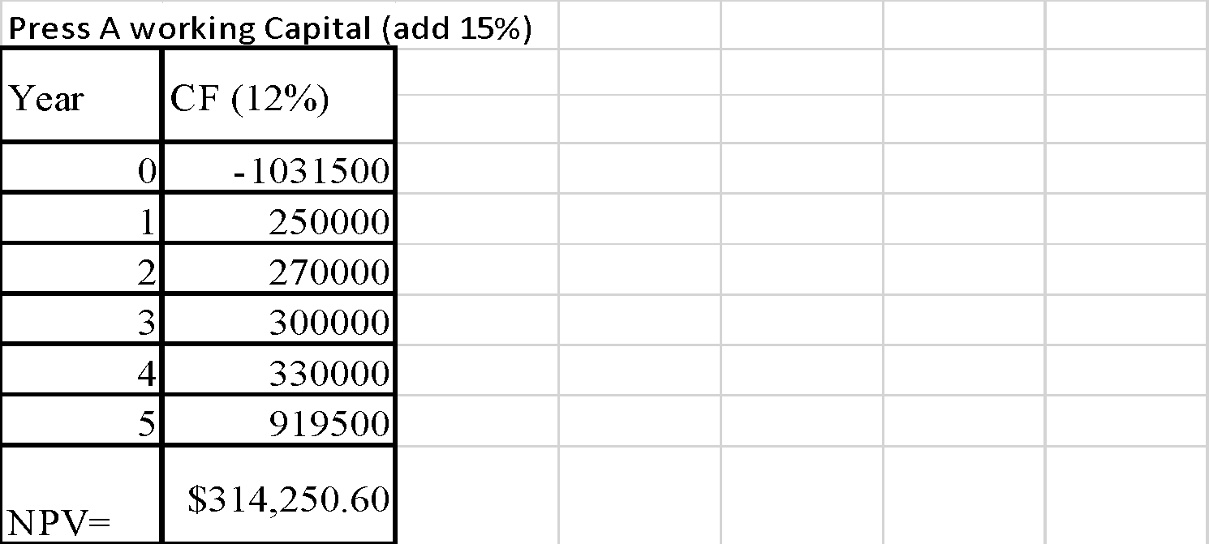

Final Recommendations
The final recommendation would be to accept Press A as an investment option. This is because it has a higher NPV and IRR compared to Old Press and Press B. This means that it would produce a higher profitability margin and would easily be able to cover the cost of capital invested. Even in the case of sensitivity analysis Press A has been the only one that has shown a positive NPV in regards to any change in its earnings, its discount factor or change in the working capital. The only adverse factor would be the emission of harmful gases due to its use. This could be easily managed with use of proper scientific methods available in the industry that could be help to lessen or eradicate the harmful effects of the gases (Hasanbeigi & Price, 2015).

References
DeFusco, R. A., McLeavey, D. W., Pinto, J. E., Anson, M. J., & Runkle, D. E. (2015). Quantitative investment analysis. John Wiley & Sons.

De Reyck, B., Degraeve, Z., & Vandenborre, R. (2008). Project options valuation with net present value and decision tree analysis. European Journal of Operational Research, 184(1), 341-355.

Hartman, J. C., & Schafrick, I. C. (2004). The relevant internal rate of return. The Engineering Economist, 49(2), 139-158.

Hasanbeigi, A., & Price, L. (2015). A technical review of emerging technologies for energy and water efficiency and pollution reduction in the textile industry. Journal of Cleaner Production, 95, 30-44.

Hekkert, M. P., Suurs, R. A., Negro, S. O., Kuhlmann, S., & Smits, R. E. (2007). Functions of innovation systems: A new approach for analysing technological change. Technological forecasting and social change, 74(4), 413-432.

Appendix
For NPV of Press A
For NPV of Press B

For NPV of Old Press

For IRR of Press A
For IRR of Press B
For IRR of Old Press

Sensitivity Analysis:
For Change in Discount Factor of Press A and Effect on NPV
For Change in Earnings of A and Effect on NPV
For Change in Discount Factor of Press B and Effect on NPV
For Change in Earnings of B and Effect on NPV
For Change in Working Capital and Effect on NPV
Press A working Capital (-15%)

