Your Name
Instructor Name
Course Number
Date

Title: The Writing Around
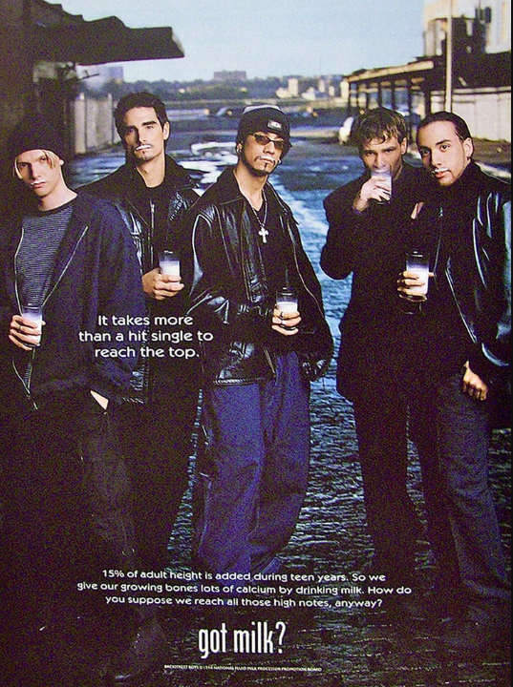
#4. TOPIC SENTENCE: that introduces what you have written in the three sections. A topic sentence should explain what you have discussed in as condensed a form as possible. If you could smoosh it all into one sentence, what would it be? | Ad campaigns are a way of promoting the necessary good habits that people should adopt through the use of attractive stimulus for the audience.
#2. Context: Explain any Background/Situation/Terms needed to understand the EVIDENCE in the second column: | The “Got Milk” campaign is highlighted through the famous band Backstreet Boys to promote the habit of drinking milk for better health.
#1. Concrete Evidence: Element of advertisement you wish to focus on (described as if the reader cannot see it): | In this advertisement, boys are reclined with ‘potential heights’ representing that height of a person need nutritious diet. Height is added in teen age specifically predetermined by milk rich in calcium (Bickerdike et al.). Their lips have absorbed milk in the ad representing they are standing tall because of the regular habit of drinking milk.
#3. Significance: Tell the reader clearly what is important about the EVIDENCE in the second column. What overall meaning do we get from that evidence? | Milk is rich in proteins, calcium, and growth factors that enable a person to grow. There is no argument on the fact that milk contains calcium and it is a complete nutritious diet, perfect for teenagers. The postures of boys are depicting their potential heights through this advertisement (Dragga and Gong). Their heads are high representing that boys need to reach heights in every field which is possible through their strong body and bones. Therefore, advertisement is showing to reach the top you need to have strong bones.

Works Cited
Bickerdike, Liz, et al. “Social Prescribing: Less Rhetoric and More Reality. A Systematic Review of the Evidence.” BMJ Open, vol. 7, no. 4, 2017, p. e013384.
Dragga, Sam, and Gwendolyn Gong. Editing: The Design of Rhetoric. Routledge, 2018.

