Student Name
Instructor Name
Course Number
Date
Introduction
A product service continuum shows the level of tangibility involved in any product (Camilleri). On one extreme, are the products which have pure physical existence and on the other extreme are the services which are purely intangible in nature. There are some products which fall in between this continuum because they are accompanied with a certain number of services for the full satisfaction of customers. An example of mobile phones would be appropriate for a product with related services. A large number of companies now offer after sales services which place them in the middle of this continuum. Another difference between the products at two ends of this continuum. The evaluation of goods is much easier as compared to the services. Customers also know exactly about their needs, wants and how a product would fulfil them. In case of service, a person may be partially aware of his or her needs and wants. (BMS.co.in). 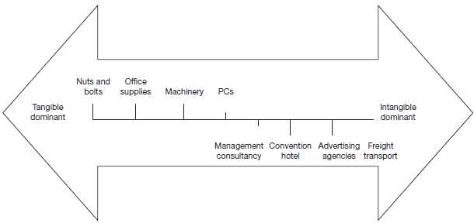
Fig 1. (Camilleri)
Application
In order to examine the raisin bran crunch cereal, there are two possibilities to examine this product. One aspect will keep this on the product side of the continuum. This will assume that there are no services associated with the product. The customer will also find it easy to evaluate the product on the bases of features like taste and flavors. This product can move on the continuum when we consider the services associated with product distribution. These services are necessary so that the product can reach the end customers. Since we are more concerned with the final product delivered to customers, we can conclude that this will remain on the tangible side of the continuum. The features like flavours and packaging can be used to differentiate products from the competitors. The company can easily find ways to improve various features of this product (Fripp).
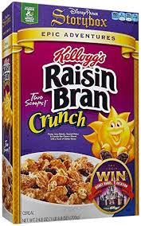
Fig 2. (BMS.co.in)

Works Cited
BMS.co.in. "https://www.bms.co.in/explain-the-goods-service-continuum/." 8 June 2012. https://www.bms.co.in. <https://www.bms.co.in/explain-the-goods-service-continuum/>.
Camilleri, M.A. "Integrated Marketing Communications." Camilleri, M.A. Travel Marketing,Tourism Economics and the airline product,Tourism, hospitality and Event Management. Springer International Publishing, 2018. 85-103.
Fripp, Geoff. "https://www.marketingstudyguide.com/tangibility-intangibility-continuum/." n.d. https://www.marketingstudyguide.com. <https://www.marketingstudyguide.com/tangibility-intangibility-continuum/>.

