Student’s Name
Instructor’s Name
Course Code
Date
Statistical Analysis
Table 1: Descriptive statistic
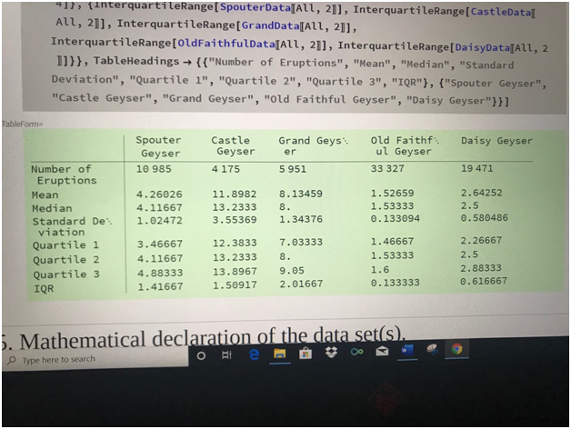
The data shows an interval of occurrence of an eruption of various Geysers. The graphs indicate a large variation in intervals from one eruption to the other. The change intervals can be seen from one graph to another of the first day, moving to the median intervals. Based on the table, there is a clear difference in means of Geysers that took place during the day within a specific time. The analysis of the table shows that Castle Geyser occurs several within an interval during the day followed by Spouter Geyser. The data shows that Castle Geyser has a mean of 11.8982, Spouter Geyser has 4.26062 and Grand Geyser has a means of 8.0. This means that the regions experience more Castle Geyser activities during the day compared to the rest. It is also evident that Castle Geyser has a median of 13.2333, which means that striking correlation between the duration of one eruption and the interval of eruption is higher for Castle Geyer. And therefore, it shows that the regions experience several Castle Geysers within the shortest time possible compared to spouter, grand and old faithful and daisy geyser. However, the data also shows that Daisy and Old faithful Geyser rarely occurs in the region.
The graph and data also show that the internal distribution of Castle Geyser is high compared to the spouter and the rest of the Geysers which take place in the region. The standard deviation of 3.5536 and Spouter 1.024 and the rest are having lower STD Dev. This means that the castle geyser is more likely to take place within a specific time compared to the rest. It is also evident the intervals of occurrence of the castle is closed and therefore, it takes place often and in multiple and huge compared to the rest. The quartile of castle geyser is high and therefore, the magnitude of each eruption is higher.

