A Transitional Living Program for Homeless Adolescents
Author name
Affiliation

A logic model is a tool that is used for the purpose of describing and articulating program theory (Savaya & Waysman, 2005). It provides the details of how the program should work in a theoretical sense. Following is a logic model based on “A Transitional Living Program for Homeless Adolescents: A Case Study”.
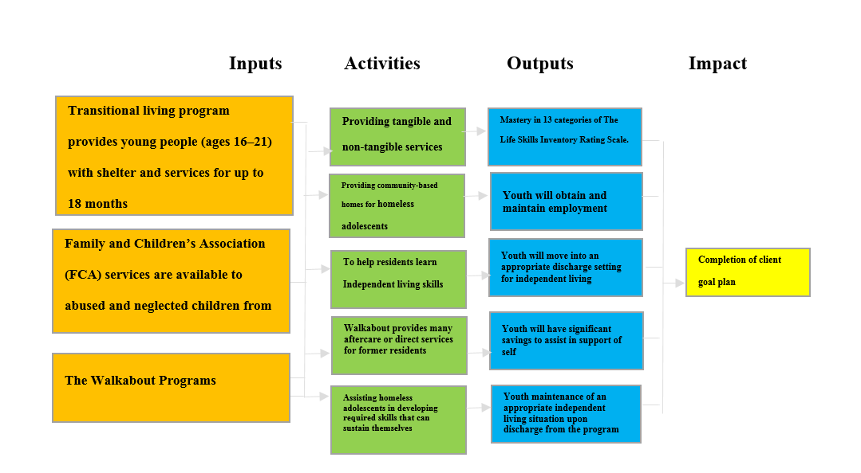

The Transitional Living Program for Older Homeless Youth is providing grants to community and faith-based non-profit and public organizations. These grants are aimed for providing longer-term residential supports (up to 18 months) to youth ages 16–21 so they have their fruitful changeover to adulthood and self-reliance. Youth as a result of having shelter and support services get themselves enable to have independent living skills. Therefore, these services such as counseling and training are a feasible alternative for youth who are not ready for emancipation.

References
Savaya, R., & Waysman, M. (2005). The logic model: A tool for incorporating theory in the development and evaluation of programs. Administration in Social Work, 29(2), 85–103.

