RUNNING HEAD: JD.COM

Assessment 2 – Strategic Direction
Student name

Institution name

Strategy Recommendation report
Contents
Executive Summary 2
Current Strategies Assessment 2
New Strategies 8
Mission 8
Vision 8
Objectives 8
Value creation 9
Target segments 10
Demographic segmentation 10
Situational segmentation 11
Behavioral segmentation 11
Geographic segmentation 11
Privacy, ethical and legal issues 11
External partners 12
Organisational model 12
Revenue model 13
Cost model 14
Strategy alignment 14
Recommendations 15

Executive Summary
Mr Liu Qiangdong founded Jingdong (JD) in June 1998. The company was started as a small counter to sell magneto-optical products. After three years of its establishment, the company was running 12 stores in the chain. Regrettably, Liu Qiangdong had to stop the extension of its stores due to SARS. Then he moved towards the idea of e-business and in 2004 company website jdlaser.com. went online. The company went for further diversification in 2010 and progressed to a comprehensive mega-site that started selling all kinds of products. Currently, the company is a partnership with the foreign e-commerce system. It also has a bulk investment in the self-owned logistic system. Its main competitor is Alibaba (Zhang et al., 2017). To compete effectively it is using different strategies such as changing buyer behaviour and using low-price strategy. It has also invented mobile online banking and introduced English website of JD.

Current Strategies Assessment
Business canvas model can provide effective strategy analysis.
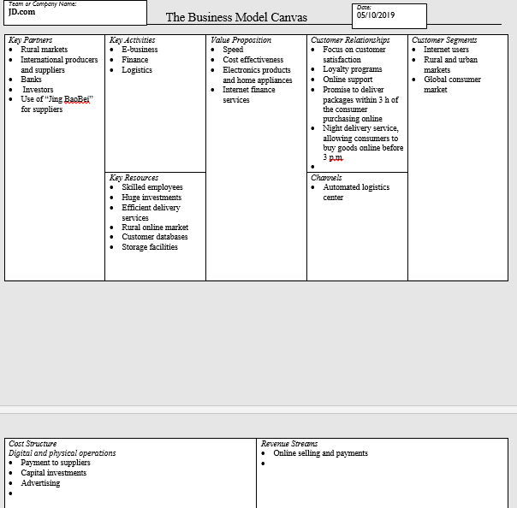
Fig. 1 Business canvas model
Core competencies
Competencies are a collection of tangible and intangible assets with skill and knowledge of the employee. In this strategic analysis, we will identify each separately.
- Tangible Assets
The assets that exist in the physical forms such as fixed assets and current assets are known as tangible assets.
- Skilled Employee
The JD has the highest number of working staff over the nation. They have more than 120,000 skilled employees wherein approximately 11,145 as warehouse staff and 5,832 as customer service personnel. The skilled employees providing high values to quick and high values to the customers.

- Logistic Systems
JD has its own logistics system which is proven to be successful to make the delivery faster than their competitors. They approximately 256 warehouses with 36 cities, pickup station around 495 and approximately 24,412 delivery people across China.
- Infrastructure
They have built their own physical warehouse and pickup station with call centre office to support the kiosk high traffic flow. The new infrastructure was built in a way to deliver the order within the timeframe of 3 hours.
- Internet finance service
JD has introduced the new payment system known as ‘Baitiao’. In this system, customer can get credit which can only be used at JD. This system helps JD to increase average monthly spending per order by 33%.
- Intangible Assets
The assets which do not have a physical appearance are known as intangible assets such as band reputation.
- Brand value
JD has developed the goodwill to reform the brand value. To improve the band value, JD has come up with own self-operated system and skilled trained team to enhance the experience of shopping online.

- Reputation
The reputation of the JD has been improved by taking the surveys from the customer over phones and emails. They also started building an alliance with social media to improve the customer experience based on their behaviours.
- Customer satisfaction
JD especially introduce the program for benchmarking customer satisfaction by various techniques. It has been observed that there was a high number of customer feedback with more than 80% satisfaction ratio.
Capabilities to identify core competencies
- A logistic system with customer satisfaction
The new logistic system has not only helped in improving customer satisfaction but also enhanced the experience to buy the products online. The system gives flexibility to the customer to get their favourite products from anywhere, anytime. It’s also integrated with a centralised data system where information about each consumer is store with security.
- Finance platform with a brand value
The finance platform which helps the consumer to buy the product on credit basis. This has resulted in an increase in brand value. This system also allow the supplier, investor and fundraiser to interactive with each other which helps the build the rapport of JD.

- A skilled employee with a reputation
Over the analysis of the case study, we have found that JD has an excess of staff which is not letting them make any profit. Though they have improved their reputation by serving their customers in a traditional manner.
- Opportunity in a rural area
We have also observed that there is a wide range of exploring into the rural region. As the local and imported products are not easily available to them. They can use a mobile application or website to make the order which can enhance the overall growth of JD.
JD.com being China’s largest online retailer for 3C products is successfully running its business using aggressive strategies to achieve the core values. These strategies are:
- JD is primarily selling magneto-optical products along with electronics, mobile phones, and computers.
- The company has three core businesses: e-business, finance and logistics.
- Currently, it is offering nearly 1.5 million products (Chan et al., 2018).
- Electronics products and home appliances have a high ratio of total gross merchandise volume (GMV).
- It has extended its target market to rural areas to capture the large potential market (Chan et al., 2018).
- Going for globalization by staring its English website with a new domain name, joybuy.com.
- The company was listed on NASDAQ in 2014 that allow different operational structure and system changes.
- It has completed four rounds of fundraising during 2007 and 2013 and uses these funds to support his logistics system and low-price strategy.
- It is also China’s largest company IPO in the USA.
- JD has launched an online customer service centre to cultivate consumers’ trust (Redrup, 2018).
- It has a self-built logistics system that has been built on an image of “joyful shopping experience” among customers.
- It has heavy investments in logistics system and owns advanced automated logistics centre.
- It is successfully managing different stakeholders in its supply chain.
- It has 7 fulfilment centres, 256 warehouses and 6,906 delivery and pickup stations across the country.
- It has strong partnerships in the industry such as a partnership with Tencent, to take benefit of the major social media platform in China.
- It also has a strategic alliance with Walmart to develop O2O.
- The company has been listed as 366th on the Fortune Global 500 (Chan et al., 2018).
- In 2012, the company started targeting cross-border e-tailing.
- The customers are not –Chinese and Chinese living aboard.
- Its main competitors are; Tencent, Yihaodian, Amazon, Suning and VIPShop.
- Alibaba is offering JD a tough competition in all spheres.
- Alibaba’s model is considered as more effective by investors due to held less inventory risk and profit margins.
- JD currently has more investments then profits (JD.COM, 2019).
- It has also been blamed for the leaking of consumer data and selling fake products.

New Strategies
JD is performing well in the market with the two-digit annual growth rate in its sales volume. However, it has been facing different challenges related to its internal operations as well as external competitors that are requiring some new strategies. The company is required to implement different strategies that can bring a balance between investment and profitability both in the short and long terms. Following is the layout for implementing new strategies:

Mission
The company has a mission to make its customer's life carefree and joyful.

Vision
The company has the vision to become the most reliable corporation in the world and gain its consumers’ trust (Chan et al., 2018).

Objectives
- Gain customers trust
- Compete, competitors, effectively
- Maintain a balance between investment and profitability
- Maintain good relationships with suppliers
- Gain a competitive advantage through its self-owned logistic system
- Expand the target markets

Value creation
In order to provide a reliable and scalable platform to its partners and customers, JD.com has to create these values. Firstly, it has to gain operational excellence by getting value-added technology, offering low prices, reducing manufacturing and distribution costs. Currently, it is using technology to achieve different objectives such as fastest delivery to satisfy customers, the facility of online shopping and payment and successfully running the logistic system. By improving this, it will be able to gain a competitive advantage by speedily marketing the new product and delivering the new product (Ma et al., 2017). With this, it will also be able to have its presence globally. The automation of operations will not only enhance the quality of operations but will also increase the profits by reducing the costs. However, as JD sells online and is in danger of different frauds and scams. It is also required to develop such strategies that can overcome these difficulties. The company currently has a bad reputation regarding the safety of customer’s data. Thus, it must have its own secure information system with all encryptions to save the data and satisfy the customers and gain their trust. Secondly, it has to focus on its employees and their skills and the efficacy of its technologies. Currently, it has efficient teams in logistics that make the delivery of products very fast. However, these teams are required to extend in all departments. Then, it should also focus more on customer satisfaction. For this, it should also offer them different incentives along with improving the quality of its products and services. It should focus on their needs and increase its product lines. With product differentiation, it can also compete well in the industry.

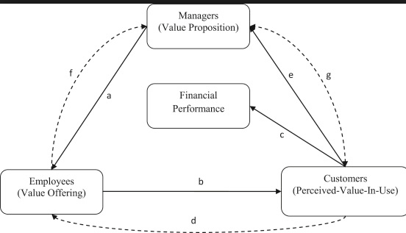
Fig. 2 value creation at JD

Target segments
JD should extend its target segments and adjusts its offers to their exclusive needs and requirements. Following steps can be taken for this purpose.
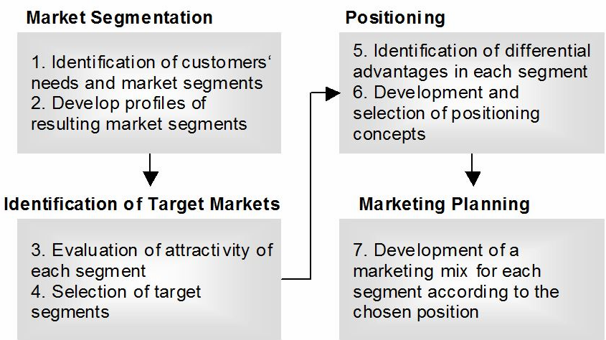
Fig. 3 Targeting JD customers

Demographic segmentation
Target customers that have internet access.

Situational segmentation
Target customers that like convenience, have interest in new products, like discounts and low prices,

Behavioural segmentation
Target recurring customers and gain their loyalty. Also, target customers that are fond of innovations and technology. Use aggressive marketing to attract these customers as they believe much in referrals, suggestions and recommendations regarding products.

Geographic segmentation
Target international customers and customers in rural areas.
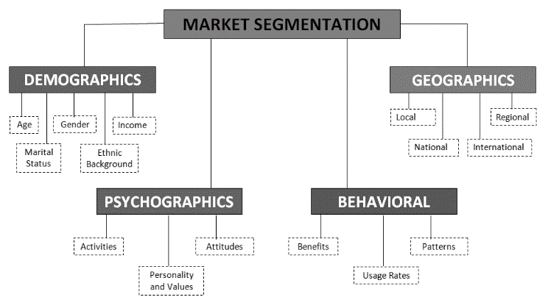
Fig. 4 Types of market segmentation

Privacy, ethical and legal issues
- As a part of e-commerce JD can face different legal and ethical issues.
- It should make strict rules with regard to collecting, preserving and disposing of consumer’s information (JUNG, 2018).
- The organisation has been involved in privacy concerns with regard to consumers. Now it’s a time to change this.
- Consumer’s identity who use Electronic Payment System must also be protected (Martin, 2015).
- The company should also refrain from behavioural advertising (Martin and Murphy, 2017).
- The company should also check for suppliers and make sure not to sell the fake products as it had happened in the past.
- It should also register its all trademarks and Intellectual property.

External partners
Walmart is the main external partner of JD. The strategic alliance between the two organisations was started in 2016 for the further development of JD business (“WALMART LAUNCHES ASDA FLAGSHIP STORE ON JD,” 2017). The aim behind this was to better serve consumers with the influential amalgamation of e-commerce and retail. Thus, it covers both online and offline retail. Walmart with this has an opportunity to expand in China e-commerce (“Walmart and JD.com Announce Strategic Alliance to Serve Consumers across China,” 2019). JD, on the other hand, is taking advantage of Walmart and Sam’s Club’s imported products. The other external partner is Tencent that is providing the company major social media platform in China.

Organisational model
Organisational model is the way of arranging people, their duties and responsibilities within the organisation to achieve the desired goals.
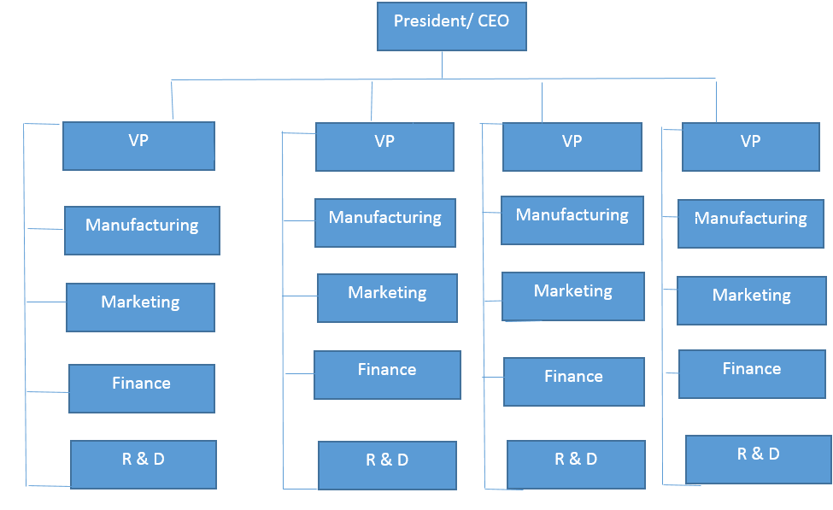
Fig. 5 Organisational structure

Revenue model
The revenue model for the organisation is

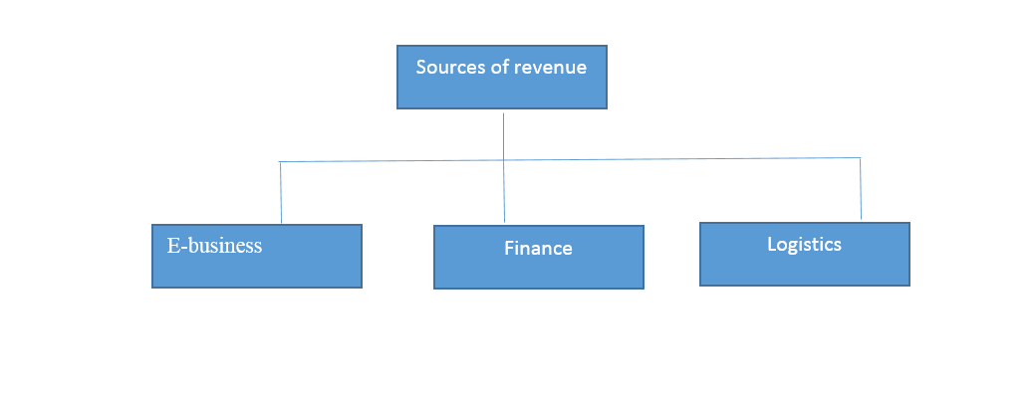
Fig. 6 the revenue model

Cost model
The cost model for the organisation is:
- Website hosting
- Customer development
- Configuration
- Maintenance of website
- Storage
- Distribution
- Employees’ salaries
- Marketing
- Training

Strategy alignment
The business model canvas is aligning e-strategy with physical strategy. By focusing on all these segments, the company can achieve its objectives and goals.
Fig. 7 strategy alignment

Recommendations
Strategic Recommendation
- Use advanced digital technique by creating a social media platform
We would like to recommend JD to create the advance digital transformation which will help the company to create an interactive dashboard using social media. We can also analyse the customer using integrated insights based on their behaviour. This would enable the JD to predict the products based on their requirements.
- Employee Layoff
Though employees are the most important resource of the organisation as JD is growth so continuously, they need to come up with an innovative technique which can help to automate the process smooth and robust.
- Strategic alignment with foreign countries
JD can make the use of Chinese government policies to expand revenue and increase profitability. As they also have their own logistics systems would add another advantage to alliance their partnerships with international brands.
- Introduction of paid membership service
They can also initiate the technique of engaging with the customers by launching the membership card. This would help the JD to engage existing customers and get new customers. This membership would help the customers to get promotions of bundle deals and discounts on orders.
- Use for cutting edge technology to delivers orders through Artificial Intelligence
As JD is growing rapidly with respect to revenue, they can develop the technological device such as drone for delivering the orders using artificial intelligence. This would reduce the manpower required to process the order for delivery. While developing cutting edge technology we need to consider the PESTEL model. Overall, this would save the lead time to deliver the order in rural regions. It would also save tremendous money at the same time there would be an upfront cost of developing the new solution. JD would definitely compete with Alibaba.

Bibliography
Chan, A.K., Huanyong Chen, C., Zhao, L., 2018. JD. com: leveraging the edge of e-business. Emerald Emerging Markets Case Studies 8, 1–30.
JD.COM, 2019. JD.com, Inc. Financial and Operational Highlights, JD.COM [WWW Document].
JUNG, C.J., 2018. How Would the New Chinese E-commerce Law Change Taobao? [WWW Document]. URL https://pandaily.com/how-would-the-new-chinese-e-commerce-law-change-taobao/
Ma, B., Xu, X., Sun, Y., Bian, Y., 2017. Online search-based advertising strategy for e-Business platform with the consideration of consumer search cost. Kybernetes 46, 291–309.
Martin, K.D., Murphy, P.E., 2017. The role of data privacy in marketing. Journal of the Academy of Marketing Science 45, 135–155.
Martin, K.E., 2015. Ethical issues in the big data industry. MIS Quarterly Executive 14, 2.
Redrup, Y., 2018. How Chinese e-commerce player JD.com is becoming an AI powerhouse [WWW Document]. URL https://www.afr.com/technology/how-chinese-ecommerce-player-jdcom-is-becoming-an-ai-powerhouse-20180719-h12vph
Walmart and JD.com Announce Strategic Alliance to Serve Consumers across China [WWW Document], 2019. URL https://news.walmart.com/2016/06/20/walmart-and-jdcom-announce-strategic-alliance-to-serve-consumers-across-china
WALMART LAUNCHES ASDA FLAGSHIP STORE ON JD [WWW Document], 2017. URL https://jdcorporateblog.com/walmart-further-strengthens-jd-com-strategic-alliance-with-launch-of-uk-retailer-asda-flagship-store/
Zhang, W., Chen, M., An, W., Zhang, J., 2017. The Key Success Factors in the Development of Platform-Based Business in China-Case Study on Alibaba and Jingdong, in: International Conference on Applied Human Factors and Ergonomics. Springer, pp. 185–193.

