Improving motivation
Author name
Affiliation

Motivation refers to the characteristics that trigger people to do something or not to do something (Broussard & Garrison, 2004). It makes people move in a specific direction to achieve a certain objective. It is one of the biggest challenges for organisations to keep their employees motivated. There are two types of motivation; intrinsic motivation and extrinsic motivation that can be used by organisations to motivate people and get the desired results. Sometimes both types of motivations can function together to achieve an objective. For example, people are sometimes intrinsically motivated to enjoy the given task and want to earn a raise after completing the task. This paper will discuss different types of motivation with examples. Moreover, there is also the analysis of different motivational theories to give recommendations to my organisation to enhance the motivation of people at the workplace.
Intrinsic Motivation
Intrinsic motivation refers to an internal form of motivation (Sansone & Harackiewicz, 2000). People struggle towards an objective for their personal gratification or achievement. They also have a belief in their internal capacities that motivate them. Here, the behaviour itself becomes the reward. These behaviours are performed as a result of their personal satisfaction that they bring. For example, the setting of personal goals can motivate employees.
Extrinsic Motivation
Extrinsic motivation, on the other hand, refers to an external form of motivation that relates to outside causes. People can be motivated to earn a reward or to avoid punishment. They are extrinsically motivated as they get a reward from others such as promotion and praise. By offering these rewards organisations can direct their employees to achieve certain objectives. These rewards are usually financial and tangible. Along with money, other extrinsic rewards can be organisation characteristics, job security as well as development opportunities for employees.
Motivation at my Workplace
I work in an IT organisation that also uses different intrinsic and extrinsic motivators to motivate employees at the workplace. There is a use of a reward system, bonuses and deductions that motivate people towards achieving their goals. It also offers different chances of getting ahead in the organisation.
Strengths of Motivation
The use of motivation at the workplace results in increased productivity. There is also an enhancement in quality in functions of the organisation. When employees are more motivated then there is also lower labour turnover. The motivated employees also have better communication among them as they like to work in teams. Along with employee’s growth, customers are also happy with the company as employees maintain the quality in products and services.
Weakness of Motivation
However, there are certain weaknesses in current strategies that require more effective strategies. Extrinsic motivation can cause harm to the organisation. Once employees get the reward, they stop working actively and their motivation ends with it. Moreover, if employees are not able to get the desired results and the extrinsic rewards, the, they get de-motivated. In addition, the financial motivation is costly for organisations and may affect work quality.
Different motivational theories can be used to understand the need and benefits of motivation in the workplace.
Maslow's Hierarchy of Need Theory
Maslow's hierarchy of need is a motivational theory that divides human needs into five tiers, as peoples actions are motivated in order to fulfil certain needs (COM, 2015). These needs in hierarchical order from the bottom are physiological, safety, love and belonging, esteem and self-actualization. In the pyramid of needs, most basic needs are at the lowest levels while the most complex needs are at the highest level of the pyramid. Needs that are present at a lower position in the hierarchy must be satisfied first such as physiological and safety needs.
People are first motivated to fulfil their physiological needs such as the need for foodstuff, water and sleep. Once people fulfil these needs then they want to have the next level of needs. These also motivate people to fulfil them and they strive for them. Needs are psychological and social when people move up the pyramid. They need love and friendship and then personal esteem. They find themselves in need of self-actualization.
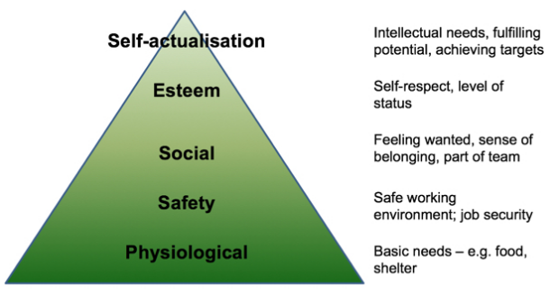
At my place, the organisation strives to first fulfil the psychological and safety needs. Then it arranges for social needs by making different cross-functional teams and groups. Employees also get different training to learn different skills that enable them to achieve certain targets to get the level of self-actualization.
Self-efficacy Theory of Motivation
In addition, there is Self-efficacy theory of motivation in which beliefs are chief, obvious clarification for motivation (Elkhawaga & El-Masry, 2017). There are different sources of self-efficacy; performance undertakings, social persuading as well as physiological and emotional states. If there is better performance then the employee gets the confidence and this increases their self-efficacy. Moreover, social pressure also matters a lot and employees strive to work under the pressure.

Additionally, this theory is based on intrinsic motivation and results in higher motivation if there are high self-efficacy and vice versa (Cook & Artino Jr, 2016). For example, if an employee has a belief that he can achieve a certain target while he lacks ability. The other employee has less belief in achieving his target but has greater ability. The first employee will be succeeded as a result of self-efficacy.
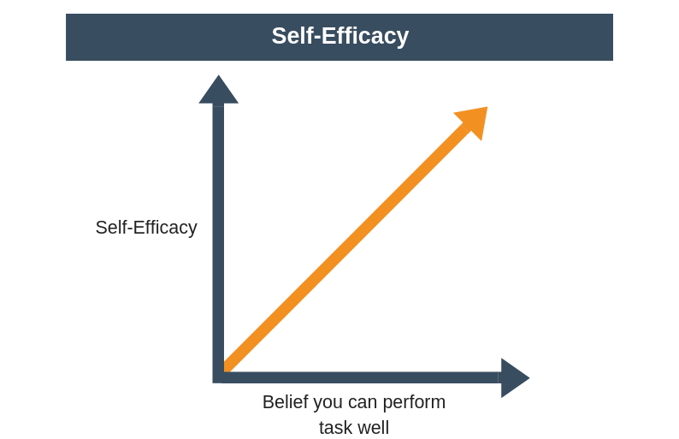
This theory is also in practice in my organisation. Employees are given different sessions by motivational speakers that motivate them and make them believe in their abilities. Moreover, there are also different learning opportunities that allow them to enhance their skills.
Herzberg’s Two-Factor Theory
According to the Two-factor theory, there are certain factors in the workplace that result in job satisfaction, while others result in job dissatisfaction. Thus, these factors act independently of each other. The satisfaction factors known as motivators are linked with the nature of work (recognition, responsibility) and organisations should go for job environment to reduce the dissatisfaction. On the other hand, there are hygiene factors whose absence results in dissatisfaction. These are mostly extrinsic such as company policies, or salary.
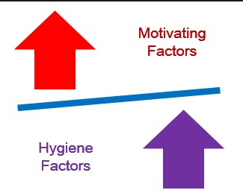
The motivators at my organisation are achievement, recognition, the work, responsibility as well as advancement. The presence of these factors increases the employee’s motivation. Conversely, the hygiene factors at my organisation are company policies, supervision, relationships as well as security. Company policies and supervision give employees direction and motivate them. similarly, when they feel their jobs are secured they are motivated.
How to improve organisational practices of motivating employees
Different strategies can be used by an organisation to improve organisational practices and motivate employees. Feedback matters a lot in supporting the intrinsic motivation among employees. Employees are able to understand organisation standards and expectations when they continuously get feedback. However, an abundance of praise can prove disadvantageous for the organisation.
Moreover, the extrinsic rewards must be offered purposefully and organisations must provide the required resources such as skills to achieve the goals related to them. Employee’s performance appraisal is an effective strategy in this regard that allows employees to compare their performance with their previous performance. This will also result in the professional development of the workforce. Likewise, management should allow employees to take their decisions. In this way, they will not only be able to show their competence but also to increase their self-efficacy.
Conclusion

Motivation is an internal feeling or force that has an effect on people behaviour. It is a continuous process that gives them direction, intensity as well as persistence (Broussard & Garrison, 2004). This can be intrinsic motivation as well as extrinsic motivation. Intrinsic motivation is related to people internal desires of performing specific tasks. For example, they may develop a specific skill that they require for performing specific tasks. On the contrary, extrinsic motivation is related to external factors such as tangible rewards. Organisations cannot motivate their employee with a single type of motivation. Extrinsic motivation has its own benefits but there is no use of it unless an employee is also intrinsically motivated. For example, an employee due to the external reward can be motivated to work but this does not give him pleasure in the long run. In addition, some people have more preference for tangible and extrinsic benefits while others are more inclined towards their self-satisfaction. Therefore, there is a requirement of a critical balance between the two types otherwise this can result in harm to the organisation.
Different motivational theories explain the factors accountable for human motivation. According to Maslow theory, people can be intrinsically motivated, if their basic needs are satisfied. These are different physiological and safety needs (COM, 2015). Moreover, the mechanism of positive feedback can be used to improve intrinsic motivation in employees. This increases their belief in their abilities and they are intrinsically motivated. Similarly, according to Herzberg’s Two-Factor Theory, there are also two types of motivational factors such as hygiene and motivators that result in the motivation of employees. Herzberg’s theory is related to the psychological needs of employees. The fulfilment of these needs enhances employee satisfaction. The organisation should design jobs in such a way that motivate employees (Sansone & Harackiewicz, 2000). Jobs are not just aimed to have the routine working but have something that can motivate them an increase in their skills and interest in the work. Moreover, the importance of rewards systems is inevitable in the organisation. Strategies about the reward system must also be checked and there must be continuous monitoring of employees in order to encourage and motivate them. There is also a need to increase people’s self-efficacy (Elkhawaga & El-Masry, 2017). They must be taught in organisations how to respond to their failures and select the ways of working. This will increase their success rate and they will get more confidence resulting in increased motivation. This is due to the reason that self-efficacy is explicitly related to the development of intrinsic motivation in employees.

References
Broussard, S. C., & Garrison, M. B. (2004). The relationship between classroom motivation and academic achievement in elementary‐school‐aged children. Family and Consumer Sciences Research Journal, 33(2), 106–120.
COM, M. (2015). Maslow’s Hierarchy of Needs: Gain vital insights into how to motivate people. Retrieved from https://books.google.com/books?id=sdVmCgAAQBAJ
Cook, D. A., & Artino Jr, A. R. (2016). Motivation to learn: an overview of contemporary theories. Medical Education, 50(10), 997–1014.
Elkhawaga, G., & El-Masry, R. (2017). Knowledge, Beliefs and Self-reported Practices of Hand Hygiene among Egyptian Medical Students: Does Gender Difference Play a Role? Journal of Public Health in Developing Countries, 3(2), 418–425.
Sansone, C., & Harackiewicz, J. M. (2000). Intrinsic and extrinsic motivation: The search for optimal motivation and performance. Elsevier.

