Your Name
Instructor Name
Course Number
Date
The Influence of Japonism on work of Vincent Van Gogh
Japonisme defines the obsession of Japanese culture and art. The latter half of the nineteenth century witnessed this obsession. Ukiyo-e, Japanese woodblock prints had been produced during the 17th to 19th centuries. Hence, these were widespread during the 1860s and were concentrating on elements of beauty in the world. They were carrying the natural landscapes, kabuki performers, sumo wrestlers as well as folk tales. Different impressionist and Post-impressionist artists have a great influence on Japanese art. These artists were going for choices to the western dominate artistic styles by following the Japanese prints. Vincent van Gogh is also one of the admirers of Japanese art and this influence can be seen in his artwork. He also invented the term "Japonaiserie to show the impact of Japanese art on his style and his generations. He was a self-taught artist who changed the expression of post-impressionism endlessly. He has 2,000 works of art that include his paintings, drawings, and sketches. This paper will discuss the effect of Japonisme on Van Gogh paintings while focusing on “Flowering Plum Orchard”, “The Residence with Plum Trees at Kameido” and “The Starry Night (1889”. Moreover, the paper will have stylistic, cultural analysis along with making links in paintings through the thematic connections.
Initially, van Gogh followed Japanese masters by making pencil sketches and oil paintings to make paintings look more striking. In 1887 van Gogh painted copies of two well-known designs of Hiroshige; the Bridge in the Rain and a Plum Tree in Bloom (Walker). Hiroshige had used Western elements in his print designs such as the use of perspective, in the Bridge in the Rain. Vincent then added frames to these designs and adorned them with Japanese typescripts. Moreover, he gradually started incorporating his style into these Japanese paintings. He was much impressed with the decorative quality and bright colors of Japanese prints. He used his concept of complementary colors such as the green against the red in Japanese designs. He also added flat surfaces, optimistic colors, strong lines as well as subject matter to the paintings to make them more attractive. According to him, art should be colorful, and joyous.
Then in 1888 Vincent van, Gogh went to Arles in Southern France in springtime. He got inspiration from the strong colors of the landscape and had a collection of paintings of flowering trees (Walker). His paintings during this era influence Japonisme. He used black contours in woodblock prints. His pen drawings during this ear provide the view of the nearby scenery (Chan). The other advancement in Japanese painting was the color change brought by Vincent. For centuries artists have been found to concern regarding the use of yellowing of drying oils in paintings. Van had used this for color changes in these paintings.
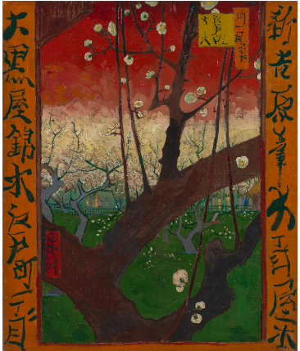
Vincent van Gogh, “Flowering Plum Orchard (after Hiroshige)” (October-November 1887), oil on canvas, 55.6 cm x 46.8 cm
Additionally, Vincent van Gogh was a lover of ukiyo-e prints and created Japanese albums for export. Van Gogh’s Japanese print collection had images of flowering trees have much resemblance with his famous painting; Almond Blossom (1890). In the painting, there are delicate and interlacing branches in blossoms. The same concept can also be seen in Togaku’s “Cranes and Cherry Blossoms” (1875–1900). Patterns of tree blossoms and flowers in the paintings are rhythmically arranged. Vincent van Gogh in his other painting also Utagawa Hiroshige, Bird and Cherry Blossoms, 1860 went for repeated motifs. These experiments over the patterns of tree blossoms and flowers from Japanese prints swayed Western art and design harshly.
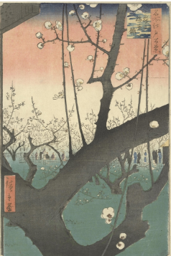
Utagawa Hiroshige, “The Residence with Plum Trees at Kameido, from the series One Hundred Views of Famous Places in Edo” (eleventh month 1857), print, 25.4 cm x 37 cm
The visual similarity in this painting is depicting the van Gogh inspiration from the Japanese print. The other interesting feature in his painting was the interest in femininity. Most of the Japanese prints that he purchased were carrying the images of female beauties (Chan). He has strived to cover every aspect of the Japanese culture that was being used by Japanese painters.
Two cultural practices such as collecting and painting have a great effect on his work. He was a collector of Japanese prints and fashioned unrealistic images of Japan; primitive land where people live close to nature. He did not modify the Japanese style rather with his style enhanced the traditions of Japanese artists.
The Starry Night (1889) is also his best-known painting that he had while staying at Saint-Paul asylum in Saint-Rémy, in Southern France. Through the window of this asylum, he saw the countryside before sunrise that had morning star. This natural beauty insured him a lot and this can be seen in his famous painting. His mid-scale, oil-on-canvas painting has moon- and the star-filled night sky. The painting appears turbulent and has three-quarters of the picture plane. In the painting, there are swirling patterns that appear as waves.
Furthermore, in the painting, there are humble houses of village neighboring to a church. The church towers are rising sharply above the surging blue-black mountains that Van has also shown in the background. A visual link between land and sky in the painting is provided with the drawing of a huge cypress tree. It has a flame-like appearance and it touches the top edge of the canvas. Metaphorically, this cypress tree is a bridge between life and death as Cypresses are also considered as trees of the graveyard and sadness.
Similarly, there are whirling forms in the sky, which are similar to astronomical observations of clouds of dust and gas in the sky. He was so fascinated with this natural beauty that he was able to have this visual contrast in his painting. This painting moved him away from his traditional impressionist connection with nature. He rather had the feelings of impatience that can be seen from the power of his swirling brushstrokes. This gives an impression of the moving of painting.
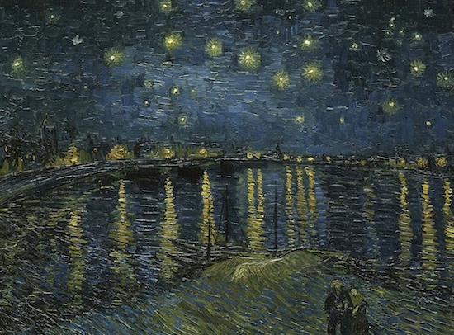
Vincent van Gogh, Starry Night over the Rhone, 1888, oil on canvas, 72 x 92 cm (Musée d'Orsay)
Vincent van Gogh today is known as the greatest Dutch painter. He had not been famous during his life however he had a large following after his death. His work is considered as foreshadowed for the advancement of expressionism as well as modernism. He was a lover of nature that he found in the Japanese paintings and got inspired (Van Gogh and the Seasons - Sjraar van Heugten). He had never visited Japan and had knowledge about the country based on typically on Japanese woodblock prints and the Ukio-e.

Works Cited
Chan, Tina. Japanese Prints: The Collection of Vincent van Gogh. REED BUSINESS INFORMATION 360 PARK AVENUE SOUTH, NEW YORK, NY 10010 USA, 2019.
Van Gogh and the Seasons - Sjraar van Heugten - Google Books. https://books.google.com./books?hl=en&lr=&id=NL88DwAAQBAJ&oi=fnd&pg=PR16&dq=+The+Collection+of+Vincent+Van+Gogh+&ots=MMXh3LeHxq&sig=j-GjjkNteX367gPEyDLvkhd9Yfk#v=onepage&q=The%20Collection%20of%20Vincent%20Van%20Gogh&f=false. Accessed 14 Aug. 2019.
Walker, Janet A. “Van Gogh, Collector of ‘Japan.’” The Comparatist, vol. 32, 2008, pp. 82–114.

