Correlation of Psychological Theories of Child Normal Development and its Impact on Personality and Child Normal Development
[Author]
[Institution]

Author Note

Correlation of Psychological Theories of Child Normal Development and its Impact on Personality and Child Normal Development

Introduction
Child psychology is one of the most significant branches of psychology, since it focuses on child behavior from prenatal development, all the way into adolescents. Earlier, they were seem as a much smaller version of adults. However, it was Jean Piaget that suggested that children’s mind work differently as compared to an adult. Thus, they think differently and consequently are more capable of handle certain psychology aspects of life when compared to most adults (Soto & Tackett, 2015).
In the present age, psychologists realize that child psychology is not only unique, but it is complex enough to demand its very own set of theories. Thus, child psychologists, while dealing with children, have to take on a unique perspective in terms of their approach. Their approach, along with their opinion, have to be customized on the basis of the case that they are working with, which is why no detail is too small for them or unworthy of being placed into consideration. They have to take into account every single experience that a child goes through in order to work with the child, understand his psychology, understand his cognitive ability and his development over a period of time in order to understand this little person and make an assessment of his development, both mental and psychological (Jirout & Newcombe, 2015).
Since childhood plays a crucial role in the development of a child, it is rather important that the child in question be studies through the lens of multiple perspectives, to ensure that the child, the people that surround him or the environment he is being raise in, nothing hinders his development. In fact, the environment the child is being raised in should be nurturing, which not only allows the child to grow into a fully functioning and capable adult, but it also allows them to be studied in an effective an unbiased manner (Kaufmann et al., 2017).

Case Study
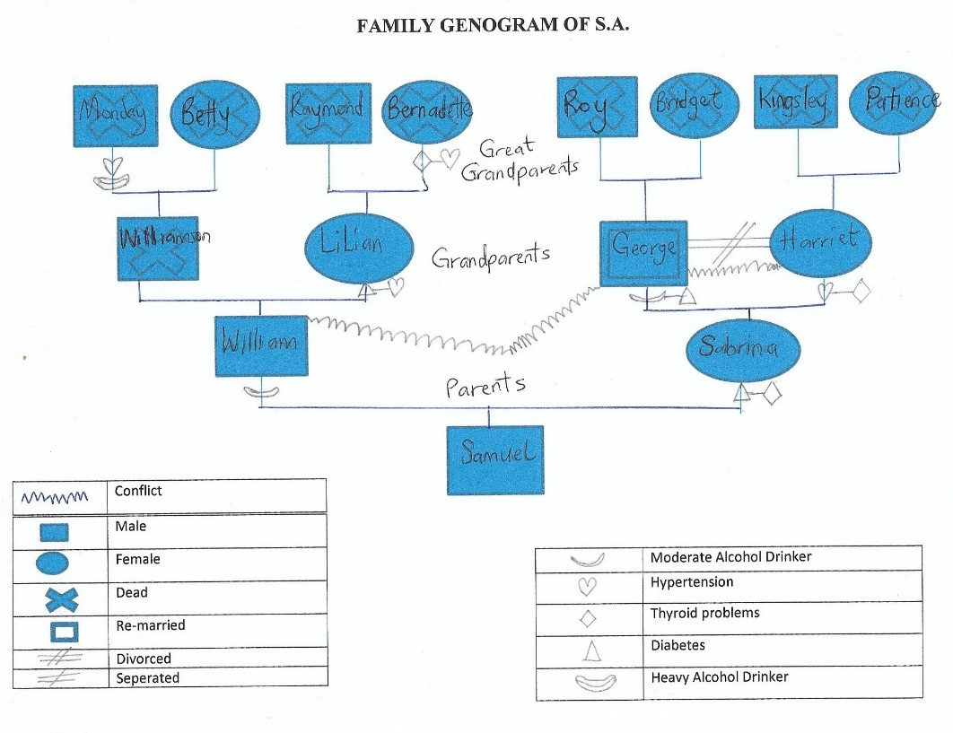
For the purpose of this paper, a three-year-old boy was observed, with his characteristic traits studies through his development, mannerism and personality to assess if the child’s development correlated with his personality. He was observed both in a clinical as well as home setting and his behavior was recorded for the purpose of assessment and evaluation. Th child in question seemed to be very inquisitive and interacted with his environment in an engaging manner. The child belongs to a family that hails from Nigeria in West Africa. They identify with the Yoruba cultural/ethnic group and migrated to the USA in 2004. They believe in Christianity and have no religious beliefs limiting their ability to receive any type of care needed or offered when sick. Children are expected to abide by the society’s rules and regulations. The behavioral expectations for the children are that they should be respectful, obedient, polite, smart, not engage in profanity, no stealing, no smoking, no indulging in criminal activity and associate with friends from good background. The genogram of the family the child lives with is as follows:

The first interaction of the child with the observer showed that the child was initially hesitant to interact with the stranger, although he was curious about this new person he was meeting and wanted to know more about her. According to Erik Erickson’s theory (Erickson & Thiessen, 2015), the child is in a psychosocial stage of development i.e. initiative vs. guilt. This showed that while the child was initially anxious and fearful of meeting a stranger, he was open to learning more and building trust overtime. The child also clung closely to his mother, which showed that he has some separation anxiety at the thought of being away from his mother. However, the child also showed some independence when his mother left to get some food and remained calm. Later, when the mother goes away to get the child some food, the nurse cautiously approaches the child offering her a toy and a book. However, the child refuses to take both especially since he notices that his mother is not around. He begins to cry and stops as soon as he spots his mother. This represents symbolic thinking and show that he has good cognition for his age and great gross motor skills.
In the second week of observation, the child has become more familiar with the observer and interacts with her by showing her his toy. He communicates in short sentences and according to Erik Erickson’s theory, the child is in a psychosocial stage of development i.e. initiative vs. guilt (Erickson & Thiessen, 2015). However, at this point it stems from the fact that the child initiates play. However, he needs to build his confidence and that is what the observer works on improving in the child. Although the child is easily distracted, he remains interested in the book the nurse is flipping through and is eager to learn the alphabets and the body parts the observer has named. However, he does not seem interested in the questions that the nurse asks, but still seeks her encouragement for doing something right. The child is seen to initiate activity, as well as the type of social interaction that he wants. Thus, the nurse supports the child’s choices in order to make him feel ambitious.
By the third week, the child has become more familiar with the observer i.e. the nurse. He seems excited to see her, and her bag of toys. He was observed to be in a playful and made eye contact with the nurse and sought her encouragement while playing with the toys. Analysis of the interaction showed Lawrence Kohlberg’s Pre-conventional stage (Kohlberg, 1985) when the child obeys and stops splashing water because he perceived there will be consequences of his action and he wanted to avoid being punished. The punishment would have been his inability to play with toys. The nurse calls the child by his first name when she arrives so that the child feels familiar to her and that he will be willing to cooperate. Unlike before, when the nurse asks who he was playing with, the child responds to her with his friend’s name. This shows that the child trusts the nurse enough to feel free to interact with her in any manner he deems fit. He also listens to her when he is admonished for splashing water everywhere and stops doing it immediately.
Upon visit on week four, the boy seems to be cranky and is crying when the nurse arrives. He is hungry and refuses to listen to his mother to brush his teeth first. Client’s speech is understandable. He can say very short sentences. Child tells mom I want cereal and goes to the cupboard to get his bowl. He then reaches to get the cereal he wants and attempts to pour the cereal but spills the cereal everywhere. The child’s mother asks him to brush his teeth before he can eat the cereal. Child cries when the pack of cereal falls and cereal spills perceiving he has done something wrong. Perceiving mom’s reaction, he moves away from the scene. Using Erikson’s theory to analyze this behavior, the child took initiative in trying to control his environment, he went to get the bowl for the cereal, and then tried to get his cereal (Erickson & Thiessen, 2015). Thus, the nurse observed child does take initiative in getting the things he needs to make his cereal and to see if he was able to get the cereal successfully. Children who experience guilty will feel like failures and be left with a sense that they are not good at many things. In this regard, the mom should have expressed that he made a mistake and find another way to teach him that brushing his teeth comes before cereal. Furthermore, the observer believes that the child did not listen initially because Maslow’s hierarchy of needs show that human beings feel the need to satisfy their physiological needs prior to anything else. The child’s physiological need in this case was hunger. With regard to his motor skills, the child attempts to brush his teeth but needed assistance unable to properly handle brushing his teeth.
By week 5, the child is very familiar with the nurse and greets her with the proclamation of it being his birthday that day, asking for presents. The nurse responds with a “No problem”, reaffirming that he will get lots of present on your birthday. The child is more comfortable and trusting of the nurse because of the consistency of visits. Children develop trust and familiarity as the relationship between care givers develops. Nurse shows child pictures of animals to name each animal, brings a doll and asks child to name the body parts which child does correctly. She puts him through a series of similar assessments and later the child is seen trying to mimic the nurse when he is playing with a child younger then himself. This child is in the pre-operational stage of Piaget’s theory (Piaget, 1976). He does not yet understand concrete logic and unable to take the view of others. He finds pretend play very interesting. He likes to use objects and pretend that they represent something else. The child’s cognitive skills are appropriate for his age.
During the last week, the child receives a new iPad as a gift from his parents. He is seen to be possessive about his gift and snatches it away from his brother when he tries to approach it. He even makes his little brother cry by pushing him down. According to John B. Watson, behavior can be controlled through positive or negative reinforcement. Modeling positive behavior can encourage positive behavior to be repeated while discouraging undesirable behavior. Furthermore, the child responds well to nurses questions but makes a fuss when he is reprimanded for pushing his brother. He has his iPad taken away and try a number of times to get it back. Child seems more upset about his brother taking his ipad than being punished by mom and doesn’t seems to realize that his action is what got him in trouble. Piaget explained that a child is not fully cognitively capable of understanding the relationship between cause and effect, or logical and abstract reasoning until at least age 6 or 7. Thus, the nurse demonstrates to the child how to make a request. Mom tells child to apologize to his little brother for pushing him down and making him cry. The child apologizes, but seemingly just to get his iPad back. However, putting the iPad completely out of reach or putting him in timeout would have been more effective.

Discussion
In order to study the child, various forms of assessment from the Denver Development Screening tools were used. This relayed the cognitive development of child and he was scored accordingly. Furthermore, the child characteristics were associated with psychological theories, which showed the reason why the child did what he did. Both these assessments were able to prove the fact that the child is developing in a normal manner psychological and is at the level of his peers in terms of his gross motor and cognitive skills. The child may exhibit an inclination of throwing tantrums and is used to getting things his way, however, these cannot be regarded as psychological ills as these are commonplace for a child his age. The child belongs to a big family, as is shown from the genogram attached, which may show why is slightly spoiled and refuses to share his toys and belonging with his brother.

Conclusion
There are a number of internal factors that influence a child’s growth, such as their personal characteristics, along with genetics. However, a child’s development involves a whole lot more than what arises from within an individual. The various factors that have a role to play in this regard, such as the relationships children have with their peers and other adults i.e. the social context, the culture the child is being exposed to as well as the socioeconomic conditions the child is being raised in. All three of these contexts constantly interact with one another and hence shape the opportunities the child is exposed to in future. Furthermore, it enriches the social associations with other people and at the same time give them a moral direction through cultural ties. This keeps imbalance at bay and allow them to grow into their own unique person with one of a kind characteristics (Piaget, 1976).
Understanding children is a huge undertaking. Not only is the field of psychology wide and deep but placing as child and his development in a certain sphere is nearly impossible. This is because of the given the number of factors that control their lives, as well as the influence these factors possess. A combination of these interactions defines the personalities of these children, labelling it as normal or otherwise. Thus, a solid understand of how children develop overtime, how they think and how his behavior correlates with child personality development theories is ideal to possess a deeper understanding of their development and help them be the very best versions of themselves in the future (Jirout & Newcombe, 2015).

References
Erickson, L. C., & Thiessen, E. D. (2015). Statistical learning of language: Theory, validity, and predictions of a statistical learning account of language acquisition. Developmental Review, 37, 66–108.
Jirout, J. J., & Newcombe, N. S. (2015). Building blocks for developing spatial skills: Evidence from a large, representative US sample. Psychological Science, 26(3), 302–310.
Kaufmann, T., Alnæs, D., Doan, N. T., Brandt, C. L., Andreassen, O. A., & Westlye, L. T. (2017). Delayed stabilization and individualization in connectome development are related to psychiatric disorders. Nature Neuroscience, 20(4), 513.
Kohlberg, L. (1985). Kohlberg’s stages of moral development. WC Crain, Theories of Development, 118–136.
Piaget, J. (1976). Piaget’s theory. In Piaget and his school (pp. 11–23). Springer.
Soto, C. J., & Tackett, J. L. (2015). Personality traits in childhood and adolescence: Structure, development, and outcomes. Current Directions in Psychological Science, 24(5), 358–362.

