Name of Student
Name of Professor
Name of Class
Day Month Year
“A Midsummer Night’s Dream: An Analysis of Theme and Thematic Development
“The Lunatic, the lover, and the poet are of imagination all compact.”
-William Shakespeare
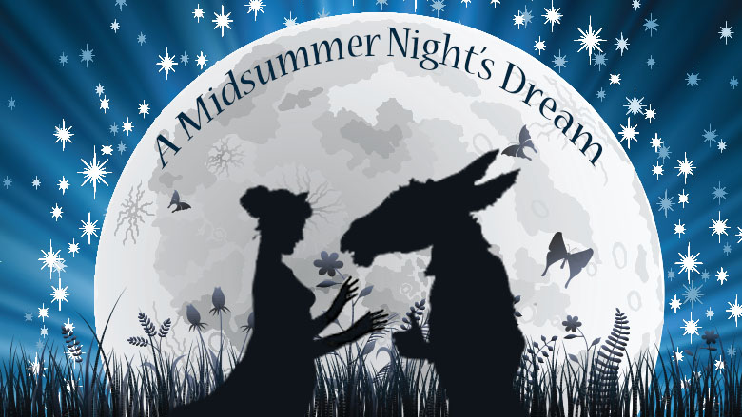
The following paper analyzes the underlying theme of "A Midsummer Night's Dream" and also highlights the significance of Hermia and Lysander in the context of the development of thematic expression of the play. "A Midsummer Night's Dream" was originally written in 1596, by most celebrated playwright William Shakespeare, and is considered as the finest comedy play in history. John Geoffrion (2018) says that “A Midsummer Night’s Dream” might just be Shakespeare’s best known comedy.” Throughout the play, a wedding ceremony (of Theseus and Hippolyta) is elaborated, through which four leading characters and their stories are artistically incorporated to the plot. The subject play portrays a love quadrangle, according to the formation, Hermia has two suitors; Demetrius and Lysander, she wants to marry Lysander but his father tries to imply a wedding bond with Demetrius. On the other hand, the fourth character named Helena loves Demetrius. The interconnectivity of dispositions and their situations made the love a main theme of the play. In the following, theme and its developmental connection with characters of Hermia and Lysander is elucidated in a precise manner.
Phenomenally, "A Midsummer Night's Dream" is an intricate play, and is written very slyly by incorporating a myriad of characters, and therefore it becomes like Russian nesting dolls and depicts the quality of a play that features several plays in it. The vast horizon of plot allows the play to indulge in numerous themes such as love, difficulties of affection, men and women, as well as dreams and supernatural phenomena. However, the theme of love surpasses other themes and becomes the most eminent aspect and guiding light of the subject play. Throughout the play, the theme of love is evident from the actions of its leading and even side characters. From Helena to Hermia, Lysander, and Demetrius as well as Oberon, Titania and Bottom, Hippolyta and Theseus all are presented in the form of lovelorn folks. Nevertheless, the play demonstrates a love that is a bit unique in way of its depiction as it is not overwhelmingly tragic, passionate, or emotional but rather a bit comical. In fact, Shakespeare attempts to present the infliction of love that can make a normal human imprudent, frantic, and unpredictable, and of course blind (figuratively).
"A Midsummer Night's Dream" is auspiciously laden with characters but the role of Hermia and Lysander is leading in developing the main theme of love. Through the subject dispositions, Shakespeare intents to reflect the light side as well as the difficulties of a single emotion that is called love. Lysander says "the course of true love never did run smooth" (1.1.134), and in due course, they bear the objections of their guardians and confront the peril of exile and even death. Throughout the plot, Hermia and Lysander portray a substantial stubbornness in order to get their lovers, Lysander temporarily attracted to Helena, but it happens under the effects of magical love potion. Regardless of carrying a lighthearted tone, "A Midsummer Night's Dream" underlines the rocky route of love through endeavors and courage of Hermia and Lysander on the path of true love. Furthermore, it was the obstinacy of both characters that created the potential of the occurrence of asymmetrical love in first place. As per rule, Demetrius is the rightful suitor for Hermia, but yet, the love of Lysander makes her become a rebel to her rituals, traditions, and even from her father.
Not only symmetrical love but also the chaos of love-potion and confusion between lovers feature the involvement of both leading characters; Hermia and Lysander. The love compels both to run away together, and the love of Helena for Demetrius enforces her to spill the beans about the elopement of Hermia in front of him. Here comes the drama. When enraged Demetrius chases love-birds, Helena follows him as well and eventually they cross the boundary of Athens, and enter into the kingdom of Puck and his master, which is the monarch of fairies and called Oberon. At this point, Helena blurts out her affection for Demetrius and he rejected her plea in the rudest manner. The complexity of love issue tickles Oberon and consequently the ado about magical love potion takes place, and the fumbled emotions augment the confusion to an exacerbated extent.
The characters of Hermia and Lysander are indispensable and crucial, because they are the only protagonists which are truly in love with each other. There is no instance of real love throughout the subject play except both. However, their love becomes forbidden for them because nor Hermia's father neither Theseus support the idea of their marriage, but yet they are actually in love, and therefore they heed no attention on the warnings of their elders. However, Hermia's father accuses Lysander to enchanting her daughter and used to say that "the man that bewitched the bosom of my child" (27, 31-2), but yet such blames never impacted the immensity of Hermia and Lysander's pure love.
By analyzing the above-given content regarding theme and characters' significance of "A Midsummer Night's Dream," it becomes evident that love is the fundamental essence of the subject play. Moreover, roles of Hermia and Lysander assist the mentioned thematic expression to develop full bloom and infuse profoundness through their unique and true bond. Nevertheless, it is a comical play, yet the twist and turns of love-based intricacies are somehow demonstrate the probable dilemma of being in love, and assert that love can bring unlimited chaos with it.

Work Cited
Geoffrion, John, and John GeoffrionJohn Geoffrion. “Review: A Midsummer Night's
Dream,Performed Midsummer in the Open Air.” DC Theatre Scene, 30 July 2018,
dctheatrescene.com/2018/07/06/review-a-midsummer-nights-dream-performed-midsumme/.
Shakespeare, William, 1564-1616. A Midsummer Night's Dream. New York :Signet Classic,
1998.

