Leadership Development
[Name of the Writer]
[Name of the Institution]

Leadership Development
Table of Contents
Executive Summary 3
Background and Analysis of Business Need 4
Overview of the interventions 5
Learning Theory 7
Evaluation of the Development interventions 9
Level 1 11
Level 2 11
Level 3 11
Level 4 12
Transfer of learning 12
Employee Characteristics 13
Training Design 13
Work Environment 13
Cost and Projected Benefits 14
References 16
Appendix I 18
Appendix II 19
Appendix III 20
Appendix IV 20

Executive Summary
Organization is an amalgamation of different ideologies that collectively make up the working place. There are some necessities that must be fulfilled in order to create a homogenous working environment. Within the realms of an organisation, a leader plays the most crucial role, he is more like an orchestra head that helps others to achieve the required goals. The assistance of a leader is not possible without communication because inadequate communication or gap in communication can lead to misunderstood ideas and mitigated professionalism. It would not be wrong to say that communication plays a central role in the engagement of employees in an organization so that they can share knowledge, ideas and experiences. Communication is itself a diverse idea, taking into account that it paves the way for promotion of motivation, support socialization, alter the attitude of individuals and it is an equal source of controlling the unrequired actions. Woodward, (2019) has highlighted that the organization where there is effective communication between employees is 8 times more practical and successful that the other companies in which employees face barriers in communication. (Woodward, et, al. 2019, pp. 71-87).
Taking into account the task of designing a leadership development plan in which employees would be trained in terms of communication and leadership skills, “Coaching Skill for Manager course” will be formulated in which training and recommendation for effective communication would be given in order to promote collaboration, sustainable management and development. The aim of the plan would be to infer "Culture Change", taking into account strategies concerning with development and learning. Major objectives of this training session would be
- Initiative effective and adequate communication in the organization
- Train and educate managers so that they can utilize the development and learning opportunities within an organization
- Initiate and empower coaching culture for sustainable development
In order to create leadership plan, ten managers will be chosen belonging to different departments taking into account that each of the managers would serve as a stakeholder of the department in the learning session as well as a cultural leader in the department. The leadership plan will comprise of the training session and other learning opportunities that could expose managers to the challenging and complex projects taking into account that andragogical learning theory, action learning theory and other learning platforms would be used to make it equally effective. The aim of the plan is to prepare and train managers with subject tools and resources adhering to drive a change in an organization and create a culture that can empower learning. The ultimate outcome of this plan is to improve communication, empower learning opportunities, re-establish bonds of communication and learning within an organization.

Background and Analysis of Business Need
With increasing competition in the timeline of business, employees are one of the greatest assets, taking into account that an organization has to make numerous efforts in order to retain the employees. Learning and knowing is a continuous process because it is the responsibility of an organisation as well to make efforts that can make an employee learn. In accordance with the subject organisation, there are a number of employees who actually belong to a different culture and they have an entirely different spectrum towards learning and knowledge. (Subramony, et, al. 2018. pp.120-129). For such employees, it is necessary to organise learning and training session so that they can overcome the gaps and play their part in the organization. These objectives can only be achieved by adhering to core principles of Human Resource Development. There are four main stages of human resource development, termed as, Investigation, Design, Implementation and Evaluation. It is significant to note that the practical implication of the HRD program cannot be achieved without the analysis of the needs of an organization. In order to get information regarding the needs of the employees and the organization, Human Resources Development Need Investigation would be conducted. (Shamir, et, al. 2018, pp. 51-76).
In order to proceed with Human Resource Development Need Investigation, focus group discussions would be made, taking into account that managers would be collecting data from their specific departments with mutual collaboration so that those needs could be addressed in the training session. (Raelin, et, al. 2018). It will also include collecting information about the type of training and guidance that the employees want to be added to the training. After an analysis of the focus group discussions, results would be analyzed manually so that action plan could be formulated. (Raelin, et, al. 2018). The analysis of the results highlighted the following points
- Many employees highlight ineffective communication channel
- There is a lack of reflection that could motivate employees
- There is a lack of attention towards employee engagement and learning opportunities
All this information will lay down the foundation of learning and development plan.

Overview of the interventions
In order to develop a successful leadership program, it is necessary to connect learning outcomes with the learning strategies and assessment. It is significant to note that the aim of learning outcomes is to articulate abilities with required knowledge and skills that are the ultimate goal by the end of program. The leadership development plan will have a sole aim of considering the needs of the organisation, parallel to the needs of the employees so that plan is developed in such a way that there is a synchronization between the set goals and availability of the resources. (Dion, et, al. 2019).
Mustafa, (2019), has asserted that the organization can achieve cultural change by the use of action learning theory taking into account that it will engage both organization and individuals by making them work in groups also known as action sets. The aim of formulating such groups is to solve organizational problems. (Mustafa, et, al. 2019. pp.77-91). It allows individuals to solve problems by working in groups and create solutions to their problems themselves. These sets would be a tool to incorporate cultural change because communication would be supported and individuals will assist one another in performing their jobs.
The plan will be initiated with an introductory session by the CEO of the organization. He will address the trainees and highlight the aim of training. CEO will highlight the factors required from both sides, trainees and trainers in order to achieve the set goals. The required expectations and future of training will be shared taking into consideration the current status and status after the successful completion of training. After the introductory address, proper training pattern would be followed. The first section will proceed by making two groups in which each of the group will be given the task to address the topic of cultural change. Each group will have to find out the cause that paves the way for negative identification and gap in the adequate working of the employees adhering to cultural realms, and then practical and workable solutions would be suggested by each of the group that they wanted to be included as part of organisational behaviour. Employees would be made to work randomly and in crossed groups so that they can share both knowledge and experience. The aim of this session is to practice and impart the essence of being a manager, highlighting that a manager should have all the competencies that can help others feel a part of the organization by assisting them. It would not be wrong to say that a manager should have certain skills of coaching, inclusion diversity and leadership skills. In order to infer the practicality of these skills, the GROW model will be used along with role play techniques so that employees can feel engaged both physically and mentally.
Understanding of diversity and catering to diversity is also one of the major objectives and it would be fulfilled by making employees have a session regarding diversity. Each of the employees will reflect and demonstrate biases and strategies that could address these biases. After that there would be a meeting of CEO with each of the participants at different times, taking into account that each of the employees will serve as a stakeholder and representative of his department. The program will end at a panel discussion in which employees will give certain suggestions and other information that could increase workability in an organization. After that, there would be a concluding session by the CEO along with dinner. Employees would be asked to reflect on what they have learnt and how the training session has contributed to their understanding of employee management and leadership. In a nutshell, the program will conclude on a review session in which each employee will reflect what they want to be improved or the narration of the unaddressed aspects taking into account that further implementations can be made.

Learning Theory
Action Learning Theory is defined as leaning strategy that emphasizes learning by analyzing the crux of learning. Learning Theory is actually a theory that allows trainees to work by adhering to the core principles of practicality. It is also defined as a facilitator that could allow the transfer of learning by using sets of groups. (Clapp-Smith, et, al. 2019. pp.10-34). The groups are made to work on the projects under study and certain issues related to problem-solving that are relevant to the organization. It allows the participants to undergo an analysis of the platform by making the groups and other sets to support unstructured sets in the stages of the action learning program. Learning Development Program allows a manager to analyse different settings involving complex situation and other issues by using different strategies such as discussions and other review methods to discuss ideas and challenges and provide learning opportunities to empower the working of the employees such as bringing about a change in the culture. (Dion, et, al. 2019).
Critical Thinking is a platform that can be utilized in order to incorporate experimental learning adhering to programme knowledge for managers. It includes analysis of different issues and presents different solutions that can reveal the organisational issues and then required goals can be achieved. It is significant to note that the sole aim of this platform is to assert possible solutions to organizational issues. It is highlighted that the aim of such platforms is to highlight the underlying issues and resolve them, taking into account the emotional and practical support from the facilitators and peers. (Koka, et, al. 2019). It is significant to note that the setting of such platforms is complex and challenging taking into account that it requires the learner to engage in the activities that can ignore analytical, reflective and explanatory ideologies along with other attributes to impart emotional intelligence. (Mc Carthy, et, al. 2019. pp.245-255).
It is asserted that by the conclusion of Learning Development Plan, the constructive alignment would be achieved between the set goals and the learners taking into account that such changes can be made that are competent with the set objectives. It is more added that structured learning will also be used as a tool that could impact certain set of learning programs among adults. It is significant to note that structural learning would be designed by using instructional methods, facilitating learners about what is the aim of material that would be taught and how more practical approach can be applied to whatever is learnt. Adult learning is also a concept that is much close to the structural learning and it can be used to solve the problems taking into account that if a problem is successfully solved then certain intrinsic and extrinsic awards are given. It is asserted that the aim of this practice is to incorporate such goals that can impart clear cut rules and dimension to achieve the desired goals. It is important to note that the aim of such goals is to infer helpful strategies. It is highlighted that there are certain set attributes to which a trainer would adhere such as, the necessity of learning, self-conceptualization, pre-operation and positive enforcement of learning and the orientation to incorporate learning that can help a trainer to achieve the desired goals. (Shamir, et, al. 2018, pp. 51-76).
In a nutshell, it can be highlighted that both theories, action learning and andragogical model is a potent tool to incorporate learning and make efforts to achieve the set goals,

Evaluation of the Development interventions

Evaluation is one of the major steps that can help and assess either set goals are achieved or not. It is also a major tool to identify the strengths and weaknesses related to specific learning intervention. It is significant to note that evaluation is a major tool to measure the impact of newly learnt strategies and skills to the requirements of a workplace. It is an opportunity of offering feedback that could improve the core structure by modifying goals and reach out to internal and internal stakeholders. Although evaluation is the most neglected tasks taking into account that organisation find it much time consuming and hard to evaluate things, side by side, many of the organizations find it financial adhering to taxing and other complexities. It is significant to note that evaluation is one of the most reliable options that can incorporate the required goals and measure the success of an organization.
In accordance with the directions of HR developer and CEO, Learning Development Program would comprise of seven steps and it will be a five-month training session. Different opportunities such as role plays, discussions, panel discussions, group elaborations, action learning and reflective evaluation will incorporate the set goals within the realms of an organizational framework. See Appendix II. It is important to note that none of the training sessions can be successfully completed without adhering to the set rules of training such as availability of the resources and the appropriate ratio of the trainees. (Dion, et, al. 2019). After deciding numeric, the choice of participants also plays a significant role in the effectiveness of training. It is asserted that employee from different departments should be included in the training so that diversity can be assessed side by side there would be cohesiveness between the employees and the departments, highlighting that knowledge can be shared between the groups.
Kirkpatrick Model is another approach that can be used for the evaluation of the Learning Development Plan because it will assert a simple and practical framework that would be applicable to a number of settings and platforms. (Sosik, et, al. 2018). See Appendix I This model can be applied to a number of setting such as government, health, military and business entities. The multi-level and sequential framework impart guidance in terms of evaluation. This approach is asserted in terms of certain stages such as reaction, learning, behaviour and results. It is significant to note that Learning Development Plan is more like an approach that provides holistic analysis from the commencement of the project to completion accompanied by rich feedback that can covey strengths and weaknesses. There are three levels of evaluation of the Kaproicks Model.

Level 1
This level will result from the collection of qualitative data that would comprise of the information collected from the set of groups by the need of learning session by using post-session questionnaires and other reviews that could add to the satisfaction of the results. In this stage, feedback is given to adjust the course of content and other techniques of learning that are necessary for the achievement of desired goals. It is a one-way procedure in which the trainees can help to modify or shift the stance of the material and other accessories that are used by the trainer.

Level 2
It is the second stage of evaluation, taking into account that will ensure evaluation would be successful only with the evaluation of the qualitative data of pre and post-training skill test and other objectives of the written tests. In this stage, the participants will be given some concrete platform so that they can share their feedback and provide concrete written and oral skill-based assessment in order to identify the current skills, attitude and knowledge of the participants that could be a source of measuring the increased learning. It is asserted that the success of any project can be made by the analysis of the action of the participants such as if the participants will repeat whatever is assigned to them in the most directed and feasible form. It is more like a repetition of level 1 but it is a more modified form where there are pre-planned tests and a simplified qualitative and quantitative data is provided.

Level 3
It is one of the most difficult section to evaluate taking into account that there is great complexity in the collection of data and uncertainty when a change will occur in the realms of a workplace. It is significant to note that the validity of the data is one of the major tools in the effectiveness of the training session. This step is a more complex form of evaluation as compared to level 1 and level 2, taking into account that it involves the collection of techniques to indicate a change in the culture of the workplace. Such techniques include using pre and post-training performance appraisals and feedback forms. This evaluation is made effective by the inclusion of online surveys of the department managers in order to make observations and independent analysis of the behavioural change that is the result in behavioural change in the workplace.

Level 4
Level 3 is then proceeded by level 4 which is considered even more difficult than the level 3 taking into account that time constraints and complexity of the data analysis taking into account that the same measures are employed to assess the changes in the participants It refers to both pre and post Human Resource Development Need Investigation measures in order to know the change in terms of culture, communication and approach towards the productivity. It is significant to note that the features of business analysis will be added to seek and know changes that can highlight the strengths and weaknesses along with the value of investing in the Learning Development Plan. In a nutshell, it is highlighted that the sole aim of certain measures and these levels of evaluation is to indicate the hidden attributes that can highlight strengths and weaknesses.

Transfer of learning

Transfer of learning is the core ideology behind any learning plan taking into account that despite a lot of intervention, knowledge and abilities of the workplace, there is no apparent change and modification in the collective results. It is inferred that there are a number of cases in which the aim and objectives of the training are not fulfilled. According to research, the measure of the transfer of learning within an organization is only 20 to 25%, where ample money is spent on the achievement of certain goals. (Shamir, et, al. 2018, pp. 51-76). It is significant to note that learning theory and learning plan can only be treated as a successful approach only if there are certain changes observed in the overall setting and there is an evidence of the application of techniques. It is asserted that the sole aim of learning transfer is not just to transfer whatever is learnt in fact it is a stance to bring a shift in the behaviour and cognitive skills taking into consideration that it can improve employee’s performance along with a change in the organizational culture.
It is asserted that there are a number of factors that influence learning transfer and they are classified into three major categories

Employee Characteristics

It refers to the inclusion of attributes such as motivation to learn, characteristics of the employees and work environment taking into account that it has a direct influence on the working efficiencies of the employees.

Training Design
Training Design highlights opportunities that can infer opportunities for the modelling of behaviour, discussion regarding the application of certain attribute in the workplace using content that is relevant and helpful to achieve the desired goals.

Work Environment
It is another aspect that plays a major role in the analysis of the transfer of learning because a positive workplace can transfer learnability environment in which both managers and peers will support each other in order to apply to learn and achieve desired goals.
It is highlighted that the collection of these factors will not only be relevant to adult learning, in fact, it is also a stance that can incorporate the transfer of learning by adhering to the set pattern of strategies and techniques. All these factors can play a significant role in the analysis of the strategies and techniques that are used for achieving set goals from the program design. There are different stages in the training program and each stage reflect a different ideology, taking into account that the CEO session will highlight the engagement of participants by explaining their feedback and final review with an aim to empower self-efficiency and goal setting. It is important to know that the GROW model and role plays also play a significant role in the transfer of learning. Role plays are a tool to practice new behaviours by the achievement feedback when an individual is made to act in a particular stance of the role. Role plays are a major tool because it infers real-life situations that can help develop self-efficacy. GROW model, on the other hand, increases the transfer of knowledge in the workplace by building the desired coaching culture. It is asserted that evaluation also facilitates transfer or learning because participants will focus on the learned behaviour and opportunities that can impart the desired behaviour. (Shamir, et, al. 2018, pp. 51-76).

Cost and Projected Benefits
Cost and projected benefit is an illustration of the idea that connects the aim of the project to the availability of the resources. Traditionally, it is assumed that a lot of investment is required for the execution of the training program. It is significant to note that both direct and indirect cost will be engaged in the execution of training taking into account that the CEO has to shun his normal routine in order to participate in the training session because the participation of CEO is necessary to reinforce productivity and an analysis of the goals. Another indirect cost is the inclusion of ten managers taking into account that the involvement of these managers will also a negation of the daily work routine. It is one of the significant cost factors because the employees will learn new skill and ideas that can add to the productivity of their work. It would not only communicate the skills but it will also identify the area in which the organization has to put in more efforts in order to achieve the required results. The training of the employees will be more like a revival of knowledge in the organization because the employees will forward the learnt skills to their departments and it will be an ultimate profit to the organization.
An analysis of the direct cost highlights that “inclusion of external trainer” would be one of the major expense to the organization. It is necessary to hire an external trainer so that the gaps within the organization can be overcome by certain strategies and opportunities. Although it is a cost factor, still there are a number of benefits that are associated with hiring external trainers taking into account that it will pave the way for the development of training schedule within an organisation and it will facilitate the upcoming recruitment of the organization. It is also important to note that the invitation of an external trainer is a platform to unite the stakeholders and managers for the realization of the necessity of the training program.
Evaluation cost can be analyzed in terms of four major stages such as investigation, designing the platform, implementation of the set goals and adequate methodology and the evaluation of applied strategies to know the effectiveness. These four stages outline a complete procedure of Learning development plan as well as the management of the steps that are to be taken in order to facilitate employees.
Investment is an undeniable part of any training plan, taking into consideration that the total investment of the leadership development program termed as, "Coaching for Managers" is $28,088. It includes the cost that is required for all set goals and necessities such as resources.

References
Clapp-Smith, R., Hammond, M.M., Lester, G.V. and Palanski, M., 2019. Promoting Identity Development in Leadership Education: A Multidomain Approach to Developing the Whole Leader. Journal of Management Education, 43(1), pp.10-34.
Dion, S., 2019. Leadership Development in a Virtual Work Environment.
Koka, S., Mutluay, M.M., Garrett, N., Felton, D. and Avivi-Arber, L., 2019. Leadership education in prosthodontics: Development and impact of the Future Leaders in Prosthodontics (FLIP) workshops. The Journal of prosthetic dentistry.
Mc Carthy, V.J., Murphy, A., Savage, E., Hegarty, J., Coffey, A., Leahy‐Warren, P., Horgan, A., O'Connell, R., Marsh, L. and Drennan, J., 2019. Development and psychometric testing of the clinical leadership need analysis (CLeeNA) instrument for nurses and midwives. Journal of nursing management, 27(2), pp.245-255.
Mustafa, S., Farver, C.F., Bierer, S.B. and Stoller, J.K., 2019. Impact of a Leadership Development Program for Healthcare Executives: The Cleveland Clinic Experience. Journal of Health Administration Education, 36(1), pp.77-91.
Raelin, J.A., 2018. Leadership Development in the Collaborative Era.
Shamir, B. and Eilam-Shamir, G., 2018. “What’s your story?” A life-stories approach to authentic leadership development. In Leadership Now: Reflections on the Legacy of Boas Shamir(pp. 51-76). Emerald Publishing Limited.
Sosik, J.J. and Jung, D., 2018. Full range leadership development: Pathways for people, profit, and planet. Routledge.
Subramony, M., Segers, J., Chadwick, C. and Shyamsunder, A., 2018. Leadership development practice bundles and organizational performance: The mediating role of human capital and social capital. Journal of business research, 83, pp.120-129.
Woodward, I.C., Shaffakat, S. and Dominé, V.H., 2019. Uncovering, Understanding, Unleashing, Overcoming: Exploring Drivers and Blockers in Leadership Development Practice. In Exploring Leadership Drivers and Blockers (pp. 71-87). Palgrave Macmillan, Singapore.

Appendix I
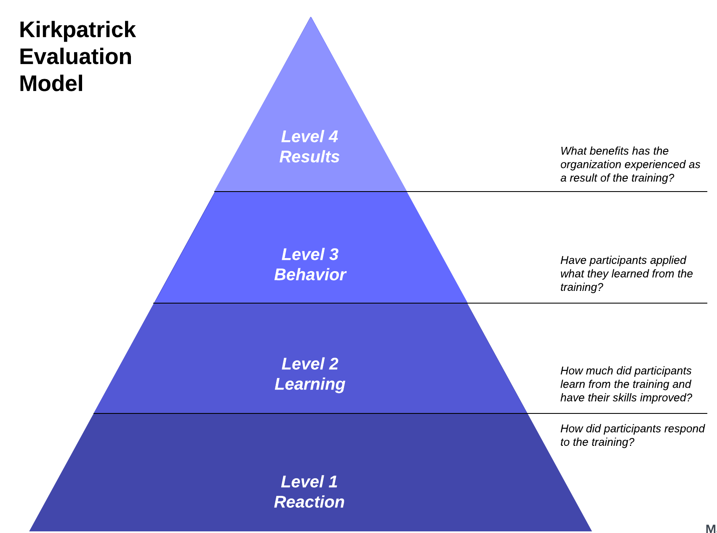

Appendix II
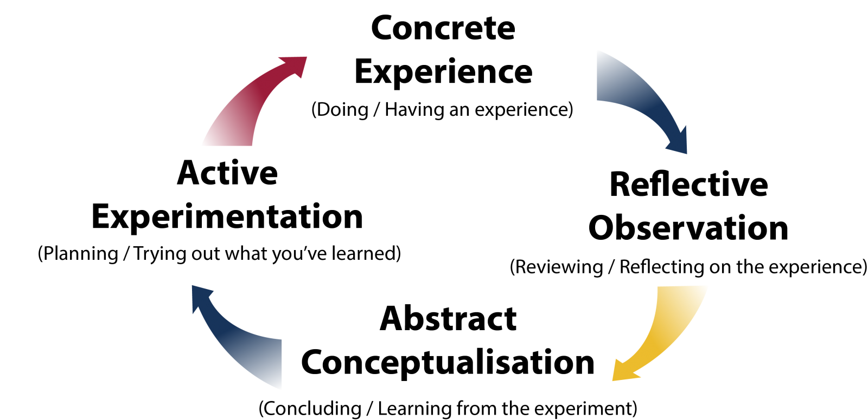

Appendix III
Leadership Development Program
Session | Action Learning Set | Time
Session I | Introductory session by CEO. | 8 Hours
Session II | Demonstration of “Communication and leadership skills”. Orally and the use of presentation slides | 8 hours
Session III | Coaching at the internal venue by using the GROW model | 8 Hours
Session IV | Internal venue session of complications that employees may face while business communication | 4 hours
Session V | Addressing organization diversity with learning sets | 4 Hours
Session VI | Speech by CEO at an eternal avenue, dinner and suggestions and review | 4 Hours

Appendix IV
Single Session Plan
Session I
Learning Objectives
- Effective communication
- Addressing diversity and employee management
- Organizational culture and homogeneity
Resources
PowerPoint Presentation Slides
Flashcards
YouTube Videos
Note Pads
Time | Topics for discussion | Action
09:00 – 09:30 | Introduction
09:30 -10:00 | Communication and complications in an organization | What is communication, how to do effective communication  Group discussion regarding biases in the workplace
10:30 – 11:00 | Break for tea
11:00 - 11:45 | Employees and Employers | Culture of organization  How employees are crucial to the organization  Role of employers in maintaining the culture of an organisation
11:45 – 12:15 | Organisational Behaviour | Using motivational video and a story  https://www.youtube.com/watch?v=GVG4wgCqeEQ
12:15 - 01:00 | Lunch Break
01:00 – 01:45 | Learning theories in an organisation | Action Learning and Andragogy in Practice: Clarifying the Andragogical Model of Adult Learning
01:45- 03:00 | Gaps in organizational culture and how to address them | Discussing biases and giving solutions to them
03:00 - 04:00 | Winding up and Evaluation | Suggestion, reviews and casual discussions

