Vila Health: Patient Care Planning
Jessica Williams
[Institutional Affiliation(s)]

Author Note

Vila Health: Patient Care Planning

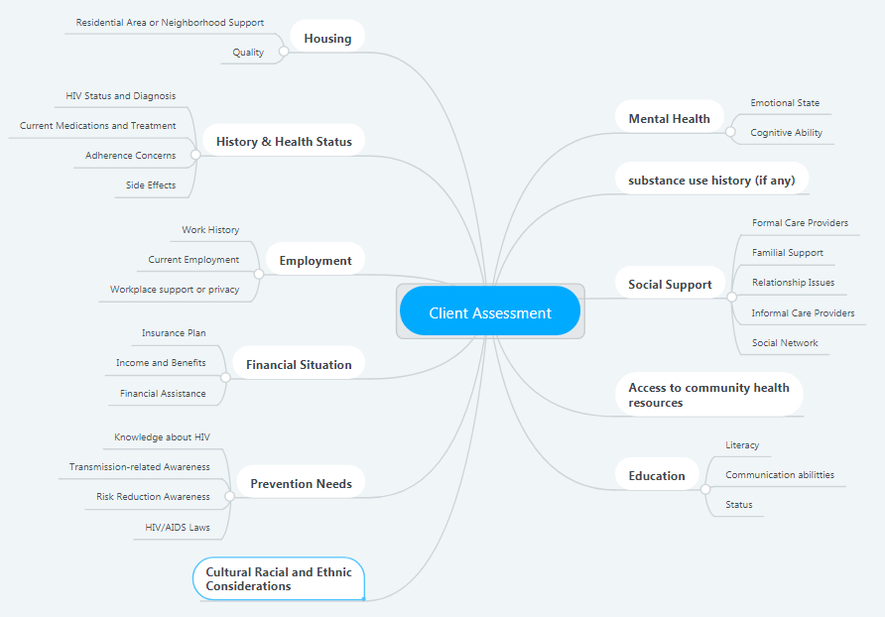
Concept Map

Client assessment is an essential part of care coordination in which information is collected, synthesized, analyzed and prioritized to identify client’s needs, strengths and resources to develop an appropriate care plan. In the case of Melissa, inquiring about her health and social status provides useful information about her physical abilities, mobility, sensory and cognitive abilities as well as mental health provides information to her care providers to tailor her treatment plan to address her individual needs. Information about her cultural background provides insight into her affiliation, interests, and upbringing using which health providers and caregivers can respect her autonomy give culturally sensitive recommendations according to her particular needs (IDPH, 2018). Her employment and housing information provides useful information regarding her self-care ability and access, while her education provides information about how quickly she would be able to understand her condition. Any significant variations from normal can be detected, and the care plan can be modified accordingly. Moreover, these elements help the care provider understand whether the patient is aware of the key issues and the processes involved in the continuum of care. Her information about community resources and access to them assists in developing a plan that can enhance Melissa’s ability to cope with the disease and maintain her quality of life, utilizing these services.

Executive Summary
Care coordination is a complex process involving organization of all care related activities between the responsible caregiver and the patients covering all the different aspects of services that the patient will access. A major component of care coordination involves reconciling the patient’s medication, managing their histories and problem lists, scheduling and coordinating their appointments, checking care gaps, transitioning, as well as providing social and psychological support.
For this purpose, a major portion of care coordination involves dealing with information from patients, families, care providers and healthcare organizations, in which multiple information systems and caregivers are usually engaged. This is precisely why the accuracy of the obtained data is important because any data delays or gaps, conflicting results, differences in information structure or in coding systems may increase the complexity of care provision. Thus, it is vital for care coordinators to ensure that all information is accurate since any failure can lead to costly mistakes (Majeed, Car, & Sheikh, 2008). The accuracy of information will ensure that Melissa is provided the right plan to manage her HIV. Since she has some prior misinformation regarding her condition, therefore providing the patient with accurate information is also a critical part of the care coordination process.
Melissa's treatment involves multiple medications and therefore the correct diagnostic data related to medication lists, problems or allergies are critical for care providers to take the right therapeutic decisions. The accuracy of data also allows for optimizing and tailoring patient care according to Melissa's individual requirements while it also contributes to the collective data archive that helps care providers to discover new correlations or ways to improve treatments and patient care (Samal, Hasan, Venkatesh, Volk, & Bates, 2018). For Melissa, taking medication exactly as prescribed is important since the wrong combination or timings could potentially lead to drug resistance, side-effects or other complications. It requires that accurate information about her is available in order to carefully devise these medication plans and rules that she has to follow.
Besides the collection of accurate data, it is also equally important to safeguard its integrity and maintain the patient's privacy as much as possible within the continuum of care. This requires carefully balancing the collection, dissemination, analysis, and use of Melissa's data with her individual rights to confidentiality and privacy. Relevant ethical principles and cultural norms should guide any decision making with regards to the dissemination and appropriate use of her data. This requires carefully balancing between protection from harm and maximizing the benefits when making use of the data, safeguarding its integrity from any inadvertent, inappropriate or malicious exposure of her individually identifiable data (Beck, Gill, & Lay, 2016). In Melissa’s case, using her data to identify her partners to protect them from infection is important but so is respecting her confidentiality wishes regarding disclosure to her ex-husband.
For this, appropriate organizational procedures should be adhered to safeguard her data when it is used, disseminated, transferred or disposed of, that apply to both electronic systems and paper-based data. Some of the main threats to data's integrity and safety include financial identity theft, data snooping and medical identity theft, especially when care coordination relies on EHRs. Providers are responsible to ensure that all EHR data remains secure, which requires them to strictly adhere to encryption protocols, access controls, audit trails, and HIPAA security and privacy rules (Figg & Kam, 2011). These measures can ensure that organizations are able to confront threats to the patient's data with regards to their safety, privacy, and integrity.
In this regard, care coordinators are recommended to review and identify all applicable guidelines and make sure that security and information confidentiality goals are clearly identified and meet safety requirements. They should also approve and review data related guidelines within their organization, and validate the effectiveness of their data security and confidentiality policies. Furthermore, they should advocate and provide support for any resources needed to improve data confidentiality while initiating or approving programs and plans to maintained and create data-security awareness. Care coordinators must ensure that the implementation of these information-confidentiality and security-related controls is synchronized across different levels of the organization (UNAIDS, 2007).

References
Beck, E. J., Gill, W., & Lay, P. R. (2016). Protecting the confidentiality and security of personal health information in low- and middle-income countries in the era of SDGs and Big Data. Global Health Action, 9, 1-7. doi:10.3402%2Fgha.v9.32089
Figg, W. C., & Kam, H. J. (2011). Medical Information Security. International Journal of Security, 5(1), 22-34. Retrieved from http://citeseerx.ist.psu.edu/viewdoc/download?doi=10.1.1.740.8786&rep=rep1&type=pdf
IDPH. (2018). Care Planning, Principles, and Services. Des Moines, IA: Iowa Department of Public Health. Retrieved from https://idph.iowa.gov/Portals/1/Files/HIVSTDHEP/case_management_standards.pdf
Majeed, A., Car, J., & Sheikh, A. (2008). Accuracy and completeness of electronic patient records in primary care. Family Practice, 25(4), 213-214. doi:10.1093/fampra/cmn047
Samal, L., Hasan, O., Venkatesh, A. K., Volk, L. A., & Bates, D. W. (2018). Health Information Technology to Support Care Coordination and Care Transitions: Data Needs, Capabilities, Technical and Organizational Barriers, and Approaches to Improvement. Boston, MA: Brigham and Women’s Hospital. Retrieved from http://www.qualityforum.org/Publications/2012/02/Care_Coordination_Commissioned_Paper.aspx
UNAIDS. (2007). Guidelines On Protecting The Confidentiality And Security Of Hiv Information: Geneva, Switzerland: United Nations AIDS Program.

