Marty
Professor
Course
12 March 2019

Title: Car Research Project
As a vehicle is being driven, a number of dynamic forces are acting upon it. Any change in the direction or speed of the vehicle exerts forces on the tires first, which transmit braking, motive and lateral forces to the vehicle’s system, and thus determines the dynamic loads acting upon it. In this paper, the maximum torque which could be exerted on the tires by a 1997 Toyota corolla, and the forces that could be exerted by the tires on the road will be analyzed and discussed, along with the RPM and acceleration of the car during the process.
Maximum Torque Exerted by Car on Tires
When a vehicle is being driven, its acceleration reaches its highest potential at peak horsepower RPM. This holds true during all shifts except the first gear, since a higher acceleration is possible through downshifting except for the first gear. The torque being applied on the wheel is a function of the engine’s torque, the differential ratio and the gear ratio. Upon reaching torque peak, the vehicle is able to generate greater acceleration than any other point.
Under ideal conditions, there would be no slip in the torque converter or the clutch, and it is assumed that all of the engine’s torque is transferred to the gear box and the differential without losses, and thus the wheel torque is proportional to the engine torque and the gear ratios. The source of torque is the engine itself, while the torque converter in the 1997 corolla’s automatic transmission connects the engine to the gearbox. The torque converter is lock-up, clutch closed and experiences no slip. In this condition, the torque at the gearbox T_{g} is a function of the engaged gear i_{x} and the engine torque T_{e.}
The torque is transmitted through the propeller shaft to the axle. The torque at the differential T_{d}, is the gearbox Torque, T_{g} multiplied by the final drive ratio i_{o.} Moreover, the engine power splits between the two front wheels of a front wheel drive car such as the 1997 Corolla. Assuming that the 2 wheels have equal RPM and the driven vehicle is moving in a straight line, the differential torque T_{d} also splits equally into two for each wheel. Therefore, torque at the left wheel T_{lw} is the same as Torque on the right wheel T_{rw.} It can be further deduced that maximum Torque at any wheel T_{w} will be half of differential Torque T_{d} due to being further split.
Combining between the different functions of T_{d,} T_{e}, and T_{g,} the Maximum wheel torque T_{w} can be written as
T_{w} = (T_{E} x I_{x} x I_{o})/2 (Combining between functions)
Since the given Engine torque of the vehicle T_{e} = 110 ft-lb = 135.58 N.m
Therefore, the values of the gear ratio and final drive ratios must be determined in order to determine the maximum theoretical torque that could be exerted by the engine on the vehicle’s tire. Since the torque T_{w} is a function of the gear ratio as well as the peak engine torque T_{e}, these values have to be obtained from the manufacturer’s specifications. Generally, manufacturers do not provide customers a complete torque curve, and thus the value of T_{e} = 110 ft-lb is likely to be the maximum torque that the engine can generate at a certain engine speed or RPM. In a torque-RPM curve, this T_{e} generally occurs when the gradient reaches a stable value for subsequent values of RPM.
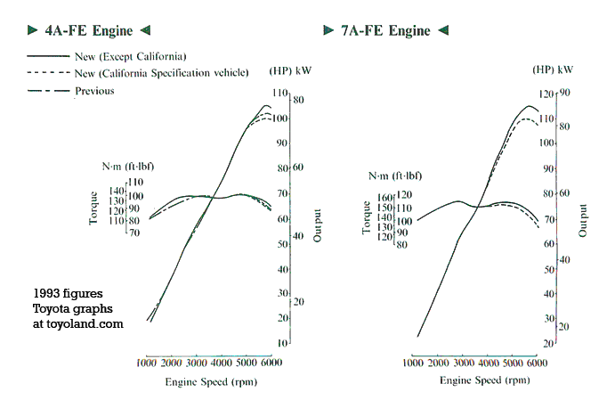
Figure 1 - Torque vs RPM Graph of Toyota's 7A-FE Engine used in 1997 Corolla (toyoland)

Furthermore, the RPM of the car is inversely proportional to the torque of the car (Husain). Therefore, it follows that the maximum possible torque on the wheels will be exerted by the engine when the car moving along a straight line is in its first gear. Under ideal conditions, engine efficiency and slippage of tires and gears is ignored.
From Toyota’s manufacturer specifications, the gear ratio for the 1st gear in a 1997 automatic-transmission corolla is, i₁ = 3.643:1, while the final drive ratio i_{o} = 2.821:1 (Corolland).
Therefore,

T_{w} = (T_{E} x I₁ x I_{o})/2
T_{w} = (138 x 3.643 x 2.821)/2
= 709.10 Nm

Maximum Force exerted by tires on road
When the maximum wheel torque T_{w} being exerted by the engine on any given wheel is known, it is possible to calculate the maximum force that the tire is exerting on the road, when the tire radius r is known.
From the principles of mechanics and statics, it is known that the force applied on a lever arm length is the torque. In this case, the wheel torque T_{w} applies itself on the hub or center of the wheel. Therefore, the radius of the wheel r_{w} will serve as the lever arm upon which the force is applied (Yong, Fattah and Skiadas). It is assumed that in ideal conditions the radius of both wheels are equal and no change occurs in the tire’s dimensions while the vehicle is being driven in a straight line.
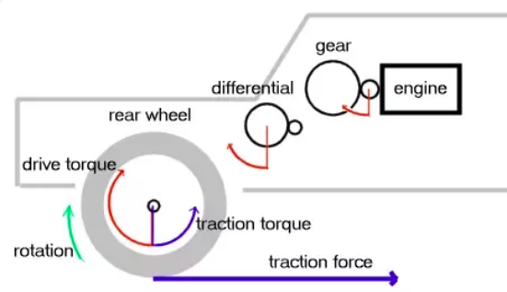
Figure 2 - Torque acting on the wheel, gearbox and differential

The torque on the left wheel equals the torque on the right wheel T_{lw} = T_{rw} with the same r_{w.} It follows that the Force on the wheels, F_{w} will apply equally on both tires and can thus said to be a function of the overall wheel torque T_{w} and the radius of the wheel r_{w.}
T_{w} = F_{w} x r_{w}

The formula for the wheel force F_{w} can therefore be rewritten as
F_{w} = T_{w} / r_{w}
Because T_{w} is dependent on the gear and final drive ratios, therefore the wheel force function is a function of the final drive ratio, the gearbox ratio, the actual engine Torque T_{e,} and the raidus of the wheel. From the manufacturer’s specifications, the size of a standard tire on the 1997 corolla is 175/65R14 81S (Wheel Size).
Therefore, the overall diameter d_{w} is 22.95 inch = 0.5829m; the tire radius r_{w} = 0.291m
Fw= T_{w}/ R_{w}
= 709.10 x 0.291
= 206 N

Maximum acceleration
When the maximum force F_{w} that the tire can exert on the road is known, the maximum acceleration a_{w} of the car can be determined. However, while moving the car undergoes a number of resistances that exert force on the opposite direction, such as the aerodynamic drag force, friction force, rolling resistance, road’s slope, and slippage. However, it is assumed under ideal conditions that these resistance forces can be ignored.
Under normal circumstances the acceleration of the vehicle depends on the sum of the total resistance forces ∑F_{R} being subtracted on the force being exerted F_{w.} Therefore to calculate the force or acceleration
∑F_{w} - ∑F_{R} = m.a

Under ideal conditions, we remove the ∑F_{R} so that the formula is reduced to:
F_{w} = m x a_{w}
The mass of the vehicle can be obtained through the manufacturer’s specifications. The curb weight of the 1997 corolla is 1045 kg (Auto 123). The curb weight represents the total weight of the car plus the average weight of an average number of passengers that are expected to be seated within the car.
a_{w} = F_{w}/m
= 206/1045 = 0.197 m/s²
Since the goal is to determine the maximum acceleration, this can be achieved by either increasing the torque or the force exerted by the transmission and the engine, or decrease the overall weight of the car that has to be moved by the engine. The maximum torque on the wheel is directly proportional to the force being applied, therefore to achieve the highest acceleration would require the vehicle to move in certain RPMs under which a maximum torque is sustained. A car that has a more powerful engine will be able to maintain higher RPMs easily, thus its engine can perform more work at a quicker rate and produce higher torques at a larger range of RPMs (see Fig 1).
To determine, the maximum acceleration of two vehicles that are being compared, it is common to use their power to weight ratio. However, the torque of the car determines the ease at which the car can maintain a certain speed. Despite a higher power to weight ratio, there are certain RPMs at which torque is not at the peak, and thus the vehicle with the lower torque at a certain RPM will accelerate slower.

RPM to run engine at 70mph in 3rd gear
ω= 9.5 v/r
v= 70mph = 312.29 m/s
r = 0.291m (Wheel Size)
For the 1997 corolla, the gear ratio 3rd gear at i₃ = 1.296 (Corolland)
and differential ratio is I_{o} = 2.821 (Corolland)
To determine the speed of a vehicle from the RPM or vice versa. It is important to understand that the transmission ratio in the gearbox acts to reduce the engine’s revolution. Similarly, the output shaft from the transmission which carries the engine’s power to the drive train has its revolutions reduced by the final gear ratio at the differential. Furthermore, each revolution that the wheel of the car makes, moves the vehicle at a distance which equals the tire’s circumference.
The transmission gear ration i_{x} will be used to determine the engine revolution in RPM at the gearbox while the i_{o} will be used to determine the RPM at the axle. Therefore, the total engine RPM ω_{e} will be reduced by the gear ratio i_{x} and become ω_{g}/i_{x} RPM. While the RPM at the differential ω_{d} will become ω_{g}/i_{o.} Therefore, the total RPM of the tire w_{t} will be ω_{e} / (i_{x}.i_{o}).
The distance that the car will move forward will be:
2πr_{w} x w_{t} where r_{w} is the radius of the car’s tire.
Combining between equations, the formula can be reduced to
0.00595 x (ω * r) / (i₃ * i₀) = v (mph) (multiplication factor for miles per hour)
Since the 3rd gear is used at v = 70 mph
I₃ ₌ 1.296:1
i_{o} = 2.821:1
r = 0.291
(ω * 0.000181) / 3.656 = 70
0.291ω = 70*3.656
ω = 879 rpm

Works Cited
Auto 123. Technical Specifications 1997 Toyota Corolla SD. 2018. 12 March 2019. <https://www.auto123.com/en/new-cars/technical-specs/toyota/corolla/1997/base/sd/>.
Corolland. 1993-1997 Toyota Corolla (US-Spec): transmissions, driveshafts, and axles. 2000. 12 March 2019. <https://www.corolland.com/corolla/1993-1997/transmissions.html>.
Husain, Iqbal. Electric and Hybrid Vehicles: Design Fundamentals. 2nd. Boca Raton, FL: CRC Press, 2011.
toyoland. Toyota 4A-F and 7A-FE engines: details and photos. 2000. 13 March 2019. <https://www.toyoland.com/engines/4A-F.html>.
Wheel Size. Toyota Corolla 1997 Alloy wheel fitment guide US domestic market. 2019. 12 March 2019. <https://www.wheel-size.com/size/toyota/corolla/1997/>.
Yong, R N, E A Fattah and N Skiadas. Vehicle Traction Mechanics. Saint Louis, MO: Elsevier Science, 2014.

