Obesity
[Name of the Writer]
[Name of the Institution]

Maldives
Sri Lanka
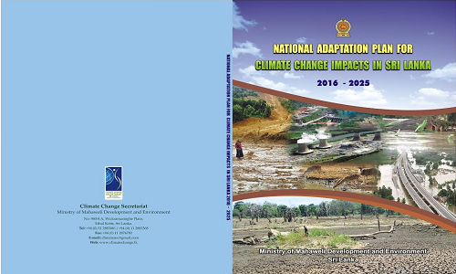
Africa
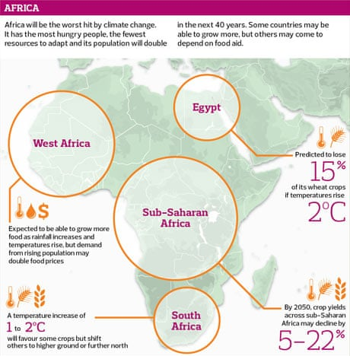
Impacts of Climate Change on Loma Linda, California
After reading the PowerPoint on the climate, I just came to know that the impacts of climate change are very worse and hard-hitting for the developing countries and region while the city I live in is a city in California, United States and it is already a developed region. But! The reading also states that we all are vulnerable as well as the impacts on the entire U.S. cannot be ignored as well. So this means that the impacts of climate change on Loma Linda, California are also to be considered. Hence some of the crucial impacts of the climate change for Loma Lina are but not only the following.
- The states are facing different hotter and drier conditions in unexpected times and sessions such as summer and winter etc. which shows that the crisis of climate is continuous.
- The climate changes have impacts on the states because the combination of decreasing precipitation and the increasing temperatures in the city especially in the winter and early spring is proving the danger.
- The rain and snowfall of entire California are also sensitive to both mid-latitude and tropical circulation changes.
- Wildfires become more frequent because the land is drying by the Droughts and killing plants’ life (Light, 2014).
- The coastal threat is also increasing with almost enough pace than the past which is because of climate change.
Issues applying in my Career
Being a business student, I would be at a managerial position in an organization and I desire it as well. So there are a number of issues that would apply to my career but the most crucial and critical (three) are below.
- Interactions with Others: Managerial position and career ask for a number of competencies in terms of interaction with others such as employees (Trevino, & Nelson, 2016). So in this career, I need to be very careful to follow ethical considerations and standards when interacting with subordinates.
- Conflict of Interest: In my career conflict of interest applies hugely because a manager looks for an organization’s wellbeing while some employees prefer and look at own benefits.
- Influence: Influence applies to my career very much in terms of Ethics or ethical standards because every manager needs to influence their subordinates not in a negative manner (Trevino, & Nelson, 2016).
Compare and Contrast Leadership: (Coercion and Tyranny)
In comparison, Coercion leadership is the process by which leaders take an authoritarian approach to the association they develop with their direct reporters. This is the leadership where leader issues order and direct reporters follow those orders. Similarly, Tyranny leadership is also a type of leadership of developing the relationship to power and control. This is the leadership which influences the culture in teams and organization by the use of relationship and power the leaders have.
In contrast, both Coercion and Tyranny are types of leaderships, but Coercion leadership is considered as the issuing of orders to get the job done quickly, boost productivity, improve workplace, and empower standards and taken as a healthy relationship (Sandra, 2018). But, the type of leadership called Tyranny is considered an unhealthy relationship of power and control by many professionals.
The Tragedy of the Commons
The Tragedy of the Commons is an economic problem where every person has his/her incentive to use a resource at an expense of other person or individual with no way to exclude anyone or any person from the utilization or consumption. This problem mainly results in overconsumption in and under the investment and eventually and finally leads to depletion or decrease of the resource. As per resource demand increase the supply because every individual who uses or consumes an additional unit directly impacts others who no longer enjoy benefits.

References
Light, J. (2014). The 10 Things You Need to Know From the New IPCC Climate Report. Grist. Retrieved 3 November 2019, from https://grist.org/climate-energy/the-10-things-you-need-to-know-from-the-new-ipcc-climate-report/
Sandra, J. P. (2018). On Leadership and Coercion – Leadership Speculations. Blog.richmond.edu. Retrieved 3 November 2019, from https://blog.richmond.edu/leadershipspeculations/2018/06/14/on-leadership-and-coercion/
Trevino, L. K., & Nelson, K. A. (2016). Managing Business Ethics: Straight Talk about How to do it Right. John Wiley & Sons.

