Research
[Name of the Writer]
[Name of the Institution]

Research

Introduction
Nursing theories describe the fundamentals of the field of nursing. They also define the role of a nurse and explain its importance. Nursing theories are there to make the field of nursing stand out from other fields such as medicine. Nursing theories consolidate concepts and purposes aimed at guiding and influencing the practice of nursing at a deeper level (Smith & Parker, 2015).
Discussion
The profession of nursing is dedicated to exploring its vast body of knowledge imperative to nursing practice. The field of nursing is very different from the field of medicine. Therefore, to maintain this difference, nurse theorists continuously identify, develop, and reconcile concepts and theories with that of the field of nursing (Smith & Parker, 2015). From a scientific perspective, nursing finds its roots in what nursing is, what nurses normally do, and the rationale behind it (Smith & Parker, 2015). Nursing focuses on the effective delivery of care and empathy based on the vast body of knowledge.
Furthermore, there are some concepts which form an integral part of the field of nursing and nursing theories. These four concepts are known as a person, environment, health, and nursing (Smith & Parker, 2015). It is almost impossible to understand any of the nursing theories without getting hands around these concepts. Often these concepts are known as meta paradigm for nursing. Most of the times, the person is one receiving nursing care. The person can be an individual, group, or an entire community. The environment can be referred to as the internal and external surroundings that might have some effect on the patient in one way or the other. The concept of health is the extent of wellbeing or wellness the person experiences. Lastly, nursing is the most important of the four concepts that have been mentioned previously. Nursing is the actions and attributes of a nurse providing care to the person. Although there have been numerous definitions of the field of nursing, the ultimate goal has been the same (Smith & Parker, 2015).
Option 1
Part 2: Explain which of the nursing concepts/theories may guide your current/future personal life, nursing practice, and research and why?
There are some theories that a nurse should incorporate if they are to succeed in the field of nursing. The following theories would be the one that I would integrate into my nursing practice, personal life and future research. The rationale behind the selection of these theories will be explained in the strengths of these theories.
Environmental Theory
The environmental theory was created by the great Florence Nightingale. Florence Nightingale is hailed as the pioneer in the field of nursing as her relentless efforts paved the way for the development of the field of nursing. The theory states that nursing is the act of using the patient’s environment to help them with their recovery from the illness (Pirani, 2016). There are five factors identified in the environmental theory of nursing. These factors are pure fresh air, pure water, effective drainage, cleanliness, and light (Pirani, 2016). At the time when Florence Nightingale forwarded her theory, the hospitals had little facilities and the staff was not trained accordingly.
The strength of the theory lies in the fact that it makes the nurse take cognizance of the importance of the environment in the process of healing. In an era of significant industrial developments and increasing global environmental concerns, every nurse needs to integrate the environmental theory to provide effective health care to the patients (Pirani, 2016). The primary reason I would select this theory because I would be able to contribute to the global environmental issue alongside providing health care to the patients.
Nursing Need Theory
Another important theory that holds immense significance in the field of nursing is the Nursing Need Theory. The Nursing Need Theory was developed by Virginia Henderson. In the Nursing Need Theory, Virginia Henderson put forward 14 simple yet effective components that address the psychological, spiritual and social needs of the nurse (Ahtisham & Jacoline, 2015).
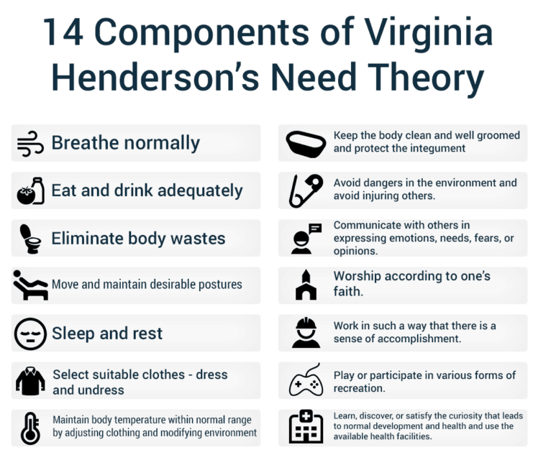
The components of the Need Theory would be beneficial for me if I were to go for a research nurse in the future. This is because with every component there is a lot of unexplored knowledge yet despite so many advancements which can improve the delivery of the health care to the patients. Furthermore, the 14 components are accepted widely in the field of nursing. Any nurse, whether beginner or experienced can integrate these 14 components into their practice so that it would not only improve their health but the patients would benefit from it ultimately (Ahtisham & Jacoline, 2015).
Part 3: How I will determine if the concepts/theory that I’m using is appropriate to care for my clients?
If the nursing theories and concepts are not producing the intended results, it would be pointless to use them any further. Therefore, it is very important to evaluate and analyze if the nursing theories and concepts employed by a nurse are producing results or not. Determining the effectiveness of the employed theories would help me to reflect on what is working for the patients and what is not (Alligood, 2017).
To measure the effectiveness of the Environmental Theory, I would ensure that the patients are provided with all the necessary components that deemed vital according to the theory (Alligood, 2017). These components are pure fresh air, pure water, effective drainage, cleanliness, and light. If a patient has been provided with these components it means that they would be making progress. If they are not progressing with their illness, I would ensure that they are provided with the aforementioned components (Alligood, 2017).
Secondly, to measure the impact of the Need Theory is to check whether a nurse is following what has been laid down in the theory or not. A nurse can only look and care for patients only when they are in a sound state of health and mind (Alligood, 2017). Therefore, the nurses must be in the best possible psychological and emotional state. If I am to provide effective healthcare to my patients, I should embrace the 14 components collectively (Alligood, 2017).

References

Ahtisham, Y., & Jacoline, S. (2015). Integrating Nursing Theory and Process into Practice; Virginia's Henderson Need Theory. International Journal of Caring Sciences, 8(2).
Alligood, M. R. (2017). Nursing Theorists and Their Work-E-Book. Elsevier Health Sciences.
Pirani, S. A. (2016). Application of Nightingale’s theory in nursing practice. Annals of Nursing and Practice, 3(1), 1040.
Smith, M. C., & Parker, M. E. (2015). Nursing theories and nursing practice. FA Davis.

