Type A, Type B Personality
[Name of the Writer]
[Name of the Institution]

Type A, Type B Personality
Abstract
Personality type plays an important role in the prediction of the behavior and attitudes of a person regarding some specific event or situation. Two popular personality types can be hugely helpful; in this respect. These personality types are Type A and Type B. Both primary and secondary measures will be used in order to check the traits of these both types of personality. The results show that there is a striking difference between both these personality types and these results can be used to generally reveal lots of facts about different person.

Introduction
Human is the best creation of the Lord. Humans have been given preference over all the other creations due to the presence of the ability to think and make decisions appropriately. Humans have been blessed with the ability to think, create, analyze, manipulate and make the decisions according to the current situation and conditions. Every person is blessed with these functions but not everyone uses them in the same way. The reason behind this difference or variation is the personality type.
Personality type is the classification of individuals on the basis of their psychological characteristics (Emerson, English, & McGoldrick, 2016). There are different types of personalities in the individuals that define their nature, attitude, attributes and behavior at a particular time or instance. One of the prominent types of personalities is personality Type A and personality Type B. There is a huge difference between both the personality types. This research paper aims to focus on both these personality types and elaborate the similarities and differences between both. The research paper will also highlight the characteristics, (whether they are positive or negative), present in the individuals of both these personality types.
Literature Review
The research and work on both these personality types are not new. Personality Type A was first discovered by not the psychologists but cardiologists, Friedman and Rosenman. Both these cardiologists observed that the chairs in their waiting rooms need upholstery more often than usual. They called the upholsterer who revealed some shocking facts. He told that the chairs had worn out in a strange manner. The leather from the armrests had worn off badly and most of the edges of the chairs needed repair.
The cardiologists did not pay much attention to the comments of the upholsterers and continued with their work. However, they took the matter seriously in the future and only after five years, they started their formal research on the topic. Friedman and Rosenman labelled the personality type, that they have observed in their patients as personality Type-A.

Methods
Psychological studies mostly consist of the qualitative studies and methodologies that need to be inculcated in the research procedures. The data collection techniques adopted for this kind of study include both primary and secondary methods. Primary methodologies that will be adopted for this study will be mostly based upon direct observation and surveys. Most of the data will be collected through various clinics and the psychiatry departments of different hospitals. A number of questionnaires will also be distributed among the respondents to check their personality type. Various personality test questionnaires are available over the internet which provides a valid and authentic measure of the personality of a person.
The secondary methods used in this study will consist of a number of research articles and research papers, that have been published in the journals. Journals with a high impact factor will be preferred for this purpose. Moreover, a number of books published on the subject of psychology and personality types will also prove helpful in this respect.
Results
The results collected from all the methods and sources intended for this study indicated towards some striking results that are shared as under.
Type A Behavior Patterns (TABP)
Individuals having personality Type A are competitive, ambitious, outgoing, proactive, highly status-conscious. They tend to become anxious more quickly and are more likely to fall prey to psychological disorders like stress and depression (Hisam, Rahman, Mashhadi, & Raza, 2014). They work strictly in deadlines and are a high level of workaholics.
Type B Behavior Patterns (TBBP)
People with personality Type B are more patient and tolerant in nature. They are generally relaxed in nature and experience lower levels of anxiety. They are generally imaginative and creative people and may focus less on winning or losing when it comes to competition. They tend to enjoy the work or task and take a minimum level of stress in the process.
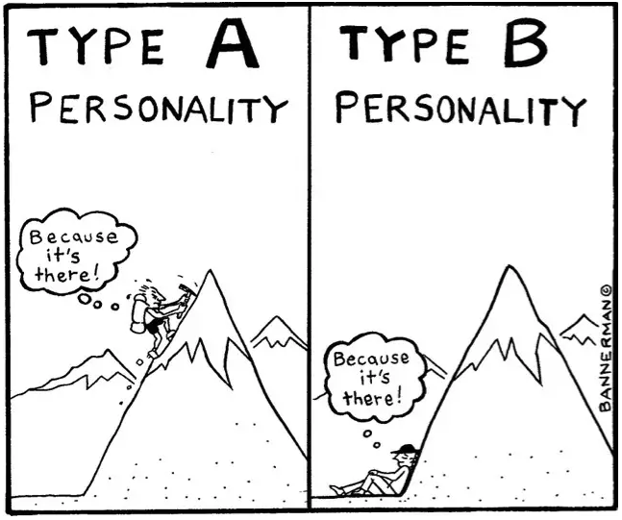
Discussion
It would not be wrong if it is said that both the personality types are poles apart owing to the observance of similarities and differences between both. The results found out after the completion of this study were completely in line with the previous studies conducted in this regard. It was observed that individuals with personality Type A suffered more frequently with ailments like heart diseases and high blood pressure. Individuals having personality Type A were at a higher risk of suffering from Coronary Heart Disease. Moreover, people possessing large number of traits were more inclined towards Type A personality types and were also more prone to stress-related illnesses like CHD.
Limitations of the Study
The limitations of this study involve many factors. One of the biggest issues in this respect is external validity. For example, the results of the study conducted on an all-male population will be different from the results of the study conducted on an all-female population. The results of the study cannot be generalized. Moreover, all the traits of a personality cannot be applied on all the individuals, for example a person may be ambitious and competitive but at the same time, he or she may have a very relaxed personality.
Implications of the Study
This study can be generally used in the prediction of the attitude and behavior of a person towards a specific event or situation but this can only be done broadly, not in the specific or narrow terms.

References
Emerson, T. L., English, L., & McGoldrick, K. (2016). Cooperative learning and personality types. International Review of Economics Education, 21, 21-29.
Hisam, A., Rahman, M. U., Mashhadi, S. F., & Raza, G. (2014). Type A and Type B personality among Undergraduate Medical Students: Need for psychosocial rehabilitation. Pakistan journal of medical sciences, 30(6), 1304.
Vollrath, M., & Torgersen, S. (2000). Personality types and coping. Personality and individual differences, 29(2), 367-378.

