Name
Name of Professor
Class
Date

Young People are disappearing in the Factory
Introduction
In recent years, there are many companies that are not providing reasonable wages to employees. Young people are willing to find a suitable job to secure their interest. However, unsanitary conditions, low wages, and long working hours are problematic to keep up in an industry. During an extended period, I am proud of the traditional Chinese industry because it produces almost everything in this world. Every week, millions of blueprints and drawing were sent to Chinese plants while millions of products were exported to everywhere all around the world. Not only domestic factories but also many international corporations develop their plants in China. Those factories significantly expanded the GDP of China and decreased the unemployment rate. Before, working in the factory means he or she has a stable and decent job. However, factories are having a problem right now due to which they cannot hire people anymore, especially after the Chinese Lunar New Year.
Students who just graduate from college rather ride a bike and deliver food than remain the same movement and repeat a thousand times in the factory. Even though many factories offer a high wage to hire people, more and more employees are running away from this traditional industry. So, why are they not willing to work in factories anymore and where are they going to do?
Discussion
Poor Working Conditions
It is notable to mention that many industries have poor working conditions which impose a potential threat to many young workers.
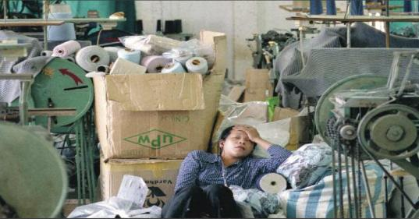
Picture showing unsanitary conditions in a factory
If you ask a new college graduate what they concern most about the new job, they will tell you about the working condition for sure. Unlike the previous laborious generation which experienced famine and poverty, young fellas do not care about salary as their parents; therefore, they want to work in a comfortable environment. Sanitary conditions and standardized working conditions are essential to young individuals to work in a factory. For example, before they sign the contract, they will be asking if the company provides lunch, dorm or even a swimming pool. Under such a background, the old and traditional factories are not able to meet the expectations of these young people.
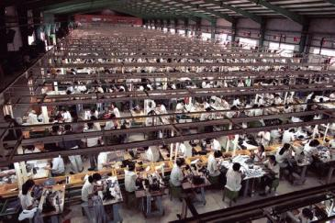
(The picture on the left is the excellent working environment of Google while the right image is taken from a Chinese factory.)
However, the fact is that most working environment in China can't even say it's terrible. Let's take Foxconn, the most famous Apple assembly corporation, as the example; "Foxconn keeps their employees in overcrowded dormitories run by military-like security forces. People work excessive hours, often with no compensation for overtime, which the company claims is made voluntarily.
Picture showing long working hours and burden
Management controls every aspect of workers' lives, interfering with their privacy. The concept of privacy is even an illusion, as up to 24 people share a room in huge blockhouses” (facing-finance). For those people who urgently need a job to support their family, they might accept this disrespectful working environment. But for those young college graduates who just stepped out from the beautiful campus life, they might refuse to work in the factory without a doubt.
No Future
Life in factories is boring and dull. Labors are bound to follow the instructions and repeat doing the same task every day. Their daily life will be detained in the plant and dorm. After working 14 hours, the only thing they want to do in the dorm is going to bed and sleep. They have no energy and time for entirement and absorbing knowledge. After a long period, people will lose their productivity and creativity. In the Chinese factory, the only promotion is to become an engineer; otherwise, you will be doing the same job until you retire. However, as I said, tedious work gradually wears down people's will and turn them into machines.
Most Chinese factories are built in the rural area which is thirty to forty miles from downtown. Labors can only take factory transportation which operates once a week to go back to their family. The long distance cut off the connection between new workers and society. For those new graduates, it is not suitable to choose such factories that are far away from the city. I used to ask a friend who worked in the factory about life there, and he told me that those days made him feel like he died at 25, but he will be buried at 75.
Impact from Other Jobs
In 2018, 7.95 million Chinese college students graduated from colleges. China divides colleges into three types which call "Yi Ben', "Er Ben," and "San Ben" respectively. “Yi Ben” is the best while "San Ben" is the worst. Among 7.95 million college graduates, only around 2 million "Yi Ben" students are competitive in the job market. In other words, 5 million college graduates lost their jobs at the moment they received their diploma. In the past, working in the factory seems like the best choice for those students who cannot find a job because it is stable and comfortable. However, food delivery service and live streaming grab those young people and put them into their pocket.
Food delivery is a new-fashioned service business that has been the most potential industry in China. The whole market worth 200 billion RMB which is about 30 billion US dollars with an increasing rate of 20 percent annually (iiMedia Research). Unlike working in the factory, deliverymen are free to allocate their time as long as they complete the minimum orders which means your salary is entirely upon to your work. If you want a break, go ahead. The flexible working time and pay perfectly fit the expectation of those unemployed young graduates. According to the "MEI TUAN 2018 Deliveryman Annual Report", 31 percent of the group of deliveryman used to work in the factory. Under those situations, it is not a coincidence that 4 million people are working as a deliveryman and half of them are aged between 21 to 30 until 2018.
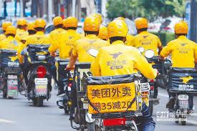
Live streaming is another potential business among teenagers and new graduates. Similar to the deliveryman, streamers have no requirement of academic degree and diploma. Many game pros have made a couple of million dollars from the game streaming career. If you are not good at the game, it is magnificent. Some streamers stream about their daily life, some of them stream about cooking food, and people even stream about their sleeping. And all you need is a good quality camera and internet. The average salary of streaming is about 5000 RMB, which is a little bit lower than the salary in the factory. But it does not require you to remain in the same movement for 12 hours.
Due to the poor working condition and the change of mind, the number of young people who showed up in the factory is not enough. Most of those people will be working for food delivery or being a streamer. These significant changes are making factory owners anxious because it expressively slows down the developing pace. Once factories squeeze their scale of production, they would have made less profit than the past. Therefore, how to attract young people's attention and keep them stay is the primary question on the agenda.
How to improve working conditions
First of all, stop cheating on the salary. Many factories offer a high salary to attract people; however, when you receive the check, the amount on the check is way less than their promise. The only way you can receive the full payment is to finish a bunch of goals the manager set, which requires people to work 14 to 16 hours per day. If you cannot do that much work, well, you can only receive about half of your expectation.
Secondly, respect your employees. A lot of factories hire internships as free labor because their price is low. Respect is a bidirectional thing. Managers hire internships for a low price and kick them away when their internships are over. Then, they will go to a new job and post their employment over and over. Come on man; people are not fools. The internet today is well-developed; every trick you throw are not secrets anymore. You will not receive respect if you do not have it for others.
Conclusion
Poor sanitary and living conditions in factories are problematic for young employees. Minimum wages and long working hours are forcing young people to turn towards other jobs such as deliveryman and streamer. Employers should need to provide reasonable wages in order to keep young people in their factories. Employers must respect their employees as it is a bidirectional thing.

Works Cited
"Foxconn Is Under Scrutiny For Worker Conditions. It’S Not The First Time.." Nytimes.com. N. p., 2019. Web. Retrieved from https://www.nytimes.com/2018/06/11/business/dealbook/foxconn-worker-conditions.html
"Foxconn: Working Conditions In Chinese Factories." Facing Finance. N. p., 2019. Web. Retrieved from http://www.facing-finance.org/en/database/cases/working-conditions-in-foxconn-factories-in-china/
"Sweatshops In China." War on Want. N. p., 2015. Web. Retrieved from https://waronwant.org/sweatshops-china

