Principle of Financial Management
Name of the Writer
Name of the University

Principle of Financial Management
Task 1
Q1
It is understandable that the retail outlets being opened in Vietnam would sell products in the Vietnamese Dong. The profit made from the sales would then be sent bank to Australian and would need to be converted into Australian Dollars. This is where the spot market comes in as this is the place where financial instruments such as currencies, securities and commodities are traded and their delivery is done immediately (Hassan and Mano, 2018). Currency from Vietnam would be immediately sold to get the corresponding value for it in Australian dollars. Furthermore, through the use of the spot market, the business would be able to buy and sell foreign currency (in this case Vietnamese Dong) without accounting for any interest rate differentials. This makes the day to day movement of currencies between the retail outlets in Vietnam and headquarter in Australia easier and without complications. An example of the spot market would be the Australian stock exchange which will help in converting currencies between the different business outlets.
Q2
The forward market is the market that facilitates the exchange of currencies. In this market, the exchange of currencies occurs at a specific future date and this is referred to as a forward rate. Now by using the forward rate or the forward market the clothing retailer headquartered in Australia to exchange the currency they receive from their Vietnamese counterparts. The exchange of the currency under the forward rate or the forward market would be done before the actual exchange of currencies. This can be explained in such a way that the retailing headquarters in Australia will form a forward contract with a commercial bank. The contract between the two parties will detail what amount of the Vietnamese dong will be exchanged when the currency will be exchanged (specific date), and at what exchange rate the currency would be exchanged. This way the clothing retailer in Australia would be selling the currency forward in time. This eliminates any downside risk exposure that the company might face.
Q3
In international business and international there are several methods of payment that can be used. There are four possible ways for possible payment mechanisms such as Letter of credit, Documentary collections, Open account, and Cash in advance. Letter of credit is counted as the best form of payment method and could be used as a payment method in between headquarter in Australia and the outlets in Vietnam (Niepmann and Schmidt-Eisenlohr, 2017). Under a letter of credit, a commitment by the bank of the importer (outlets in Vietnam) will be made by payment to the exporter (headquarter in Australia) if all the conditions within the contract are met. Furthermore, through the use of a letter of credit as a form of payment method risk can be mitigated as this document is issued by a bank and written by a financial institution in favour of the buyer to the exporter. Furthermore, under this agreement, the only part that the exporter has to do is to meet the terms and conditions listed within the agreement and the agreed payment would be received.
Q4
The current foreign exchange rate between one Australian dollar and the Vietnamese Dong is around fifteen thousand seven hundred and thirty-seven Vietnamese Dong. That means for every one Australian dollar a person can buy around fifteen thousand seven hundred and thirty-seven Vietnamese Dong. If some Australian goods are sent over from Vietnam to Thailand then the use of Australian currency would be better as the settlement currency for the trade of these goods. This is because the rate of conversion between the one Australian dollar and the Thai Baht is twenty Thai Baht. So when the sales proceeds are received from Thailand for the goods that were sent over from Vietnam the rate of conversion is much lower. This allows for an increased amount of profit to be accessible to the company in Australia rather than converting the sales proceeds to Vietnamese Dong and then onwards onto Australian Dollar. So choosing the Australian dollar as the settlement currency is the best options for the movement of goods between Thailand and Vietnam.
Q5
As the clothing retailing business has been quite successful in Australia, the company can use a myriad of financing options to finance the establishment and the expansion of the newly constructed outlets in Vietnam. The company can apply for a loan in the international banking sector for financing the new outlets (Agliardi, et al, 2016). This loan would require a low cost of capital and are granted over a given period of lending. Furthermore, if the company faces bankruptcy, the repayment of these loans will take the highest priority. Furthermore, the company can issue bonds in the bond market, which investors can buy and will mature over time. Furthermore, just as the debt they also have a low requirement for the cost of capital and are paid out before equity if bankruptcy occurs.
Task 2
Dear aunty Stottie, thank you for considering me able enough to advise you regarding your investment in the shares of the Telstra communication company. Please allow me some time to give you a full view of the various factors that should be considered while making investment decisions.
In terms of macroeconomic or country related factors, Australia is still finding its footing. Overall, Australia is on the thirteen places in the countries with the largest economy in the whole world. Furthermore, the country's economy grew by a whopping two per cent, although it was expected to be more, even this is something to be appreciative of. This has lead to an increase in household income, and investments in the business. All of these factors show that businesses are currently booming in Australia. This is also one of the reasons for the growth that Telstra has witnessed in the last year and this growth is expected to continue for years to come. With the innovation in telecommunication technology such as mobile broadband, the telecommunication industry is seeing an expedient growth. This is helping to offset the balance of losses that the fixed-line services were producing. The user uptake in this industry is on higher due to the spectrum of mobile broadband and is leading companies to new heights of success.
Telstra is one of the giants in the mobile and telecommunication industry. Its operations include most of Australia and other countries as well. But there are certain macroeconomic and industry factors that affect the choice of investing in such a company. Primarily, There have been recent developments by Telstra corporation competitors in terms of technology (Campbell, 2017). This means that Telstra is losing its competitive advantage, forcing its share price to go down. Furthermore, with no current development in technology, the product offering is taking a hit. Moreover, the telecommunication industry is taking on more and more costs and with Telstra declining share prices it can be considered as a bad investment. On the other hand, the skill level at Telstra is increasing exponentially. This is a good sign as with more skill more innovation occurs which directly impacts the share price. Furthermore, as there is stability in the exchange rate of the Australian dollar, this investment could be very profitable for you auntie.
Historically, Telstra has seen a good return on its shares. Furthermore, for the last year, the share price and the return have kept exceeding the expectations of many investors. Currently, the dividend yield that is being paid out by Telstra to its shareholders is three percent and this has kept increasing over the last few years. Moreover, the current policy of Telstra is to pay out dividends or fully franked dividends of around seventy to ninety percent of the earnings that are underlying in the fiscal year of 2018. This is a behemoth amount of dividends being paid, but shows that the company uses less to reinvest in the business itself. Furthermore, the first tranche of the Telstra shares of the Australian government has just been sold. These were four billion shares and to institutional investors, it is trading publicly at a price of three dollars and forty pennies and to retail investors at three dollars and thirty pennies. This shows the confidence the value of return that the Australian government is expecting on the Telstra shares.
The share price of the Telstra stock has seen a varying amount of changes within different periods. For the three years, the share price has a variety of movements in which it has increased and decreased. For the period starting from 9 September 2016 to 9 September 2019, the share price was primarily at five dollars, but at the end of this period, the price fell to four dollars. Furthermore, for the time frame of 9 September 2014 to 9 September 2019, the share price saw a movement from six dollars to four dollars. Lastly, for the period starting from 9 September 2009 to 9 September 2019, the share price increased from three dollars to four dollars. This shows that the share prices for Telstra has been fluctuating and has been very volatile. Furthermore, in comparison to ten years in the past, the share price is still better, but according to recent data, the current share price does not improve investor confidence.
The Telstra stocks for the period of the last ten years were not that volatile. But in all actuality, during the last ten years, the share prices kept an increasing trend. Furthermore, the high and low prices for the last year have been comparatively the same with little difference between them. Whereas, for the last five years, there has been increasing volatility between the share prices of Telstra. Rather than following a general trend the values for the share prices and the high low price variations have been increasing and decreasing without a pattern. Furthermore, for the last three years again there has been a high level of volatility in the share prices of Telstra. There has been exponential increase and decrease in share prices during this time and this caused a major impairment in the high-low price variation of the Telstra stock. This increasing level of volatility in the share prices is reducing the confidence of investors within the stock of Telstra.
Auntie Stottie, one more thing can be considered while investing in stocks. This concept is about diversification and in essence, is the financial representation of the English example of not putting all of your eggs in one basket. In this, there is a portfolio of different assets and have the ability to earn the highest return with the lowest amount of risk (Lyanders, et al, 2019). So aunty stottie, within a diversified portfolio the stocks do not correlate with each other and when the value of one rises the value of the other falls. This minimizes the overall risk. For example, let's assume that you want to invest thousand dollars, so you invest five hundred dollars in company A’s (beverage) stock and five hundred dollars in company B's stock (healthcare). So when the stock value of the company decreases, the stock value of company A decreases the value of the stock of company B will increase. This is because those two stocks are not related. So the original investment in company A's stock is now worth two hundred and fifty dollars while the investment in B's stock is now worth six hundred and fifty dollars. Their loss has led to the value of the portfolio at nine hundred dollars, which is better than a total loss of thousand dollars.
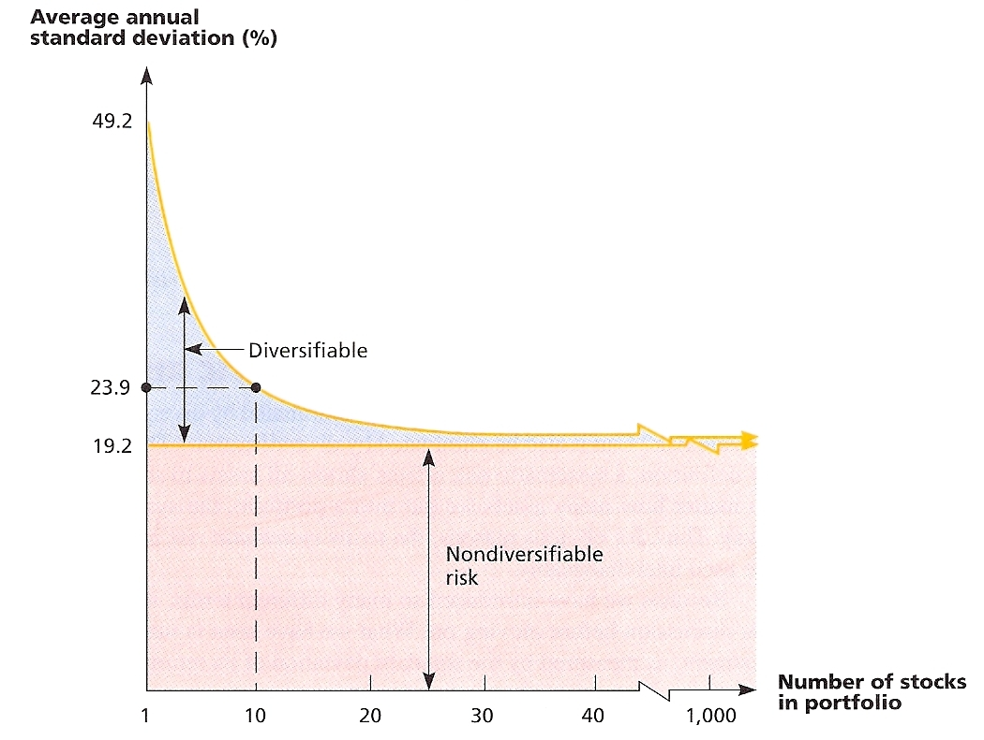
Aunty stottie another option that can be considered for you are investing in other asset classes. Now asset classes are alternatives to the stock investment that you are currently planning to do. They exhibit the same similar characteristics and are also subject to the same laws and regulation (Sensoy, at al, 2015). Now four asset classes can be used as a choice of investment for you aunty stottie. Those are stocks or equities, which you are currently thinking of investing. Then comes fixed income or bonds, the comes money market and cash equivalents and lastly, real estate or other tangible assets.
The last and the most important thing for you to consider before investing in the stock of Telstra is is its Beta. Now, the Beta shows the volatility of the stock compared to the overall market and is also an indication of the riskiness of a stock (Liu, et al, 2018). So the Beta of Telstra for the last three year monthly has been around 0.77. Now the Beta of the market is 1.00 and as the Beta of Telstra is less than one that means this stock moves less in comparison to the market. This means that even if this stock is much less risky, but the expected return is going to be low for this stock.
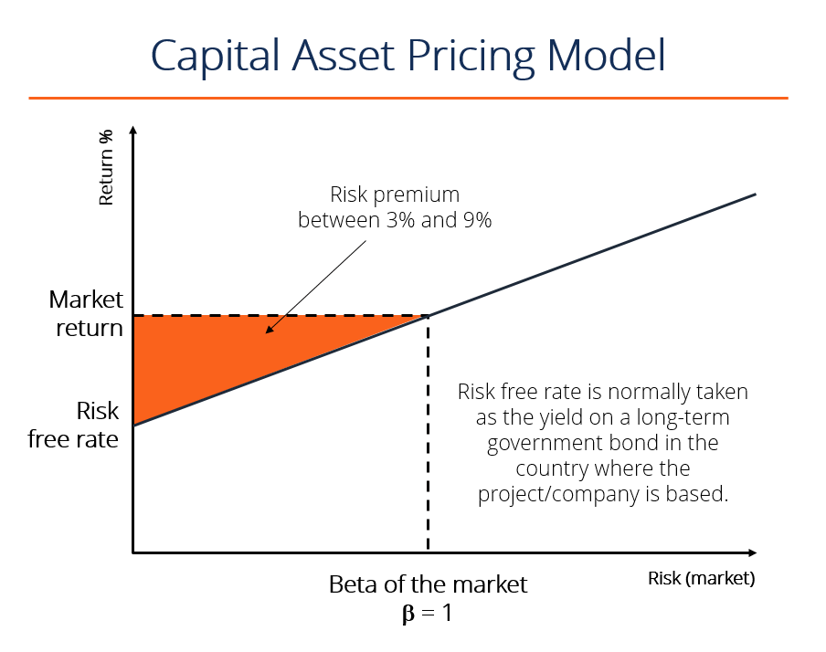

References
Agliardi, E., Agliardi, R., & Spanjers, W. (2016). Corporate financing decisions under ambiguity: Pecking order and liquidity policy implications. Journal of Business Research, 69(12), 6012-6020.
Campbell, I. (2017). Telstra's Future Mode of Operation-the transformation of the Telstra's Network-1992/93. Journal of Telecommunications and the Digital Economy, 5(4), 18-69.
Hassan, T. A., & Mano, R. C. (2018). Forward and spot exchange rates in a multi-currency world. The Quarterly Journal of Economics, 134(1), 397-450.
Liu, J., Stambaugh, R. F., & Yuan, Y. (2018). Absolving beta of volatility’s effects. Journal of Financial Economics, 128(1), 1-15.
Lyandres, E., Marchica, M. T., Michaely, R., & Mura, R. (2019). Owners’ Portfolio Diversification and Firm Investment. The Review of Financial Studies.
Niepmann, F., & Schmidt-Eisenlohr, T. (2017). International trade, risk and the role of banks. Journal of International Economics, 107, 111-126.
Sensoy, A., Hacihasanoglu, E., & Nguyen, D. K. (2015). Dynamic convergence of commodity futures: Not all types of commodities are alike. Resources Policy, 44, 150-160.

