Assignment#2
Mark Wrublewski
MGT3059 Operations Management SU01
12/17/2019

Activity | Time | Activity | Time
A | 7 | F | 2
B | 3 | G | 6
C | 8 | H | 5
D | 4 | I | 4
E | 6 | J | 2

- Critical path. In the network diagram of the project, there are many paths that can be taken from the beginning of the project to the completion of the project. he critical path method is used to estimate the shortest project duration in the schedule model and determine the schedule flexibility of the logical network path. This schedule network analysis technology uses forward and backward push along the schedule network path without considering any resource constraints , and calculates the earliest start ES, earliest end EF, latest LS, and latest LF of all activities date.
- The earliest and latest start and end dates obtained are not necessarily the project schedule , but only the established parameters (activity duration, logical relationship, lead, lag, and other known constraints) are entered into the schedule A result obtained after the model indicates that the activity can be implemented during this period.

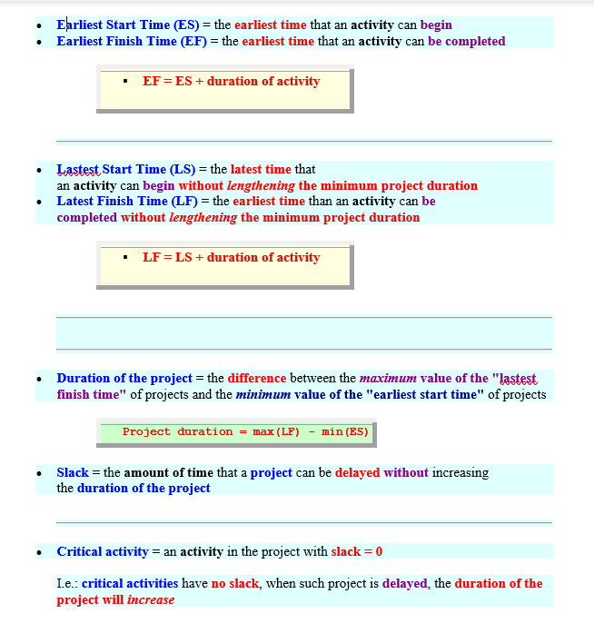

ACTIVITY | ES | EF | LS | LF | ACTIVITY | ES | EF | LS | LF
A | 0 | 7 | 0 | 7 | F | 15 | 17 | 15 | 17
B | 7 | 10 | 8 | 11 | G | 17 | 23 | 17 | 23
C | 7 | 15 | 7 | 15 | H | 15 | 20 | 18 | 23
D | 7 | 11 | 11 | 15 | I | 23 | 25 | 23 | 25
E | 9 | 15 | 11 | 17 | J | 25 | 27 | 25 | 27

Slack time
- It is time duration in which an activity may delayed from earlies completion time but there will be no effect on current completion time.

Activity | Slack time
A | 0
B | 1
C | 0
D | 4
E | 6
F | 0
G | 0
H | 3
I | 0
J | 0

On the critical path activity we ha equaling EST AND LST. It shows that both the rows with equal values show earlier time and critical time for this project.
- For the bonus of $400 , daily saving will be $400 because one single activity crashes with I and that is C.

References
Andrade, P. A. de, Martens, A., & Vanhoucke, M. (2019). Using real project schedule data to
compare earned schedule and earned duration management project time forecasting capabilities. Automation in Construction, 99, 68–78. https://doi-org.southuniversity.libproxy.edmc.edu/10.1016/j.autcon.2018.11.030
Shojaei, A., & Flood, I. (2017). Stochastic forecasting of project streams for construction project
portfolio management. Visualization in Engineering, 5(1), 1. Retrieved from https://search-ebscohost-com.southuniversity.libproxy.edmc.edu/login.aspx?direct=true&db=edo&AN=ejs42584145&site=eds-live
Kallantzis, A., Soldatos, J., & Lambropoulos, S. (2007). Linear versus Network Scheduling: A
Critical Path Comparison. Journal of Construction Engineering & Management, 133(7), 483–491. https://doi-org.southuniversity.libproxy.edmc.edu/10.1061/(ASCE)0733-9364(2007)133:7(483)
Zhou, T., Zhou, Y., & Liu, G. (2017). Comparison of critical success paths for historic district
renovation and redevelopment projects in China. Habitat International, 67, 54–68. https://doi-org.southuniversity.libproxy.edmc.edu/10.1016/j.habitatint.2017.06.008
References

