Sam Balagadde
Technical Writing
ENGL 372
Dr. Patricia Lynne
CAR TIRE CHANGING: AN INSTRUCTIONAL MANUAL
Learning different skills proven to be useful in most devastating circumstances and learning how to change a tire of the car is one of them. All drivers should necessarily learn the skill because in any case of the accidental flat tire they can evade the peril of great disappointment just in a jiffy. The following instructional manual proffers practical and easy steps regarding changing the flat or faulty tire of the car.
Things You Require:
The required equipment generally come with the vehicle and mostly placed either on the trunk area, floor or side compartments or could be found under the backseat of the car. Things you will need to change the tire of your car include:
  - A spare tire
  - A lug wrench or tire iron
  - Jack
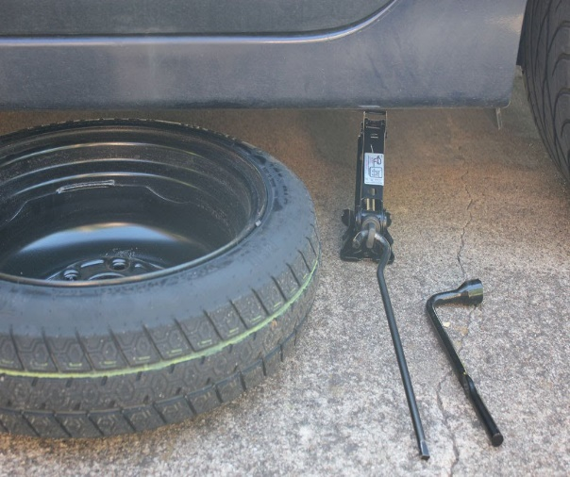

How to Change the Tire of a Car
Before Getting Start
- As soon as you find out that you are facing a bad tire, find a safe location to stop the car.
- After resting the vehicle in a safe and secured location, turn on the hazard lights so others could be aware of the situation.
- After that apply the parking brake and wheel wedges to prevent the possible rolling of the car.
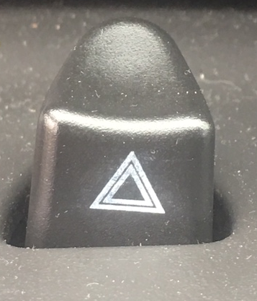
Removing the Tire
- With the help of lug wrench lose the lug nuts by turning them counterclockwise but do not take them off.
2. Now, position the jack under the back or front axle of the car depending on which tire is flat.
3. Wind the screw with the hole at the end of the jack clockwise to lift the car as showed in the picture below. Have patience as this step takes a bit more of time.
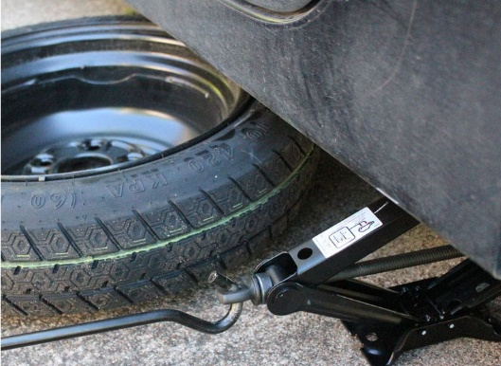
4. Once the car is jacked up, make sure that tire is not touching the ground anymore, now take the previously loosen lug nuts off.
5. Carefully pull the flat tire off the wheelbase.
Changing the Tire
- Get the spare tire, align and push it into the wheelbase where the removed tire was.
- Put on the lug nuts back on, by using your hands

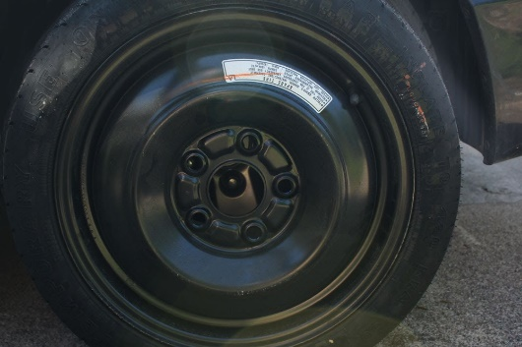

Finalizing the Changing of Car’s Tire

1. After changing the tire using the screw on the jack to lower the vehicle and bring it back to the ground.
2. Now tighten the lug nuts by using the lug wrench, make sure to tighten the lug nuts carefully and securely.
3. Put the equipment and removed tire back in their proper location.
4. Ta-da!! Congratulations you have learned the most effective skill of changing the tire of your vehicle. Now enjoy a hassle-free ride.

