Week 5 Assignment - Hazard Identification
[Name of the Writer]
[Name of the Institution]

Week 5 Assignment - Hazard Identification
Mechanical Hazard
Crushing is one of the mechanical hazards. Crush point hazards occur where there are two objects that are moving towards each other or when there is a solid object approaching a stationary object. Crush points also exist when equipment is either raised or lowered with a three-point hitch, also when the components are moved by some hydraulic cylinders (Myers & M, 2010).
Processes
There are different processes that can create this hazard such as unguarded moving parts, momentums of the material and critical situations. Usually, workers are injured by the machinery because of the unguarded or uncovered moving parts which might lead to fatal crushing incidents. It can cause fatality to a single part or the whole body. The movement of material that can either shift or collapse and bury a worker is also counted in mechanical hazards because objects such as vehicles are perched on a jack. The situations in which workers are pinned between some moving object or a stationary one is also one of the processes, leading to mechanical injury (Myers & M, 2010).
Risk Assessment
Crushing point is one of the serious mechanical hazards, having a high-risk assessment
Steps for Risk Assessment
Following are the steps followed for risk assessment
- The first step of risk assessment is the identification of risk, such as, the threat of the employees getting injured by the machinery.
- The second step is the identification of the population that is harmed or hurt by the hazards. it will include the identification of the workers and their quantity as well.
- Third step is the evaluation of risks and the decision making of precautions. It is one of the steps that demands critical analysis of the situations, hazards, and impacts.
- In this fourth step, all the findings are recorded and then analyzed so that they can be implemented. It might be a single go or a complete strategy that is to be implemented.
- This step is the reflection of the risk assessment in order to know if the desired results are gained or not. It is more like a reevaluation (Myers & M, 2010).
Recommended Controls
There are different controls that can be proposed and used of overcoming the hazards such as training workers to pay more attention to their work and thinking critically. Providing gloves and other clothing elements can also reduce this risk. The mechanical risk can also be reduced by making workers trained and more aware of escaping techniques and critical actions that can save their life (Myers & M, 2010).
Second Risk assessment
The second risk assessment infers that controls can play a central role in overcoming the gaps and reducing risk. The assessment matrix is as follows
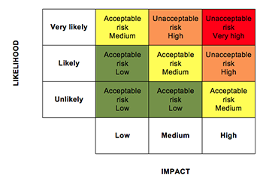

Fall Hazard
There are different types of Fall Hazards, taking into account that these fall hazards can cause serious harm to the workers. Falling from a ladder is one of the common types of falls that is observed in the workplace.
Processes
Different processes can pave the way for this kind of fall. One of the major processes is that of the pressure of works which might lead to a fall. The ladder at wrong angle can also cause this harm along with the fall to occur because ladders break or can slip because of the slippery floor or dirty workplace. All these falls can cause serious injuries to the workers that might lead to a complete breaking of bone(s) and even impotency, taking into account that life-threatening situations can be created (Kim et al., 2018).
Risk Assessment
Taking into account, the serious life threats, the following risk assessment is made

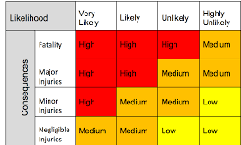

Steps for Risk Assessment
Risk assessment is a systematic procedure that is accomplished by following a series of steps.
Conducting Risk Survey
The first step of risk assessment is carrying out a risk survey that can help to know or identify the risk. This risk survey plays a central role in the identification of the risk (Kim et al., 2018).

Identification of the risk
After conducting a survey and analyzing responses or incidents, some particular risk is identified. This risk is analyzed in terms of a particular risk that is connected with other dimensions of the risk identified (Kim et al., 2018).
Assessing the importance of risk and likelihood of risk
In this step the stance of risk is identified, if the risk is important or is a momentary observation (Kim et al., 2018).
Creating Risk Management plan
This step involves the formation of a risk management plan that comprises of different steps and control measures that can help to overcome the risk. Also, in this step, both practical and theoretical measures are defined so that some solid results can be achieved (Kim et al., 2018).
Implementation of the Risk Assessment plan
It is one of the most crucial steps of any risk assessment plan, taking into account that the measures are developed into practice (Kim et al., 2018).

Controls
There are different control measures that can be used to overcome the risk such as ensuring the ladder is placed in a clean area. Then, the workers should not be rushed or pressurized when they are doing work with ladders. Also, the ladders provided to the workers should be maintained according to standards, in fact, trained employees should be used to do that task. In addition, the risk of falling off a ladder can also be mitigated by teaching workers what to do when they think that the ladders are not at a good angle or there is a risk of fall. This step can also be developed by helping workers with workplace dresses that can reduce the intensity of injury in case of fall (Kim et al., 2018).
Second Assessment
Based on control measures, the probability of falls can be reduced to a notable point, where the assessment table is as follows.
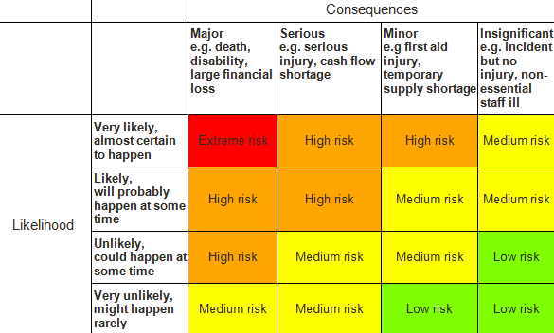

References
Kim, D., & Portillo, M. (2018). Fall Hazards Within Senior Independent Living: A Case-Control Study. HERD, 11(4), 65–81. https://doi.org/10.1177/1937586717754185
Myers, M. (2010). Review of Occupational Hazards Associated with Aquaculture. Journal of Agromedicine, 15(4), 412–426. https://doi.org/10.1080/1059924X.2010.512854

