Instruction Manual: How to Replace a Flat Tire
Jinni
[Institutional Affiliation(s)]

Author Note

Instruction Manual: How to Replace a Flat Tire
How often do people find themselves in a situation where they get a flat tire and feel helpless because they have no clue how to change it? Surveys suggest that nearly 60% of young drivers today are not confident that they can replace a flat tire (Spector, 2016). Flat tires can come about anywhere, and it is quite apparent that knowing how to change a tire is a necessary skill for any driver. Fortunately, changing a flat tire is not too difficult and knowing how to work with a few simple tools can enable you to change one by yourself. By adhering to the following guidelines, changing a flat will not take you more than 15 to 30 minutes. It is, however, important that you do not leave out any of the 10 steps.

Required Equipment and Tools
Most of the tools you will need usually come with the vehicle. These include:

- Jack
- lever arm
- inflated spare tire
- lug wrench
- Owner’s manual.

In case you do not have these items stored in the vehicle, it is important that you purchase them as early as possible. It is also important to ensure that the spare tire is inflated according to the recommended PSI figure (Leister, 2018).
There are a few other items that usually do not come with the vehicle but it is useful to store them in the car’s trunk; they could be especially helpful in certain circumstances. These items include:

- A fully charged flashlight
- Rain Coat
- Wheel Wedges
- A rectangular piece of Wood to Secure the Jack
- Gloves

Key Terms and Processes
The tools and equipment that you will be using include:
- Tires: A rubber covering that is placed around a wheel to create a soft contact between the vehicle and the road
- Lug Nuts: A set of nuts that fasten the wheel to the vehicle’s axle by threaded studs.
- Jack: A small device that can lift the vehicle off ground
- Wrench: A tool that helps unscrew or tighten the lug nuts.
- Lever arm: A tommy bar that operates the Jack

Sequence of Tasks

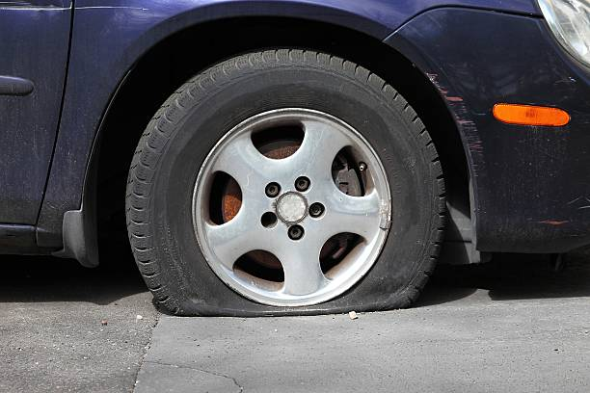
Step 1: Find a Safe location
- When you realize that the tire has gone flat, you have to slowly reduce the speed of the vehicle without abruptly turning. Search your surroundings for a level ground and wide space.
- Check your surroundings for incoming traffic. Avoid spots where an inattentive driver could inadvertently hit you or your vehicle
Step 2: Prepare
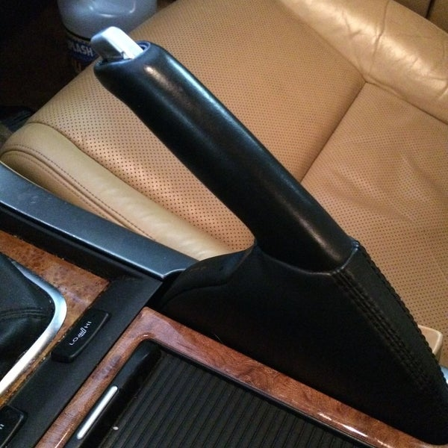
Once you have found a spot and pulled off to the side or a safe location. The next step is to:
- Turn the hazard lights off
- Turn the engine off
- Activate the parking brakes
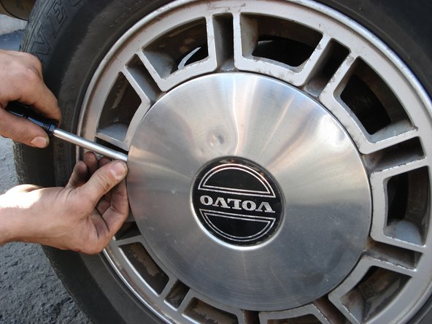
- If you could not find level ground, wedge your tires by means of a piece of wood or rock. If you cannot find any, turn your steering wheel completely to one side

Step 4: Take the Hub Cap Off
- Insert a screwdriver or a sharp object in the gap between the hub cap and the tire
- Slightly apply force towards the outer side
- Repeat the process from other areas around the hub’s circumference, until it loosens

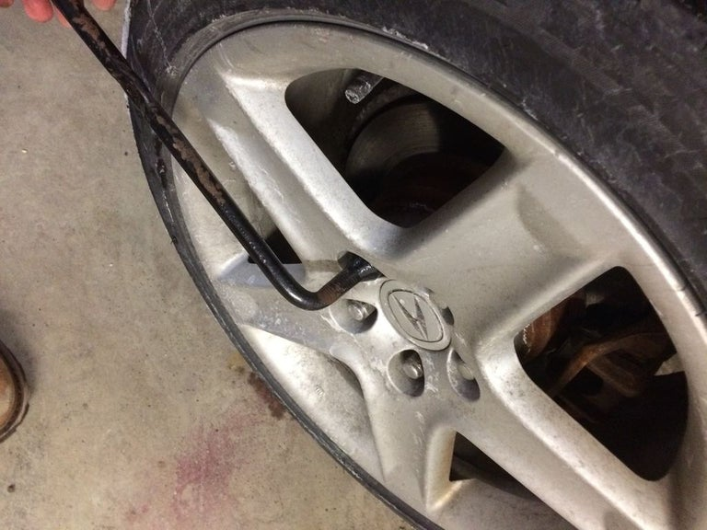
Step 5: Unscrew the Lug Nuts
- Use the lug wrench and place it over the lug net’s head
- Rotate the wrench counterclockwise until it becomes loose
- Stop rotating when you find that the nut can spin freely.
- Do not completely remove the nut and repeat the same steps for the remaining nuts.

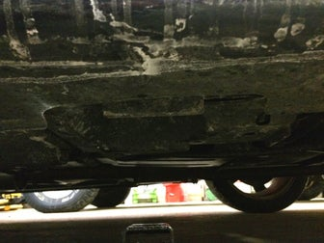
Step 6: Place the Jack in the correct place
- Slide down slightly under the car to locate the chassis frame
- Place the jack under the exact spot. If you cannot locate the frame, use the owner’s manual to find the right spot.
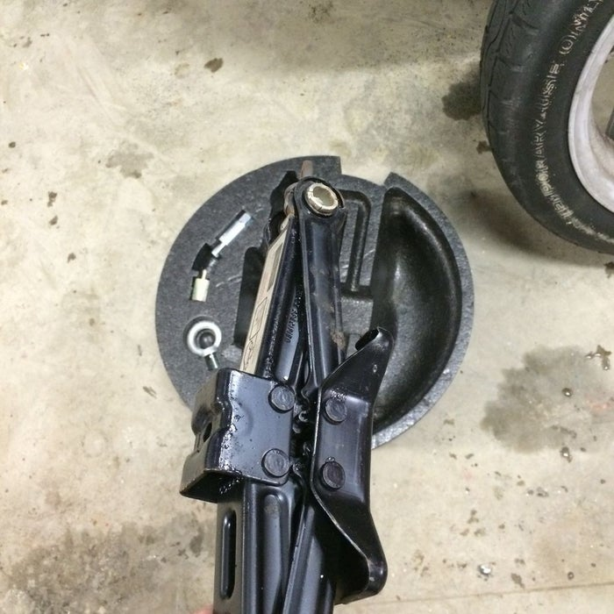
- Make sure that the leverage point of the jack is facing towards you.
- Adjust the Jack’s height manually between the frame and the ground by rotating the screw.
- Most cars come with a scissor jack that operates by a rod-like lever arm.
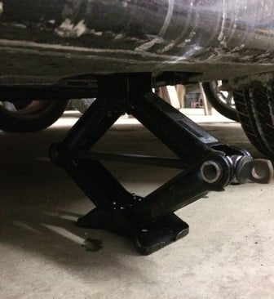
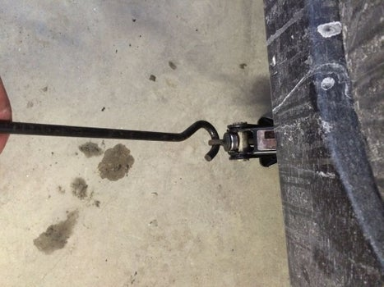

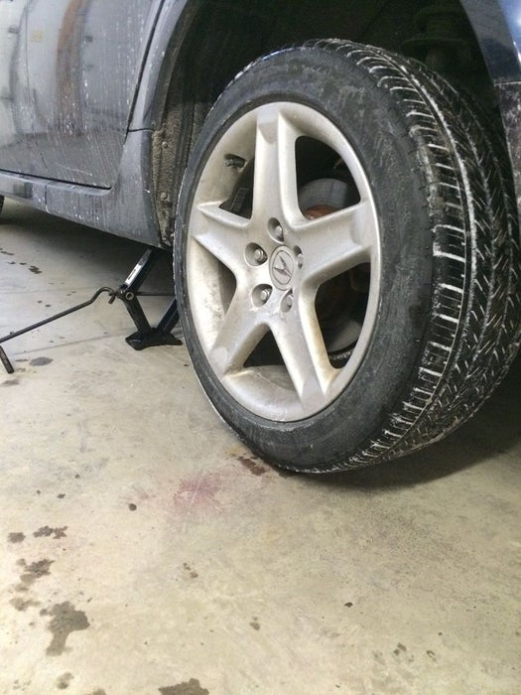
Step 7: Raise the Jack
- Insert the lever arm into the jack’s point of leverage by placing it inside the designated holes.
- Take the other end of the lug wrench into your hand, and ensure that the lever arm is straight and makes a near 90 degree angle with the car’s door.
- Begin turning the lever arm clockwise to operate the jack.
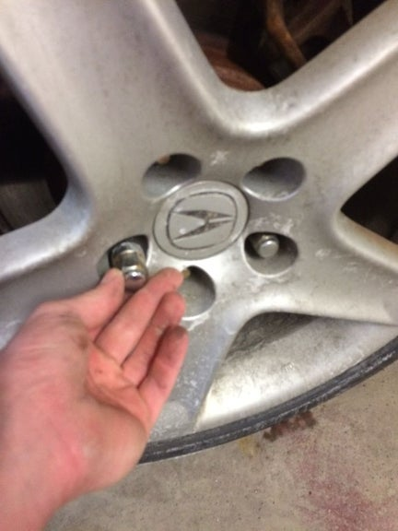
- The jack will raise and lift the car with it. Continue the process until the wheel can spin freely.

Step 7: Unfasten the Lug Nuts
- Once the wheel is free, loosen and remove the lug nuts by hand or the wrench.
- Secure the lug nuts in a safe location
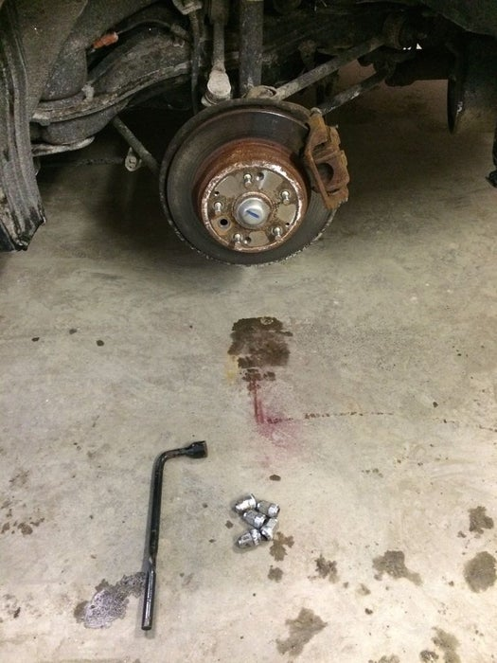
- Grab the flat tire and remove it slowly, allow it to slide off the studs. Pull the tire towards yourself first.
- It is heavy so you will have to apply some strength to lift it and place it on the ground

Step 8: Replace the Tire
- Take the inflated spare tire out of the trunk and align its holes with the studs on the axle
- Once the tire is correctly oriented, push it inside; the studs should pass through the holes
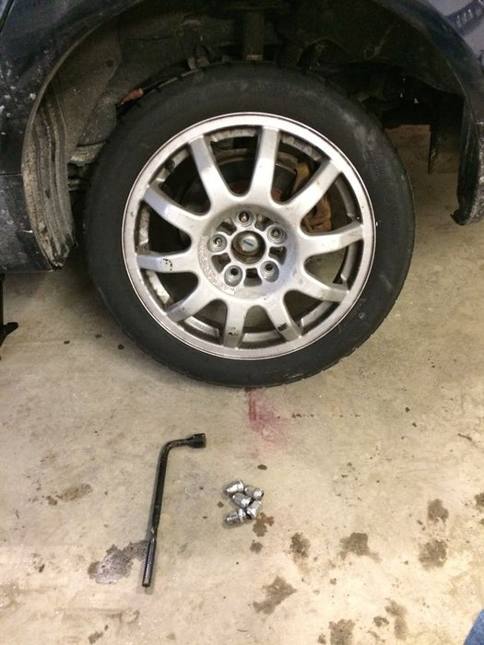
- Tighten the lug nuts by hand onto the studs by rotating them clockwise.
- Continue to manually tighten the nuts until they feel stiff

Step 9: Lower the Car and Tighten the Lug Nuts
- Re-insert the lever arm into the jack and rotate counterclockwise.
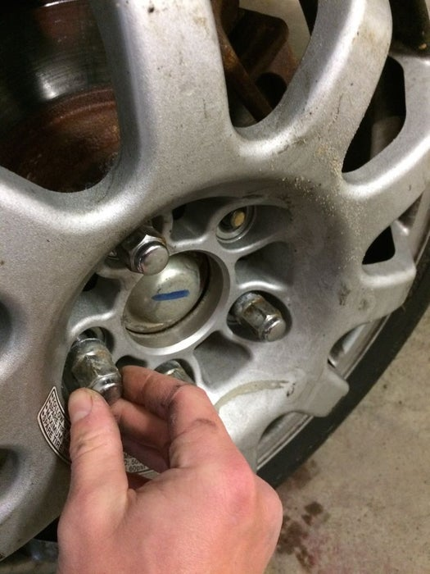
- Keep rotating until the Jack lowers itself and the vehicle with it.
- Once the wheel touches the ground, and is thus no longer free to rotate, use the wrench to further tighten the lug nuts.
- Rotate the nuts in clockwise motion until they are securely fastened.
- Replace the hub cap over the wheel by placing it over the designated spot. It will snap back in.
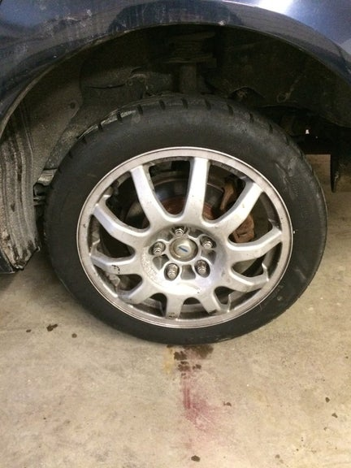
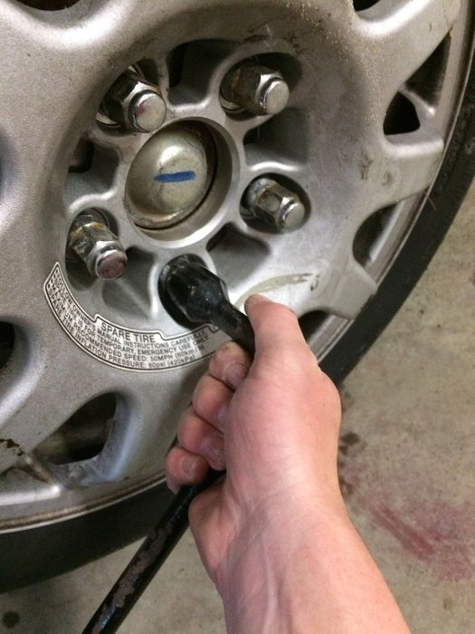
- Again make sure that the lug nuts are securely fastened, after the vehicle is on the ground.

Step 10: Gather all the equipment and go
- Place the flat tire into the trunk where the spare tire used to be
- Gather all the tools and equipment and place them securely in the trunk and glove box
- Visually inspect the tires and the lug nuts to see if everything looks good.
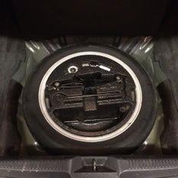
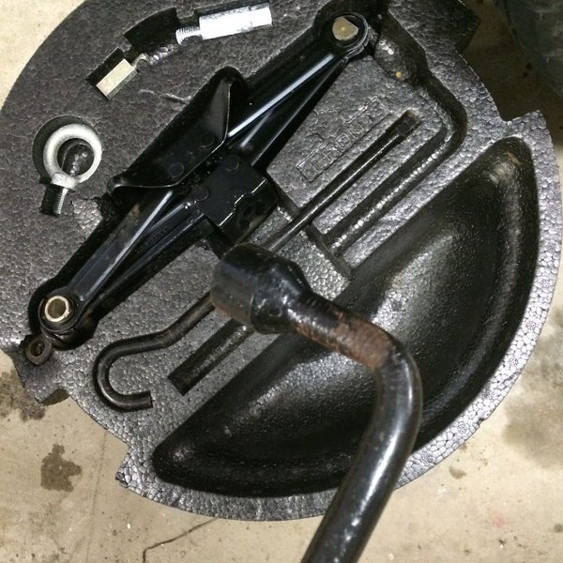
- Drive to the nearest tire technician to get the flat tire fixed or replaced because spare tires are not designed to drive high speeds or long distances.

Safety Precautions
Although the process is fairly safe, however, there are a number of safety precautions you must take. For your safety, it is important to take the following things into account:
- Find the right parking spot; avoid areas where the roads are curved as an incoming driver will have difficulty seeing you.
- Do not change tires on a road with a narrow shoulder, especially when there is oncoming traffic.
- Pick a spot that has a level ground surface. In case you are on an inclined hill, make sure to use wooden wedges or bricks to lock the wheels
- While rotating the jack, do not raise it too high; lift the vehicle only as much as it allows the wheel to rotate freely.
- After the tire is replaced, use the wrench to tighten the lug nuts after the wheel is completely on the ground, and the jack is free.
- Do not remove the lug nuts before lifting the vehicle up using the jack.
- Make sure to apply the parking brakes of the car.

Troubleshooting and Useful Tips
One of the most important tip for vehicle owners in this case is to regularly have the tire pressures inspected by a technician. It is important to maintain the tire pressure between 30 to 40 PSI, or as mentioned in the owner’s manual. If the tire pressure seems low, you should drive slowly to the nearest fuel station to get them inflated at the required pressure. Furthermore, it is important for drivers to know that right or clockwise motion is to tighten the nuts and the left or counterclockwise motion is to loosen them. Some cars have allow or aluminum rims; in that case, it is important to carefully perform the process. It will also be useful to keep spare lug nuts, just in case, because they are easy to lose.
Additionally, even if you are skilled at replacing the tire, prevention is better than treatment. Therefore, it is important to keep the tires inflated and rotated according to the manufacturer’s guidelines. If the tire’s tread seems worn off, replace them with new ones. A worn off tire is more likely to skid, blow up, or prone to punctures. Even though, it is not possible to avoid a flat tire situation altogether, however, proper care and maintenance will substantially improve the performance of the tires (Leister, 2018). It can also reduce the likelihood of getting a flat tire in the first place as the tire becomes more immune to external vulnerabilities.

References
Leister, G. (2018). Passenger car tires and wheels: Development -- manufacturing -- application. Cham, Switzerland: Springer.
Spector, N. (2016, September 28). 60 Percent of People Can't Change a Flat Tire - But Most Can Google It. Retrieved July 31, 2019, from NBC News: https://www.nbcnews.com/business/consumer/draft-60-percent-people-can-t-change-flat-tire-most-n655501

