Research Paper: Human Rights in Egypt
[Author Name(s), First M. Last, Omit Titles and Degrees]
[Institutional Affiliation(s)]

Author Note
[Include any grant/funding information and a complete correspondence address.]

Research Paper: Human Rights in Egypt
Egypt has been in the news over the past few years, for all the wrong reasons in terms of human rights. Gross human right violations has been reported by the Amnesty international, Human rights watch and the UNRC’s annual report. Some important issues related to the human rights situation in Egypt will be discussed in this paper.

Labor Rights

Working conditions
On 30th October 2018, the center for economic and social rights published a report regarding labor rights and workplace equality in Egypt in which several progress indicators are shown to be lacking. Egypt Social Progress Indicators (ESPI) (“ESPI,” 2018) found that the standards that were informed by global human rights values, as well as development pledges to measure progress, depict a general necessity for broad strategy changes to improve socio-economic conditions and work settings (“Labor rights and workplace equality in Egypt,” 2018). Figure 3 shows the labor unemployment rate in Egypt as per the UNICEF data.

Employee benefits
In Egypt, it is well documented that there is a ban on independent trade unions. Independent trade unions are organizations which tend to fight for the rights of traders and employees when necessary. Apart from that, the spending on labor and the working class by the government has been decreased as per the IMF bailout program adopted by Egypt. Due to this very reason, in 2016, a total of 26.5% of the youth (people between 15 and 29) were reported to be unemployed. This is a shocking figure considering that majority of the population of Egypt are in this age group.

Civil and political rights

Freedom of the Press
According to a report published, in May of this year, by the Tahrir Institute for Middle East Policy, Egypt is amongst the worst offenders against freedom of the press (“TIMEP Brief,” n.d.). Other sources provide a very similar account of the situation. According to the RFS newsletter, Egypt is the country with the greatest number of journalists in jail. Most convicted without adequate trial (“Egypt,” n.d.). International media outlets such as Al Jazeera and BBC have also been banned by the government on allegations of supporting violence. The narrative of anti-terrorism has been used to delegitimize protests by the regime. The results of which can be seen through the eruption of even more protests as shown in Figure 1 and Figure 2.

Discrimination
In Egypt, there seems to be a multi-dimensional discrimination policy. One layer of discrimination is against the political rivals of the ruling party. The second layer of discrimination is against the opposing journalists. The third against the LGBT community and women. Focusing on the first layer of discrimination, the authoritarian reign of President Sisi has been a prime example. The persecution of political opponents such as the Muslim brotherhood (Ikhwan ul muslimeen) can be used as a case study for it.

Freedom of thoughts and religion
The constitution of Egypt formally recognizes the absolute right of a citizen to religion of their choice. But in effect, it only identifies three Abrahamic religions i.e. Islam, Christianity and Judaism. According to a report by the US embassy in Egypt, the state of Egypt does allow freedom for the three Abrahamic religions to build places of worship and it is also working actively against ISIS which stands to inhibit it. Egypt has also begun an operation in its northern area against an offshoot of ISIS which lately blew up a mosque because Sufis frequently worshipped in it.

Right to a fair trial
The constitution of the state of Egypt states that Islam is the religion of the state and the main source of legislation is the Sharia. But in practice, it is not being up-held. The articles 189, 193 and 185 grant the president broad and unchecked supervisory powers over the judiciary (Avenue, York, & t 1.212.290.4700, 2019). These articles are used to influence the course of trials and get favorable decisions.

Women Rights

Education
The indicators for women education are improving gradually. The percentage of literate girls has increased from 66.3 % in 1999 to 90% in 2013 (Project, 2018). This, along with the increasing number of USAID projects for women education can paint a bright future for the country. A dark side though is the number of Egyptians suffering from mental health issues as shown in figure 7.

Marriage and divorce
As per the Egyptian civil code, a woman needs permission from a ‘wali’ or caretaker before she can enter into marriage. This directly contradicts the “right to marry” mentioned under Article 16 of the UN constitution. Similarly, a woman has to go to court to get divorced while a man can just verbally divorce his wife. Due to these reasons, in 2013, Egypt was ranked as the worst in terms of women rights in the 22 Arab nations by Thomson Reuter’s foundation (Foundation, n.d.).

Abortion
In the state of Egypt, according to 1937 penal code, abortion is prohibited. But an exception is allowed in case of necessity. Necessity is generally interpreted to imply, saving the life of the mother. So as long as the life of the mother is not in danger, adoption is not permissible (Avenue et al., 2019). This remains to be the case in 2019 as well.

Equal Pay
As per the Central Agency for Public Mobilization and Statistics (CAPMAS), approximately $56 were paid to women whereas $60 to men on a weekly basis in 2017. This means that women earn 0.926 for every 1 EGP paid to men. This gender pay gap is not as bad when compared to other countries. But one thing that needs to be noted is that, the data for this survey remains to be inadequate and skewed. A more comprehensive study was conducted by UNICEF which states that women constitute a total of 21% of the total workforce, while men, the remaining 79%. Another thing that needs to be taken into consideration is that unemployment rates amongst women is much higher than that of men.

Children’s rights

Children labor
As per the international labor organization, about 1.8 million children are engaged in child labor in Egypt, in 2019. More than half of them work in hazardous work environments. The government is working closely with the international labor organization and CAPMAS for improvement in numbers.

Children abuse
According to stats provided by UNICEF, the greatest concern about child abuse comes in the form of female genital mutilation (FGM). The trend has decreased gradually over the past 10 years but regional discrepancies still exist (“Child Protection,” n.d.). The second biggest concern comes in the form of child marriage. It affects about 6.4 percent of the total women population in their teens. Figure 4 shows the percentage of people reporting relevant issues according to the data provided by UNICEF.

Orphans
As per UNICEF, the number of orphans existing in Egypt is around 1700000. A number of private orphanages such as SOS villages, madrassas and Coptic orphanages work for the education and welfare of these children. There is a need though, on a governmental level to take responsibility and address the issue of orphans and to provide them with quality education.

Appendix
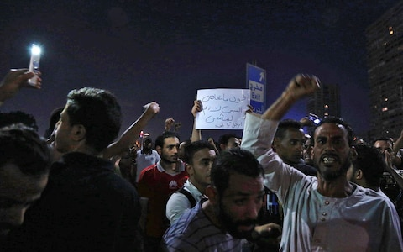
Figure 1- Egypt clamps down on protestors.

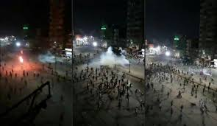
Figure 2- Clampdown on journalists

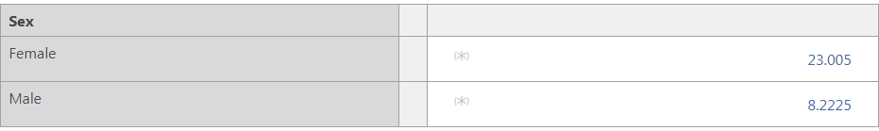
Figure 3-UNICEF-Percentage of unemployed labor force

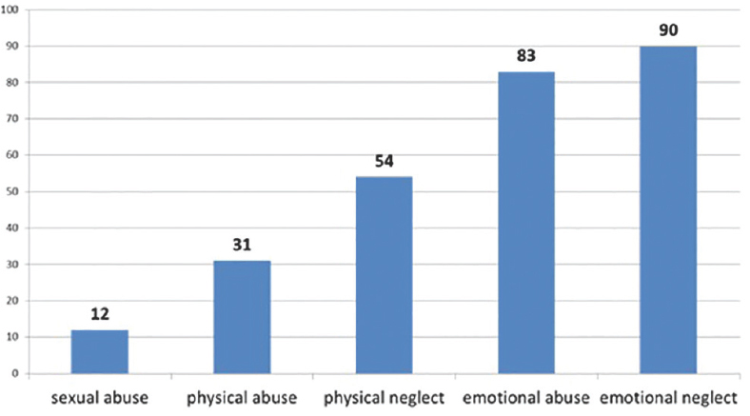
Figure 4-UNICEF-Percentage of people reporting issues.
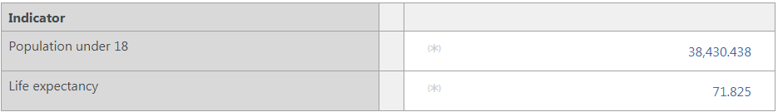
Figure 5-UNICEF-Life expectancy of population under 18

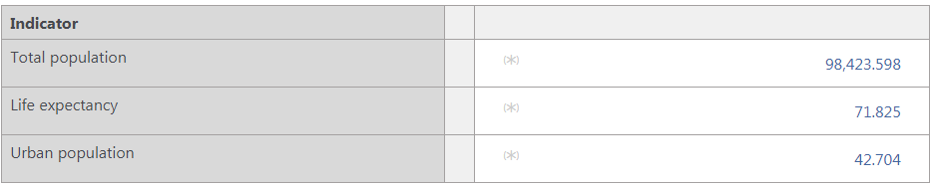
Figure 6-UNICEF-Life expectancy of population

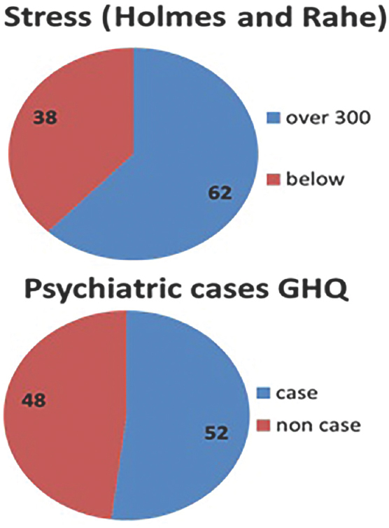
Figure 7-Participants score on Holmes and Rahe scale according to World health questionnaire

References
Avenue, H. R. W. | 350 F., York, 34th Floor | New, & t 1.212.290.4700, N. 10118-3299 U. |. (2019, April 20). Egypt: Constitutional Amendments Entrench Repression. Retrieved November 21, 2019, from Human Rights Watch website: https://www.hrw.org/news/2019/04/20/egypt-constitutional-amendments-entrench-repression
Capacity of Egyptian Government, Workers’ and Employers’ Organizations Strengthened to Combat Child Labour [Project]. (2016, April 1). Retrieved November 21, 2019, from http://www.ilo.org/africa/technical-cooperation/WCMS_548918/lang--en/index.htm
Child Protection. (n.d.). Retrieved November 21, 2019, from https://www.unicef.org/egypt/child-protection-0
Egypt: One of the world’s biggest prisons for journalists | Reporters without borders. (n.d.). Retrieved November 21, 2019, from RSF website: https://rsf.org/en/egypt
ESPI: Egypt Social Progress Indicators. (2018, June 8). Retrieved November 21, 2019, from CESR website: http://www.cesr.org/espi-egypt-social-progress-indicators
Foundation, T. R. (n.d.). The world’s five most dangerous countries for women 2018. Retrieved November 21, 2019, from Poll2018.trust.org website: http://poll2018.trust.org/stories/item/?id=${mainContent.identifier}
Labor rights and workplace equality in Egypt: New measure finds progress lacking. (2018, October 30). Retrieved November 21, 2019, from CESR website: http://www.cesr.org/labor-rights-and-workplace-equality-egypt-new-measure-finds-progress-lacking
Project, B. (2018, July 20). 10 Empowering Facts About Girls’ Education in Egypt. Retrieved November 21, 2019, from The Borgen Project website: https://borgenproject.org/facts-about-girls-education-in-egypt/
TIMEP Brief: Press Freedom in Egypt. (n.d.). Retrieved November 21, 2019, from TIMEP website: https://timep.org/reports-briefings/timep-briefs/timep-brief-press-freedom-in-egypt/

