Sports in America during 1800-1877
[Name of the writer]
[Name of the institution]

Before the nineteenth century, Americans believed in work only and they had no place for recreational activities in their lives. This was due to their religious, economic, and political beliefs. Therefore, most of the United States sports had evolved due to European practices. However, some sports inventions are American such as basketball, snowboarding, volleyball as well as skateboarding. President Thomas Jefferson during his time emphasized over the need for exercise and fitness and for this, he promoted running and swimming. Then presidents Theodore Roosevelt and John F. Kennedy stressed over the physical activity. Now the United States has become a sports-minded country and there are millions of sports fans in the country who follow football, baseball, and hockey. This paper will discuss the history of sports in America during 1800-1877 and will discuss different games in detail.
Baseball:
This was a popular game of the late 1800s. Boys had played this game in streets using balls and bats. Abner Doubleday invented this game in 1839 and Americans started playing baseball on a small level via local rules. In 1840, clubs were established and written rules were adopted. In 1845, Alexander Cartwright introduced standardized rules with reference to bases, size of the ball as well as the pitching the ball. These rules were known as Knickerbocker rules. Americans had played this game during the civil war and they had professional teams for the game. By the 1860s, it was known as America's "national pastime” as children and people having average height and weight and can play this game in comparison with football and basketball.
Thus, the game has a special place in American life and is played at almost every place in America during the spring and summer months. There are two teams in the game who take turns and play defense and offense. Each team has nine players active at a time. The first baseball game was recorded in 1846. The game summary was in the form of paragraphs having long sentences. In 1858, the National Association of Base Ball Players was established. However, they had played the game differently. For example, at that time pitchers were thrown underhand. Moreover, the U.S business communities also played an effective role in the development of the game. They had stimulated their workers to participate in that game in order to develop the discipline. Additionally, women baseball progressed in America. Their participation in the game was the result of social, political and economic times.
In addition, the baseball game was a small-scale version of the greater social scraps in America. After the Civil War, the game got the effects of racial separation. To overcome this, in 1876 in Texas there established all African-American league, known as the New Star Colored League. Till the 20th century, almost all large cities in the eastern United States had professional baseball teams. Therefore, there are number of amateur levels that allow the game such as little leagues and professional leagues. In the U.S., the highest level of baseball is Major League Baseball (MLB). North, South and Central American players are part of this. It is divided into two leagues: the American League and the National League, which are further divided into East, Central, and West.

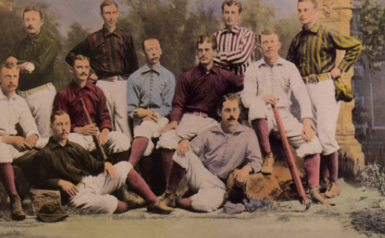
Football:
Walter Camp is the inventor of this game and Americans had played this game since colonial times. The game had its origin from the European game of Rugby. Originally the game was popular as a result of British informal empire in 1830. The first college football game was played between Rutgers and Princeton in 1869. They at New Jersey played a soccer-style game. This was a very different game from the one that we play today. They were not allowed to pick up the ball. But they had to kick or swipe at it while moving towards the scoring zone. This game version was brutal and messy resulting in injuries. After the Civil war, athletic clubs were popular that had a football team. In 1873, the first Intercollegiate Football Association (IFA) was established in order to standardize the rules for the game.
In 1876, upon declaration of Thanksgiving,a national holiday by Abraham Lincoln matches was played every next year. Thus, the development of American football is lined with Ivy League and playing on Thanksgiving Day.
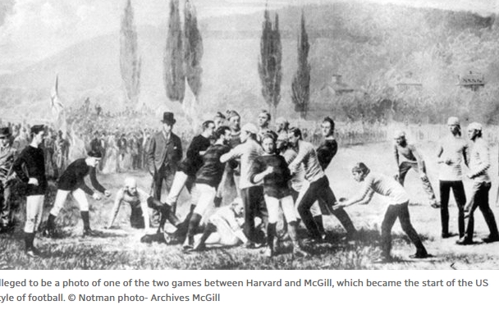
Walter Camp known as the ‘father of American football’ had a major role in the development of this game. He made efforts and organized the game towards its modern form. He was a member of the American Intercollegiate Football Association and instructed for establishing common rules such as the system of downs as well as the number of players per side. Then with the establishment of new rules and equipment, it became a professional sport in the 1890s.
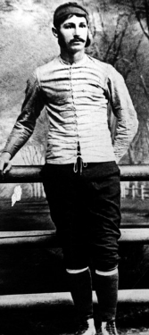
Camp with his efforts made it legalized in 1888 to tackle below the waist. This proved as an offensive strategy and made the game a messy one. It is also known as “flying wedge”. This style of play was extremely brutal and the game was nearly stopped in the 1890s and early 1900s. However, this game was banned due to injuries as players had not worn helmets at that time. The game was first banned in Yale in 1860 than in Harvard in 1861. The game was then adopted by schools and first formal football club was established in 1862. In 1960, there formed The American Football League. In addition, the participation of women in the game started with the establishment of National Football League (NFL).
Ice hockey:
James Creighton invented this game in 1872 and the first artificial ice rink was built in the U.S. in 1894. The game was started with the Canadian immigrants who used to play this game with sticks and balls on frozen ponds and lakes during the winter season. The game had first set of rules known as “Halifax rules”. Here the puck was not allowed to leave the ice as well as no forward passing was allowed. In the late 1800s, this game became very famous. Now there was a need to have a set of formal rules. In 1877 the Montreal Rules were created. According to these rules, injured players were not allowed to replace. In addition, the team sizes were positioned at seven.
After a few years, in 1896, the second artificial ice rink was formed in New York. Now, there is a national hockey league which is a certified hockey league in North America.

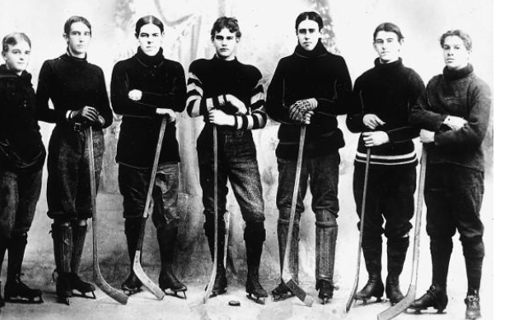

In North America, the game is popular but still requires hard rules. There can be a midgamefight between two players. These fights are permissiblealso at a professional level. Nearly 800,000 youth are registered in North America for ice hockey leagues. Fights have made the game risky as players are always at risk of injury. The potential risks are body checking as well as aggressive play. Moreover, primarily the game was considered as a game for the upper class, however, during the late 1800’s middle and lower class also started playing this game. The game was made part of Olympics in 1920. Moreover, the participation of women in the game also assisted in its growth. The National Women's Hockey League was established in 2015.

Bibliography
Brown, Matthew. “British Informal Empire and the Origins of Association Football in South America.” Soccer & Society 16, no. 2–3 (2015): 169–82.
Collins, Tony. How Football Began: A Global History of How the World’s Football Codes Were Born. Routledge, 2018.
Crepeau, Richard C. NFL Football: A History of America’s New National Pastime. University of Illinois Press, 2014.
“Cusimano, Michael D., Gabriela Ilie, Sarah J. Mullen,... - Google Scholar.” Accessed May 15, 2019. https://scholar.google.com.pk/scholar?hl=en&as_sdt=0%2C5&q=Cusimano%2C+Michael+D.%2C+Gabriela+Ilie%2C+Sarah+J.+Mullen%2C+Christopher+R.+Pauley%2C+Jennifer+R.+Stulberg%2C+Jane+Topolovec-Vranic%2C+and+Stanley+Zhang.+%22Aggression%2C+violence+and+injury+in+minor+league+ice+hockey%3A+avenues+for+prevention+of+injury.%22+PloS+one+11%2C+no.+6+%282016%29%3A+e0156683.&btnG=.
Davies, Richard O. Sports in American Life: A History. John Wiley & Sons, 2016.
Edelman, Robert, and Wayne Wilson. The Oxford Handbook of Sports History. Oxford University Press, 2017.
Elias, Robert. Baseball and the American Dream: Race, Class, Gender, and the National Pastime. Routledge, 2016.
Heaphy, Leslie A. Black Ball 9: New Research in African American Baseball History. Vol. 9. McFarland, 2017.
History of American Football, n.d. https://www.youtube.com/watch?v=JX1BqLQ4HaA.
“Johnson, Victoria E. "‘Together, We Make Football’:... - Google Scholar.” Accessed May 15, 2019. https://scholar.google.com.pk/scholar?q=Johnson,+Victoria+E.+%22%E2%80%9CTogether,+we+make+football%E2%80%9D:+The+NFL%E2%80%99s+%E2%80%9Cfeminine%E2%80%9D+discourses.%22+Popular+Communication+14,+no.+1+(2016):+12-20.&hl=en&as_sdt=0,5.
“Kuhn, Andrew W., Benjamin C. Noonan, Bryan T. Kelly,... - Google Scholar.” Accessed May 15, 2019. https://scholar.google.com.pk/scholar?hl=en&as_sdt=0%2C5&q=Kuhn%2C+Andrew+W.%2C+Benjamin+C.+Noonan%2C+Bryan+T.+Kelly%2C+Christopher+M.+Larson%2C+and+Asheesh+Bedi.+%22The+hip+in+ice+hockey%3A+A+Current+concepts+review.%22+Arthroscopy%3A+The+Journal+of+Arthroscopic+%26+Related+Surgery+32%2C+no.+9+%282016%29%3A+1928-1938.&btnG=.
“Lewinson, Ryan T., and Oscar E. Palma. "The Morality... - Google Scholar.” Accessed May 15, 2019. https://scholar.google.com.pk/scholar?hl=en&as_sdt=0%2C5&q=Lewinson%2C+Ryan+T.%2C+and+Oscar+E.+Palma.+%22The+morality+of+fighting+in+ice+hockey%3A+Should+it+be+banned%3F.%22+Journal+of+Sport+and+Social+Issues+36%2C+no.+1+%282012%29%3A+106-112.&btnG=.
Robertson, John G. The Games That Changed Baseball: Milestones in Major League History. McFarland, 2016.
Silverman, Alex, and Staff Writer. “U.S. Hockey Growth Showing up on NHL Rosters,” 2017. https://www.sportsbusinessdaily.com/Journal/Issues/2017/02/27/Leagues-and-Governing-Bodies/USHockey.aspx.
“Watterson, John. "best-Known of His Books for Boys... - Google Scholar.” Accessed May 15, 2019. https://scholar.google.com.pk/scholar?hl=en&as_sdt=0%2C5&q=Watterson%2C+John.+%22best-known+of+his+books+for+boys+were+The+Substitute+%281908%29+and+Jack+Hall+at+Yale+%281909%29.+He+collaborated+with+Harvard%E2%80%99s+Lorin+F.+Deland%2C+inventor+of+the+flying+wedge%2C+on+Football+%281896%29%2C+and+for+31+years+edited+Spald-ing%E2%80%99s+Official+Intercollegiate+Football+Guide.%22+Sports+in+America+from+Colonial+Times+to+the+Twenty-First+Century%3A+An+Encyclopedia%3A+An+Encyclopedia+%282015%29%3A+221.&btnG=.

Elias, Baseball and the American Dream: Race, Class, Gender, and the National Pastime.
Davies, Sports in American Life: A History.
Robertson, The Games That Changed Baseball: Milestones in Major League History.
Edelman and Wilson, The Oxford Handbook of Sports History.
Heaphy, Black Ball 9: New Research in African American Baseball History.
Brown, “British Informal Empire and the Origins of Association Football in South America.”
History of American Football.
“Johnson, Victoria E. "‘Together, We Make Football’:... - Google Scholar.”
“Watterson, John. "best-Known of His Books for Boys... - Google Scholar.”
“Watterson, John. "best-Known of His Books for Boys... - Google Scholar.”
Collins, How Football Began: A Global History of How the World’s Football Codes Were Born.
Crepeau, NFL Football: A History of America’s New National Pastime.
Silverman and Writer, “U.S. Hockey Growth Showing up on NHL Rosters.”
“Lewinson, Ryan T., and Oscar E. Palma. "The Morality... - Google Scholar.”
“Cusimano, Michael D., Gabriela Ilie, Sarah J. Mullen,... - Google Scholar.”
“Kuhn, Andrew W., Benjamin C. Noonan, Bryan T. Kelly,... - Google Scholar.”

