Your Name
Instructor Name
Course Number
Date

Information Systems in Business
Response 1
HTML
HTML stands for HyperText Markup Language. It is a language used to design documents. These documents are then displayed using web browsers. These documents form the foundation of websites as HTML is used to design the front end of every page. HTML is used in combination with other programming languages to form a complete website. The basis of HTML is formed with the help of its components called elements. Elements are represented by the use of tags. Tags can come either in pairs or alone. The tags that come in pairs are of the form <tags></tags> while the tags that come individually are of the form </tag>
CSS
CSS stands for Cascading Style Sheets. CSS is a language that is used to define the presentation of documents that are developed using HTML. CSS gives the documents another dimension by adding features that would result in sophisticated designs of the web pages. CSS is basically used to keep the presentation of different elements separate from their functionality. The different properties like colour, font-style, etc. are all kept separate. CSS is of three types: inline, internal, and external. Inline means that the properties are defined at the place where the element is created. Internal means the CSS is present in the same file but in a different block. External means that the CSS is placed in a different file and the link to that file is made in the main page.
Javascript
Javascript is a high-level programming language. JS is used as a client-side scripting language for webpages. JS can also be used without the interference of web browsers. Javascript helps to create webpages that one can interact with and it forms the basis of the web applications. A huge percentage of website developers use JS in their works and web browsers fully support its execution through dedicated elements. Initially, JS was only used on the client-side as a scripting language but nowadays, it is also integrated with server-side components that are used in web-servers and databases. JS follows the object-oriented programing paradigm and is a just-in-time compiled language (How Software Is Made). It means that the code for JS language is executed at the execution time of the software and not earlier like it happens in other languages (How Computers Work - Software).

Response 2
The given page is an online service that is used to execute HTML, CSS, and JS codes. The page is divided into 2 parts. The left pane contains details about the user. The right pane is divided into four parts. 3 parts are used to write codes for HTML, CSS, and JS while the fourth part shows the output. The existing scripts had elements of HTML and CSS embedded in the website (Alawar and Abu Naser). It showed an output with a box that changes colour depending upon the side it is accessed from (Multi-Direction Hover - JSFiddle).

Response 3
The given code is run in the HTML section of the jsfiddle. The code basically displays 5 lines of data (Multi-Direction Hover - JSFiddle).
- I love Pizza
- I love Beans
- I love Tacos
- I love Fish
- I love Chicken
The above lines are displayed as output on a white screen. The code is written with a combination of HTML and JavaScript. The <script> tag is used to represent the code that belongs to JS. The main display of lines of text is done through JS while the arrangement of the lines is done through the paragraph element of HTML (Alawar and Abu Naser).

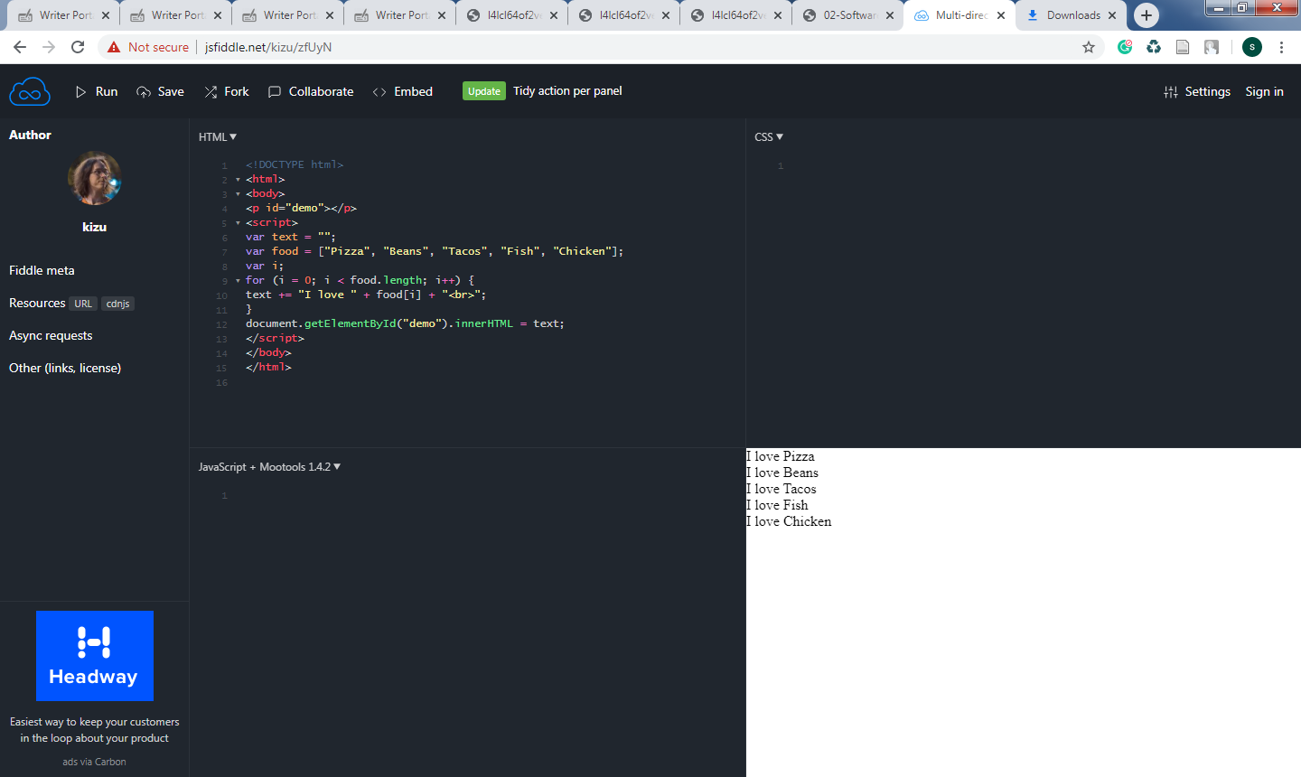

Response 4
The code has been modified and the names of my favourite foods have been added.
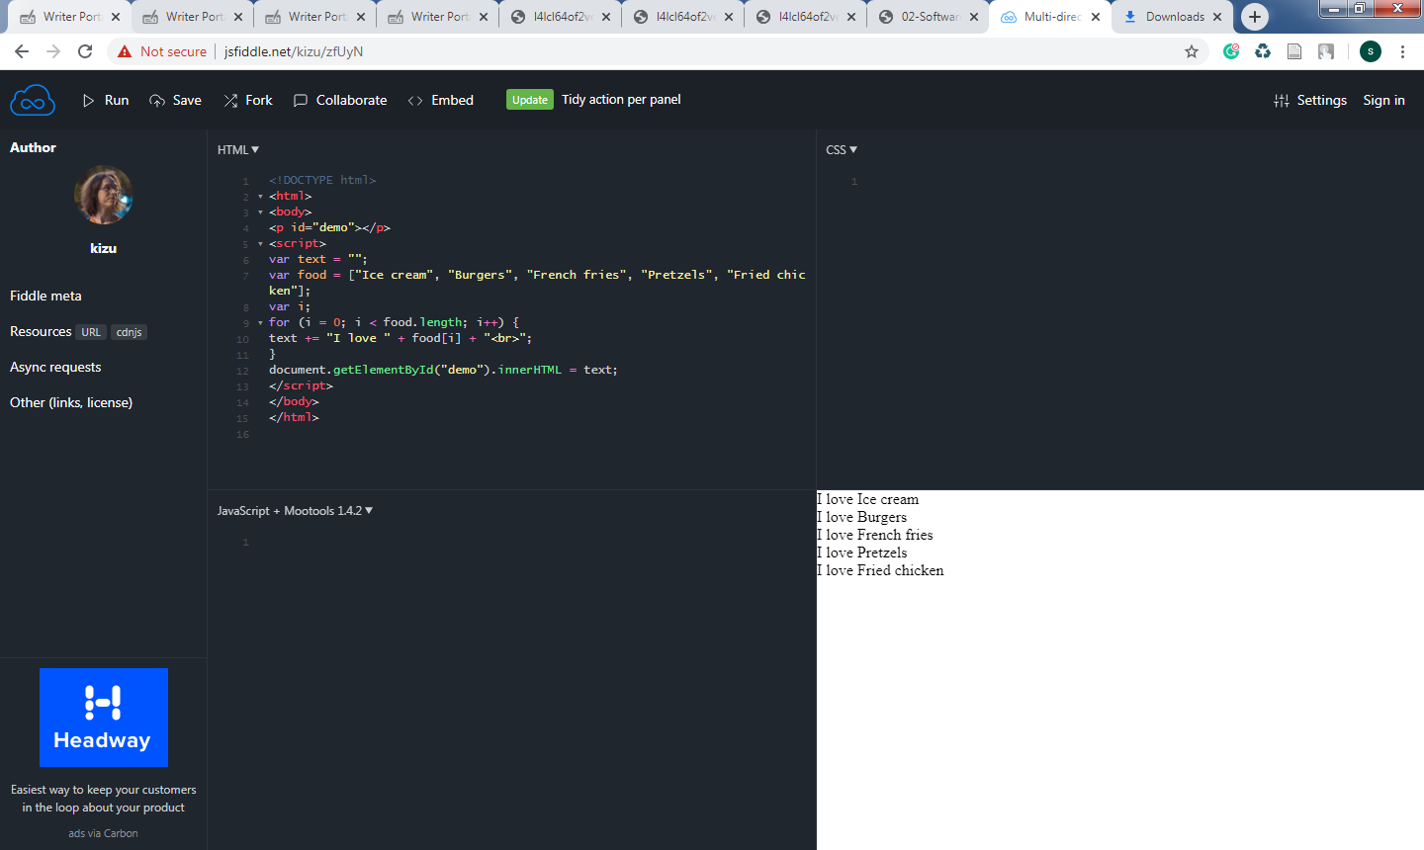

Works Cited:
Alawar, Mariam W., and Samy S. Abu Naser. “CSS-Tutor: An Intelligent Tutoring System for CSS and HTML.” International Journal of Academic Research and Development, vol. 2, no. 1, Mar. 2017, pp. 94–98.
How Computers Work - Software. https://introcomputing.org/how-computers-work-software.html. Accessed 16 Jan. 2020.
How Software Is Made. YouTube, https://www.youtube.com/watch?v=bWdeGTJxMQc. Accessed 16 Jan. 2020.
Multi-Direction Hover - JSFiddle. http://jsfiddle.net/kizu/zfUyN/. Accessed 16 Jan. 2020.

