UNIT 5 DB

Student’s name
Institution’s name

UNIT 5 DB
Introduction
According to the mentioned case, global strategy plan is ready to get implemented, managed, and supported. In this context, the required elaboration is given below.
Globalization and Its Efficacy for Organization:
Globalization is an effective way to expand the market for a business's products and services that are imperative for its long-term fruition. Globalization proffers exacerbated benefits to business and opens up the paths to access the international business markets. (Quain, 2019) The notion of globalization connects the productive efficacy with the target international markets. Moreover, globalization supports an organization to provide its products and services to a wide customer-base at relatively low prices. (Marcic & Daft, 2010) On the other hand, the company can attain maximized advantages through the sharing of international technologies, skills, and ideas.
The Rationale for the Decision
The underlying purpose of taking the subject decision regarding globalization is the interrelated pros and the developmental pace of the international and national market place. Furniture businesses have ample of opportunities to augment and improve the overall business activities of furniture productions. By implementing globalization strategic framework, the company can increase its profitability and financial stability in the market. Moreover, through practising globalization, the company can add value to its profile by incorporating enhanced labour, technology, and skills as well as funding. Furthermore, the global presence of business will help it to gain exacerbated competitive advantages over local rivals as well.
Geographic Location for Global Expansion
According to research and observation, it is evident that India's market is a feasible geographical location to expand the furniture business. And it is the market place that features fewer intricacies in exporting furniture-based products than any other similar country. Similarly, India can be considered as a gateway to establish a furniture market in other Asian countries. Further, the recent epoch of globalization creates several opportunities in Indian and Chinese markets, and according to such privileges the company can utilize the developed infrastructure to transport and market the furniture efficiently.
Information to Support the Decision
According to the statistics in 2017, India exported furniture worth approximately 494 million dollars. (World's Richest Countries, 2017) India is a leading name in furniture exporting and is generating massive profits through the subject exports. The other supporting information is given in the below charts.
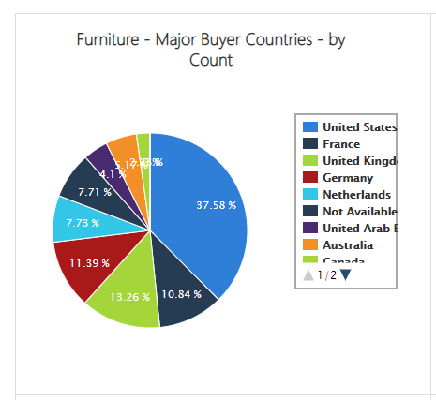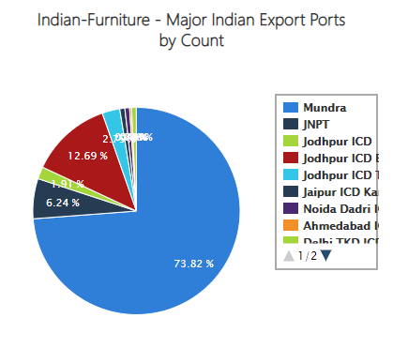

Decision and the Overall Goal of Growth and Expansion
Subsequent to the implementation of globalization strategy to expand the company's business to India, the business will be equipped with a chance to sell the furniture to different local regions as well. And as it is mentioned above that India can become a link between the company and their Asian countries, through which, it would be convenient to transport the exporting goods to other nearby countries that in turn, will boost the overall market share and sales of the company. Likewise, the company can take initiative to commence an online shopping facility for the nearer locations of central Asia as well. In this way, the company can indulge in the substantial potency of profit maximization and increased market share, simultaneously.
Refuting the Opposing Perspective
Phenomenally, any proposed opposing perspective regarding the efficacy of globalization is utterly futile and vague. Globalization is a new black that has enwrapped the entire world of international businesses. It is absurd to consider that a company can save itself from the effects of globalization by avoiding its practice because globalization has sufficient potential to impact every organization in the global market. Globalization opens up the new horizons for a business in another country and proffers it with a chance to employ the resources of that country for production. Elevated investments and augmented market shares are the most eminent aspects of globalization. However, it also has a few disadvantages, such as excessive competition, but that can be tackled by a smart strategic framework.

Reference
Daft, R. L., & Marcic, D. (2017). Understanding management. Australia: Cengage Learning.
Fastest-Growing Furniture Export Countries. (2017).
http://www.worldsrichestcountries.com/top-furniture-exporters.html
Indian Furniture Export Data. (2019, March 16). https://www.infodriveindia.com/india-export-
data/indian-furniture-export-data.aspx
Quain, S. (2019, March 05). Why Has Globalization Become so Important?
https://smallbusiness.chron.com/globalization-become-important-77671.html
Sakir, S., & Sakir, S. (2014, December 15). Globalization Is Only a Good Thing If It Benefits All
Groups of Society. https://www.huffingtonpost.ca/salman-
sakir/globalization_b_5992002.html

