Economics
Student’s Name
Institution
Date

- Complete a table for Q, Price, TC, MC, MR and profits. Start the price at the number of letters in your first and last names combined for Q = 1,

Quantity | Total Cost | Marginal Cost | Total Revenue | Marginal Revenue | Profit
0 | $ 8 | --- | $ 0 | --- | $ -8
1 | 9 | $ 1 | 8 | $ 8 | -1
2 | 10 | 1 | 16 | 8 | 6
3 | 11 | 1 | 24 | 8 | 13
4 | 13 | 2 | 32 | 8 | 19
5 | 19 | 6 | 40 | 8 | 21
6 | 27 | 8 | 48 | 8 | 21
7 | 37 | 10 | 56 | 8 | 19

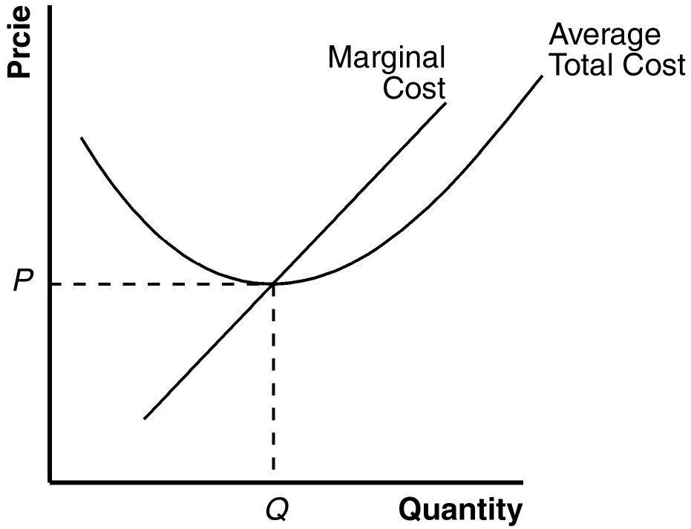
- As an economist I would advise her to reopen the booth. First, the business has indicated a success performance in the last weeks. The decline in performance might be due to some market factors such as decrease in demand or increase in supply. I would advise her to look at the competitors and the market change to determine the decline in sales. The analysis also indicates that the business has high demand from students and it would be appropriate to continue (Scauzillo, 2019). I would also advise her not to get discouraged with the cost of setting up the business. The cost is high since it is projected that she would spend approximately $250 for setting up the business. However, the profit can be increased and I would advise her to derive tactics to increase the business sales. This could be done through intensive marketing online to increase demand. With increase of demand the profitability would be high as well.
- Glendale Water and Power is enjoying the monopoly since it is only the company producing energy and supplying the Loss Angels region. The monopoly occurs when a single firm supplies the market with specific products and in this case, Glendale Water and Power is the only know company, which produces energy in the region. The monopolistic of the market by a single company (Lister, 2016). Monopoly of a market occurs in various ways. First, it could be through the control of supply chain from the production. And Glendale Water and Power controls the production of energy in the region and this gives it a competitive advantage over the rest of the companies, which supply energy in the region. The monopoly has an effect in the market and it affects both price and demand. In a monopoly market, the supply is constant, the demand is the demand and the price always remains the same. It makes the consumers to suffer of high prices of the commodities and therefore, it is always not encouraged. Monopoly can also refuse to sell goods to customers and this can lead to direct shutdown of business.

- For sales of juices and other related products it would be advisable to have variable explicit cost. The variable explicit cost is based on the output registered by a company. And therefore, explicit costs are the expenditures incurred by the company when producing goods (Lister, 2016). The variable cost changes when the company increases or decreases the production, while the fixed cost remains the same whether the company increases or decreases the production. The fixed cost is not good for business and it can make the business to incur a lot of loses (Kenton, 2017). It is important to have variable explicit cost as the method of costing for business.

Bibliography
Kenton, W. (2017). Explicit Cost. https://www.investopedia.com/terms/e/explicitcost.asp , 2-35.
Lister, J. (2016). Explicit & Implicit Business Transactions. Journal of Business and Economic , 2-18.
Scauzillo, S. (2019). Glendale puts its natural gas plant back on the table — while LA, others back away from fossil fuels. https://www.dailynews.com/2019/04/06/glendale-puts-its-natural-gas-plant-back-on-the-table-while-la-others-back-away-from-fossil-fuels/ , 2-35.

