Coordinated Market vs Liberal Market
[Name of the Writer]
[Name of the Institution]

Contents
Introduction 3
Two Models Of Capitalism 3
Role of the Political Institutions 4
Capitalist System 5
Structure of Financial Organizations 6
Role of Political System 9
Sensitivity of the Global Market 10
Role of European Union 11
Reasons for Success of these Economies 12
Conclusion 13
References 14

Coordinated Market vs Liberal Market

Introduction
The globalization model is a model of a corporate dictatorship that is characterized as a strategy for the expansion of commercial and financial operations of large transnational corporations, which is preceded by a military and political expansion of the imperialist states. The military alliances of the imperialist states and the military apparatuses of other states promote the penetration and expansion of transnationals in international markets The agents of international financial and economic corporatism are the protagonists of the new model of neoliberal development and to achieve their goals, they have dispensing with the intermediation of the political institutions of the nation-state (Asheim & Coenen, 2018). In this paper, it is going to be seen that how the more coordinated economies are in much better health and shape as compared to the conventional economies

Two Models Of Capitalism
In the 90’s, there were two models of the capitalism that where working at that point of time that were quite a contrast to one another. The first type of capital was witnessed in the Rhineland Germany and the other was witnessed in the United States and the United Kingdom. The first one committed to making sure that the long term growth is needed to be brought into the economy where on the other hand, the second idea was based on how profit making ability of the entities can be made better and how the value creation and its process for the shareholder can be improved. The ideas were to make sure that the right sort of balance among both the rationales is needed to be carried out (Asheim & Coenen, 2018). The problem is that there are many people who were concerned about the short sightedness of the European model. It did not talk about how it can be made sure that the more adaptable changes are needed to be implemented in the economy and how the pace of the economy is supposed to be made better. On the other hand, the other major concern was the social cost of taking these short-term goals that might trigger the economy but in the long run, they were not creating any useful thing for all the stakeholders at the given point of time. The new issue was further amplified the given economic crisis in the sense that the growth model that was witnessed here was quite unsustainable to say the least. The effort way thus needed to be made more flexible and adaptable economic model is needed to be worked upon that would benefit all the stakeholders appropriately.
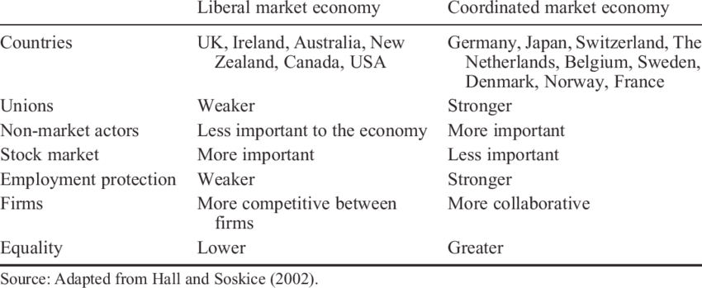

Role of the Political Institutions
The political institutions are determinant in the economic results. The different factions that make up global financial corporatism enter into serious conflicts because of the interests they have in strategic areas of globalization. The differences of class interests between nations are obscured in abstract categories (Asheim & Coenen, 2018). Likewise, global conflicts between different dominant classes clash with each other and the tendency is that war conflicts develop more between these groups with corporate interests in the global than between specific nation-states. Many of these inter-corporate financial and economic confrontations global are the causes of wars, more than the clashes between nations. Society is dominated by large transnational corporations that exercise a form of economic dictatorship (Barry & Nienhueser, 2016). They do so through a supranational structure of institutions, managed by a technocratic bureaucracy at the service of capital, which without any control that balances its economic, political and military power, imposes decisions and restricts the political sovereignty of nation-states (Asheim & Coenen, 2018). These same forces also motivate individual capitalists and capitalist companies to concentrate and centralize their control in various media where wealth accumulates. The spatial structure of geographic units delimited by physical and geographical boundaries define the types of interrelations between the various entities. They suppress political sovereignty by the concept of consumer sovereignty and leave decisions in the development opportunities that individuals have in the hands of the market (Benjamin & Wigand, 2017).

Capitalist System
The capitalist system encourages and encourages continuous and growing consumption. The role of the market imposes criteria for the treatment of citizens based on their purchasing power as consumers, weakens the bonds of solidarity and dismantles the possibilities of collective action (Benjamin & Wigand, 2017). The poor confronted the rich with a problem of collective action: how to create collective arrangements to control the external effects of poverty, while preventing another rich from gaining profits from their actions without contributing (De Swaan Abram, 1997). Therefore, institutions can be perceived as equilibrium solutions to problems of collective choice. Globalization establishes these supranational powers that center on the power of financial markets and impose their decisions on economic policy to national states, with drastic reductions in functions (Barry & Nienhueser, 2016). Thus, the market takes the leading role of development and subordinates the State and society. However, nations that have achieved higher levels of economic development are those that maintain regulations in their financial markets. The recognition that the results of the globalization model implemented until now, oriented by large corporations through their bureaucracies, with their inevitable economic and financial crises, have not been as expected, questions their legitimacy. Even democratic control is difficult to establish and problematic, in addition (Barry & Nienhueser, 2016). As always, it is the imperialist State that always develops the function of crisis management of those States that have problems of currency devaluation, insolvency for the payment of debt, etc. as well as for transnational companies with financial problems.
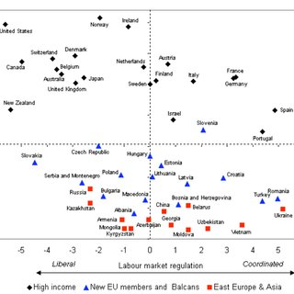

Structure of Financial Organizations
Financial organizations and international investors with multinational capitalist interests have changed the national economic and political decision-making structures through the harassment of financial crises. The financial liberalization that enters as hot money in the form of foreign investments to the countries that liberate their economies, generates speculative bubbles that at the slightest hint of risk that changes the mood of the investor and tries to reap the most that can leave desolation and financial devastation (Benner & Löfgren, 2017). The direct beneficiaries of capitalism recover when they effectively claim that the economic crisis is coming to an end, but this means a high decline in living standards and public services for the majority of citizens, especially the working class (Bosch & Charest, 2018). The privatization of the benefits, risks and responsibilities of public services also alienates social aspirations, which are canceled if subjectivity is excluded from the social order. Due to these measures, the problem was faced among different stakeholders who that how the income and the standard of living of the people who were living in that point of time could be managed in an appropriate manner (Benner & Löfgren, 2017). The effort was needed to be made with regards to how it was going to be made sure that the important sectors the encompass the sub sectors of the economy can be worked upon to make sure that greater sustainability is obtained. . International financial institutions impose globalization processes through anti-democratic and non-transparent procedures (Benner & Löfgren, 2017).
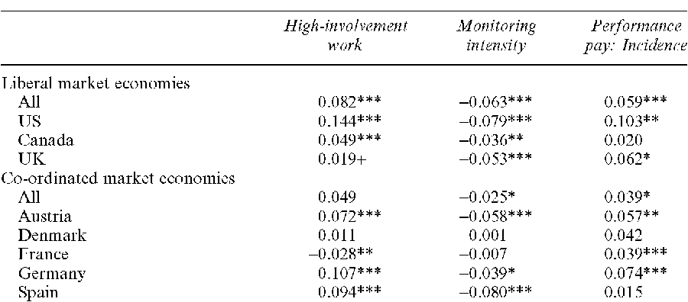

Role of Political System
Democracy is a basic component of the proposed development. The traditional concept of democracy has been reworked in order to support and maintain the status quo of the capitalist system (Benner & Löfgren, 2017). Both the Bank and the other institutions are strong in arguing at a macro level about financial policies and strategies, but they are poor at arguing or giving examples at the micro level of the benefits of globalization for the poor. The benefits obtained by some of the nations of the world that have been involved in the processes of globalization by themselves, have been distributed in an equitable manner (Farndale et al, 2014). However, other nations have not achieved it, especially those that have had the advice of international financial institutions. The international financial institutions impose on the nation-states principles for the management of their economic policy based on the fundamentalism of the free market, which are applied in the debtor countries with negative consequences, while the developed countries evade its application. The processes of globalization do not equitably reward societies or individuals. The globalization of the market economy accelerates trade liberalization, promotes the efficiency and competitiveness of domestic producers and develops deep business contacts (Akkermans et al, 2016). The idea was to make sure that how the system is going to be developed that would allow all the stakeholders to have an equal footing in the economy and allowing them to ensure that they are able to take the most of the competitive advantage that the economy is having at the given point of time. . For Porter (1991), competitiveness, companies have to compete in an environment formed by four attributes that stimulate or limit the creation of competitive advantages. These attributes are the availability of factors of production, internal demand, the structure and strategy of the rivalry of companies and related sectors (Bosch & Charest, 2018).

Sensitivity of the Global Market
Global markets require sensitivity to the local needs of products and services and their spatial and temporal dispersion by the company. The success of the businesses depends on the scope in the global expansion of the organizations (Bosch & Charest, 2018). The competitive challenges posed by the globality of markets to nation-states and organizations in general, consist of identifying the forces of increasing complexity and intensity to adapt to changes, as well as developing processes to identify the characteristics of their global competitors. and to take into account the associated competitive advantages. This means recognizing the possibility of cooperation among competitors as an attempt to conspire and to reduce risks, as can be found in the case within a particular industry operating at the global level. The manipulators may have the expectation that others cooperate, giving themselves the problem of the "cripple", but the illusions about the low costs of cooperation may prevail. Social capital solves this problem of the traveler, through the implementation of sociability strategies that strengthen the bonds of trust, cooperation and generosity between the parties. The formation of coalitions between competitors redirect their energy towards others that are not part of it. Hitt, Keats and DeMarie (1998) argue that companies that move to new markets have many opportunities but also many challenges to overcome and exemplify with the increase of incentives for innovation and improvement opportunities to earn returns on that innovation. However, international expansion activities complicate operations in the various environments. To take advantage of opportunities for regional positioning economies, companies have to learn effective ways to coordinate operations across the borders of many countries (Bosch & Charest, 2018).

Role of European Union
With the current economic crisis, the third difficulty arises: the EU's common rules are under tension as a result of the financial crisis and its effects on the real economy (Busemeyer & Trampusch, 2012). The need to save banks and employment in the sectors of industry with the greatest weight in each country is leading national governments to take measures that fit with difficulties in the liberal scheme and that border protectionism or direct aid to companies , in clear contradiction with the spirit and rules of the EU (Bosch & Charest, 2018). If we add to this the inevitable growth of deficits - partly due to counter-cyclical mechanisms and partly due to stimulus and bail-out packages - that go beyond what is foreseen in the EU's stability and employment pact, it can be thought that the "European model" is going through a transitional moment from which changes in the medium term could arise. The central argument is that if we can talk about a "European model" it is not so much in terms of the organization of the economy, but in what we might call the model of society (Carlin & Soskice, 2018). In Western Europe it is based on the recognition of social rights of citizenship that the State must guarantee (Busemeyer & Trampusch, 2012). The idea that the State should be a "Welfare State", that there is a public responsibility in the creation and maintenance of equal opportunities and social cohesion, is what European societies have in common, regardless of whether or not this idea has been reached from different histories and ideologies, from which it has been more or less successful in different countries, and from which it has been subjected to the pressures of the globalized and competitive economy (Busemeyer & Trampusch, 2012).

Reasons for Success of these Economies
Some analysts considered such a capital injection as a signal of integral monetary relaxation, but this was refuted by the authorities. The government will firmly avoid resorting to a cascade of stimulus policies, as announced at the meeting on Monday (Busemeyer & Trampusch, 2012). Those responsible for policy making are fully aware of the bitter results left by the decision to flood the economy with large volumes of investment made a decade ago: short-term growth gained strength, but so did the potential economic risks. Government regulations will be specific and designed to ensure that the performance of the economy is within a reasonable range, was decided at the meeting. "Coordinated economy has done well to rule out massive stimulus," Japanese securities company Nomura said in a research report. Absolutely aware of asset bubbles, Coordinated economy is in the middle of a deleveraging campaign, in which debtors, including local governments and businesses, are moving quickly to reduce their outstanding accounts to safer levels (Campbell & Pedersen, 2017). The growth of China's macro leverage rate decreased by 10.9 percentage points in 2017 with respect to the average speed between 2012 and 2016, according to the issuer's data. Nomura believes that the new political stance is positive for the capital market in the short term, and that the country's battered (Busemeyer & Trampusch, 2012)high-yield bond markets can benefit from the stimulus. Chinese stocks, after more than a month of showing a mediocre performance, recovered this week, with a rise of 2,900 points in the Shanghai Composite Index after three consecutive days of good performance. For its part, the Shenzhen Composite Index closed at 9,465.8 points, materializing a rise of 1.63 percent.

Conclusion
The superiority of the uncoordinated economies ("Anglo-Saxon") would come from the greater flexibility of the labor market. Without obstacles or high costs for dismissals (seen as "rigidities"), companies could maximize their competitiveness to adapt to new market conditions, which would imply a greater capacity to create jobs for both existing companies and new companies, thanks to the absence of obstacles for its creation. On average, the lower protection of workers would result in a greater dynamism of the labor market, a greater capacity to create employment (Campbell & Pedersen, 2017). This dynamism, however, has not prevented in the current decade there has been an increase in inequality and a strong concentration of wealth, which have only been able to be reconciled with a climate of economic well-being thanks to successive bubbles (on the stock exchanges). values ​​and in the real estate market) that have allowed middle and lower-middle income families to finance their consumption through indebtedness (Carlin & Soskice, 2018). The liberalization of the single market has put strong pressure on governments to privatize public companies, partially or totally, and the prohibition on companies, public or private, receiving government assistance, except for restructuring (Carlin & Soskice, 2018) The objective is to avoid unfair competition that would result from the fact that some companies have aid against the others, as well as avoid the danger that public companies make investment decisions or management decisions based on political and not strictly business criteria (Campbell & Pedersen, 2017).

References

Akkermans, D., Castaldi, C., & Los, B. (2016). Do ‘liberal market economies’ really innovate more radically than ‘coordinated market economies’?: Hall and Soskice reconsidered. Research Policy, 38(1), 181-191.
Asheim, B. T., & Coenen, L. (2018). Contextualising regional innovation systems in a globalising learning economy: on knowledge bases and institutional frameworks. The Journal of Technology Transfer, 31(1), 163-173.
Barry, M., & Nienhueser, W. (2016). Coordinated market economy/liberal employment relations: low cost competition in the German aviation industry. The International Journal of Human Resource Management, 21(2), 214-229.
Benjamin, R., & Wigand, R. (2017). Electronic markets and virtual value chains on the information superhighway. MIT Sloan Management Review, 36(2), 62.
Benner, M., & Löfgren, H. (2017). The bio-economy and the competition state: transcending the dichotomy between coordinated and liberal market economies. New Political Science, 29(1), 77-95.
Bosch, G., & Charest, J. (2018). Vocational training and the labour market in liberal and coordinated economies. Industrial relations journal, 39(5), 428-447.
Busemeyer, M. R., & Trampusch, C. (Eds.). (2012). The political economy of collective skill formation. Oxford University Press.
Campbell, J. L., & Pedersen, O. K. (2017). Knowledge regimes and comparative political economy. Ideas and politics in social science research, 167, 172-90.
Carlin, W., & Soskice, D. (2018). German economic performance: disentangling the role of supply-side reforms, macroeconomic policy and coordinated economy institutions. Socio-Economic Review, 7(1), 67-99.
Farndale, E., Brewster, C., & Poutsma, E. (2014). Coordinated vs. liberal market HRM: the impact of institutionalization on multinational ﬁrms. In International human resource management (pp. 20-39). Routledge.
Hollingsworth, J. R., & Boyer, R. (2017). Coordination of economic actors and social systems of production. Contemporary capitalism: the embeddedness of institutions, 1-47.
Iversen, T., Pontusson, J., & Soskice, D. (Eds.). (2016). Unions, employers, and central banks: macroeconomic coordination and institutional change in social market economies. Cambridge University Press.
Kydd, J., & Dorward, A. (2016). Implications of market and coordination failures for rural development in least developed countries. Journal of international development, 16(7), 951-970.
Lorenz, E., & Lundvall, B. Å. (Eds.). (2016). How Europe's economies learn: coordinating competing models. Oxford University Press.
Malone, T. W., & Laubacher, R. J. (2017). The dawn of the e-lance economy. In Electronic business engineering (pp. 13-24). Physica, Heidelberg.
Molina, O., & Rhodes, M. (2017). The political economy of adjustment in mixed market economies: A study of Spain and Italy. Beyond varieties of capitalism: Conflict, contradictions and complementarities in the European economy, 223-252.
Nölke, A., & Vliegenthart, A. (2019). Enlarging the varieties of capitalism: The emergence of dependent market economies in East Central Europe. World politics, 61(4), 670-702.
Parry, E., Dickmann, M., & Morley, M. (2018). North American MNCs and their HR policies in liberal and coordinated market economies. The International Journal of Human Resource Management, 19(11), 2024-2040.
Schmidt, V. A., & Thatcher, M. (Eds.). (2017). Resilient liberalism in Europe's political economy. Cambridge University Press.
Schneider, B. R., & Soskice, D. (2018). Inequality in developed countries and Latin America: coordinated, liberal and hierarchical systems. Economy and society, 38(1), 17-52.
Shire, K. A., Mottweiler, H., Schönauer, A., & Valverde, M. (2018). Temporary work in coordinated market economies: Evidence from front-line service workplaces. ILR Review, 62(4), 602-617.
Streeck, W., & Thelen, K. (2017). Institutional change in advanced political economies. Debating Varieties of capitalism: a reader, 95-131.
Streeck, W., & Thelen, K. A. (Eds.). (2016). Beyond continuity: Institutional change in advanced political economies. Oxford University Press.
Thelen, K., & Kume, I. (2016). Coordination as a political problem in coordinated market economies. Governance, 19(1), 11-42.
Zlot, R., Stentz, A., Dias, M. B., & Thayer, S. (2018). Multi-robot exploration controlled by a market economy. In Proceedings 2002 IEEE International Conference on Robotics and Automation (Cat. No. 02CH37292) (Vol. 3, pp. 3016-3023). IEEE.

