Tamar Osiasvhili
Instructor Name
Course Number
Date

Meningitis

Introduction
Our brain is covered with a fluid, which is a protective membrane. This fluid is sometimes infected by a viral or bacterial infection. This infection causes swelling and risks the functions of the brain and spinal cord. There are also likely chances of getting this disease after using certain drugs, an accident or cancer. Diseases have to be treated in time, otherwise, they may become fatal for individuals. Therefore, it is important to identify particular causes resulting in meningitis, which demands immediate medical treatment. Bacterial meningitis may be fatal and this may result in permanent disabilities including hearing loss, damage to brain and learning disabilities. When compared to bacterial meningitis, viral meningitis is not that serious and fatal, while this is less severe. People having a normal and strong immunity with viral meningitis are likely to recover on their own.
Symptoms:
The symptoms for meningitis include fever, headache, and stiffness in the neck. There are also other symptoms apart from onset symptoms, which include vomiting, confusion, which results in an altered status of the human mind. This also results in photophobia, which is the sensitivity in our eyes when exposed to light. There are lesser likely chances that symptoms may appear in children and it depends on their ages, however symptoms for meningitis may include slow inactivity, ill-temper, vomiting, and poor feeding (Tønjum et al. 413).
Diagnosis:
When meningitis is suspected, doctors collect blood samples or they may collect a sample of cerebrospinal fluid. After having laboratory reports, causes for this bacterial disease will be identified, then it will be possible to diagnose the disease appropriately. Diagnosis of bacterial meningitis includes the Vitro and culture testing of antimicrobial patterns and later, antibiotic treatment may be suggested (van de Beek et al. 544).
Treatment of the Disease:
Meningitis may be treated with the help of antibiotics and Cerebrospinal fluid treatments and this has to be treated on time. Treatment for meningitis depends on the cause of disease in an individual. Immediate treatment is required for bacterial meningitis, however, a doctor may suggest antibiotics to avoid the spread of extra bacteria in the body. For a reduction in inflammation, a doctor may suggest corticosteroids to an individual.

Incubation Period of Illness and Convalescence Period
The incubation period for the illness of meningitis is a maximum of five days after having initial contact with the bacteria. In some people, the incubation period may be counted as 24 hours, which is a rapid appearance of symptoms of meningitis. While for viral meningitis, the incubation period is counted from few days to few weeks. This may last for only seven to ten days maximum, however, individuals having this viral disease may recover of their immunity can fight back with the disease. Bacterial meningitis may be recovered but bacteria causes life time disabilities of individuals being infected by bacteria (El Bashir et al. 616).

Chemotherapeutic Agents (Drugs Used for Treatment)
There are several treatments for meningitis if diagnosed on time. Initial chemotherapeutic treatment for meningitis is Ampicillin plus cephalosporin due to suffering of individuals from Hemophilus influenza. The recent treatment includes the cephalosporin due to appearance of gram-negative bacilli and Trimethoprim-sulfamethoxazole can be also used as a useful treatment drug (Ampel and Labadie).

Vaccines Available
With the development in the medical field, there have been vaccines, which are developed for the treatment of meningitis. Neisseria meningitides is considered as one of the reasons for causing meningococcal meningitis in individuals, while there are vaccines for the treatment of this type of disease (McIntyre et al.). As discussed, bacterial meningitis is fatal, therefore, timely treatment is important. For bacterial causes of meningitis, there are two types of vaccines: first is a meningococcal conjugate vaccine, which targets bacterial serotypes. The second type of vaccine for the treatment of meningitis is MenB, which targets specific strains with shorter protection gap.

How is Bacterium Transmitted
There are more likely chances in meningitis diseases that germs may spread very easily by causing meningitis. People who live closer are likely to have meningitis and suffer from this disease. Military and students who live in halls are likely to have this disease. The reservoir for Neisseria meningitides is only humans, while animals are not infected. The bacterium is transmitted through close contact of individuals such as kissing, coughing on someone, and sneezing without putting any handkerchief on face. Another source of bacterium transmission is smoking which also includes passive smoking. This can be also transmitted in those places where there are many people are in closer contact. While bacteria are carried in throat and this sometimes enters the human brain through bloodstreams.
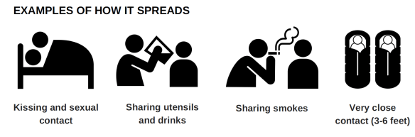

How can the bacterium/illness be avoided
It is important for individuals to protect themselves from severe and fatal diseases. There are some prevention measures, which individuals may be directed by the doctors to avoid bacterium or one can follow general precautionary measures. These include having adequate rest, no smoking, avoiding meeting people who are sick. This disease mostly spreads because of prolonged and closer contact of people with each other. Transmission may be avoided with the help of chemoprophylaxis furthermore; it is also suggested to people living in non-epidemic conditions. Vaccines may also be used to avoid any further spread of this disease.

Any notable feature of the disease
The Neisseria meningitis causes rashes on human skin, which may be considered as a symptom and this targets human capillaries.
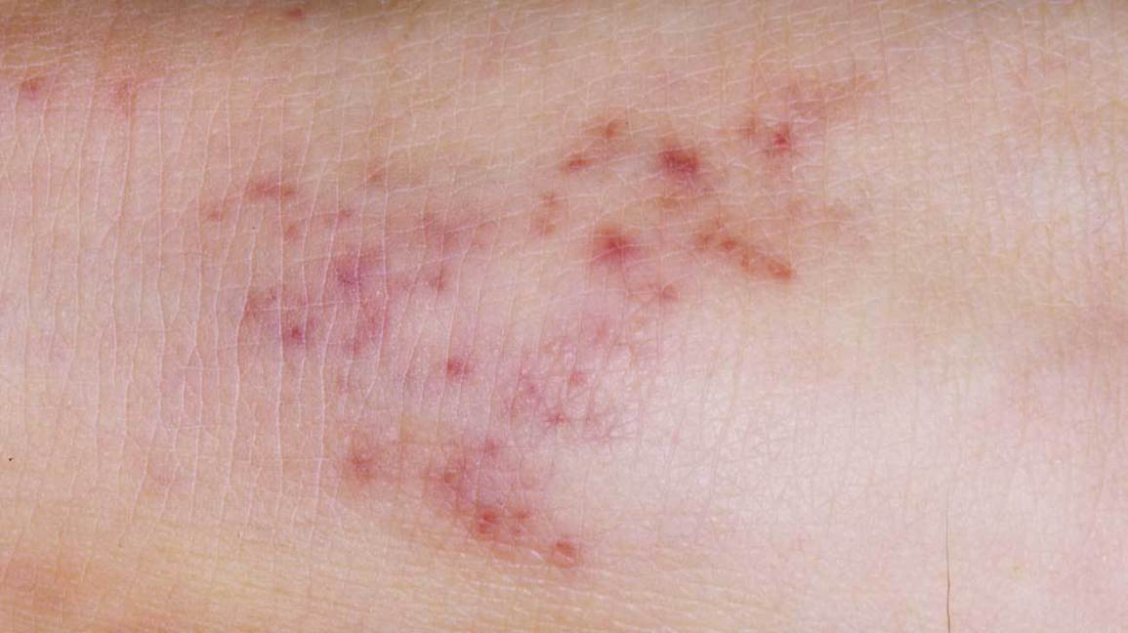

Works Cited:
Ampel, Neil M., and Enrique L. Labadie. “Chemotherapy for Bacterial Infections of the Central Nervous System.” Western Journal of Medicine, vol. 147, no. 3, 1987, p. 309.
El Bashir, H., et al. “Diagnosis and Treatment of Bacterial Meningitis.” Archives of Disease in Childhood, vol. 88, no. 7, 2003, pp. 615–20.
McIntyre, Peter B., et al. “Effect of Vaccines on Bacterial Meningitis Worldwide.” The Lancet, vol. 380, no. 9854, 2012, pp. 1703–11.
Tønjum, Tone, et al. “Meningitis.” The Prokaryotes: Human Microbiology, 2013, pp. 401–27.
van de Beek, Dꎬ, et al. “ESCMID Guideline: Diagnosis and Treatment of Acute Bacterial Meningitis.” Clinical Microbiology and Infection, vol. 22, 2016, pp. S37–62.

