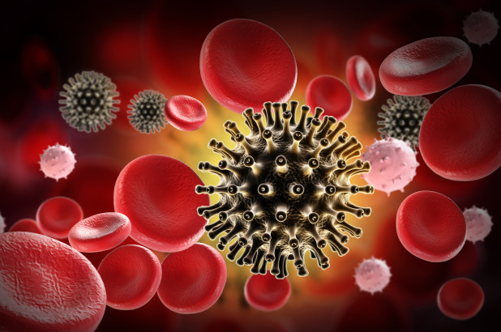

HIV

Weekly Newsletter

Today, HIV is recognized as one of the major global public health issues that affect communities around the world. The hazards of HIV are increasing, which requires necessary and appropriate attention. The health indicator of HIV stands for human immunodeficiency virus that eventually leads to the disease of AIDS if not properly treated on time. The growing risk of HIV is a chronic concern because it affects the immune system of the body. The virus of HIV restricts the body's ability to fight against the causes of the disease successfully. HIV is recognized as sexually transmitted infection (STI), and this approach eventually increases the potential risk of the spread of this disease. Infected blood can also cause the occurrence of infection of HIV, or it is transmitted from mother to child. It is noteworthy to mention that there is no complete cure for HIV/AIDS, but there is the existence of specific medications that can reduce the overall progression of this disease. Today, it is critical for healthcare providers to identify different preventive approaches to promote healthcare domains against the risk of HIV.
History and Trends of HIV
Consideration of the historical background of the issue of HIV is important to understand the current position of this healthcare concern. It is widely established that the problem of HIV started from region of Kinshasa, in the Democratic Republic of Congo during the period of the 1920s. It was the time when the factor of HIV transmitted from the species of chimpanzees to humans. The 1980s was the time when people start considering the infection of HIV and the risk of disease of Aids. Identification of current trends of HIV is also essential to make better inferences about the current prevention position of this healthcare issue. Global statistics indicate that approximately 36.7 million people are living with the issue of HIV. 1.8 million are ranked as new cases of HIV infections (Sahasrabuddhe & Vermund, 2007). The region of Sub-Saharan Africa (SSA) is mainly influenced by HIV, with a 76% contribution. 36.2 million victims of HIV are characterized as adults, whereas 1.7 million were children.
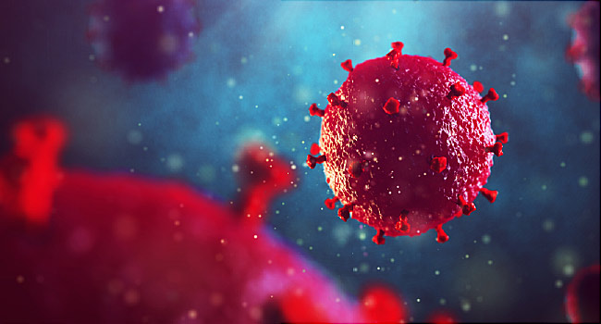
Primary, Secondary, and Tertiary Prevention
When it comes to the prevention of the issue of HIV, then it can be segregated into three major forms of primary, secondary, and tertiary inhibition. The practical idea of primary HIV prevention focused on decreasing the occurrence of overall transmission successfully. This approach focused that there is need to be fewer people who become HIV infected. On the other hand, the phenomenon of secondary HIV prevention diminishes the pervasiveness of this disease by adopting the facets of early detection and rapid intervention. This perspective can be illustrated as they minimize the risk of HIV-positive people to progress towards the extreme of AIDS. Critical consideration of tertiary prevention is also important to ensure the successful reduction of further complications associated with the issue of HIV (Brenner et al, 2007). The future consideration of HIV prevention is an essential step to control the calamity of this healthcare issue. The main target of tertiary prevention in the case of HIV is to target people with severe HIV infection specifically. Identification of the risk behaviors is a critical step to ensure significant prevention against the issue of HIV.
Role of Health Professionals in Promoting Health

Healthcare professionals play a critical role when it comes to prevent the health issue of HIV successfully. Healthcare professionals need to provide better healthcare prospects to the community to reduce the risks of HIV infections. Explicit healthcare communication is mandatory to enhance the awareness level of people when it comes to risks of HIV. It is one core responsibility of healthcare providers to improve the quality of care in the community according to the defined roles and responsibilities (Alfsen, 2004).
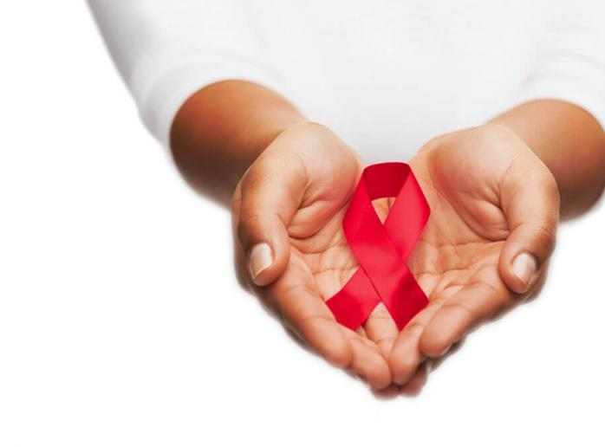
It is one primary responsibility of healthcare professionals to develop better HIV programs according to the distinct requirements of the community. It is important to encourage community members from the perspective of HIV testing. Connecting victims with the appropriate form of care is another mandatory task for healthcare professionals with the active consideration of psychosocial support for the patients. Healthcare professionals need to consider the well-being of patients during the entire process of the healthcare domain, considering the sensitivity of the issue of HIV. The successful application of individual and group counseling is a necessary practical step by the healthcare providers to enhance the knowledge of people about the risks of HIV.
Effects of Globalization as the Global Burdens of HIV
Currently, the factor of globalization can never be ignored when it comes to the identification of specific factors associated with the healthcare problem of HIV. The risks of HIV closely linked with the growing spectrum of globalization. Active consideration of the factor of globalization is important because it eventually enhances the spread of disease of HIV/AIDS at the international level. The prospect of modern travel facilities ultimately increases the risk of rapid dissemination of HIV infection beyond national borders. The economic expansion in the form of globalization increases the hazard of the devastating implications of HIV. The global burden of the issue of HIV eventually increase after the dramatic expansion of different global paradigms appeared in the form of globalization. It is observed that rapid economic development in the form of globalization increases the prevalence of HIV. The factor of the interagency coalition can never be ignored when it comes to the identification of possible indicators of HIV.
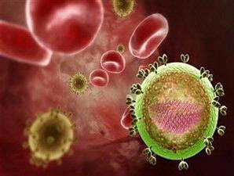
The rapid connectivity of different communities increases the risks of transmission of HIV infection from one person to another (Lears & Alwood, 2000). The factor of globalization recognized as the potential reason for the spread of HIV around different communities. The experts presented the argument that when people moving away from home to other countries, then there are higher chances for them to involve in casual and unsafe sex activities that eventually increase the risk of HIV infection.
Effects of Environmental Factors on Population’s Health
A detailed understanding of the effects of environmental factors in the case of the population’s health is also important because this spectrum is eventually linked with the indicator of HIV. The epidemic of HIV/AIDS can never be ignored from the consideration of specific environmental implications. The socioeconomic problem of HIV is greatly associated with the factors of poverty, cultural domains, traditions, and the prospect of global development. There is the existence of different environmental berries that restrict the preventive approach in the case of HIV. These environmental restrictions established in the forms of the hassle of getting proper care, the improper association between patient and healthcare provider, specific social attitudes, and proper funding for the element of care. All these practical implications play a critical role as the structural barriers when it comes to consideration of HIV treatment and prevention.
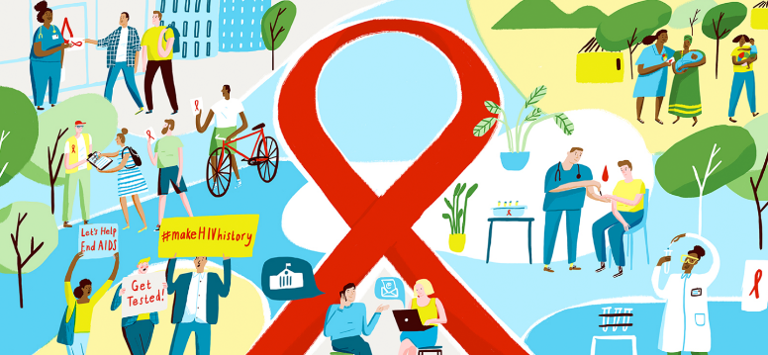
Evaluation of Communication Strategies
Successful adoption of suitable communication strategies is a necessary practical measure to deal with the epidemic of HIV successfully. The fundamental aim of the communication strategy is to ensure a low prevalence of HIV by implementing effective preventive measures. Enhancement of knowledge about the issue of HIV is necessary step to promote care-seeking behaviors according to the needs of communities. Community involvement is essential to positively impact people’s knowledge and attitude towards the issue of HIV. This consideration also helps to improve the approach of prevention and treatment for the issue of HIV.

References
Alfsen, A. (2004). Environmental factors in HIV/AIDS epidemic development: New perspectives for gender equity and global protection against HIV transmission. Annals of the New York Academy of Sciences, 1023(1), 164-174.
Sahasrabuddhe, V. V., & Vermund, S. H. (2007). The future of HIV prevention: Control of sexually transmitted infections and circumcision interventions. Infectious disease clinics of North America, 21(1), 241-257.
Lears, M. K., & Alwood, K. S. (2000). The natural history, current status, and future trends of HIV infection. Lippincott's primary care practice, 4(1), 1-19.
Brenner, B. G., Roger, M., Routy, J. P., Moisi, D., Ntemgwa, M., Matte, C., ... & Leblanc, R. (2007). High rates of forward transmission events after acute/early HIV-1 infection. The Journal of infectious diseases, 195(7), 951-959.

