1- Solve following equations using MATLAB and send your output here. (Output could be a screen shot or MATLAB file):
a) x-14=-2y-3z
b) 40-4x=6y+8z
c) x+3y+7z-28=0
>>W=[1 2 3;-4 -6 -8;1 3 7]
>> v=[14;-40;28]
>> A=W^-1*v
>> x=A(1)
>> y=A(2)
>> z=A(3)
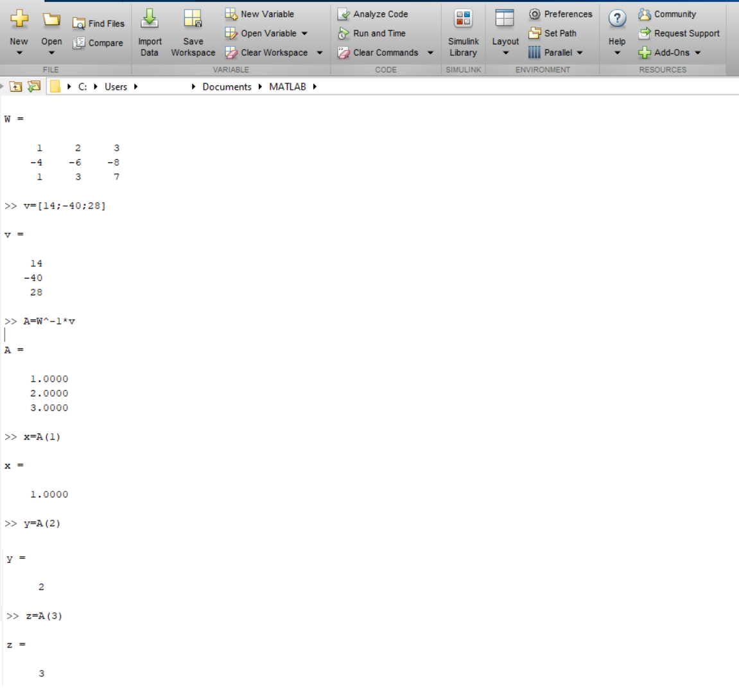
2- Plot following function in MATLAB and send your output here. (Output could be a screen shot or MATLAB file):
Y = X . COS(X) . SIN(X)
Don't forget to have title as " f(X) = X . COS(X) . SIN(X) " and label for X and Y axis
x= linspace (-30, 30)
y=x.*cos(x).*sin(x);
plot(x,y);
title('f(X)=X*SIN(X)*COS(X)');
xlabel('X-axis');
ylabel('Y-axis');
