Project Deliverable 1: Automated Reporting System
Student’s Name
Institutional Affiliation

Project Deliverable 1: Automated Reporting System
Organizational Background
The organization has seen a significant change in the course of the most recent past years, through acquisitions and mergers. These progressions have frequently brought about office moves and arrangement of new server rooms. It needed to move its IT framework to outside areas with adaptability to grow or contract to meet the business needs.
What The Company Does
The organization had a necessity to embrace a circumstance investigation of their current shared administrations and ICT frameworks. Working at board level, the company drove the group that ran workshops and embraced a complete arrangement of meetings crosswise over the two associations to build up a present state survey and an underlying discoveries paper. This has empowered the sheets to recognize dire moves to be made covering association, procedure, data, and ICT.
Databases
The initial phase in the report advancement process has to do with your information. Some report improvement apparatuses like JReport Designer enables you to make a metadata layer which gives you the capacity to semantically oversee and characterize distinctive information assets. A metadata layer along these lines enables you to make a simple to utilize, straightforward level information structure. This is in critical advance in mechanizing report exercises since it gives you a superior interface to communicate with your information in a progressively important manner. To ensure this is achieved SQL Database is the best solution.
System Analysis
Computerized reporting is utilized to improve generally speaking client efficiency, or to remind clients to achieve certain undertakings. By sending or giving helpful data to clients on interims they need it you make it simpler for them to locate the significant information they need. This is especially critical for reports with expansive datasets (Kerzner & Kerzner, 2017). You can have a report with a substantial informational collection planned to naturally keep running out of sight so when a client needs to see the information, they can see it promptly, rather than holding up until it's been run.
Security
An Artificial Intelligent reporting apparatus works likewise to many reporting technologies, however with extra security, booking, and the board highlights which permit report engineers, managers, and clients to mechanize distinctive detailing exercises (Soomro, Shah & Ahmed, 2016).
Networking
Automated report booking enables you to proactively convey data ideal to your clients. Report booking permits you set up explicit parameters to convey data in a vital way. You can set up a time span to report amid, pick the recurrence (e.g., day by day, week by week, month to month), and what time to send it on. Reports can be conveyed through an assortment of methods whether it is a forming framework (e.g., HTML, PostScript, PDF, and so on.), email or fax– there are numerous strategies for conveyance. This enables you to streamline data appropriate to you or your clients to keep awake to date on the most basic data.
Computer Infrastructure
From here, you can begin fabricating the information perceptions and reports that bode well for your end clients. One of the advantages of utilizing JReport is the capacity to characterize security parameters dependent on client's authorizations and after that utilization those security consents to imagine information in various ways relying upon the client type. This is basically mechanizing a reporting framework since it enables designers to distribute a solitary report that can be utilized for a wide range of clients and associations along these lines eliminating the all-out time expected to create and empower reports at scale. This is additionally the time with which you're ready to plan reports to go out at explicit occasions or dependent on explicit conditions, further eliminating the need to effectively oversee and run reports.
Human-Computer Interaction
Automated Reporting is the art of conveying reports containing pertinent business data at determined interims or after an activated occasion so clients don't need to invest the energy finding the data themselves. Computerized reporting can include numerous kinds of reports relying upon the necessities of the end client. With big business level, BI and reporting applications frequently give diverse approaches to the timetable, trigger, and burst reports out. For instance, a booked report might be conveyed once seven days like Monday at 8 am consistent. They can be activated when a particular occasion occurs, for instance, when another business bargain brings a deal to a close, the report may be sent to a business official. Or as well, they might be blasted out, which is a type of planning utilized for bigger report arrangements or organizations where the information may change from client to client (Schwalbe, 2015). This type of revealing is utilized to make examination manager's employments simpler, rather than booking numerous reports with isolated information in each report to clients contingent upon their security authorizations. Blasting enables directors to utilize a solitary blasting key to give clients the correct data from one single report.
Web Design
Website composition isn't just about how the site looks and feels but at the same time is a great deal about how it functions and reacts. At the point when website specialists deal with a site, they fuse not simply those components that add visual intrigue to it yet in addition endeavor to make it very responsive, utilitarian, snappy and valuable. So as to make an exceedingly usable and compelling site, planners pursue certain rules that go about as thumb principles or standard focuses to remember.

Gantt Chart
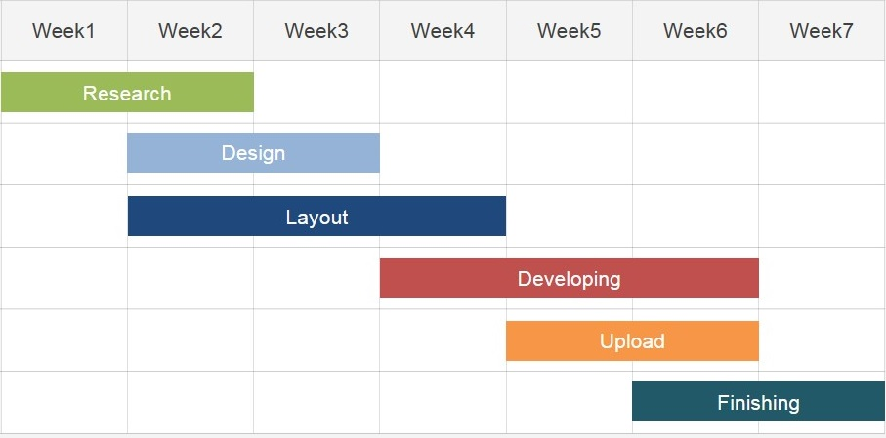
Development Phases
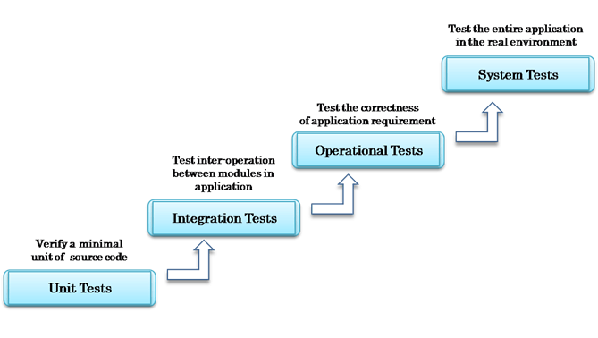

References
Kerzner, H., & Kerzner, H. R. (2017). Project management: a systems approach to planning, scheduling, and controlling. John Wiley & Sons.
Schwalbe, K. (2015). Information technology project management. Cengage Learning.
Soomro, Z. A., Shah, M. H., & Ahmed, J. (2016). Information security management needs a more holistic approach: A literature review. International Journal of Information Management, 36(2), 215-225.

