Project Deliverable 1: Project Plan Inception
Section 1: Project Introduction
  - Background information of the company.
Lansing Ophthalmology has been in a position to build a customer capacity of over one hundred thousand patients of which seventy-five thousand are seen every year. There is always need for a secure system. At home most of us use our computers for internet banking, ordering things online, and social connection. Without a safe mode, an individual can lose important data that can lead to fraud and identity theft. When an organization is not using a secure computer system, the vital information of the company is at the risk of landing to the wrong hands. Hackers can get the information and steal organizations revenue and also customer information which is risky. Organizations are required by law to protect the confidentiality, integrity, and authenticity of customer information.
  - The type of business in which the company is involved.
The issue with Lansing Ophthalmology is that it wanted to be in line with new management improvement techniques to ensure that it achieves its goals in the healthcare industry. Lansing Ophthalmology as a business organization wanted to implement improvement technique commonly known as six sigma and Lean manufacturing which are used in the identification and reduction of defects that are experienced in the production methods which were encountered in the organization for more than two decades
    - Databases
We look at identification and formulation of data flow diagrams (model) which constituted architectural design and the identification of data structure for the application which constituted data structure design of this project. It’s the integral part in working software that is worth implementing. It shows how different entities interact within the system.
Web browser
PHP
SQL database
SERVER

System backend: The back end of the system consists of the SQL database and server. SQL is used as a storage media for data entries (made from the webpage module) and processed information. The user is not aware of this as he/she just interacts with the interface provided for them in the front end.
System front end: This is the interface that the user interacts with in order to enter data. It is made possible by using web browsers e.g. Mozilla Firefox and internet explorer.
There are three design levels that will be applied in development of the system which are
- Design Methodology
- Architectural design
- Component design
- Interface Design
- Database design
    - Systems Analysis
The entire development procedure for this system was based on incremental model of software development. The system was broken down into modules and subtasks. During the initial module development, an initial version of the system will be developed then submitted to supervisor and colleagues to criticize it. It’s from their criticism that it will able to know the user needs in details. During the development process, the system will go through the phases of feasibility study, requirements elicitation, requirements analysis, design, coding, verification and validation and implementation and support.
    - Security
Information is exposed to outer impacts since it very well may be gotten to remotely from wherever around the world, which uncovered specific information, for example, credit card data for web-based obtaining held by organizations to potential security breaks. This lessens the selection of big data computing framework in many developing organizations since the administrations set up needs to keep up security over the web, hindering its development particularly in the business environment. This is on account of distributed computing as an innovation includes the interconnection of different applications and systems, which are inclined to assaults accordingly decreasing the rates of data sending by numerous legislatures and organizations in a large portion of the businesses.
    - Networking
The system will generally interact with various entities from database server to user interface. This is as shown above.
    - Computer Infrastructure

Software requirement for development
- Operating System (Windows 7 and above).
- Web browsers: Mozilla, Google Chrome, Internet Explorer.
- Integrate Development Environment (IDE) tool – Net Beans.
- Gantt Project for project management.
- WAMP (Windows Apache MySQL PHP) Server.
- Ozeki Server (manager and monitor).
- Macromedia Dreamweaver studio 8.
- EDraw.
- XAMPP (Windows SQL PHP) Server 1.8.0 [PHP 5.4.4].

Hardware Requirement for development
- HP PC, PROCESSOR; AMD Athlon (tm) II P360, Dual-Core Processor 2.40 GHz, with 2GB RAM and 500 Hard disk and 64 –bit Operating System.
- Flash disk.
    - Human Computer Interaction
The purpose of the project is to develop a computerized system that will address the above-mentioned problems, improve efficiency in carrying out management tasks in the e-commerce Sector and provide a reliable system to produce receipts and send short messages to the head of departments may be to send bills or make communication to the customers.
The human computer interaction aspects of the project include:
- To secure all registered admin with a password.
- SMS sending for communication purposes.
- The person in charge of a department can produce a report.
- Auto calculation of bills
- Production of monthly receipts or on demand.
    - Web Design
In designing the systems’ interface, an attempt to emulate Jacob Nielsen’s usability heuristics as described below is used:
User control
The interface has been made to adapt to the needs of the user. I provided more than one way of doing same task. This is made possible by provision different links located at different parts for doing the same task
Match between system and real world
The web-page module was designed to emulate/resemble the normal requirements as it is in the educational sector.

Section 2: Gantt Chart / Project Plan
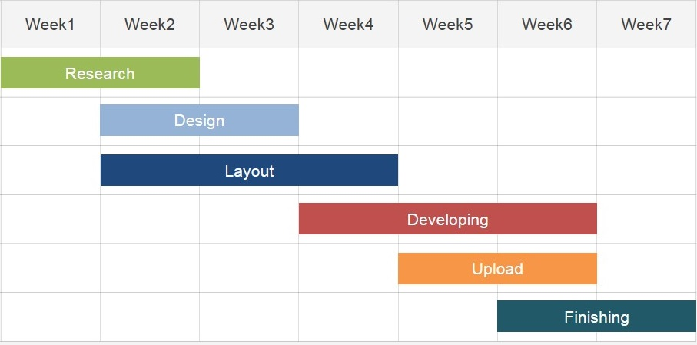

References
Näslund, Dag. "Lean, six sigma and lean sigma: fads or real process improvement methods?." Business Process Management Journal 14.3 (2008): 269-287.
Kopetz, Hermann. Real-time systems: design principles for distributed embedded applications. Springer Science & Business Media, 2011.

