Section I: Introduction
Every day, more than twenty-five people lose their lives in the United States due to road accidents involving an impaired driver, i.e., one death per hour (National Highway Traffic Safety Administration, 2017). The annual cost of such accidents is more than $40 billion (Blincoe et al., 2015). In the year 2016, approximately ten thousand people died in accidents due to impaired driving. It amounts to twenty-eight percent of the all accident related deaths in the country (National Highway Traffic Safety Administration, 2017). In about sixteen percent of such accidents, alcohol (both legal and illegal) is involved whereas twenty-five percent include marijuana users (Compton et al., 2015). In 2017, twenty-percent of the road accident deaths occurred due to drunk drivers (Drunk Driving Fatality Statistics, n.d.).
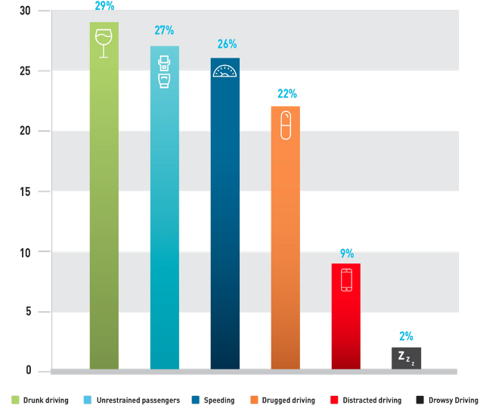

Public health is the science of developing systems for creating conditions that encourage healthy behaviors, prevent disease, and promote health across the entire population (Ashton & Seymour, 1988). Examples of public health efforts include discouraging tobacco use (Bero, 2003), creating smoke-free environments, preventing injury, and preparing for emergency (Friedan, 2010), to name a few. The legislator devises public policies to improve the health of entire population. Therefore, the stakeholders of a public health policy include the legislator itself, coalition members, funding agencies, partners, and the taxpayers or general public (Freedman et al., 2009).

Section II: Legislative Policy on Impaired Driving
California expanded its ignition interlock device program statewide, starting January 1st 2019 (“Statewide Ignition Interlock Device Pilot Program”, n.d.). Previously, ignition interlock device restrictions were left open to the discretion of a judge with a mandatory thirty-days suspension of the driving license. The convicted drivers are only allowed to go to certain places during the suspension period such as school, work, and driving-under-influence school (“Statewide Ignition Interlock Device Pilot Program”, n.d.). However, this program compels the drinking-while-intoxicated convicted drivers to get an ignition interlock device installed in their vehicle before getting their driving privileges reinstated (“Statewide Ignition Interlock Device Pilot Program”, n.d.). Also, under the program, the device continuation period increases with the number of convictions.
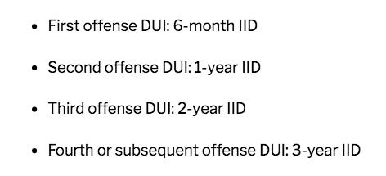
Therefore, the best choice for the drivers to avoid the device getting in the vehicle is not to get convicted in the first place (“New California DUI Ignition Interlock Device Laws 2019 | Solution Law,” n.d.). The program will remain effective till January 2026. If deemed effective, the program will be continued (“Statewide Ignition Interlock Device Pilot Program”, n.d.).

Section III: Non-legislative Policy on Impaired Driving
Mass media campaigns have always been an effective tool of promoting pubic healthcare programs (Noar, 2006). Traditionally, media has been divided into three categories (Edelman & Salsberg, 2010). Paid media includes conventional advertising. Earned media is what is achieved for free, such as through news, etc. Owned media includes channels or properties owned by advertisers. Examples include broacher and websites. Mass media uses a combination of all three media types. With the passage of time, growth of social media has further lubricated the option with more diversity (Noar, 2006; Gil de Zúñiga et al., 2012). For these reasons, media has successfully been playing an effective role in spreading public awareness on the consequences of drunk driving (Gold et al., 2011; Hamm et al., 2014; Livingston et al., 2013).

Section IV: Evaluation
The Center for Disease Control recommended use of ignition interlocks for all convicted driving-while-intoxicated offenders (“Policy Impact: Alcohol Impaired Driving”, n.d.). Also known as car-breathalyzers, ignition interlocks are devices preventing persons who have consumed alcohol from driving (“Statewide Ignition Interlock Device Pilot Program”, n.d.). These devices can be installed in vehicles, typically after a driver is convicted driving-while-intoxicated (Teoh et al., 2018). As per the past literature on the success of ignition interlocks, it is clear that they reduce the rate of re-arrest of the (once convicted) drivers by a median of sixty-seven percent (Teoh et al., 2018). Also, it is proven that people with installed ignition interlocks had fewer road crashed in comparison to the drivers whose license had been suspended on the conviction of driving-while-intoxicated (Teoh et al., 2018). As per a report, more than sixteen thousand ignition interlocks were installed in California in 2017 (“Ignition Interlocks Laws in the United States of America,” 2018). In between June 2006 and December 2017, installation of the ignition interlocks prevented more than two hundred thousand attempts to drive while under influence or being intoxicated (“Ignition Interlocks Laws in the United States of America,” 2018).
Among the studies on use of mass media and social media tools in effectively combating accidents due to impaired driving, data indicates that campaigns working on reducing alcohol use are much more successful than the campaigns working on tobacco or illicit drugs (Noar, 2006; Derzon & Lipsey, 2002). Recently, the National Highway Traffic Safety Administration of California has started programs to eliminate drunk drivers from the road (“Administration,” n.d.). Its programs primarily consist of State safety grant programs, public awareness campaigns, and research (“Administration,” n.d.). Also, studies show that messages such as “DUI: The $8866 Hangover” (Yadav & Kobayashi, 2015) and “Drunk Drivers Should be Barred” (Epperlein, 1987) have helped in making campaigns emphasizing on the consequences of alcohol-induced driving successful.

Section V: Concluding Remarks
Both legislative and non-legislative policies must be employed in an attempt to reduce and prevent the consequences of impaired driving on the roads of California. Such a policy mix will help the State to prevent injury, and prepare for emergency (Friedan, 2010).

References
Administration, N. Drunk Driving. Retrieved from https://www.nhtsa.gov/risky-driving/drunk-driving
Ashton, J., & Seymour, H. (1988). The new public health (Vol. 1). Milton Keynes: Open University Press.
Bero, L. (2003). Implications of the tobacco industry documents for public health and policy. Annual review of public health, 24(1), 267-288.
Blincoe LJ, Miller TR, Zaloshnja E, Lawrence BA. National Highway Traffic Safety Administration. The economic and societal impact of motor vehicle crashes, 2010. (Revised). U.S. Department of Transportation, Washington, DC; 2015. Available at: http://www-nrd.nhtsa.dot.gov/pubs/812013.pdfCdc-pdf (Accessed: 6th June 2019)
Compton RP, Berning A. National Highway Traffic Safety Administration. Traffic Safety Facts Research Note: drugs and alcohol crash risk. U.S. Department of Transportation, Washington, DC; 2015 Available at: http://www.nhtsa.gov/staticfiles/nti/pdf/812117-Drug_and_Alcohol_Crash_Risk.pdfCdc-pdf (Accessed: 6th June 2019)
Derzon, J. H., & Lipsey, M. W. (2002). A meta-analysis of the effectiveness of mass-communication for changing substance-use knowledge, attitudes, and behavior. Mass media and drug prevention: Classic and contemporary theories and research, 231-258.
Drunk Driving Fatality Statistics. Retrieved from https://www.responsibility.org/alcohol-statistics/drunk-driving-statistics/drunk-driving-fatality-statistics/ (Accessed: 6th June 2019)
Edelman, D., & Salsberg, B. (2010). Beyond paid media: Marketing’s new vocabulary. McKinsey Quarterly, 1-8.
Epperlein, T. (1987). Initial deterrent effects of the crackdown on drinking drivers in the state of Arizona. Accident Analysis & Prevention, 19(4), 285-303.
Freedman, D. A., Bess, K. D., Tucker, H. A., Boyd, D. L., Tuchman, A. M., & Wallston, K. A. (2009). Public health literacy defined. American journal of preventive medicine, 36(5), 446-451.
Frieden, T. R. (2010). A framework for public health action: the health impact pyramid. American journal of public health, 100(4), 590-595.
Gil de Zúñiga, H., Jung, N., & Valenzuela, S. (2012). Social media use for news and individuals' social capital, civic engagement and political participation. Journal of computer-mediated communication, 17(3), 319-336.
Gold, J., Pedrana, A. E., Sacks-Davis, R., Hellard, M. E., Chang, S., Howard, S., ... & Stoove, M. A. (2011). A systematic examination of the use of online social networking sites for sexual health promotion. BMC public health, 11(1), 583.
Hamm, M. P., Shulhan, J., Williams, G., Milne, A., Scott, S. D., & Hartling, L. (2014). A systematic review of the use and effectiveness of social media in child health. BMC pediatrics, 14(1), 138.
Ignition Interlocks Laws in the United States of America. (2018). Retrieved from https://www.madd.org/wp-content/uploads/2018/06/State-IID-overview.6-18-18.pdf
Livingston, J. D., Tugwell, A., Korf-Uzan, K., Cianfrone, M., & Coniglio, C. (2013). Evaluation of a campaign to improve awareness and attitudes of young people towards mental health issues. Social psychiatry and psychiatric epidemiology, 48(6), 965-973.
National Highway Traffic Safety Administration. Traffic Safety Facts 2016 data: alcohol-impaired driving. U.S. Department of Transportation, Washington, DC; 2017 Available at: https://crashstats.nhtsa.dot.gov/Api/Public/ViewPublication/812450External (Accessed: 6th June 2019)
New California DUI Ignition Interlock Device Laws 2019 | Solution Law. Retrieved from https://www.solutionlawapc.com/criminal-defense/new-california-dui-ignition-interlock-device-laws-2019/
Noar, S. M. (2006). A 10-year retrospective of research in health mass media campaigns: Where do we go from here?. Journal of health communication, 11(1), 21-42.
Policy Impact: Alcohol Impaired Driving. Retrieved from https://www.cdc.gov/motorvehiclesafety/pdf/PolicyImpact-Alcohol-a.pdf
Statewide Ignition Interlock Device Pilot Program. Retrieved from https://www.dmv.ca.gov/portal/dmv/detail/dl/statewide_iid_pilot
Teoh, E. R., Fell, J. C., Scherer, M., & Wolfe, D. E. (2018). State alcohol ignition interlock laws and fatal crashes. Arlington, VA: Insurance Institute for Highway Safety.
Yadav, R. P., & Kobayashi, M. (2015). A systematic review: effectiveness of mass media campaigns for reducing alcohol-impaired driving and alcohol-related crashes. BMC public health, 15(1), 857.

