MGH PATA CASESTUDY
Student’s Name
Professor’s Name
Subject
University
Part 1 – Introduction:
Founded in 1811, Massachusetts General Hospital is the third oldest and one of the largest hospital in the United States. It also is the home to Ether Dome, the birthplace of anesthesia. Since the early 1990s, the risks associated with administration of anesthesia had decreased. However, doctors still need to know that if a patient’s body is strong enough to take anesthesia. For this purpose, the patients had to go through a pre-admission workup. The pre-admission testing area of Massachusetts General Hospital consists of a waiting room, a lab, and twelve exam rooms. It has been facing the challenges of long patient wait time and staff inefficiencies for more than two years now.

Part 2 - Case Questions:
1) Who are the stakeholders in this process?
The stakeholders in this situation include the patients, the pre-admission testing providers (i.e., medical doctors and registered nurses), and surgeons. Firstly, the patients have to go through long waiting time. They have been spending four hours in the premises despite the fact that the appointment time is of two-and-a-half hours. Secondly, the pre-admission testing providers experienced direct impact. Their working hours run from 7 am to 5 pm but they have to stay as late as 7 pm or sometimes 8 pm because the appointments are rarely completed by 5 pm. Lastly, surgeons were effected because they had to give their patients appointments for the pre-admission testing (within 30 days of their preliminary examination) but the long days and patients pile-ups have been persistent in the pre-admission testing area (Prince, 2011).
2) What is your take on the current state of operational performance?
The pre-admission testing area of the Massachusetts General Hospital is providing high-quality patient- and family-focused care services despite the operational challenges it has been facing for two years now.
3) Describe the process and flow.
The timing of the clinic is 7 am to 5 pm, Monday through Friday. Every half hour, four patients are scheduled from 7 am to 3 pm. During the lunch, only two patients are scheduled. After check-in, the patients can wait in the waiting room. Meanwhile, one of the two attendants locates their medical charts and puts in the holding bin of the lab. The patients taken into the lab within fifteen minutes of their arrival, where patient vitals and EKG are taken at the beginning of the appointment while blood samples are taken at the end of it. The medical charts are then placed in the nurse’s holding bin, which indicates that the patients are ready to be seen by a registered nurse, whereas patients are sent back to the waiting area. The charge nurse escorts the patients from the waiting area into an exam room and find an available registered nurse to assign to the patient. The registered nurse goes through the recent and past medical information of the patient. Once cleared, the patients are sent to medical doctors (Erickson et al., 2012). They diagnose the patients and send them for blood works. After giving the blood for testing, the patients can checkout of the clinic.
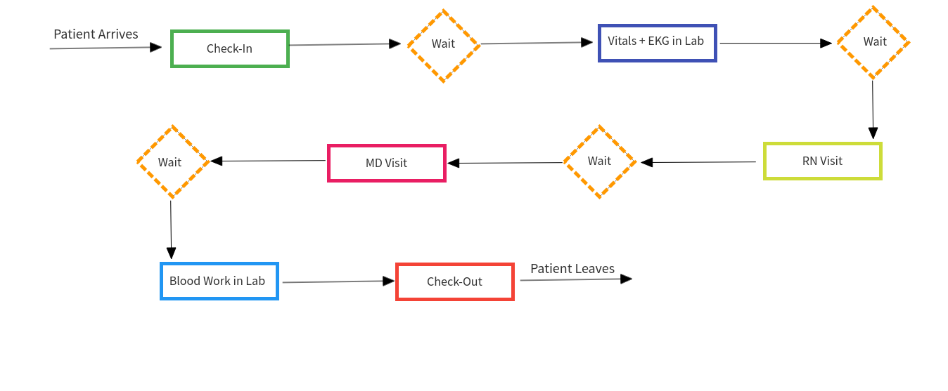
4) Evaluate the task force recommendations:
The task force made the following recommendations:
a. Not enough time between appointments: Every half hour, four patients are scheduled from 7 am to 3 pm. During the lunch, only two patients are scheduled. It results in file pile-ups on the lab’s holding bin.
b. Not enough room: The premises of the clinic have enough room for handling the patients. However, the number of patients increases by every passing day. Therefore, the clinic must start a new campus.
c. Not enough physicians: It is not a matter of concern for the clinic right now. It must have enough space to accommodate more staff.
5) Are these the primary contributors to longer patient wait times?
Primarily, the answer to this question is affirmative. Not enough time between appointments mean constant patient file pile-ups on the front desk, which further delays the process. In a similar fashion, not having enough exam rooms also cause delays in the examination process. However, not having enough physicians is not a major concern right now due to the fact that the clinic needs room to accommodate physicians.
6) What factors do you think contribute most to variations in the clinic flow? What level of control, if any, does the preoperative clinic have to eliminate variations?
Not providing enough time between appointments and not having enough room are the two main concerns causing variation in the clinic flow. Primarily, the clinic must work on starting a second shift of work. In this way, the clinic will find more time to attend the patients without investing anything on the infrastructure.
7) What are your overall recommendations for change?
In this regard, two recommendations can be made as under:
- Firstly, the clinic can start another campus nearby. In this regard, it must rent a suitable place in the same vicinity. However, it can be a costly alternative for the hospital.
- Secondly, the clinic can start a second shift. In this regard, the clinic must hire new staff and start seeing more patients in the same premises. It is a less costly option in comparison to the previous recommendation.

Part 3 - Summary Paragraph:
The pre-admission testing area clinic is providing high-quality patient- and family-focused care services. However, the long days and patients pile-ups have been persistent in the pre-admission testing area (Prince, 2011). Therefore, the clinic must work on starting a second shift of work. In this way, the clinic will find more time to attend the patients without investing anything on the infrastructure.

References

Erickson, J. I., Ditomassi, M., & Adams, J. M. (2012). Attending registered nurse: an innovative role to manage between the spaces. Nurs Econ, 30(5), 282-287.
Price, D. J. (2011). Managing variability to improve quality, capacity and cost in the perioperative process at Massachusetts General Hospital (Doctoral dissertation, Massachusetts Institute of Technology).

