Clinical Preventive Services and Health Care Coverage
Student’s Name
Professor’s Name
Subject
University
Date

Section I: Gonorrhea, Screening
Gonorrhea is one of the most commonly reported sexually transmitted disease in the country (CDC, 2012). As per the reports of the CDC in 2012, more than 30,000 cases of gonorrhea have been reported in the country (CDC, 2012). Despite the fact that most identified cases are reported, it is difficult to estimate the incidence of gonorrhea because the infection is asymptomatic, it is never diagnosed (CDC, 2014). It also facilitates HIV transmission (CDC, 2012; Baeten & Overbaugh, 2003; Røttingen et al., 2001).
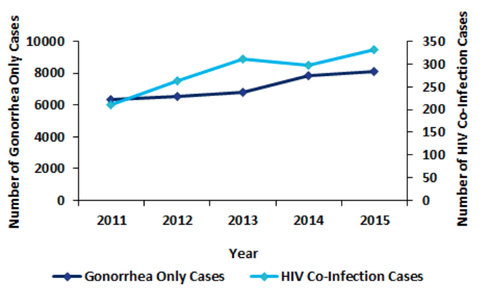
Therefore, early detection and intervention are critically important. Potential harms of the screening include false-negative or false-positive results (Chernesky et al., 2005; Gaydos et al., 2013; Schachter et al., 2003; Shrier et al., 2004; Taylo et al., 2012; Taylor et al., 2011; Van Der Pol et al., 2012a; Van Der Pol et al., 2012b; Schoeman et al., 2012; Stewart et al., 2012). It can also cause anxiety and labeling associated with positive results. The costs are high too, i.e., almost $16 billion per annum, as per a report of CDC (2012), which prescribes annual screening of gonorrhea in females, who are sexually active of all ages (Workowski & Berman, 2010). It also prescribes annual screening of gonorrhea in men, who are sexually active who have sex with other men (Workowski & Berman, 2010). It does not prescribe regular screening for general population (Workowski & Berman, 2010). The magnitude of net benefit remains moderate due to the asymptomatic nature of the infection (USPSTF, 2014a). Moreover, the high morbidity associated with untreated gonorrhea and effective of antibiotic treatment for the infection also keeps the net benefits at a moderate level (USPSTF, 2014a).
An evidence-based approach is a prerequisite in initiating gonorrhea screening in adults in America. Previously, in 2005, the USPSTF prescribed gonorrhea screening in all females, who are sexually active including pregnant women but are at an increased risk of getting infected, i.e., they are too young or have other social or individual factors involved (USPSTF, 2014a). In 2007, the Task Force prescribed gonorrhea screening in all females, who are sexually active including pregnant women of age 24 and above (USPSTF, 2014a). In 2014, the Task Force prescribed gonorrhea screening in women, who are sexually active of 24 or above years of age (USPSTF, 2014a). It also prescribes gonorrhea screening in elderly women who are prone to infection (USPSTF, 2014a). As per the American Congress of Obstetricians and Gynecologists, the prescribed age is 25 years (Burstein et al., 2010). However, for men, who are sexually active, current evidence on the effectiveness or need of gonorrhea screening remains insufficient in assessing the benefits and harms affiliated with the process (USPSTF, 2014a).

Section II: Healthful Diet and Physical Activity, Counseling
Stroke and heart diseases are leading causes of death in America primarily due to the fact that the risk factors associated with these diseases are very common (CDC, 2015). Approximately, more than 2000 people die of cardiovascular diseases in the country everyday (Mozaffarian et al., 2016). As per the USPSTF, approximately half of the youth (adults under the age of twenty years) have high cholesterol levels or high blood pressure (USPSTF, 2014b). Most of the youth does nothing to control them and are current smokers (USPSTF, 2014b). According to the previous research, one of the best ways to control the increasing risk factors of heart related diseases is through behaviors counseling programs. These programs are performed with the help or assistance of a professional trainers, who shares tools promoting physical activity and healthy diet, helps people set goals, provides education, and regularly follows up on the people (USPSTF, 2014b). The trainers can include a number of professionals such as psychologists, health educators, exercise professionals, physiotherapists, dieticians or nutritionists, and other trained professionals (USPSTF, 2014b). The interventions can be made as low intensity (web- or print-based material with tailored feedback) and medium- and high-intensity (group counseling and face-to-face meetings or both, with text message, email, and telephone follow ups).
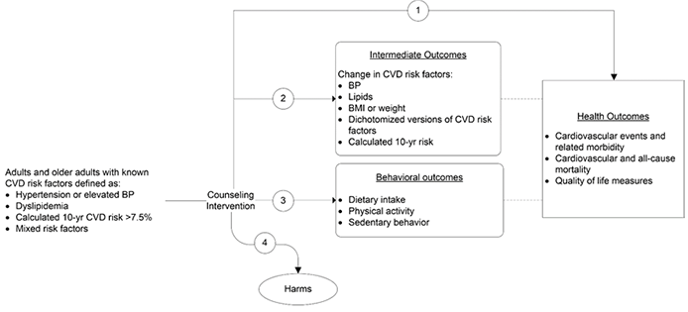
The overall magnitude of net benefit of getting involved in healthful diet and physical activity for reducing the risks of cardiovascular diseases is positive but small (Siu, 2015). Moreover, since the harms associated with the training sessions are at most small, the Task Force concludes that the net benefits of the counseling are small particularly for the individuals who do not have obesity or are at high risk for cardiovascular diseases (Siu, 2015). Therefore, only the individuals who are willing to take advantage of the counseling services are the ones most likely to benefit from it (Siu, 2015). The clinical considerations with regard to population include adults of 18 years or older, who are of normal weight or are overweight. However, it does not include the people with known cardiovascular risks such as people with obesity, diabetes, abnormal blood glucose level, dyslipidemia, and hypertension (Whelton et al., 1992). People with obesity are provided with intensive, multicomponent interventions (Moyer, 2012). Similarly, adults with dyslipidemia, hypertension and other cardiovascular risks are provided with intensive counseling as well (LeFevre, 2014). However, very limited evidence concerning the effects of such behavioral interventions is present in the literature.

Section III: Aspirin for the Prevention of Cardiovascular Disease, Preventive Medication
An evidence-based approach is a prerequisite in initiating (low or high) dose of aspirin in patients with cardiovascular diseases. In America, cardiovascular diseases are one of the leading causes of mortality. It causes 1 in 3 death in the country (Heron, 2013; Mozaffarian et al., 2015). The net benefits of using aspirin to prevent cardiovascular diseases are evidently clear (Baigent et al., 2009). For this reason, guidelines continuously prescribe aspirin for people with history of stroke or myocardial infarction (JBS3 Board, 2014; Smith et al., 2011). In 2009, the Task Force prescribed age-, sex- and outcome-specific use of aspirin (NIHCEN, 2013). Later, the prescriptions were updated in 2016 (USPSTF, 2016). The policy prescriptions have been updated based on concurrent reviews on aspirins and colorectal (Chubak et al., 2015), a decision model (Dehmer et al., 2015), and additional evidence about harms (Guirguis-Blake et al., 2015).
The USPSTF prescribes aspirin for the prevention of cardiovascular disease for both men and women (USPSTF, 2009). Previously, the age range for each of the gender remained different from each other (USPSTF, 2009). According to the archived summary prescriptions on use of aspirin, in this regard, the Preventive Services Task Force prescribed men with age of 45 to 79 years only when the potential harm due to increased gastrointestinal hemorrhage are overcome by the potential benefits due to reduction in myocardial infarctions (USPSTF, 2009). Similarly, women aged 55 to 79 years were prescribed to use aspirin in the same manner as well (USPSTF, 2009). For men and women aged 80 years or more, the summary prescribed that the evidence was insufficient (USPSTF, 2009).
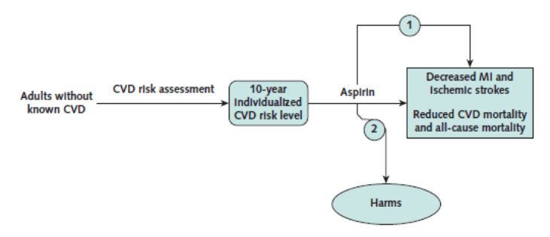
However, in 2016, the USPSTF updated the prescriptions. It prescribed initiating low-dose of the medicine for primary prevention of cardiovascular disease in adults (both men and women) aged 50 to 59 years (USPSTF, 2016). However, the adults must have 10-percent or greater 10 years risks of the disease (USPSTF, 2016). Also, the adults must have be willing to keep taking the low-dose of aspirin for the next years, have a life expectancy of ten years, and are not at an increased risk of bleeding (USPSTF, 2016). For adults, with age 60 to 69 years, the decision to initiating low-dose aspirin must be taken on individual basis (USPSTF, 2016). Moreover, the current evidence does not support initiating aspirin use in adults younger than 50 years of age, and older than 70 years of age (USPSTF, 2016).
Additionally, initiating low-dose aspirin to prevent cardiovascular diseases is in the best interests of the insurance companies as well. Studies have shown that secondary prevention of cardiovascular diseases through prescribing of aspirin is cost-effective in low to medium income countries (Ortegón et al., 2012; Lim et al., 2007; Megiddo et al., 2014). However, only a minority of adults assesses the insurance programs in these countries (Basu & Millett, 2013). Additionally, approximately fifty-percent of the people are able to show adherence to pharmacotherapy in long-term observational cohorts (Jackevicius & Mamdani, 2002; Kopjar et al., 2003; Benner et al., 2002). Overall, aspirin remains effective for public health. However, it is unclear that which sub-group of the medicine is most effective (Greving et al., 2011).

Section IV: Concluding Remarks
More research work, both academic and commercial, with regard to the asymptomatic nature of the infection, the high morbidity associated with untreated gonorrhea and effective of antibiotic treatment for the infection must be carried out for increasing the magnitude of net benefit of prescribing gonorrhea screening in the country. Similarly, aspirin remains effective for overall public health but it is unclear that which sub-group of the medicine is most effective. Therefore, more research must be carried out in this context.

References
Baeten JM, Overbaugh J. Measuring the infectiousness of persons with HIV-1: opportunities for preventing sexual HIV-1 transmission. Curr HIV Res. 2003;1(1):69-86.
Baigent C, Blackwell L, Collins R, Emberson J, Godwin J, Peto R, et al; Antithrombotic Trialists' (ATT) Collaboration. Aspirin in the primary and secondary prevention of vascular disease: collaborative meta-analysis of individual participant data from randomised trials. Lancet. 2009; 373:1849-60. [PMID: 19482214]
Basu S, Millett C. Social epidemiology of hypertension in middle-income countries: determinants of prevalence, diagnosis, treatment, and control in the WHO SAGE study. Hypertension. 2013; 62:18–26.
Benner JS, Glynn RJ, Mogun H, Neumann PJ, Weinstein MC, Avorn J.Long-term persistence in use of statin therapy in elderly patients. JAMA. 2002; 288:455–461.
Burstein G, Jacobs A, Kissin D, Workowski K. Changes in the 2010 STD Treatment Guidelines: What Adolescent Health Care Providers Should Know. Washington, DC: American Congress of Obstetricians and Gynecologists; 2010. Accessed at www.acog.org/About_ACOG/ACOG_Departments/Adolescent_Health_Care/Changes_in_the_2010_STD_Treatment_Guidelines__
What_Adolescent_Health_Care_Providers_Should_Know on 20th June 2019
Centers for Disease Control and Prevention, National Center for Health Statistics. Leading causes of death, 2015. https://www.cdc.gov/nchs/fastats/leading-causes-of-death.htm. Accessed on 20th June 2019
Centers for Disease Control and Prevention. 2012 Sexually Transmitted Diseases Surveillance. Atlanta, GA: U.S. Department of Health and Human Services, Centers for Disease Control and Prevention; 2014. Accessed at www.cdc.gov/std/stats12/default.htmThis link goes offsite. Click to read the external link disclaimer on 20th June 2019
Centers for Disease Control and Prevention. Gonorrhea—CDC Fact Sheet (Detailed Version). Atlanta, GA: U.S. Department of Health and Human Services, Centers for Disease Control and Prevention; 2014. Accessed at http://www.cdc.gov/std/Gonorrhea/STDFact-gonorrhea-detailed.htmThis link goes offsite. Click to read the external link disclaimer on 20th June 2019.
Chernesky MA, Martin DH, Hook EW, Willis D, Jordan J, Wang S, et al. Ability of new APTIMA CT and APTIMA GC assays to detect Chlamydia trachomatis and Neisseria gonorrhoeae in male urine and urethral swabs. J Clin Microbiol. 2005;43(1):127-31.
Chubak J, Kamineni A, Buist DS, Buist DS, Anderson ML, Whitlock EP. Aspirin Use for the Prevention of Colorectal Cancer: An Updated Systematic Evidence Review for the U.S. Preventive Services Task Force. Evidence Synthesis No. 133. AHRQ Publication No. 15-05228-EF-1. Rockville, MD: Agency for Healthcare Research and Quality; 2015.
Dehmer SP, Maciosek MV, Flottemesch TJ. Aspirin Use to Prevent Cardiovascular Disease and Colorectal Cancer: A Decision Analysis. AHRQ Publication No. 15-05229-EF-1. Rockville, MD: Agency for Healthcare Research and Quality; 2015. Accessed at www.ncbi.nlm.nih.gov/books/NBK321651This link goes offsite. Click to read the external link disclaimer on 20th June 2019
Gaydos CA, Van Der Pol B, Jett-Goheen M, Barnes M, Quinn N, Clark C, et al; CT/NG Study Group. Performance of the Cepheid CT/NG Xpert Rapid PCR Test for detection of Chlamydia trachomatis and Neisseria gonorrhoeae. J Clin Microbiol. 2013;51:1666-72.
Greving, J. P., et al. "Statin treatment for primary prevention of vascular disease: whom to treat? Cost-effectiveness analysis." Bmj 342 (2011): d1672.
Guirguis-Blake JM, Evans CV, Senger CA, Rowland MG, O'Connor EA, Whitlock EP. Aspirin for the Primary Prevention of Cardiovascular Events: A Systematic Evidence Review for the U.S. Preventive Services Task Force. Evidence Synthesis No. 131. AHRQ Publication No. 13-05195-EF-1. Rockville, MD: Agency for Healthcare Research and Quality; 2015. Accessed at www.ncbi.nlm.nih.gov/pubmedhealth/PMH0079304This link goes offsite. Click to read the external link disclaimer on 20th June 2019
Heron M. Deaths: leading causes for 2010. Natl Vital Stat Rep. 2013; 62:1-96. [PMID: 24364902].
Jackevicius CA, Mamdani M, Tu JV.Adherence with statin therapy in elderly patients with and without acute coronary syndromes. JAMA. 2002; 288:462–467
JBS3 Board. Joint British Societies' consensus recommendations for the prevention of cardiovascular disease (JBS3). Heart. 2014;100(Suppl 2):ii1-67. [PMID: 24667225]
Kopjar B, Sales AE, Piñeros SL, Sun H, Li YF, Hedeen AN.Adherence with statin therapy in secondary prevention of coronary heart disease in veterans administration male population. Am J Cardiol. 2003; 92:1106–1108.
LeFevre ML; U.S. Preventive Services Task Force. Behavioral counseling to promote a healthful diet and physical activity for cardiovascular disease prevention in adults with cardiovascular risk factors: U.S. Preventive Services Task Force Recommendation Statement. Ann Intern Med. 2014;161(8):587-593.
Lim SS, Gaziano TA, Gakidou E, Reddy KS, Farzadfar F, Lozano R, Rodgers A.Prevention of cardiovascular disease in high-risk individuals in low-income and middle-income countries: health effects and costs. Lancet. 2007
Megiddo I, Chatterjee S, Nandi A, Laxminarayan R.Cost-effectiveness of treatment and secondary prevention of acute myocardial infarction in India: a modeling study. Glob Heart. 2014
Moyer VA; U.S. Preventive Services Task Force. Screening for and management of obesity in adults: U.S. Preventive Services Task Force recommendation statement. Ann Intern Med. 2012;157(5):373-378
Mozaffarian D, Benjamin EJ, Go AS, et al; Writing Group Members; American Heart Association Statistics Committee; Stroke Statistics Subcommittee. Heart disease and stroke statistics—2016 update: a report from the American Heart Association. Circulation. 2016;133(4):e38-e360.
Mozaffarian D, Benjamin EJ, Go AS, Arnett DK, Blaha MJ, Cushman M, et al; American Heart Association Statistics Committee and Stroke Statistics Subcommittee. Heart disease and stroke statistics—2015 update: a report from the American Heart Association. Circulation. 2015; 131:e29-322. [PMID: 25520374]
National Institute for Health and Care Excellence. Secondary prevention in primary and secondary care for patients following a myocardial infarction. Partial update of NICE CG48. London: Royal College of Physicians; 2013. Accessed at https://www.nice.org.uk/guidance/cg172/evidence/myocardial-infarction-secondary-prevention-full-guideline-pdf-248682925This link goes offsite. Click to read the external link disclaimer on 20th June 2019
Ortegón M, Lim S, Chisholm D, Mendis S. Cost effectiveness of strategies to combat cardiovascular disease, diabetes, and tobacco use in sub-Saharan Africa and South East Asia: mathematical modelling study. BMJ. 2012; 344
Røttingen JA, Cameron WD, Garnett GP. A systematic review of the epidemiologic interactions between classic sexually transmitted diseases and HIV: how much really is known? Sex Transm Dis. 2001;28(10):579-97.
Schachter J, McCormack WM, Chernesky MA, Martin DH, Van Der Pol B, Rice PA, et al. Vaginal swabs are appropriate specimens for diagnosis of genital tract infection with Chlamydia trachomatis. J Clin Microbiol. 2003;41:3784-9.
Schoeman SA, Stewart CM, Booth RA, Smith SD, Wilcox MH, Wilson JD. Assessment of best single sample for finding chlamydia in women with and without symptoms: a diagnostic test study. BMJ. 2012;345:e8013.
Shrier LA, Dean D, Klein E, Harter K, Rice PA. Limitations of screening tests for the detection of Chlamydia trachomatis in asymptomatic adolescent and young adult women. Am J Obstet Gynecol. 2004;190:654-62
Siu AL; U.S. Preventive Services Task Force. Screening for abnormal blood glucose and type 2 diabetes mellitus: U.S. Preventive Services Task Force recommendation statement. Ann Intern Med. 2015;163(11):861-868.
Smith SC Jr, Benjamin EJ, Bonow RO, Braun LT, Creager MA, Franklin BA, et al; World Heart Federation and the Preventive Cardiovascular Nurses Association. AHA/ACCF Secondary Prevention and Risk Reduction Therapy for Patients with Coronary and other Atherosclerotic Vascular Disease: 2011 update: a guideline from the American Heart Association and American College of Cardiology Foundation. Circulation. 2011; 124:2458-73. [PMID: 2205293]
Stewart CM, Schoeman SA, Booth RA, Smith SD, Wilcox MH, Wilson JD. Assessment of self taken swabs versus clinician taken swab cultures for diagnosing gonorrhoea in women: single centre, diagnostic accuracy study. BMJ. 2012;345:e8107.
Taylor SN, Liesenfeld O, Lillis RA, Body BA, Nye M, Williams J, et al. Evaluation of the Roche cobas CT/NG test for detection of Chlamydia trachomatis and Neisseria gonorrhoeae in male urine. Sex Transm Dis. 2012;39(7):543-9.
Taylor SN, Van Der Pol B, Lillis R, Hook EW III, Lebar W, Davis T, et al. Clinical evaluation of the BD ProbeTec™ Chlamydia trachomatisQx amplified DNA assay on the BD Viper™ system with XTR™ technology. Sex Transm Dis. 2011;38(7):603-9.
United States Preventive Service Task Force. Behavioral Counseling to Promote a Healthful Diet and Physical Activity for Cardiovascular Disease Prevention in Adults with Cardiovascular Risk Factors. 2014b.
USPSTF United States Preventive Services Task Force: Archived: Aspirin for the Prevention of Cardiovascular Disease: Preventive Medication. 2009. Accessed at: https://www.uspreventiveservicestaskforce.org/Page/Document/UpdateSummaryFinal/aspirin-for-the-prevention-of-cardiovascular-disease-preventive-medication on 20th June 2019.
USPSTF United States Preventive Services Task Force: Aspirin Use to Prevent Cardiovascular Disease and Colorectal Cancer: Preventive Medication. 2016. Accessed at https://www.uspreventiveservicestaskforce.org/Page/Document/UpdateSummaryFinal/aspirin-to-prevent-cardiovascular-disease-and-cancer on 20th June 2019
Van Der Pol B, Liesenfeld O, Williams JA, Taylor SN, Lillis RA, Body BA, et al. Performance of the cobas CT/NG test compared to the Aptima AC2 and Viper CTQ/GCQ assays for detection of Chlamydia trachomatis and Neisseria gonorrhoeae. J Clin Microbiol. 2012a ;50(7):2244-9.
Van Der Pol B, Taylor SN, Lebar W, Davis T, Fuller D, Mena L, et al. Clinical evaluation of the BD ProbeTec™ Neisseria gonorrhoeae Qx amplified DNA assay on the BD Viper™ system with XTR™ technology. Sex Transm Dis. 2012b ;39(2):147-53.
Whelton PK, Appel L, Charleston J, et al. The effects of nonpharmacologic interventions on blood pressure of persons with high normal levels: results of the Trials of Hypertension Prevention, phase I. JAMA. 1992;267(9):1213-1220.
Workowski KA, Berman S; Centers for Disease Control and Prevention. Sexually transmitted diseases treatment guidelines, 2010. MMWR Recomm Rep. 2010;59(RR-12):1-110.

