Citizen Science Project
Your name
Affiliation

Introduction
Anything that makes our earth dirty and unhealthy is called pollution. It has immense effects on land, air and water. Products that are daily used by human beings like packages, food, games, school supplies or electronics etc. combine to increase pollution. All these products end up in large underground dumps called landfills. These landfills not only affect human beings but also animals. The flood of 2018 in Carolina was due to heavy rain storm, and according to national weather service eight trillion gallon of rain was recorded across the Carolina state. Which became the major issue of flooding and due to which all the polluted water majorly hit the state. It was recorded by the NASA that the color of the river has turned dark brown or black due to pollution. This is an alarming condition for the people of Carolina and the government that due to their actions the state had to go through so much suffering. Throwing dumps in the river or the underground landfills have caused massive diseases in the flooding, and who is behind all this? We humans are the major cause of the pollution. It’s our habit to dump the waste in the underground landfills and when natural disasters like flood hits the area all the waste comes above the surface causing blockage of water and massive emergence of dangerous bacterial infections and diseases. The core point of this paper is to discuss the actions of people causing pollution in the Carolina state.
Observations
Many observations have been made on the effects of pollution and its causes. The heavy rain storm brought a disastrous flood to the state and the rivers started to swamp coal ash dumps and low-lying hog farms which rose the major concerns of pollution. The observations and collected data showed that coal ash landfill collapsed at the L.V. Sutton Power Station near Wilmington, Carolina which is an on-going situation for the government because it contains the unknown amount of potentially contaminated storm water flowing into a nearby lake. Before flood, power plan plant near Goldsboro, old coal ash dumps were covered by the soil and all the dump was brought back to the surface by the flood of Neuse River. Dumping of waste is never a solution it’s a hazard because flood can bring back the waste in toxic ways back to the land causing massive pollution. Another observation showed that an associate press photographer flew over Eastern North Carolina and he saw several flooded hog farms along the Trent River. Such farms can become the significant water contamination hazard after the flood because of large amount of pits are filled with hog urine and feces. Many of the hog waste is disposed in the river and according to AP analysis the data show that at least forty five active Carolina farms are at high risk of being flooded by the nearby streams and rivers just because of the hog waste disposal and imagine the diverse effects of the flood filled with contaminated and polluted water. Federal forecast predicted many rivers that are at high risk of flooding and this an awakening situation for us. Officials of Carolina has suggested the farmers to take their animals to the higher ground levels. In the dumping of coal ash Duke Energy played a vital role. It was recorded that millions of tons of ash has been dumped into the areas near waterways. Duke did not handled the coal ash waste well and was found guilty for violating nine clean water Acts and for the illegal discharge of coal ash dumps at five North Carolina power plants.
In 2016, Hurricane Mathew flood waters eroded the underground coal ash which flowed into Neuse River. Hence, even capping the coal with soil is not a permanent solution to the problem. Even the Lumber River is at high risk of flooding. It is expected to crest at more than twelve feet above the flood stage putting floodwaters near the earthen dike which contains the plants coal ash dump and it’s a major hazard for the state.
Environmentalists have been warning from ages that Duke’s coal ash dumps and pounds are big hazard. They said it can pose a great threat towards the drinking water supplies and safety of the public. Duke Energy should immediately remove its coal ash dumps near the water lines as it a great threat towards flood and public health.
Process of data collection
A mock budget is in which we analyze the expenses or budgets, and also how the money will spent towards the better solution of the problems. For the mock budget of Carolina we analyzed the operating, capital and tax expenditures to analyze the behavior of state towards the better solution of the pollution. The collection of data is an important step as it enables us to look into a deeper picture of the problem. We first started to collect our data about the operating expenditure. This expenditure is related to on-going process for a product or an item. We initially started looking for appropriations bills and governor’s budgets for Carolina. We also searched online to retrieve information about the specific adaptions used by Carolina for prevention of pollution and we also reviewed the climate action plans of Carolina. The results of collected data showed that Carolina is putting its efforts for eradication of pollution and has spent one hundred and nine thousand dollars on the on-going issue of drinking water contamination. It constituted on a 0.2% of the total budget of the government.
Capital expenditure is the amount of money spent on upgrading or maintaining the industry, company or any resources. For finding the capital expenditure of Carolina on pollution we conducted online searches by using terms lie capital investment plans of Carolina or capital expenditure of Carolina. Although, the search did not gave great answers but according to the results Carolina government has spent one twenty billion dollars on pollution since 1954 to 2014. Which is a great amount to spend.
Tax expenditure are the methods of deduction, exemptions, or credits in order to benefit certain group of sources or activities. We used the same approach of internet surfing and searching with technical terms like tax credits by Carolina, tax deduction by Carolina or tax credits by Carolina etc. This led us to the website of the Institute of Taxation and Economic policies which contains all the tax expenditure reports of the states. We searched for Carolina and it showed that Carolina government has used sixty two million dollars. The tax expenditure focus was on recycling which is a great solution towards the pollution (because all the packaging, food product waste, or any sort of plastic will be recycles and would not be thrown into rivers or dumped at landfills) and it only used 0.2% of the budget of the government (Zachary Bean, Frederick Hunt, Alan Bidelspach, 2007).
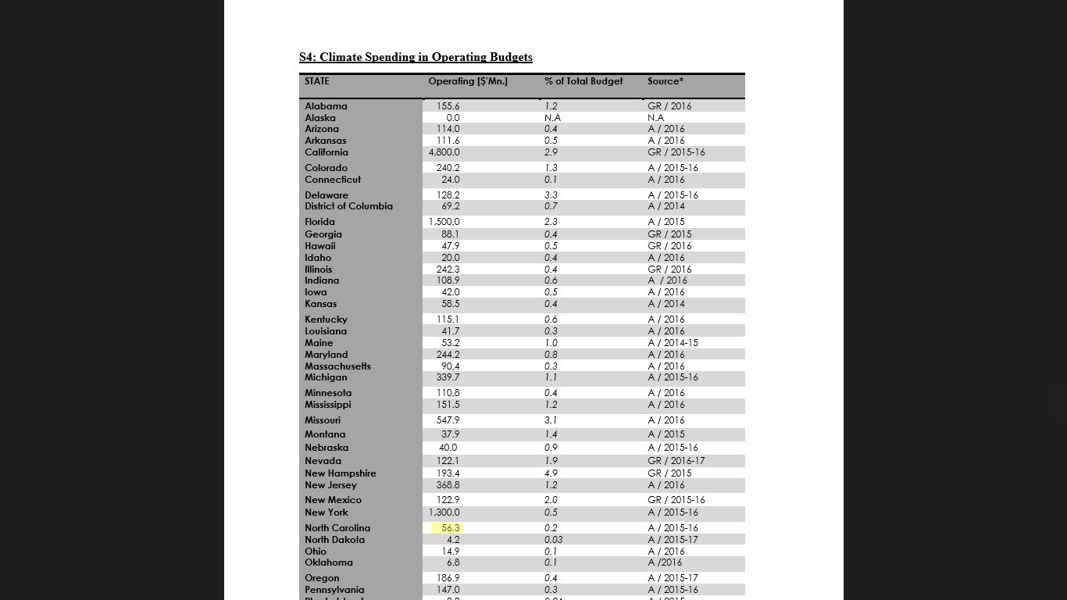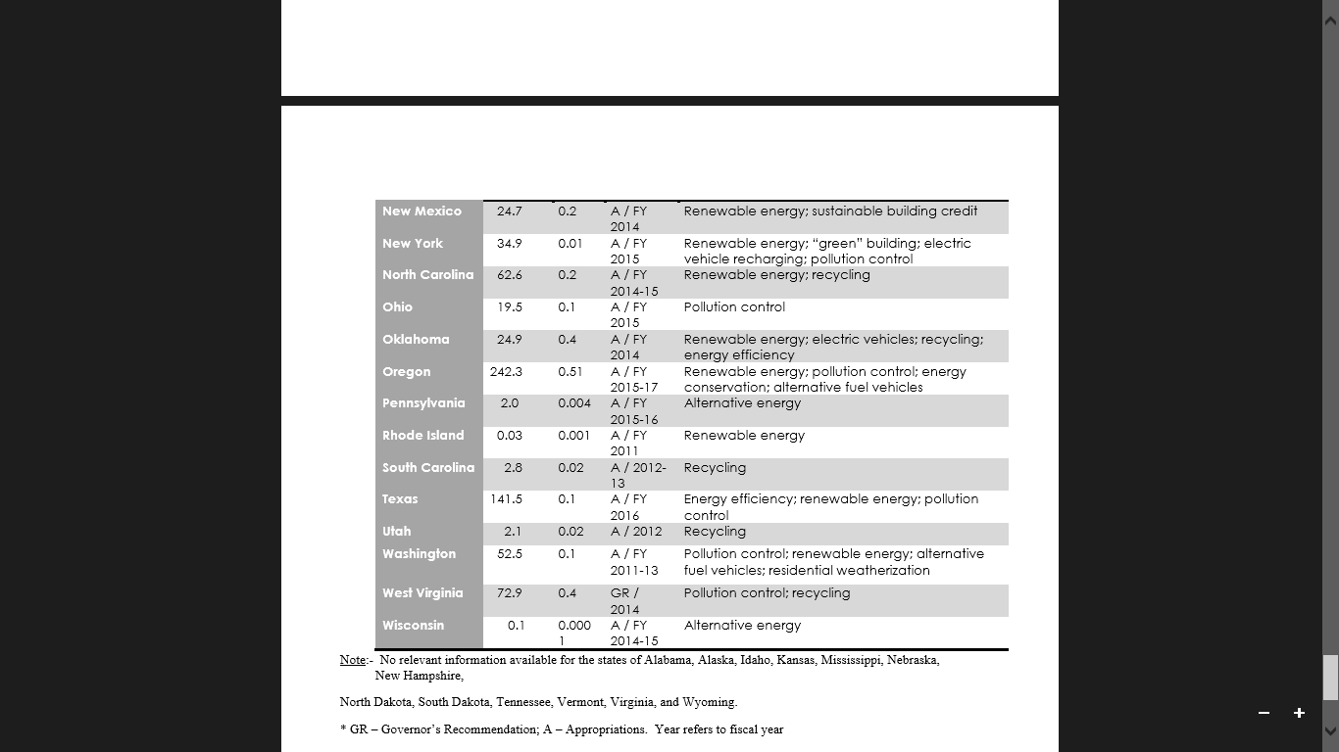

Conclusion
The actions of people are the major cause of pollution. Every day many people have been observed throwing away tons of disposable cups and plastic made products into the river. Which causes the blockage into the water and eventually leading towards the flooding of rivers. It is important for the industries and companies to understand that rivers are not made for the storage of the toxic waste material. They should stop dumping their waste in the landfills and should follow proper measures to get rid of the waste materials. The actions that people should follow to save themselves from pollution are to stop flushing contaminated liquids, pills or drugs down the drain which destroys the quality of natural water system. Proper disposal methods should be used for medications. Detergents and bleach should be used in the minimum amount in the houses instead people should use phosphate-free detergents and soap. The major cause of water pollution is the excessive use of fertilizers, pesticides or herbicides, because these chemicals often find their way into the water and contaminate it. Government should ensure the proper sewage system so that toxic material should be saved from going into rivers and oceans because the drinking water comes from the rivers and causes many diseases. Proper disposal of trash is very important. People should learn the point that disposal of waste products is very important as it helps us in the getting rid of the blockage of the water. Many people have a bad habit of dumping the products directly into the water systems. Disposal of products directly into the rivers not only cause pollution but also kill the poor sea living animals. It should become the habit of the people to by environment friendly products. So that we could be safe from global warming and ozone depletion. Plastic is the most harmful thing in the water pollution because it is not dissolvable into the water causing some series damages. Hence, people should always tend to use such plastic which water dissolvent. Such shoppers have been developed which are environmental friendly and can be dissolved into the water without causing any harm or damage. Government should plant green trees in large amount of number as they help a lot in the production of the oxygen. If we start following all these points we can easily get rid of the pollution (Vernberg, Vernberg, 2013).

References
Zachary Bean, E., Frederick Hunt, W., & Alan Bidelspach, D. (2007). Evaluation of four permeable pavement sites in eastern North Carolina for runoff reduction and water quality impacts. Journal of Irrigation and Drainage Engineering, 133(6), 583-592.
Vernberg, F. J., & Vernberg, W. B. (Eds.). (2013). Pollution and physiology of marine organisms. Elsevier.

