HLTENN010
Student Name | Rachel Maree Taylor
Training Package  National Code | HLT54115 | Qualification Name | Diploma in Nursing
Unit Code | HLTENN010 | Unit Name | Apply a palliative approach in nursing practice

ASSESSMENT INSTRUCTIONS
Type of Assessment | Assessment  Complete online unit  Clinical reflections and activities
Instructions for Written Assessment Task | Assessment  Part A Online Unit  Students are required to complete the Centre for Palliative Care online learning package and print your certificate on completion.  Certificates are to be submitted by the due date  ALWAYS keep a copy of your certificate  Part B Clinical placement documentation and reflection  On your clinical placement you need to complete the clinical documentation table and reflection activity.
What do I need to do to achieve a satisfactory result? | All questions and reflections must be completed.
Due date/time allowed | As per Assessment schedule

SUMMARY OF ASSESSMENT TASKS
Summary of Assessment Tasks | Task | Satisfactory |  | Unsatisfactory
 | Written Assessment | ☐ |  | ☐
Assessor Feedback | Assessors Feedback
 | Assessor’s Comments:
 | Print Name:  Signature: |  | Date:
Student acknowledgement of assessment outcome | Student Feedback  Please sign and date to acknowledge that you have received results and feedback on your assessment. You have the opportunity to provide feedback to your Assessor in the space below.
 | Student’s Comments: Would you like to make any comments about this assessment?
 | Signed: |  | Date:

Please note that TAFE NSW is required to retain copies of all completed assessments, where practical, for a period of 3 years (or in accordance with regulatory/licencing requirements) after the completion of a student’s studies.

Part A online unit

This online course for health professionals, Palliative Care: Getting Started, serves as an essential introduction to the key palliative care concepts required to provide best practice clinical care.

You can complete the online course in about two hours. Embedded short films ensure the course is interesting, as well as informative, and interactive quizzes confirm your understanding of the key concepts.

OBJECTIVES:
After working through this module you will be able to:
1. Provide a definition of the different models of palliative care and their main principles
2. Explore when a referral to palliative care can be beneficial to the patient and their family
3. Describe the range of professionals that can make up a palliative care team
4. Describe some common symptoms that people with a terminal condition may face
5. Explore some common palliative treatment options that can improve quality of life for both the patient
and their family
6. Identify some common medicines used to treat symptoms in palliative care
7. Explore how psychosocial and spiritual care is provided
8. Explain some common care considerations when caring for a dying patient and their family
9. Identify some ethical issues around end of life care
10. Explore usual bereavement responses and strategies to identify complicated bereavement

Access the Palliative Care getting Started training website and complete the online learning package for https://www.centreforpallcare.org/page/31/online-courses

You will need to complete a short survey and give your details so that a password can be generated. Use your new password to commence this online module
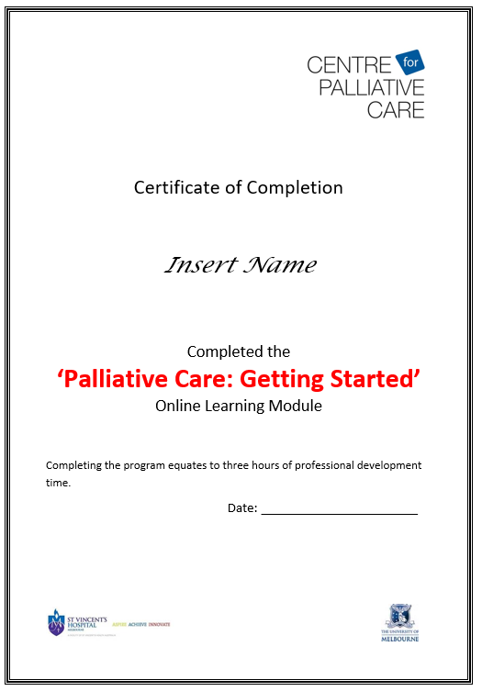
On completion save and print a copy of the certificate and submit to the teacher

Grading: Satisfactory / Not Satisfactory

Remember:
Make sure to print or save your certificate prior to closing the browser.
Make sure you record username and your enrolment key

Apple iPad Users:
If you require a copy of your certificate of completion please make sure you are able to save PDF files on
your device prior to commencing the learning package

Part B

Clinical Placement Documentation and Reflection

When you are on Clinical Placement you need to complete the following table and a write a reflection on your experience/thoughts of palliative care.

Document five examples of what you have observed, practised, performed or discussed related to the following criteria: (The first 3 symptoms have been given for you to complete)
Document additional examples during your clinical placement

Health Information | Clinical Presentation | Possible Nursing Interventions
Respiratory difficulties  Due to Heart Failure | Patients having heart failure and respiratory problems.  Reduction in arterial oxygen saturation after 6 to 72 hours  patients with progressive symptoms of dyspnoea, an increasing requirement for oxygen.  Severe, acute confusion, respiratory distress, cyanosis, and diaphoresis may be evident. Cough, chest pain, wheeze, haemoptysis, and fever | The patient-nurse interactions are an important aspect of managing patients with dyspnoea. A thorough nursing assessment and measurement of systemic observations allows the nurse to gain an understanding of how patients are managing their breathlessness. Observations should be accurately and clearly recorded on patients’ observations charts and in their nursing records. Nursing intervention can break this cycle.  The nursing staff provides the patient oxygen therapy. A nurse suggests and helps them in breathing exercise to improve the breathing. Moreover, nurses provide them support through their services and conversation with their patients.
Wound management  of Diabetic foot ulcer with terminal cancer. | The diabetic foot ulcer having cancer cells spread in other parts of the body. The wound is slowly recovering and causes weakness to the patient.  The clinical presentation of infected wounds includes fever, erythema, oedema, induration, increased pain, and a change in drainage to a purulent nature. However, symptoms of infection in chronic wounds or debilitated patients may be more difficult to distinguish. In these cases, diagnosis may rely on non-specific symptoms such as loss of appetite, malaise, or decrease in glycaemic control in diabetics. | The nurse provides best services and being kind with such patients whose lives are ending.  Monitor site of impaired tissue integrity at least once daily for colour changes, redness, swelling, warmth, pain, or other signs of infection.  Monitor status of skin around wound. Monitor patient’s skin care practices, noting type of soap or other cleansing agents used, temperature of water, and frequency of skin cleansing.  Keep a sterile dressing technique during wound care.  Premediate for dressing changes as necessary.  Wet thoroughly the dressings with sterile normal saline solution before removal.
Pain  With terminal breast cancer. | Pain location - The location of pain is an important part of the history; ask the patient to describe the type of pain and the location on a pain diagram (anterior/posterior and lateral view of human picture)  Precipitating factors - Ask questions about factors that provoke or intensify pain; this information may provide clues concerning possible etiologist or associated disorders  Alleviating factors - Ask the patient if any factors help to alleviate the pain; for example, rest may decrease pain of musculoskeletal origin  Quality of pain - Ask the patient to describe the quality of pain; various terms can be used to describe the quality of pain, including throbbing, pounding, shooting, pricking, boring, stabbing, lancinating, sharp, cutting, lacerating, pressing, cramping, crushing, pulling, pinching, stinging, burning, splitting, penetrating, piercing, squeezing, and dull aching  Radiation of pain - Ask the patient if the pain spreads or radiates; spreading or radiating pain is a characteristic of neuropathic pain | Foresee the need for pain relief.  Acknowledge reports of pain immediately.  Get rid of additional stressors or sources of discomfort whenever possible.  Provide rest periods to promote relief, sleep, and relaxation.  Determine the appropriate pain relief method.  The terminal breast cancer can cause pain in some parts of the body. Nurses provide them some pain killers to relieve their pain. It has to be noted that if the cancer is confined by the breast, then it is not going to be life threatening in any case, but what has happened here is that the cancer has spreaded to lymph nodes, then it becomes terminal cancer.
End Stage of Life | Incontinence and the lack of the congestion is one of the primary determinants of the end of the life symptoms. It has to be noted that the clinical assessment has to be done during the course of the whole process in the manner that better care is provided to the patient. | Sleeping. ...  Incontinence. ...  Restlessness. ...  Congestion. ...  Urine decrease. ...  Fluid and food decrease.

Reflection:
This reflection will include your individual experiences of palliative care. These may include your personal, theoretical or clinical experiences. Identify your need for self-care. Describe strategies you might use to sustain your social and emotional wellbeing.

Palliative care is the specialized medical care for the people with serious illness. The care is focused on the relief from intensive pain and serious illness. The purpose of this care is to improve the health of the patient and to facilitate both the patient and the family. The patients who have a death causing disease are provided palliative care by the specialize trained team of doctors, nurses and other concerned staff. They work together with the patient’s family to provided extra ordinary support. I had an experience with palliative support when my mother had a heart failure and she had problem with heartbeat, shortness of breath, and weaknesses. I was with her in hospital she had a severe pain. The doctors and nurses were very cooperative and provided her the best possible care. Palliative care is an approach that improves the quality of life of patients and their families facing the problem associated with life-threatening illness, through the prevention and relief of suffering by means of early identification and impeccable assessment and treatment of pain and other problems. When she was admitted she had very critical condition. The doctors shifted her to ICU for the intensive and urgent care. The first step was to provide her the basic treatment to bring her to normal conditions. As she was able to talk they made proper care planning. The staff was very polite, and they tried different medical trials to reduce the pain and the discomfort. The nursing staff had provided medicines, food, and other support to the patient in best possible way. Her pain was eased and was able to live a normal life. They put her on ventilator to get oxygen to the longs and the whole body. Her oxygen level was 60 which was extremely low. After a week her oxygen level reached 98, so the doctors removed the ventilators. The nurses helped her to walk some steps each day. Now one of the key aspect of the healthcare is to make sure that the pain assessment and pain management is carried out in an appropriate manner. The idea must be to make sure that how the quality of the treatment can be improved if regular pain assessment is being carried out at the end of the patient. Not only that, effort is also needed to be done to ensure appropriate patient management in terms of how the patient’s condition is going to be stabilized in case of any event. This is one of the thing that is needed to be integrated into the pain management guidelines as well.
The hospital administration also provided psychological support to mom and me. The psychological support decreases the tension of the patient and thus the pain is reduced up to certain level. The patient with life limiting conditions having range of psychological, spiritual, and social challenges. The palliative staff highly considered the cultural dimension and provided all the services and counselling’s considering the cultural traits. They consider the values, beliefs and the preferences as important factors. The purpose of palliative care is to improve your current health status and sustainable in future. The life limiting illness makes a patient mentally weak and causes depression and anxiety. The patients are properly guided and provide all the correct information regarding the health. The family members of the patient especially the spouse or children who are taking care of the patient becomes a victim of the mental health issues. The doctors and other staff provided us the documented plan. They asked my mum and me about our concerns and the suggestions to provide care according to the personal and cultural requirements. The support provided by palliative care team is physical, emotional, and spiritual. They highly value the religions and appreciate religious beliefs of the patients. The religious patients are convinced easily to accept the illness and death.
They also follow ethics in all the situations, they don’t do any unethical activities. The palliative support team provides cultural and ethical based support in the terminal phase. They are also preparing a patient who are dying in few days or months both mentally and spiritually. The properly do all the documentation and clearance of a dead person. They properly manage a dead body and provide the family all the reports and causes of the death. Fortunately, my mother got the best treatment she was recovered from very intense conditions. In my view the palliative services are best in Australian hospital. The nursing staff is working in palliative care department where the patients are dying or living with great pain and hardness. There are more chances for the staff to burn out and employee’s turnover intention could be high. To maintain the staff and raise their satisfaction level higher hospital administration has to rotate their job after a specific time and provide them with certain sessions to keep them normal. Living with such a reality of life, and serving the patients with the end phase of life can make the nursing staff and other palliative care staff exhausted, so proper counselling and other refreshment techniques should be applied.

References
- Brameld, Kate, Katrina Spilsbury, Lorna Rosenwax, Kevin Murray, and James Semmens. "Issues using linkage of hospital records and death certificate data to determine the size of a potential palliative care population." Palliative medicine 31, no. 6 (2017): 537-543

