1.The minimum distance between the Sun and Saturn is 1.4×10⁹ km while the maximum distance between the Sun and the Earth is1.5×10⁸ km. What is the minimum distance between the Earth and Saturn in kilometers?

kilometers
×10
The minimum distance between Earth and Saturn is 1.25X10⁹ kilometers.
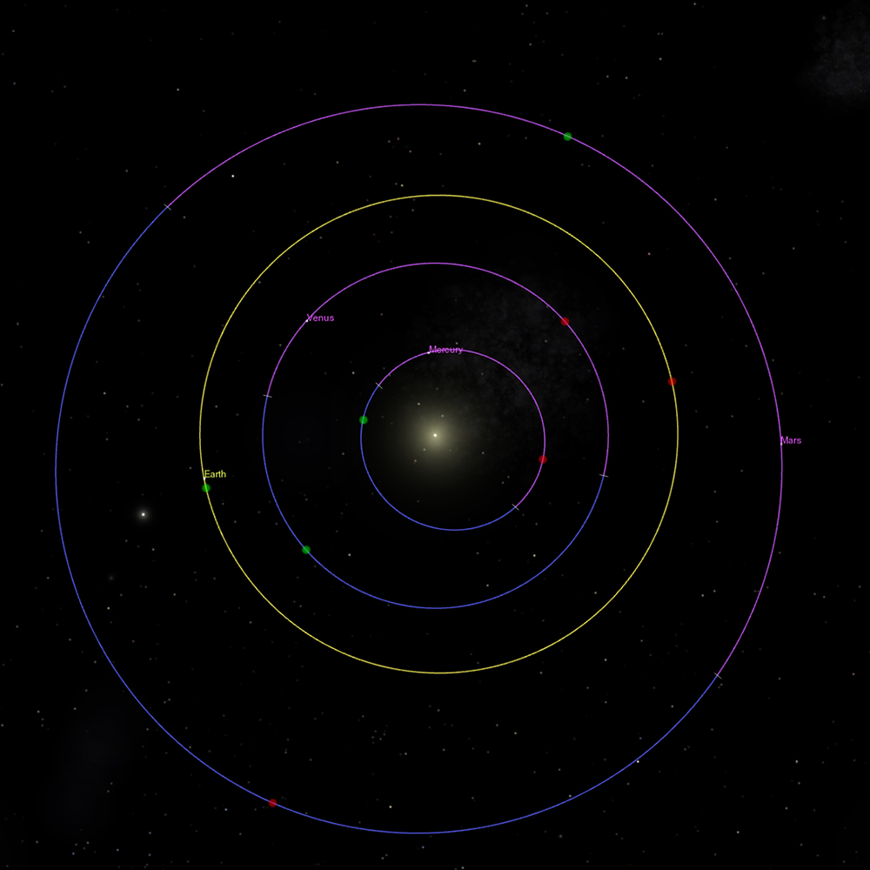

2.The Apollo 8 spacecraft, the first mission to take humans to the vicinity of the Moon, traveled a total distance of 9×10⁵ kilometers in 150 hours. What is the average speed in kilometers per hour?
×10 |  | km h⁻¹

In meters per second?
×10 |  | m s⁻¹
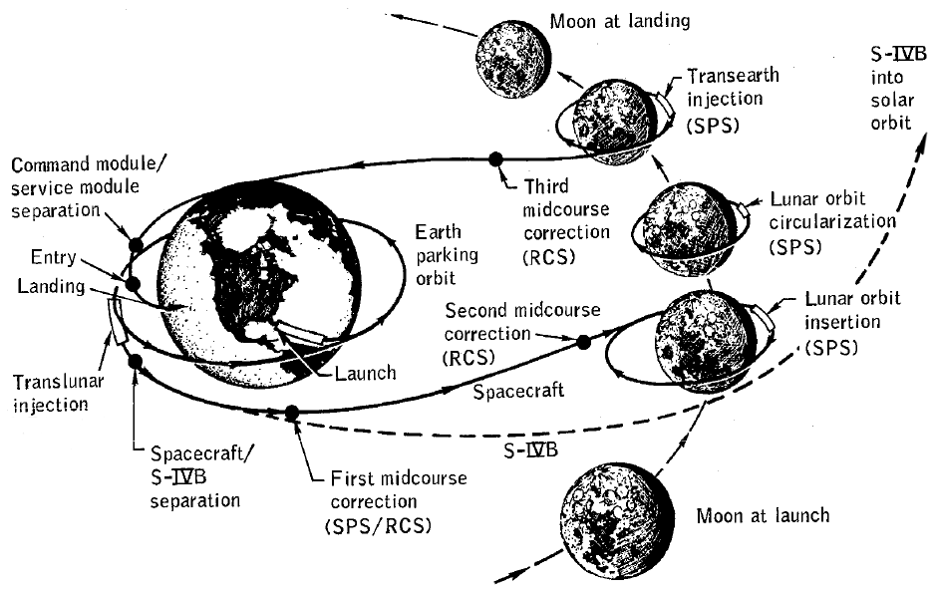
LicensePoints possible: 2

3. You may remember learning in grade school that 30% of the surface of the Earth is land. (Note that the symbol for Earth is ⊕.) In other words,
Land Area⊕=0.3×Surface Area⊕=0.3(4πR²⊕)
Earth has a radius of R⊕=6300R⊕=6300 km.
Meanwhile, the surface area of Mars is
Surface Area of Mars=1.4×10⁸ square kilometers.
What is the ratio of the Earth's land area to Martian land area?
In other words, calculate
Land Area⊕Land AreaMarsLand Area⊕Land AreaMars =
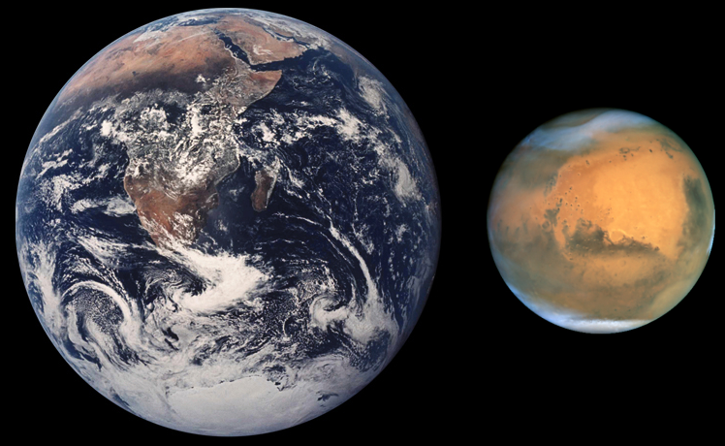
LicensePoints possible: 1

