Advocacy advertisement

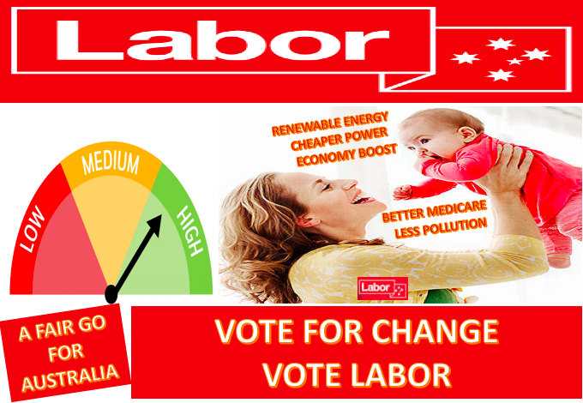

This assignment is aimed at reflecting the key objectives of the Labor Party Australia. The text will attract the Australians desiring to have better Medicare policies, a healthy environment to live in, cheap resources, economic growth, rights to everyone, and healthy living environment. The targeted audience of this advertisement includes parents, employees, female workers, underserved individuals, individuals desiring climate stabilization and patients requiring improved Medicare policies.
As far as the language is concerned, I preferred using simple English so that individuals with varying ethnic backgrounds could comprehend it easily. The advertisements use an attractive title for persuading the audience. The rhetoric tools used for capturing the attention of the audience include logos, ethos and pathos. The party logo is integrated for providing a demonstration to the viewers. Ethos is another selected rhetoric tool that would enhance the credibility of information through linking it with rational, authentic and valid sources. This makes it more persuasive for the viewers by providing rational grounds to their decision-making. Political agendas are often based on rationality and logic; hence ethos would be used to add ethical appeal. As subheadings, I highlighted the key objectives of the Party, through which people can come to know how the Labor Party is focused on bringing change in Australia.
I used multiple font styles, colour, text boxes, and visuals to attract people with different interests. I utilized the psychological facts for making the vision more appealing; bold and larger sized fonts to grab the audience’s attention. The red colour is used in the background with white text that makes it readable. A normal font of 14 is used so it is easily readable. Bright colours like red, yellow and green are used for adding attractions for the viewers. Psychology based evidence strongly supports that colourful and novel stimulus is successful in drawing audience interest through eliminating the elements of boredom and monotony and making their eyes to perceive something unique and interesting.
I used convincing text in the advertisement with the highlights of what the Labor Party aims to do for Australians. For example, the ethos was used as a persuasive strategy in which the logo and objectives of the Labor Party were presented in an attractive manner. According to Aristotle, when any credible figure, object or event is presented as a reference tool to convey some message; it becomes more valid and authentic information for them. When it becomes authentic, more individuals allow it to modify their preexisting set of cognitive schemas or thinking patterns. This alteration in thinking patterns is the key factor in estimating the extent of behavioural change. This is what we call revolution at the public level. Hence, using the Party logo and objectives as a basis to convey the message in the advertisement will not only make the advertisement effective but also produce constructive changes among the audience.
While developing the advertisement, I focused to use effective words such as words highlighting the significance of the change, striking the audience’s interests and their future apperceptions. For example, individuals who do not possess appropriate income resources and suffer chronic health issues at the same time will undoubtedly find the Medicaid objectives highly captivating. For the youngsters who are worried about the pessimist future of the Earth and want to mitigate the climate change would seek satisfaction through reading the problem objective indicating the same issue. This is how I used effective words and phrases as thought-provoking agents. Moreover, the Labor Party has various planning strategies for various individuals that need to be highlighted therefore I first highlighted the stimulating title, then party plans and objectives.
Pathos is incorporated for adding emotional appeal. The visuals of a mother and baby are added in the advertisement for evoking emotions among the audience. This is an effective tool that will convince them that the Labor Party's agenda is to bring prosperity for all. The highlighted texts like ‘economy boost', ‘cheaper power' and ‘better Medicare' exhibits the use of pathos. The purpose of these texts is to develop emotional appeal by highlighting the positive aspects of the Labor Party. The inclusion of pathos has allowed building continuous interaction of the advertisement with the audience.

