Business plan Infographics

Health Court
Fruits, vegetables and other healthy products such as yoghurt, fresh salads and fruits combinations, and fresh juices

The vision to promote healthy products for school students

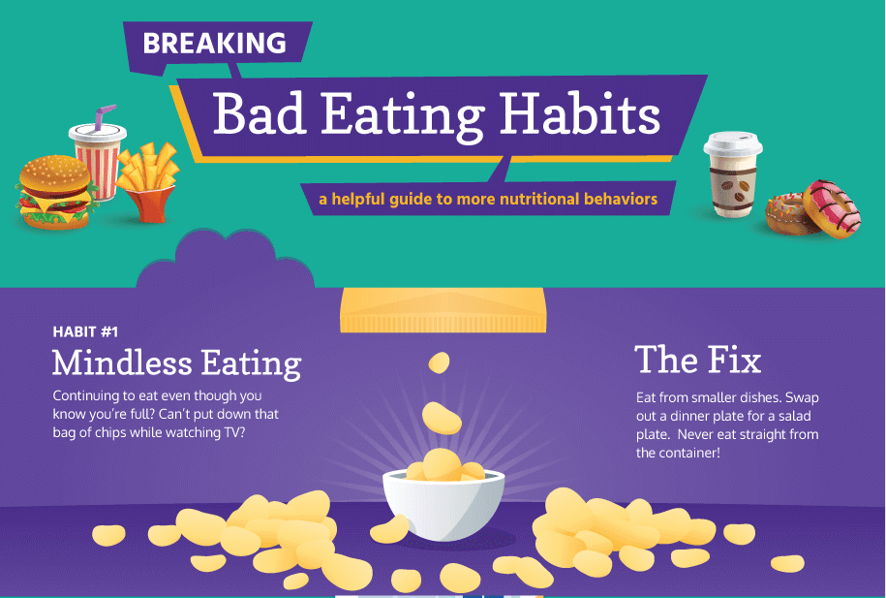

Business model canvas

Key partners  The owners of the business (two female partners). | Key activities  Offering healthy food to the children including vegetables, milk, juices and fruits.  The school canteen will resolve the problem of unhealthy food by offering nutritious meals.  Minimizing health related issues due to the reliance of kids on unhealthy food.  Promoting overall health status by replacing unhealthy eating patterns with healthy ones. | Value proposition  Health Court will deliver better food choices to the students.  The unique selling proposition is the strength of the business, its weakness is that the natural products are perishable and may get waste, the opportunity is to offer something new and catchy and educated youth convinced about health.  “You must eat at Healthy Court because it kills obesity and gives you energy”. | Customer relationships  The business aims at providing high-quality food for retaining its customers.  Fresh vegetable, fruits and juices are provided on a daily basis.  Feedbacks will be taken from the customers for evaluating their level of satisfaction. | Customer segments  The business targets children of the school.  The first segment includes children having ages of 4 to 8 years.  The second segment includes children with ages of 9 to 13 years.  The third segment includes children having ages between 14- 16 years.  Different menus will be sold such as milk will be added for the children of 4-8 years age group.  Marketing strategies:  The promotion activities will be done across all the departments of the school, and the school social media page and the website (Amaro and Duarte). The sales will be done through the canteen counters and the canteen counters will display the products in safe hygienic glass containers.
 | Key resources  The partners (owners) are responsible for providing resources and finance for the business startup.  The plan required a total investment of 500,000 AUD. ]The key resources include equipment, raw materials and supplies. Staff will be hired for the canteen. |  | Channels  The canteen will maintain a relationship with suppliers who will be responsible for providing fresh stocks of vegetables, fruits and other ingredients on a daily basis.  The food that the canteen is unable to sold will be disposed of daily.
Cost structure  * 200000: Security and Lease Payment  * 90000: Decoration  * 160000: Equipment and Utensils  * 20000: Raw Material and Inventory  The variable costs are about 100000 AUD per month. Out of this total cost of one month, 100000 AUD. |  | Revenue streams  - The estimations reveal that the average sale of about 4000 per day then the total revenue is about 100000 AUD a first month.  - The business expects to attain 3% growth in the next month.  - For the second month, revenues are expected to be 103000 AUD which accounts for the profit of 3000.

