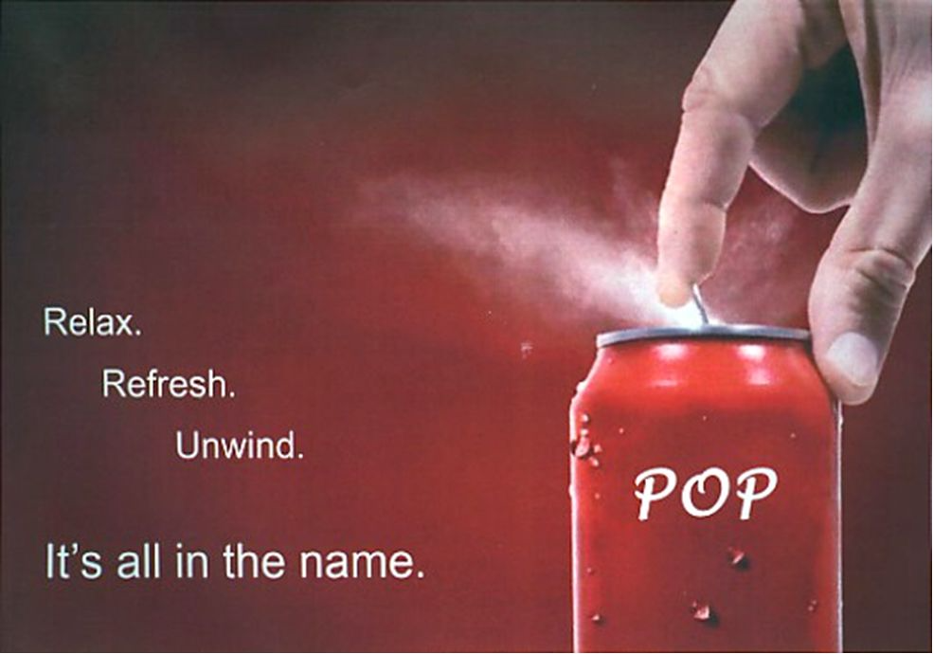
It’s fresh and clean… The taste gives you complete refreshment & JOY!
Because
- First: It means pure and fresh.
Second: The TANGalized soda gives cool, TANCY, deep-down refreshment.
- Buy POP today! Enjoy the finer quality.

Why we have the aging baby-boomers in the business!
Nothing does it like POP!
SWITCH TO POP

If sweet soft drink leaves you thirsty…

NO THIRST
FUN
RELIEF
ENERGETIC
COOL

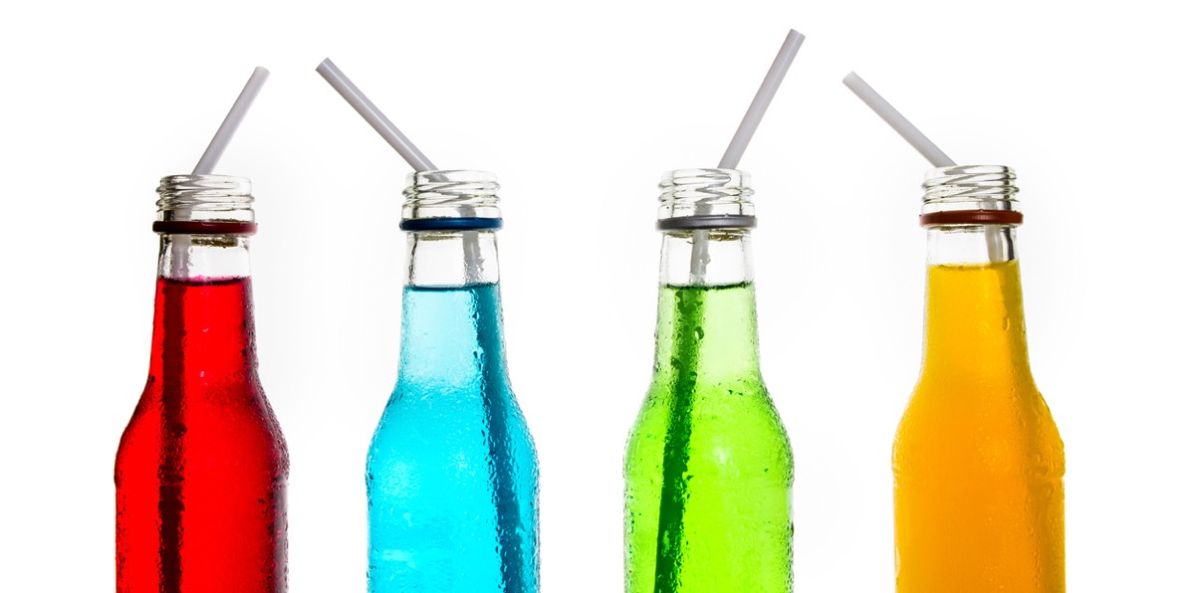

Different flavors for each day... To add colors in your life

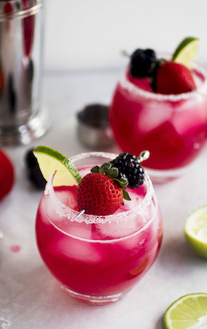
Ice-Cold!
Makes your everyday cool.
CHEER-UP!!
POP~ matches the mood of aging baby-boomers because it is friendly and bright.

SO Be a fresh-up boomer… bring added fun to your boring lives.

You can get it at any place
AMAZING
FUN
REFERESHING
ENERGETIC
Its different because….
- Not processed
- Not unnatural
- Not unhealthy

Life without POP is not cooool & Happy HOMES have POP!!

Aging baby-boomers will be delighted with its thirst-quenching strawberry flavor.

Be Fun at your age….

Keep a supply of POP on hand!
LOOK at the distinctive carry carton….
TAKE six bottles home
You will not regret your decision

POP
TO DRINK
FORGET
DONT

SODA campaign 1
The name of the soda is ‘POP’ that is appropriate for targeting the aged boomers having ages between 50-65 years.
Demographics
It will target aged baby boomers who have monthly incomes of $75,000- $100,000 per year. The customers are married and acquire at least education of college level.
Psychological factors the advertisement include specific texts that directly target the aged baby boomers. The texts like “why we have aging baby boomers in business” will create persuasion for the targeted customers.
Visual texts are used such as “It’s fresh and clean. The taste gives you complete refreshment & JOY!” This creates element of fun for the customers and they will be inclined to taste the product.
The add also provided reasons for switching to POP that will increase the persuasive power.
Images are also included in the print ad that builds connectivity of the product with customers. The picture of the aging baby boomers is effective for targeting the people of same age group. This is a practical methods used for showcasing that the soda is for the aging people. The ad has incorporated pathos for building emotional appeal (McQuarrie & Mick, 1999). The aging baby boomers after watching the picture of older people will be motivated to buy the drink. This establishes a strong bond POP with thee clients. The emotions of the viewers are evoked by making them feel that the drink is only for them.
Specific texts are also used that provoke the audience to taste the new product. The ad mentions, “nothing does it like pop”. This builds an unpredictable temptation among the aging baby boomers and they will be convinced to drink the soda (Albakry & Daimin, 2014).
The visual rhetoric of the advertisement use pathos for building emotional appeal. The print ad has used bold statements like “different flavors for each day to add colors in your life”. The catchy texts are made more appealing by adding colors and powerful texts. This is a practical strategy employed for catching viewers’ attention (Bulmer & Buchanan‐Oliver, 2006).
Another effective tool integrated for making the advertisement more powerful is by addressing the aging baby-boomers. This indicates that the ad is using segmentation for selling the product to the right customers. This creates attraction for the aging baby-boomers by claiming that the drink is only for them.

References
Barber, Benjamin. “Overselling Capitalism with Consumerism”. Reading Pop Culture A Portable Anthology, edited by Jeff Ousborne, 2 ed, Bedfort/St. Martin, 2016, pp. 22-25.
Bulmer, S., & Buchanan‐Oliver, D. M. (2006). Visual Rhetoric and Global Advertising Imagery. Journal of Marketing Communications , 12 (1).
Albakry, N. S., & Daimin, G. (2014). The Visual Rhetoric in Public Awareness Print Advertising toward Malaysia Perceptive Sociolculture Design. Social and Behavioral Sciences 1 , 155, 28 – 33 .
McQuarrie, E. F., & Mick, D. G. (1999). Visual Rhetoric in Advertising: Text-Interpretive, Experimental, and Reader-Response Analyses. Journal of Consumer Research , 26 (1), 37–54.

