[Your Name]
[Instructor Name]
[Course Number]
[Date]

Marketing Journal Post 11: The Macroenvironment

Macro Environment
Macro Environment refers to the external environment in which a business or organization operates. Macro Environment is also defined as the major external and uncontrollable forces and factors that have an impact on the decision making the process of an organization or business. As well as they have an impact on the strategies, operations, and performance of a business. These factors/forces include;
- Economic Factors/Forces
- Natural Factors/Forces
- Demographics Factors/Forces
- Legal Factors/Forces
- Social Factors/Forces
- Political Factors/Forces
The specific examples of the factors of the external environment that affect an organization are; cultural tastes, competitors, fluctuation in interest rates, weather and climate, and government policies and regulations etc. (Samnani, p.p. 37-40).

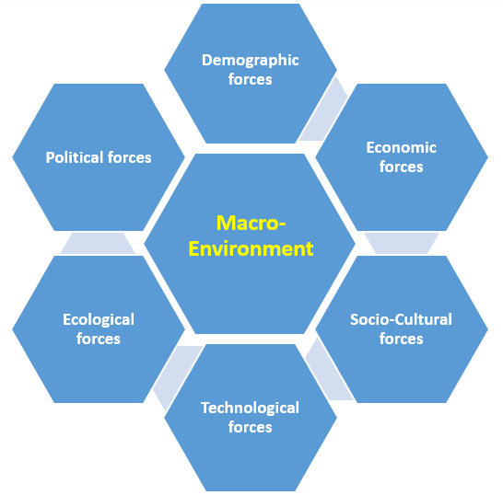
Factors in the Macro Environment
After a marketing analysis of my product (Corona Suave 50/50 blend 3-inch Paint Brush), it has been concluded that all four factors in macro environment have impacts on it but the following three (3) have a higher impact on my product than the others.
- Economic Factors
Economic factors involve all the determinants of the economy and states. As our product is more expensive than many competing products. So, very few changes in the economic factors such changes in interest rates, changes in buying behaviour, or variations spending rate of consumers put huge impacts on the price of Corona Suave 50/50 blend 3-inch Paint Brush. At the result, we would have to change the price range accordingly (Osborn, and James, p.p. 231-246).
- Technological Factors
Technological factors also have enough impact on my product. It has impacts on my products because a bit of technological advancement and development dramatically affect the wants and preferences of consumers. So the offering of a bit technological competitive product by a well-established competitor can affect sales volume of my product (Babatunde, and Adebola, p.p. 64).
- Demographics Factors
Demographics could impact my product up to an extent. It could impact my product because changes in the general population can lead to an increase or decrease in sales and demand for my product. Like, an increase in population can lead to higher sales and demand and household pattern changes may cause sales and demand in both a positive and negative way.

Work Cited
Babatunde, Bayode O., and Adebola O. Adebisi. "Strategic Environmental Scanning and Organization Performance in a Competitive Business Environment." Economic Insights-Trends & Challenges 64.1 (2012).
Osborn, Richard N., and James G. Hunt. "Environment and Organizational Effectiveness." Administrative Science Quarterly (1974): 231-246.
Samnani, Amina. "Macro-Environmental Factors Affecting the Secondary Industry." Science and quality management 31 (2014): 37-40.

